https://docs.google.com/presentation/d/1ujLkYqVmRjn6wiZON2mpxRpshtbKD5kcHysZceYnOCo/edit#slide=id.g204cf49ec9d_0_33

# About (Drug Product Database) DPD

* The DPD contains product specific information on drugs approved for use in Canada.
* The database is managed by Health Canada and includes human pharmaceutical and biological drugs, veterinary drugs, radiopharmaceutical drugs and disinfectant products
* Managed by Health Canada (federal regulator)
* It contains approximately 47,000 products that are currently approved, marketed, dormant or cancelled.

# The wrapper functions

**Drug Consumption**:

* Input : Drug Name (Exact Match)
* Output : Drug Form (Pill, Tablet, Powder, Syrup etc) & Route of Administration (Oral, Topical, etc)

Underlying API calls : /route, /drugproduct, /form

Example:

Input: ACETAMINOPHEN 325MG

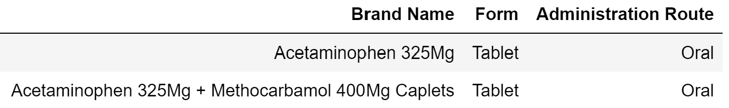

# Target Audience & Potential Use & Advantages

* Can be used by Pharmacists and Doctors to search drugs through the database of the appropriate form and route of administration according to the patient’s preference.
* Faster search results as the search is not generic and does not use drug id for search input as drug ids are not well-known.

# Future Work

* Create a wrapper function that gives users the option to pick a format to provide input i.e. name of the drug or drug code by showing a table of drug names and drug ids and still implement the wrapper functions that we have shown.
* Create a wrapper function that takes as input the name of the ingredient to which the patient is allergic and show drugs that are free from that ingredient.
* Create a wrapper function to find the form and route of administration of the drug depending on the schedule of the drug i.e., is it a prescription drug, OTC, or Narcotic etc.

# Distinguishing Feature

Currently you cannot input a drug name and find the **form and route of administration of the** **active** **drugs in one API call**. The wrapper function helps do just that.

# Technical Challenge