Bellanger Pierre
Bragotto Marta
Kararji Dylan
Manzo Giuseppe Sebastiano
Go-Kart Project
ensea 2022-2023

Go-Kart Summary
General Scheme 2
Physic study 3
System Scheme 3
Available Data 3
Hypothesis of Study and Data 4
Electrical Components of the Kart: An Overview 5
Motor Description and Control 7
Motor Control Algorithm 9
Board Selection 12
Sensors 13
Throttle Sensor 13
Code for ADC Measurement 13
Current Sensor 17
Voltage Sensor 21
Voltage Converter 48V → 15V 23
Voltage Converter 48V → 5V 24
Datasheet Links 25
PCB Design 26
Hall Sensor PCB 26
Logic Shift PCB 29
Improvements and Further Development 32

General Scheme
The elements are placed on the Go-Kart chassis as shown in the photo. The battery is small and placed in front of the driver. The motor is placed on the right side and the inverter in the back. If the battery was bigger, it could be placed on the left side, to balance the weight of the motor, as well as the inverter if was smaller could be placed differently.
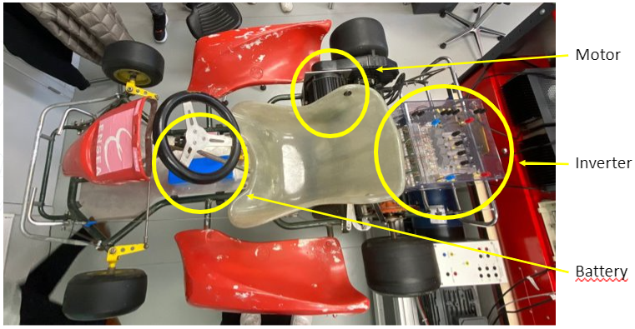

Physic study

System Scheme
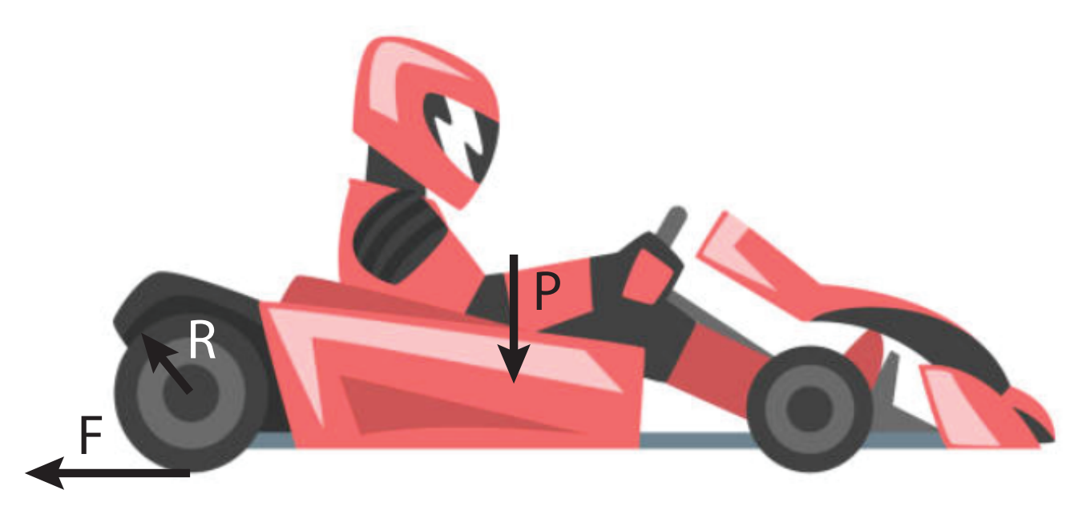

Available Data
- Battery voltage
- Battery dimensions
- Motor performance estimation as follows
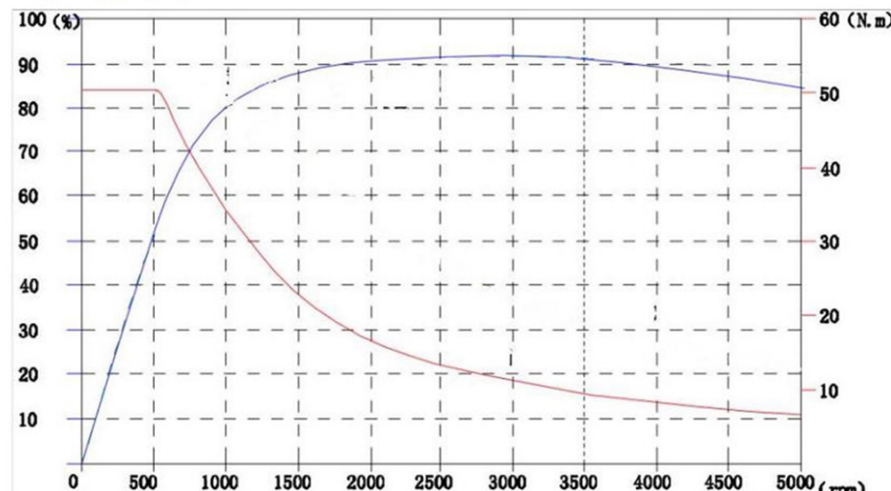

According to the physical data of the kart, the reduction ratio between the motor shaft and the wheel axis needed to be determined.

Hypothesis of Study and Data

Wheel radius r = 130mm (Tyre + Rim)
Maximum Speed of the Rotor N = 3000 rpm
Maximum Torque = 50 Nm from 0 to 600 rpm theoricaly (Motor 3kW)
The weight of the kart has been estimated as 80 kg while the average weight of a pilot as 70 kg.
Total weight = 150 kg
Since 150 kg kart needs to be moved, then the force of inertia would be at least 1500N.
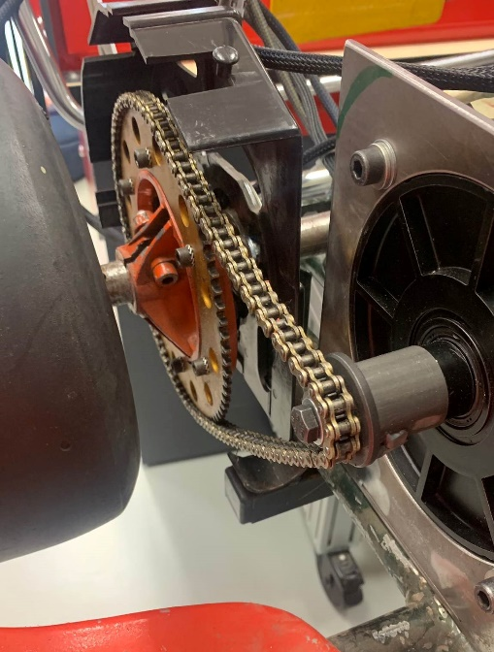
So,
$$F_{weight}=\frac{{Torque}_{wheel min}}{R_{wheel}}$$
And,
$${Torque}_{wheel min}=195 N.m$$
$${Torque}_{motor}*e*Ratio= {Torque}_{wheel}$$
With an estimated efficiency of 100%
$${Ratio}_{wheel→motor}=4$$
Moreover, with and estimated efficiency e of 90%,
$${Ratio}_{wheel→motor}=4,3$$

Wheel ratio needs to be at 1/4,3 maximum.
1/5 has been chosen as motor to wheel ratio in order to assure the requested torque and the top speed around 30 km/h.
In the workshop, ENSEA has a 12th gear and a 76th gear. The ratio in this case would be about 1/6; it will decrease the speed but validate the needed torque.
After asking at the mechanical workshop, the good ratio has been developed and is the one displayed on the kart. Our maximum speed will be then 23 km/h, good enough for using the go kart indoor.

Electrical Components of the Kart: An Overview
The electrical system used in the car is composed of the following elements:
- BLDC motor
- Inverter
- 48V Battery
- Electronic Board (NUCLEO – G431RB)
- Voltage Converters (TEN 8-4813WI, TEN 8-4821WI)
- Logic Shift PCB
- Hall Sensor PCB
- Current Sensor
- Voltage Sensor
- Throttle sensor
The elements are connected as follows:
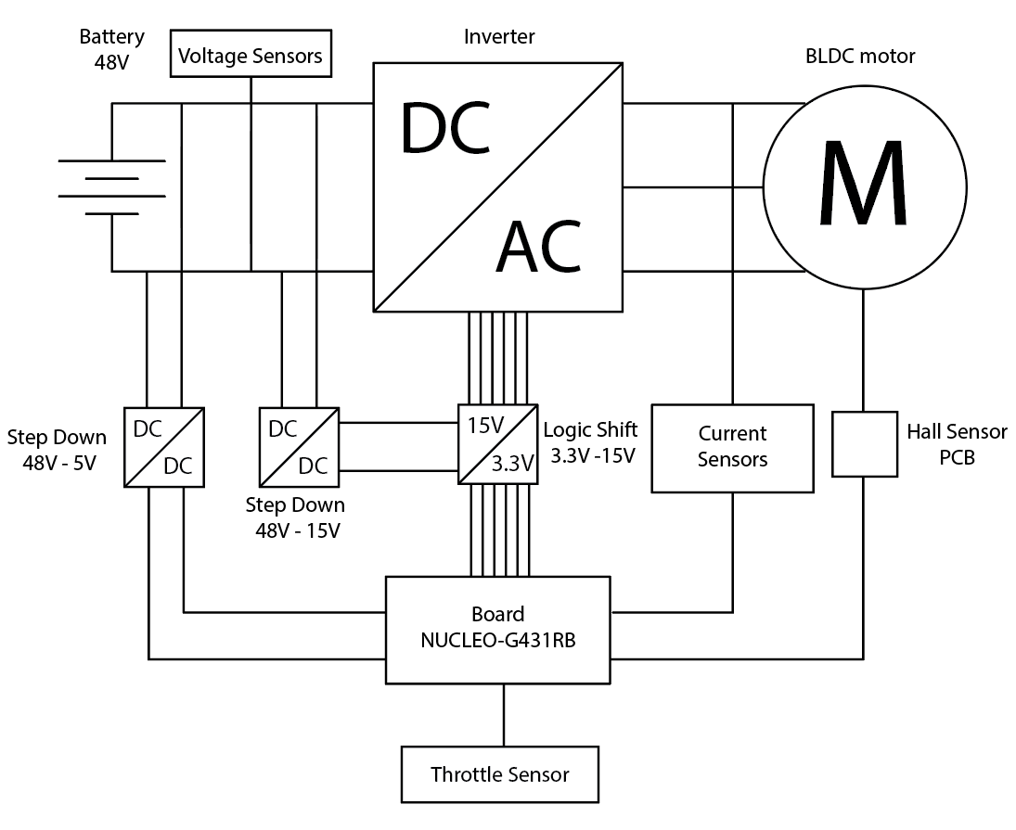
The general idea is to control the inverter gates to convert DC voltage from the battery into AC voltage to power the motor as required by the user through the throttle commands. The board reads current and voltage values from the sensors (current sensor, voltage sensor and hall sensor), as well as throttle request from the pedal and determine how to switch the six gates (called H1, L1, H2, L2, H3, L3) following the algorithm created (see Motor Description and Control chapter for more details). The inverted used is made by IGBTs (Insulated Gate Bipolar Transistor), which need a 15V input command, so the 3,3V voltage output of the board is shifted into a 15V command by the Logic shift (see Logic Shift PCB chapter for more details). To have a 15V voltage reference a DC-DC converter is used and connected to the battery. The board itself is powered by 5V voltage by a DC-DC converter connected to the battery (see Voltage Vonverters chapter for more details).
The hall sensors are located inside the motor and in order to be powered they need a 5V supply. So they’re connected to a dedicated circuit to be read (see Hall Sensor PCB chapter for more details).
Both the Logic Shift and Hall sensor PCBs has been studied, designed, realized, and tested from scratch.

Motor Description and Control
A brushless DC electric motor (BLDC motor) is a synchronous motor using a direct current (DC) electric power supply, in this case a 48V battery. It uses an electronic controller to switch DC currents to the motor windings producing magnetic fields which effectively rotate in space and which the permanent magnet rotor follows. Hall sensors are positioned in the motor to have rotor orientation information, needed by the electronic controller. It adjusts the phase and amplitude of the DC current pulses to control the speed and torque of the motor.
Given the Hall sensor information, six rotor configurations can be found and for each configuration only two of the three phases are powered, as shown in the image below.

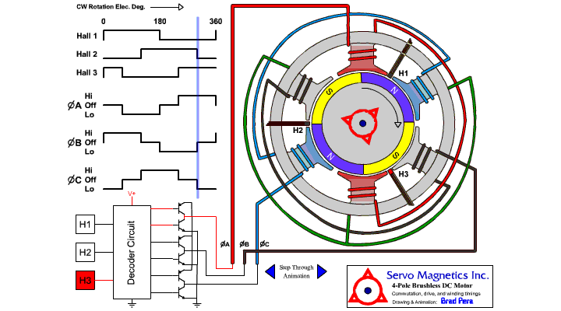

Then the inverter’s switches are commanded following hall sensors information. Switching logic is fixed by the table below:

HA | 1 | ↓ | 0 | 0 | ↑ | 1
HB | 0 | 0 | ↑ | 1 | 1 | ↓
HC | ↑ | 1 | 1 | ↓ | 0 | 0
H1 | ↓ | 0 | 0 | 0 | ↑ | 1
L1 | 0 | ↑ | 1 | ↓ | 0 | 0
H2 | ↑ | 1 | ↓ | 0 | 0 | 0
L2 | 0 | 0 | 0 | ↑ | 1 | ↓
H3 | 0 | 0 | ↑ | 1 | ↓ | 0
L3 | 1 | ↓ | 0 | 0 | 0 | ↑

Notice that inverter gates are called H1, L1, H2, L2, H3, L3, where H for high, L for low and the number refers to the inverter’s leg. The up arrow (↑) means that the transistor is switched on and the down arrow (↓) means that transistor is switched off.
Graphical representation of Hall sensors, Phases voltages and transistor switching:
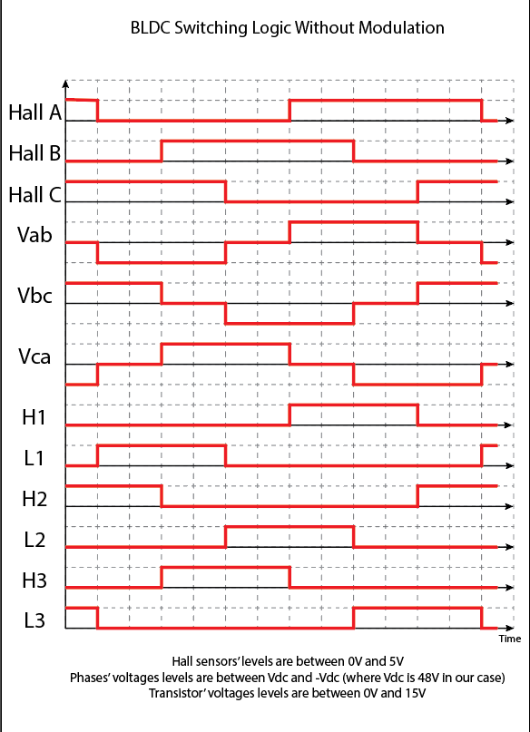

Motor Control Algorithm
This motor is controlled with respect to throttle request. This value is used to modulate output voltage. This operation can be performed with many different methods as PWM (pulse width modulation), FOC (Field Oriented Control) and others.
In this case the modulation is performed to recreate a sine-wave voltage form using square waves signals, proportional to the throttle request. Throttle value is interpretated as percentage of voltage required by the pilot: if it is at 100% the switching logic will be performed as shown before (red line), otherwise the transistor switching will be anticipated or delayed according to the following graph:

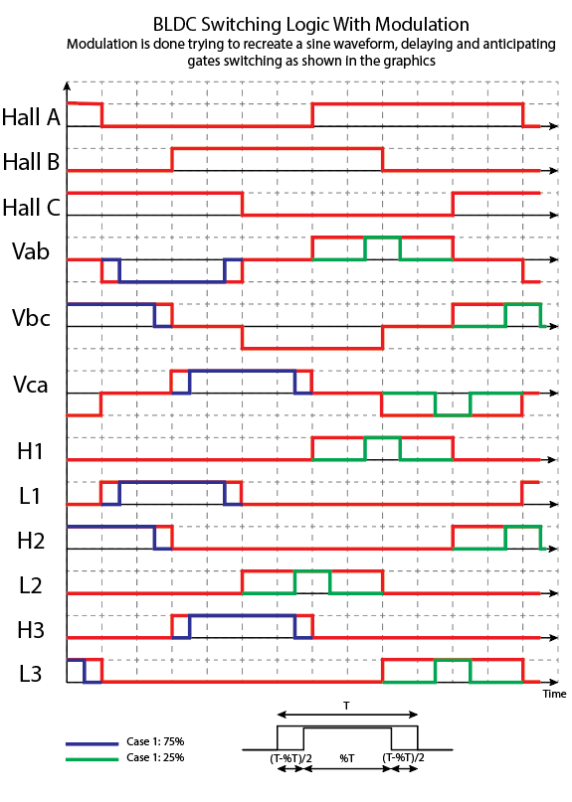

Notice that for values between 0% and 50% (green line) first the switch off operation of the designed gate is performed and then the switch on operation of the other one. For values between 50% and 100% (blue line) first the switch on operation of the designed gate is performed and then the switch off operation of the other one.
Once switching logic modulation method is defined, the control algorithm is developed. It is described in detail in the following flowchart diagram:

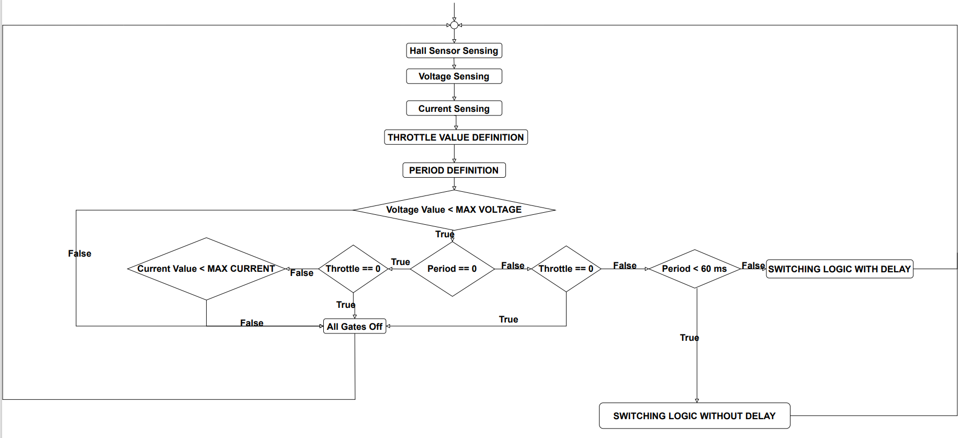

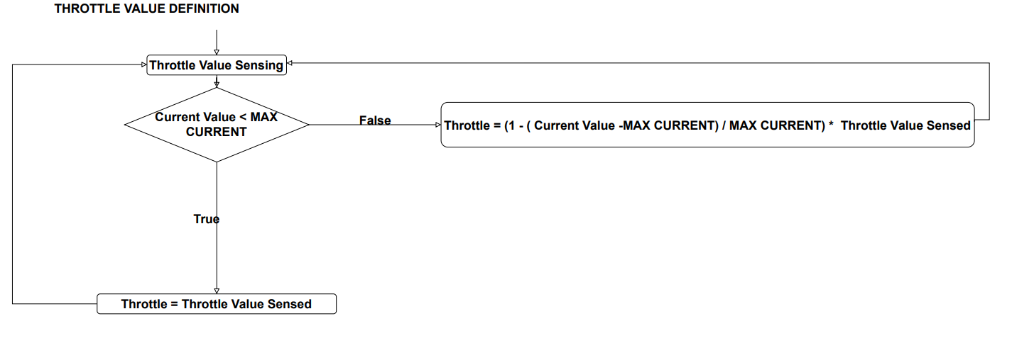

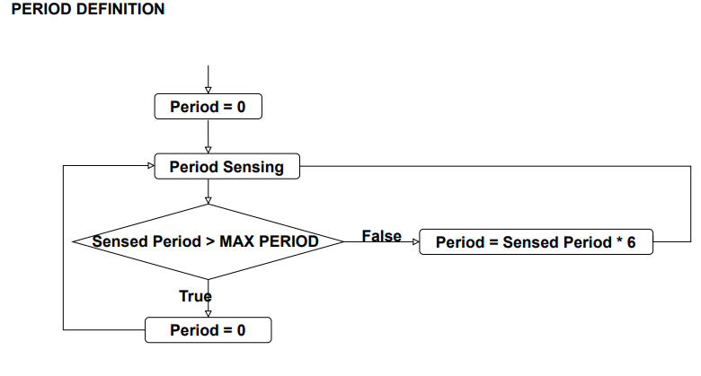

It is a control mainly based on current value sensed, purely proportional to the current overshoot over the maximum possible value for the current. The maximum value of the current is a constant value in this algorithm, but it could be better defined and change during time depending on different parameter, as motor temperature or overshoot time.
No gain has been defined for the proportional controller. It could be defined during physical testing on the motor. Moreover, if there were motor parameters available, simulation could be performed to realize a more sophisticated control, for example a PI or PID controller.
This control flowchart has been translated into C code through the STM32 IDE.
Period is measured setting pins connected to Hall sensors as EXTI-GPIO ports and enabling interrupts for both rising and falling edges. Then a timer is set to measure the time. When the interrupt call-back function is activated, the value of the timer is stored, and the period is calculated as the difference of the values of the stored timer over the timer frequency.
Period is set to 0 as the first value and it is reset to 0 every time the kart slows down and then stops, so the rotational period increases over the maximum period value. This is a parameter that can be chosen, in this case is set at the period for having 0.5m/s speed.
The delay operation is performed in the code using the HAL_DELAY() function. Switching commands are transmitted using HAL_GPIO_WritePin function and Hall sensors are read using HAL_GPIO_ReadPin. Look at the attached code for more details.

Board Selection
To power the motor, use the sensor needed by the control and control the inverter the following requirements are determined to choose the correct board:
- 6 GPIO output pins to command inverter gates
- 3 GPIO EXTI mode pins to sense Hall sensors
- 5V for Hall Sensor
- 1 ADC pin for current sensor
- 1 ADC pin for voltage sensor
- 1 ADC pin for throttle sensor
- Ground electric signals
NUCLEO-G431RB board has been chosen
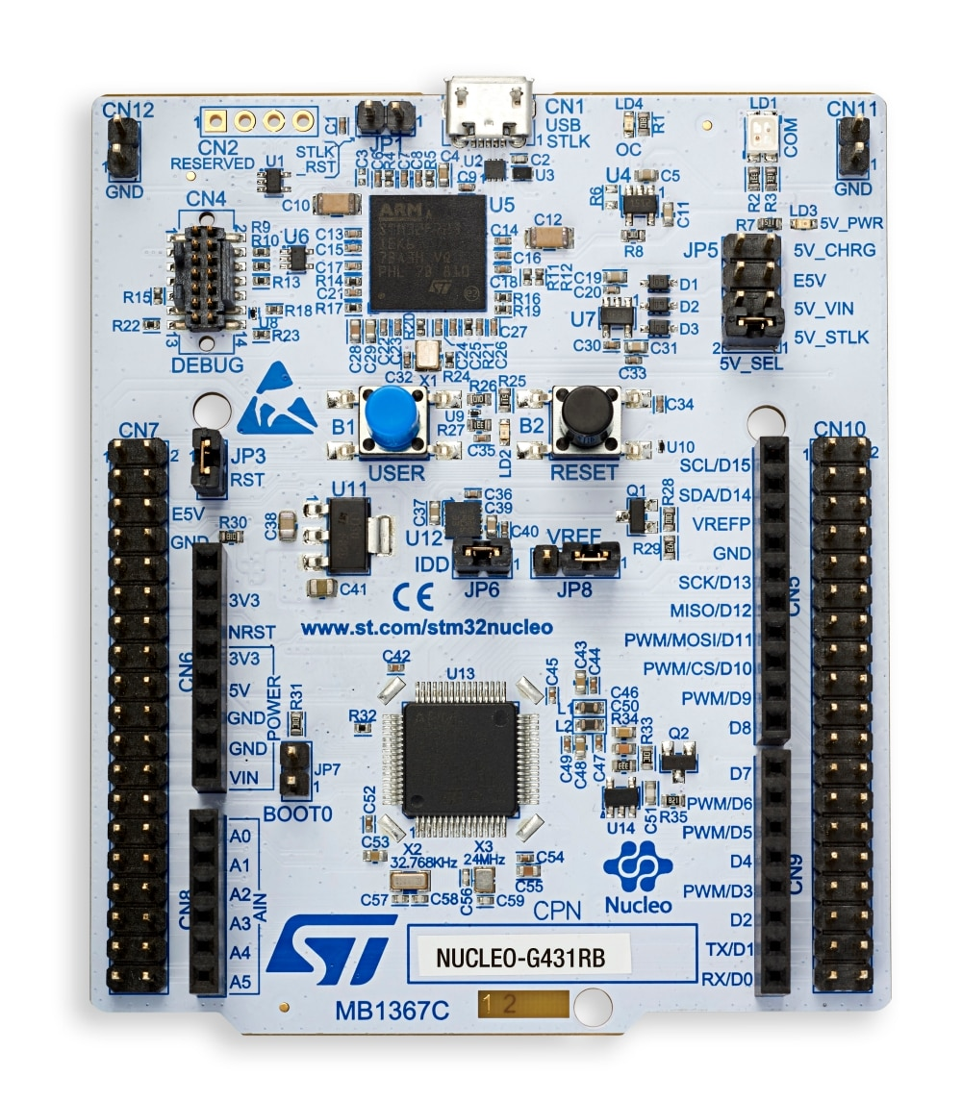

Sensors

Throttle Sensor
Naturally in order to make the kart running, an interface between the pilot and the kart is needed. It is represented by the throttle pedal for the torque request, but a way to connect the throttle and the motor needed to be developed. A potentiometer has been connected to the throttle pedal in order to measure the throttle request.
The board has been connected to an Analog to Digital Converter (ADC) that translated the outcome information from the potentiometer.
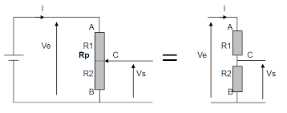
The STM32 Nucleo –G431RB board powers the potentiometer with a Ve=3.3V voltage while the output voltage Vs will vary between 0 and 3.3V according to the value of the potentiometer. For the sake of having the throttle request value into a percentage one, a conversion has been developed.
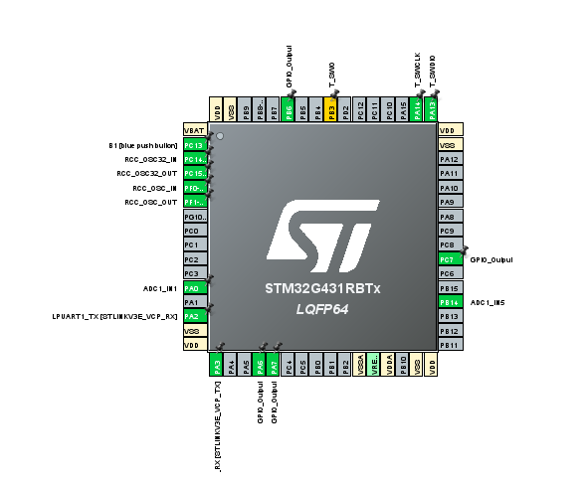

Code for ADC Measurement
An ADC (ADC1) has been set on an analog pin PA0.
A timer then is set to manage the interrupts, so the configuration of the parameters of the timer TIM1 has been done by choosing a frequency of the clock of 170MHz and a Prescaler of 1700-1.
Since the wanted sampling frequency of the sensor is 10KHz the following settings have been set out. Notice that the Trigger Event: Update Event setting has been chosen in order to trigger the ADC measure.

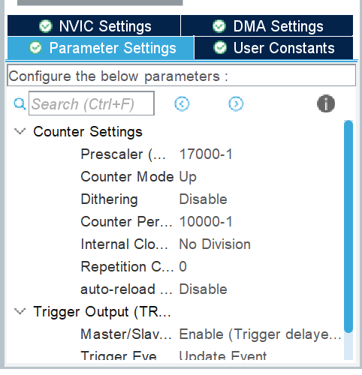
For what concerns the ADC1 here below there is the set configuration
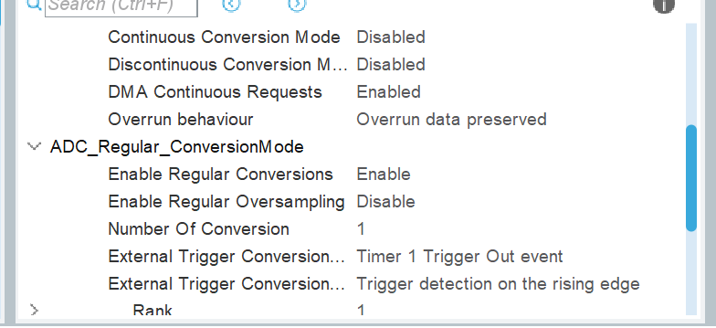

After the setting of all the configurations the coding began.
A good way to code this type of function is by software triggering, interruption at the end of the acquisition of the sensor samples.
In the main function, an integer flag has been initialised at 0 and this value is changed to 1 each time the ADC is called in the while loop thanks to the interrupt call-back function of the ADC.
when flag=1 the conversion begins as following in the code:
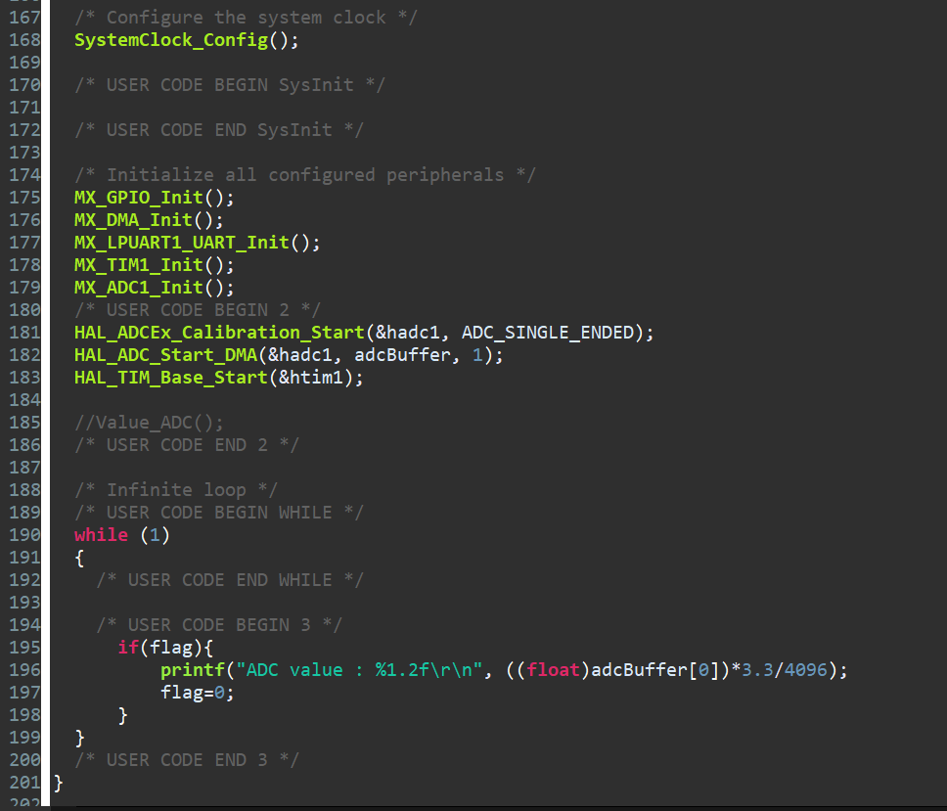
The white variables are global ones.
The interrupt call-back function is modified as follows

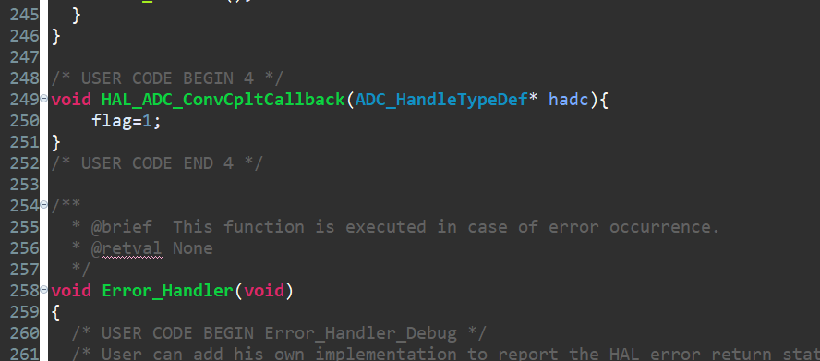
Through the terminal emulator client PuTTY, the values of ADC changing according to the throttle can be seen as a prove if the functioning of the code.
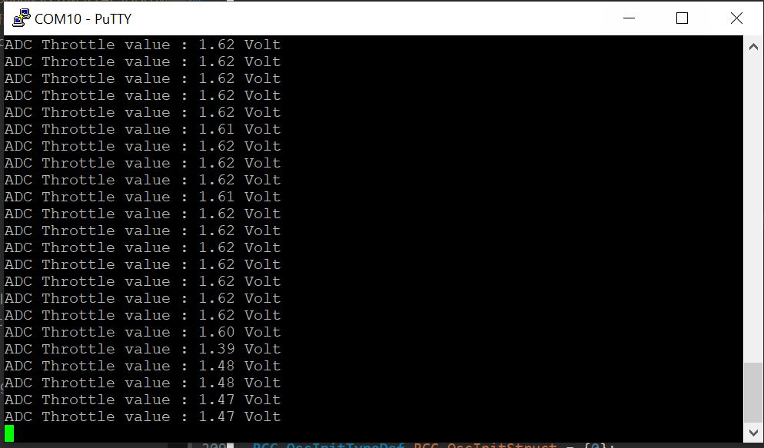
The results are then converted in the code of the BLDC control as a percentage.

Current Sensor

Current sensors are used to measure the amount of current flowing in the electric motor. They are used in motor control to control the speed and power of the motor accurately and efficiently.
Three phase current sensors are used and are installed on each phase of the motor that individually measure the current flowing in each phase.
In nominal conditions, the maximum value of the motor’s current is 72.9A, but could be at 100A with short peaks during the start, it was imperative then to choose sensors that could receive and measure these current values.
By following this request, the L31S100S05FS current transducers from Tamura were chosen. They can measure a current up to 100A in nominal condition, and has a saturation current over 300A. The sensor is powered by a 5V voltage and requires a 10kOhms resistor.
Schematic diagram of the current sensor is shown in the photo
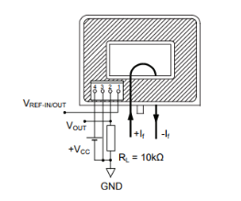

At Port 1, we have the reference voltage of 2.5V.
At Port 2, we have the output voltage and the 10kOhms resistor connected to the ground.
Port 3 is directly connected to ground.
With Port 4, we supply the sensor with 5V.

Voltage values:

Supply voltage Vcc = +5V
Reference voltage Vref = 2.5V ± 0.020V
Offset voltage Vof = Vref ± 0.025V (at If = 0A)
Output voltage Vout = Vof + 0.625V ± 0.015V (at If = 100A)

Tamura L31S100S05FS current sensor

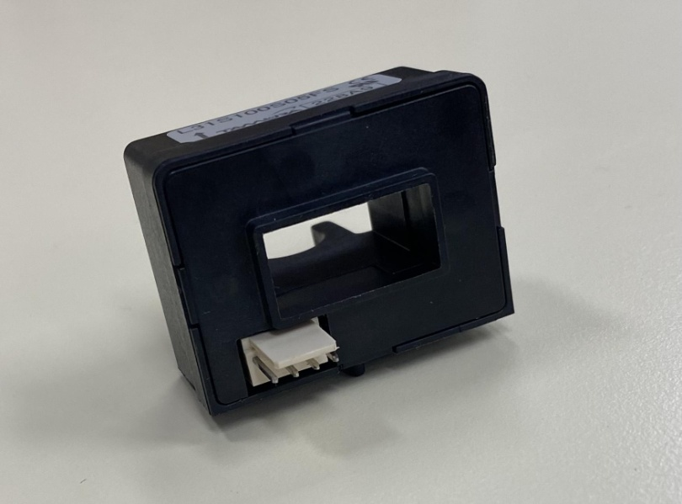

In order to test the functionality of the current sensor, a simple circuit with a power supply and a resistor was made, in which a cable from the circuit is passed through the opening in the sensor. The current sensor is powered as shown in the previous diagram and the values obtained are read on an oscilloscope.

Circuit used to test the Tamura’s current sensor

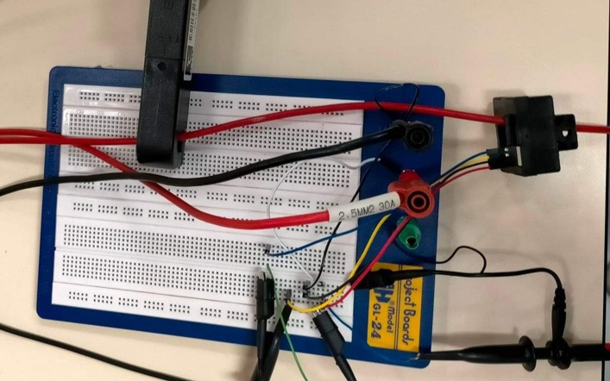

Visualisation of the different signals on the oscilloscope

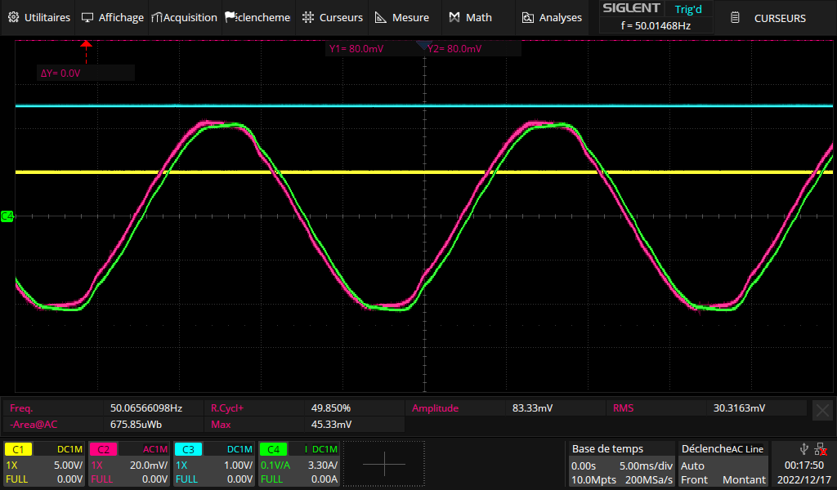

In yellow: the supply voltage at 5V
In blue: the reference voltage at 2.5V
In green: the measured current, at 6.6A
In pink: the output voltage at 41.67mV

According to the datasheet :
- 100A → 0.625V (625mV)
- 10A → 0.0625V (62.5mV)
- 1A → 0.00625V (6.25mV)

In theory, the voltage should have been : 6.25 * 6.6 = 41.25mV
The result is suitable because 41.67mV and 41.25mV are close.

For the go-kart’s motor, the usage interval is from 0A to 72.9A:
73A → 456.25mV
This will give an output voltage between 0mV and 456.25mV.

The voltage value will be recovered by the ADC of the STM32 with a code roughly similar to the accelerator’s one. In order to recover the current value, we need to convert the raw value :

voltage = (float)adc_value * VMax / ADC_RESOLUTION;
current = voltage / SENSOR_SENSITIVITY;

With : Vmax = 2 * 456,25mV
SENSOR_SENSITIVITY = 6,25
The 3 current sensors are displayed on the motor phases wires as shown in the photo
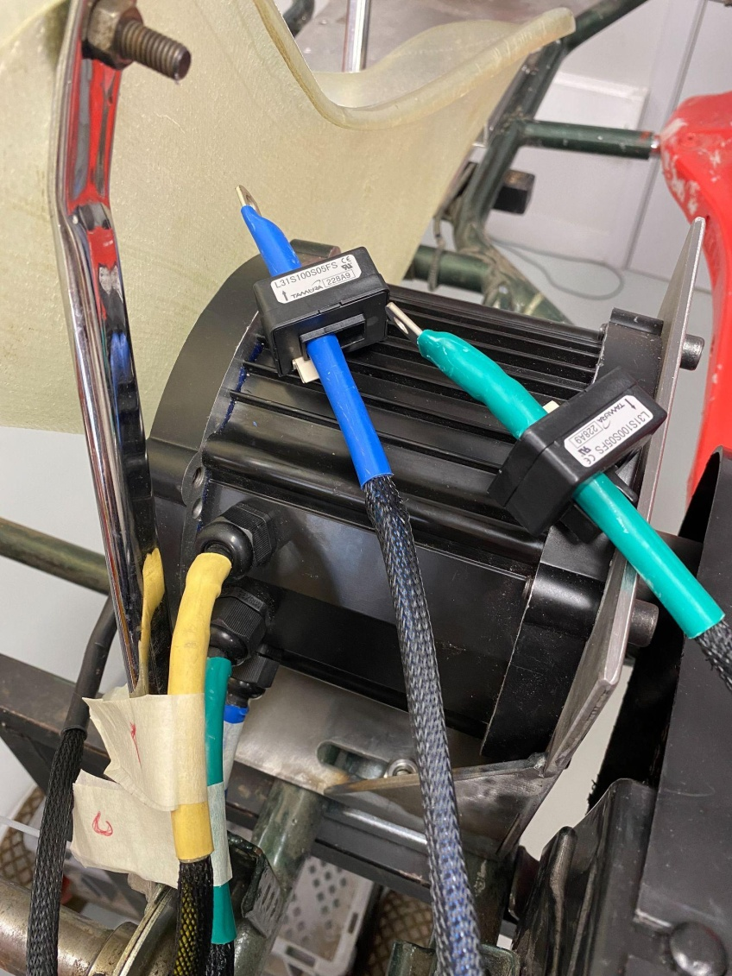

Voltage Sensor

The voltage sensor is used to measure the state of the kart's battery.
It’s connected directly to the battery and measures the battery output voltage. This voltage varies with the state of charge of the battery and can be used to determine the amount of power remaining in the battery.
This motor can go up to 48V with the battery, it was necessary then to choose an appropriate sensor.
LV 25-P voltage sensor is chosen, which is actually a transducer, from LEM. The sensor will be supplied with 15V thanks to a voltage, described later, and can measure between 10V and 500V.

Schematic diagram of the voltage transducer
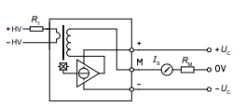

Supply voltage Uc: 12V to 15V
Primary rms current rating: 10mA
Primary voltage rating Vp (HV): 10V to 500V

LV 25-P voltage sensor from LEM
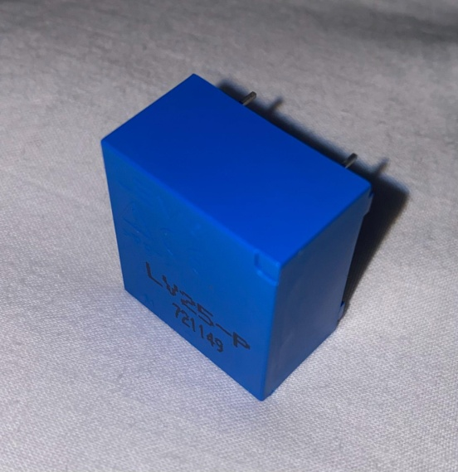

The optimum accuracy of the transducer is achieved at the rated primary current. Wherever possible, R1 should be calculated so that the nominal voltage to be measured corresponds to a primary current of 10 mA.
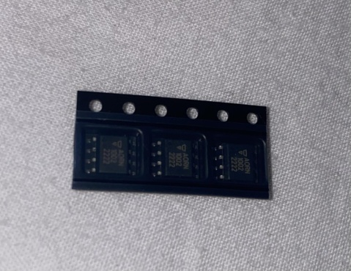
For the sake of simplicity and practicality, 100V has been chosen as the nominal voltage.
Voltage to be measured VPN = 100V -> R1 = 10 kΩ / 1 W, IP = 10mA
But then and if needed, we can take 50V to get closer to the 48V of the battery. It will therefore be necessary to change the value of the resistor.
Therefore a precision resistor R1 of 10kOhms is used ans shown in the photo.

Voltage Converter 48V → 15V
A 48V-15V voltage converter is used to reduce the 48V supply voltage to a 15V output voltage. It is used to power the inverter gates, which require a voltage of 15V to be switched. The inverter will also be used to power the voltage sensor.
To meet this need, the TEN 8-4813WI voltage converter from Traco Power was chosen.
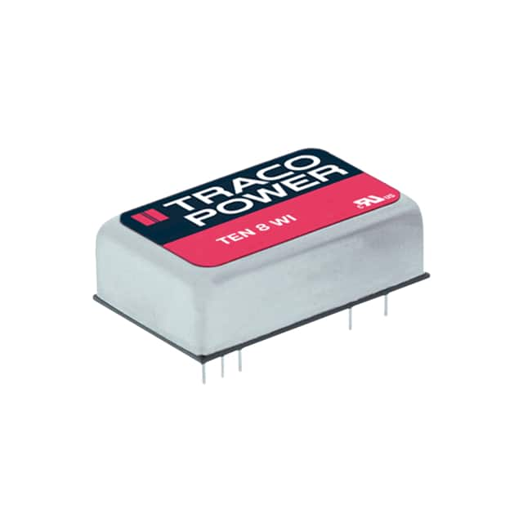
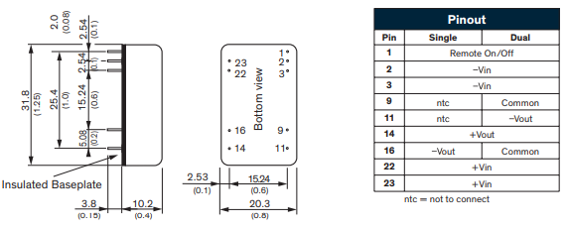
In input voltage, the component can accept between 18VDC and 75VDC with 48VDC as nominal voltage.
In output voltage, the component delivers 15VDC and a current of 533mA

Voltage Converter 48V → 5V
A 48V-5V voltage converter is used to reduce the 48V supply voltage to a 5V output voltage. It is used to power NUCLEO-G431RB electronic board, which requires a voltage of 5V maximum to work properly. The electronic components have voltage and current limits to avoid damaging the components. Using a converter to reduce the supply voltage keeps the components within these limits.
The TEN 8-4821WI voltage converter from Traco Power was chosen to meet our needs.
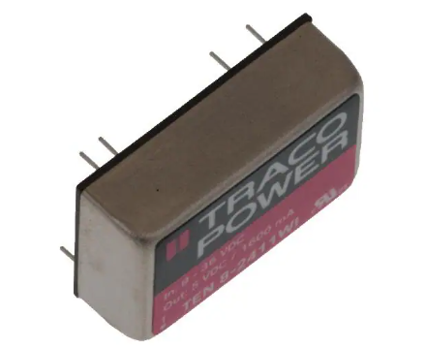
In input voltage, the component can accept between 18VDC and 75VDC with 48VDC as nominal voltage.
In output voltage, the component delivers 5VDC and a current of 800mA

Datasheet Links
- Current sensor:
https://www.mouser.fr/datasheet/2/397/TCOA_S_A0010069265_1-2563810.pdf
https://www.mouser.com/datasheet/2/397/L31SXXXS05FS-267665.pdf
- Voltage sensor :
https://www.farnell.com/datasheets/1866272.pdf
https://4donline.ihs.com/images/VipMasterIC/IC/VISH/VISH-S-A0012465569/VISH-S-A0012465569-1.pdf?hkey=6D3A4C79FDBF58556ACFDE234799DDF0
- Voltage converter 48V-15V :
https://www.tracopower.com/fr/fra/ten8wi-datasheet
- Voltage converter 48V-5V :
https://www.tracopower.com/fr/fra/ten8wi-datasheet

PCB Design

Hall Sensor PCB
This board has been designed in order to read the sensed values of the Hall Sensor integrated in the motor capsule.
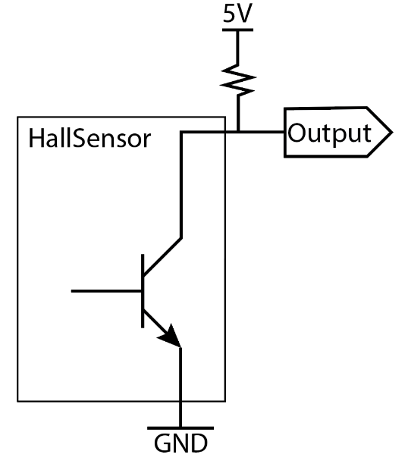
The goal of the PCB is connecting each of the three cables of the Hall Sensor to a circuit in order to create a current flow of minimum 20mA that is the required current by datasheet to read the output values of the sensor.
The Hall Sensor is considered a switch with voltage loss of 0,4 V as written in the datasheet.
So each line of the Hall Sensor can be represented as the circuit on the left, and then is easy to compute the minimum value of the resistor R needed for our purpose:
$$VR= \frac{5V – 0,4V}{20 mA}=230 Ω$$
Expanding the concept to the three lines of the sensor, the following circuit has been created.
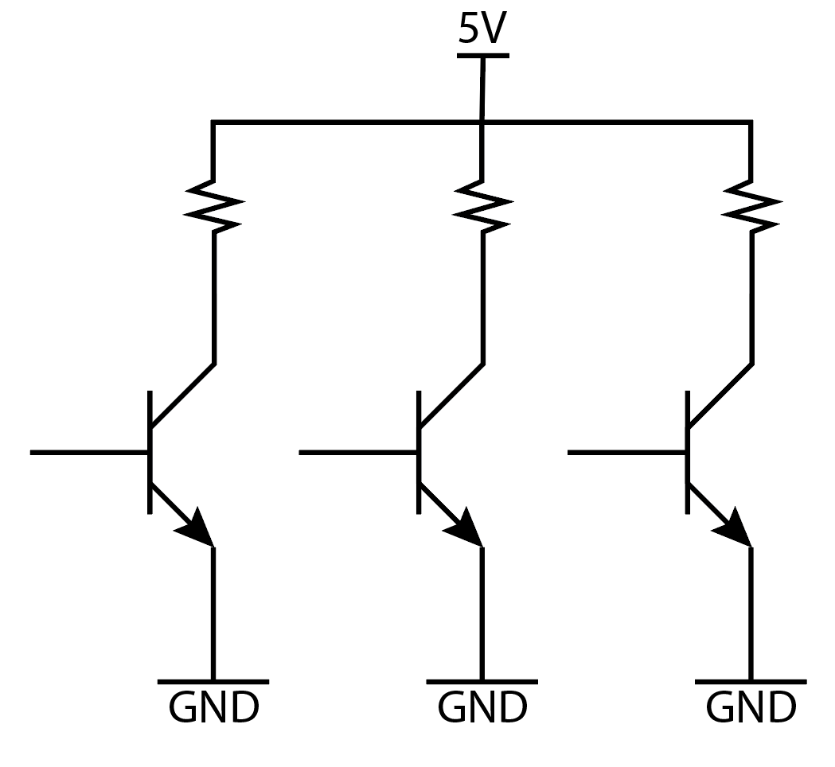

The chosen value of R is 270Ω since it was the first available type of resistor that fitted the board to be realised.
Through the software Kicad, the Schematic and Layout of the PCB have been designed.

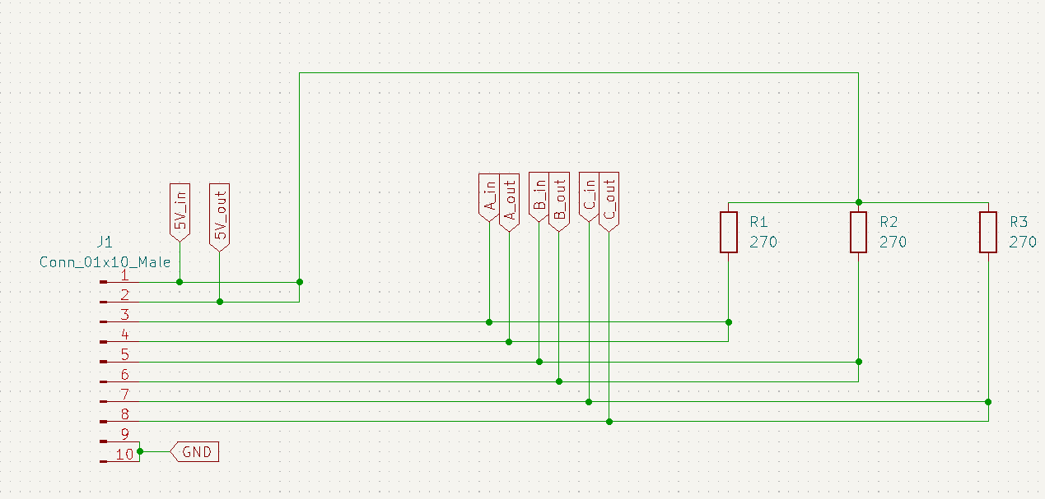

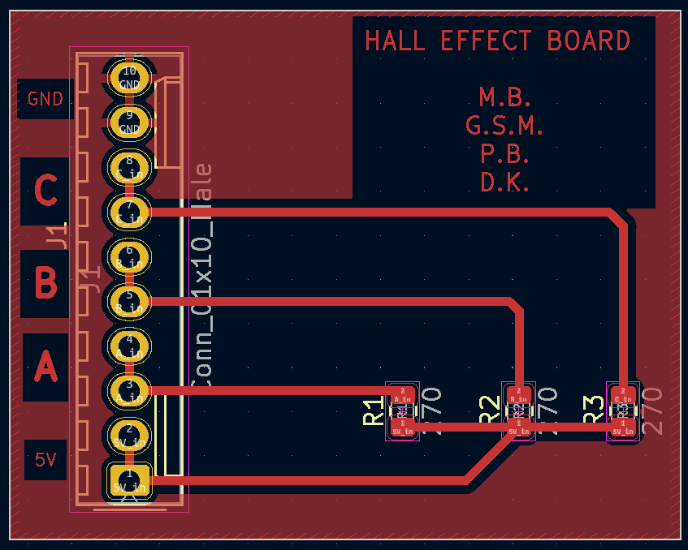
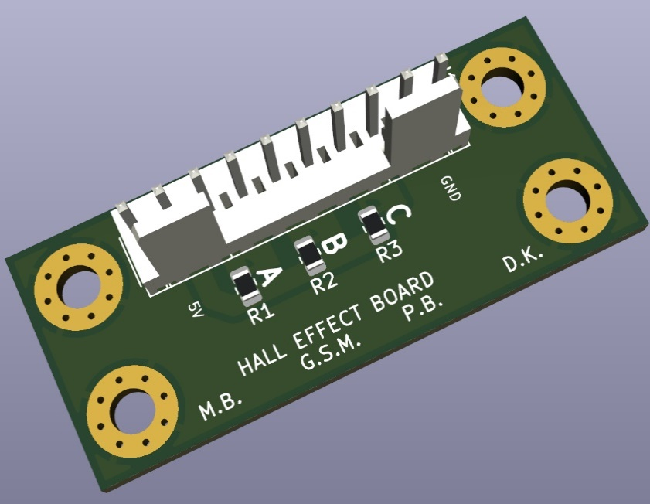

The board has then been printed and soldered.
In the end it has been tested and it proved to work imagined. In the first the wheel is rotating slowly, in the second it moves faster.
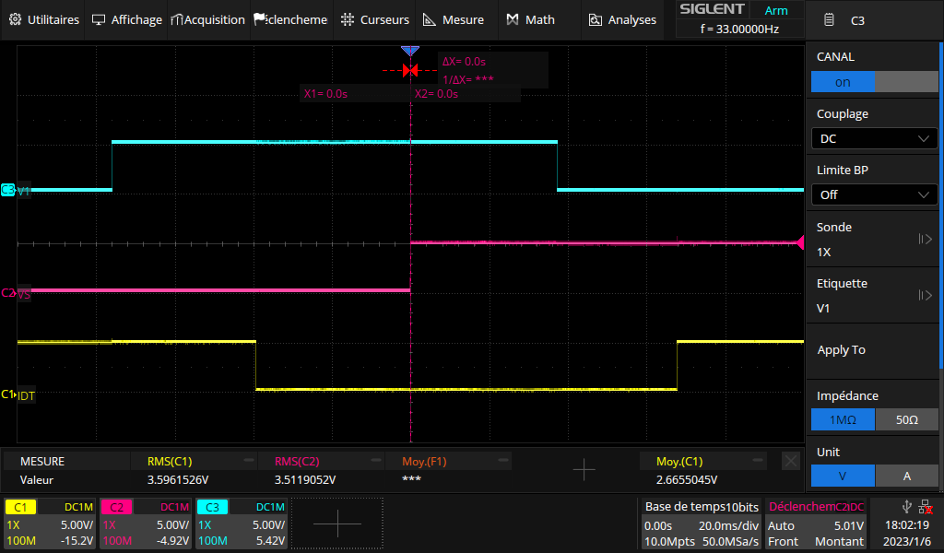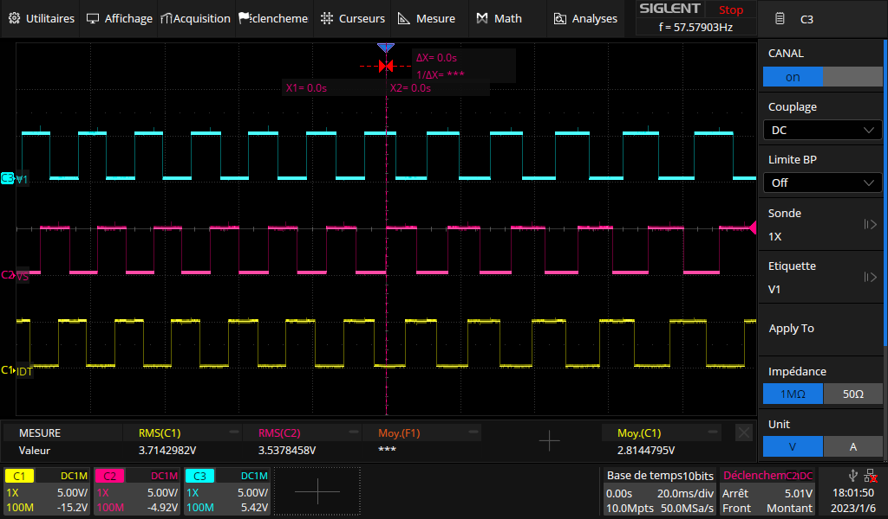

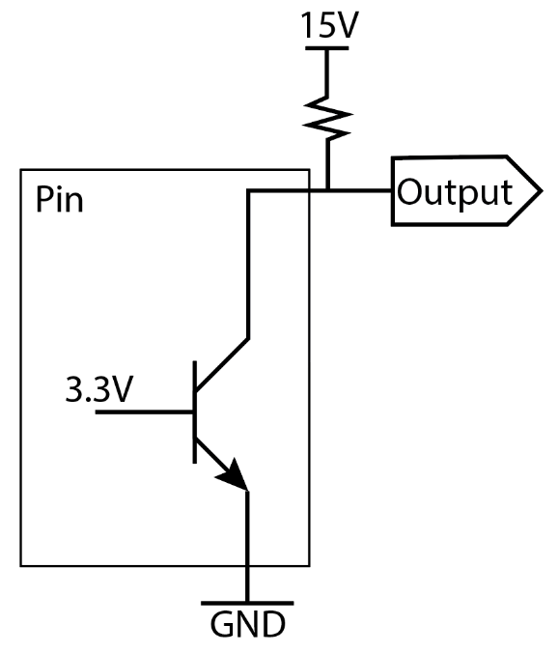
Logic Shift PCB
The goal of this board was converting input signals of 3.3V on the left into output signals of 15V on the right.
The conversion has been performed through the usage of the NPN BJT (bipolar junction transistor) 2N2222.
When the input signal reaches 3.3 voltage (high level logic) then the output is 0V, and when the input is 0V the output comes out to be 15V. The board makes the output have a opposite behaviour with respect to the input and so the logic command has to be performed oppositely.

Through the software Kicad, the Schematic and Layout of the PCB have been designed.

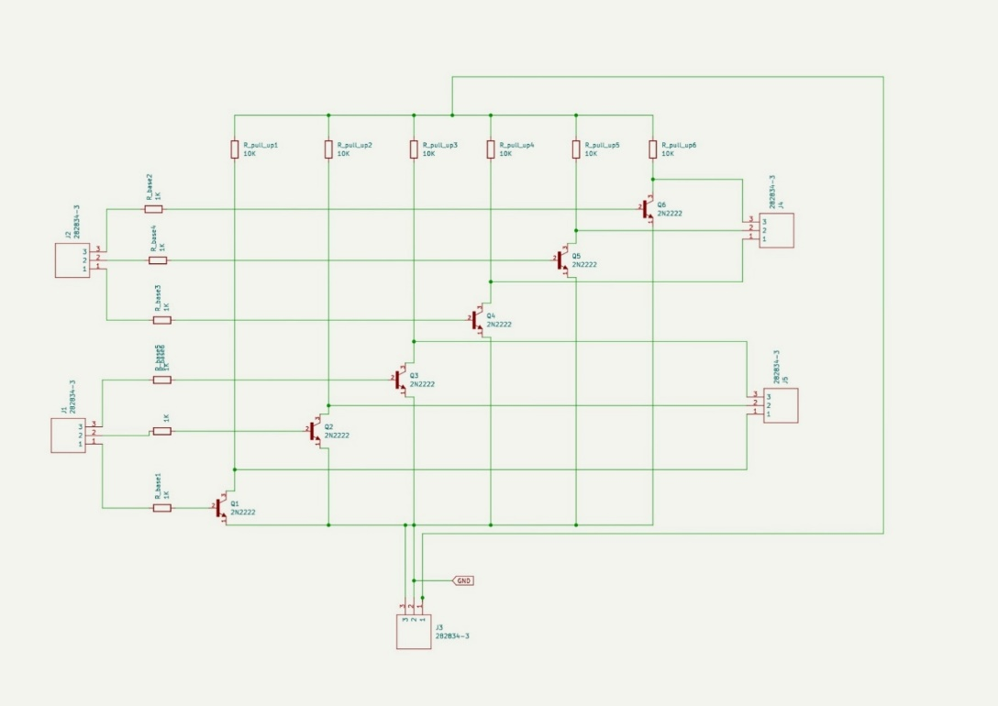

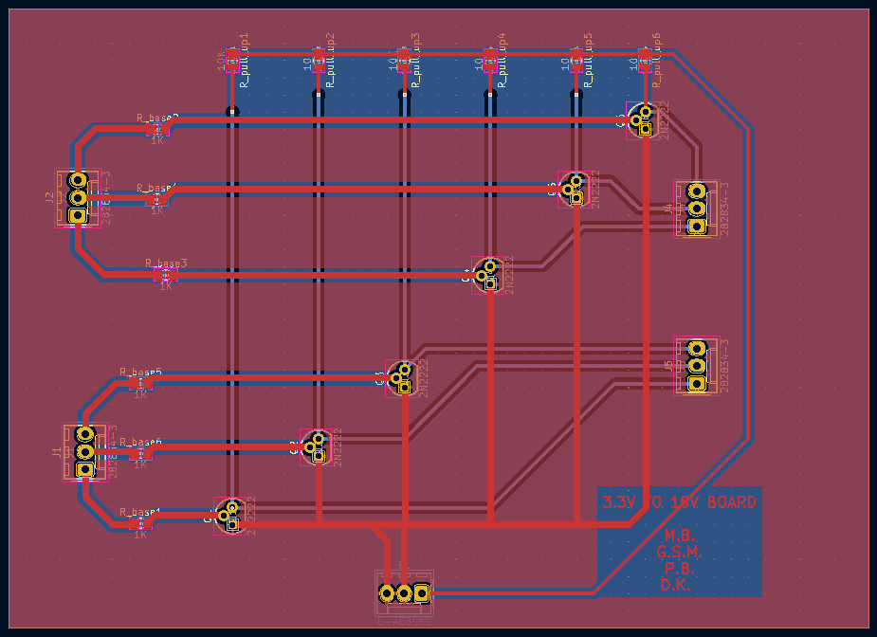
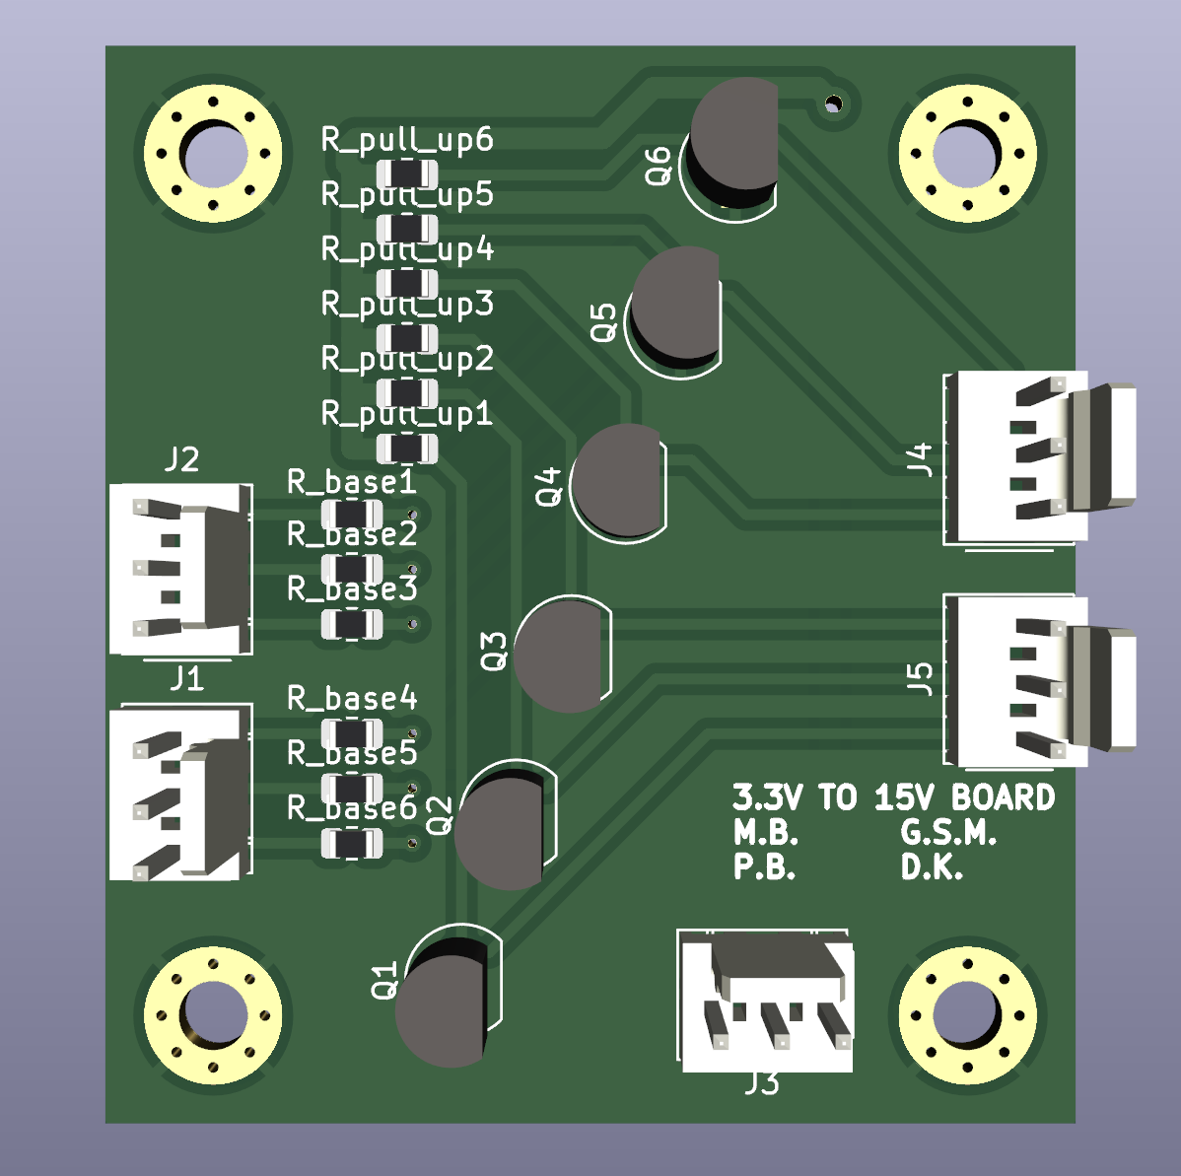
The board has then been printed and soldered.
In the end it has been tested and it proved to work as designed.
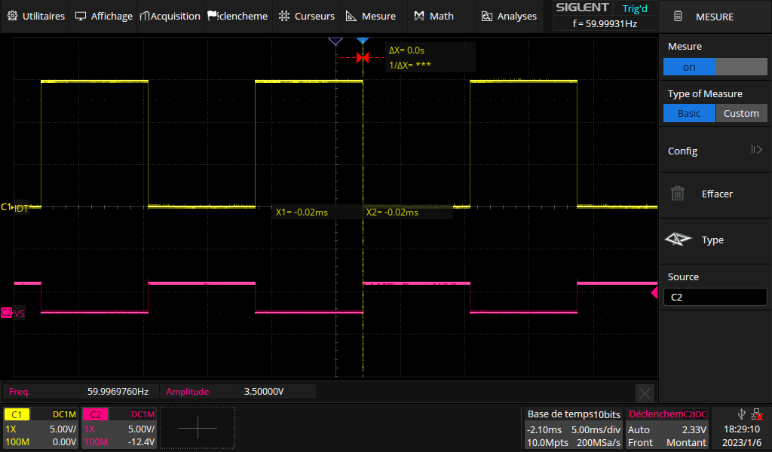

Notice that there is a little delay in switching. It is determined with the oscilloscope around 1 μs (985 ns) as shown in the photo.
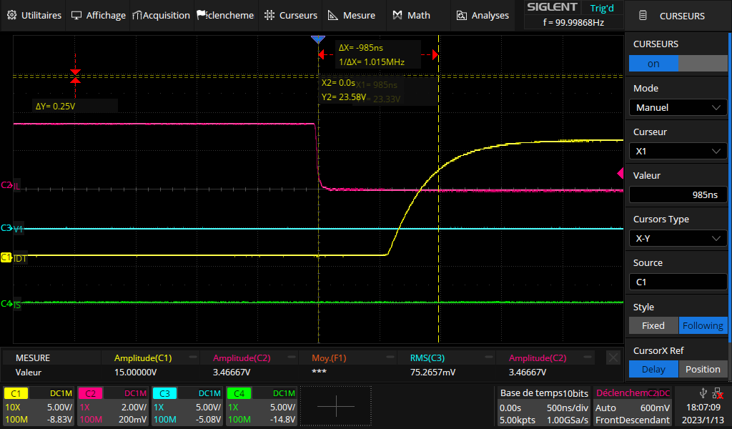

Improvements and Further Development
Motor datasheet could not be found, so the simulation and complex analysis of the system could not be performed.
To better control the motor, first thing to do is to model the motor parameters. Once motor parameters are available, system simulation can be performed to do more complex controls. System simulation could be done in MATLAB with Simulink for example.
The inverter could be controlled also to use the motor as a generator, when braking for example.
Moreover, a new inverter can be designed to have a smaller and lighter element to be set in the kart.
For the sensor, new PCBs could be designed to easily read sensor’s outputs and for all the components that need a PCB to be read.

