Bug Report
Bug Name: | Attempts to write data to an empty object.
Description: | For the writeToJson method in the Comments class, when the jsonobject class that was passed to it is initialized to null, the program interrupts the error.
Test Case: | testWriteToJsonEmpty()
Location of error: | Comments class, writetojson method.

Bug Name: | Attempts to write data to an empty object.
Description: | For the writeToJson method in the Course class, when the jsonobject class that was passed to it is initialized to null, the program interrupts the error.
Test Case: | testWriteToJsonEmpty()
Location of error: | Course class, writeToJson method.

Bug Name: | Attempts to write data to an empty object.
Description: | For the writeToJson method in the Lessons class, when the jsonobject class that was passed to it is initialized to null, the program interrupts the error.
Test Case: | testWriteToJsonEmpty()
Location of error: | Lessons class, writeToJson method.

Bug Name: | A null pointer was used to initialize the property when the object was created.
Description: | In the Module class's writeToJson method, when a null parameter is assigned to the quiz property passed to the constructor, the program breaks with an error due to calling the null object's method.
Test Case: | testWriteToJsonNonempty()
Location of error: | Module class, writeToJson method.

Bug Name: | Attempts to write data to an empty object.
Description: | For the writeToJson method in the Module class, when the jsonobject class that was passed to it is initialized to null, the program interrupts the error.
Test Case: | testWriteToJsonEmpty()
Location of error: | Module class, writeToJson method.

Bug Name: | Attempts to write data to an empty object.
Description: | For the writeToJson method in the Question class, when the jsonobject class that was passed to it is initialized to null, the program interrupts the error.
Test Case: | testWriteToJsonEmpty()
Location of error: | Qusetion class, writeToJson method.

Bug Name: | Attempts to write data to an empty object.
Description: | For the writeToJson method in the Quiz class, when the jsonobject class that was passed to it is initialized to null, the program interrupts the error.
Test Case: | testWriteToJsonEmpty()
Location of error: | Quiz class, writeToJson method.

Bug Name: | Attempts to write data to an empty object.
Description: | For the writeToJson method in the User class, when the jsonobject class that was passed to it is initialized to null, the program interrupts the error.
Test Case: | testWriteToJsonEmpty()
Location of error: | User class, writeToJson method.

Report:
Take a screenshot showing your test cases, and if they passed or failed.
testAddRepliesNonempty():
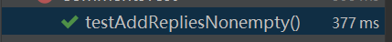
state:Pass
testWriteToJsonNonempty():
state:Pass
testAddRepliesEmpty():
state:Pass
testWriteToJsonEmpty():
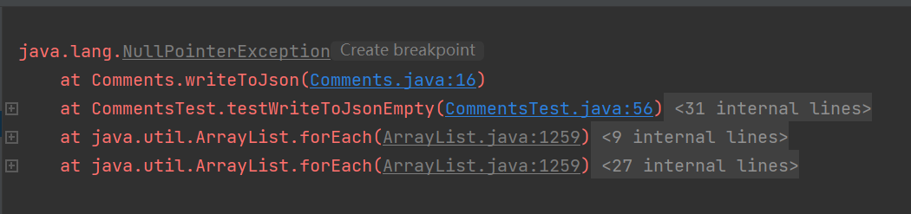
State:Pass

state:Failed
testDelCourseEmpty():

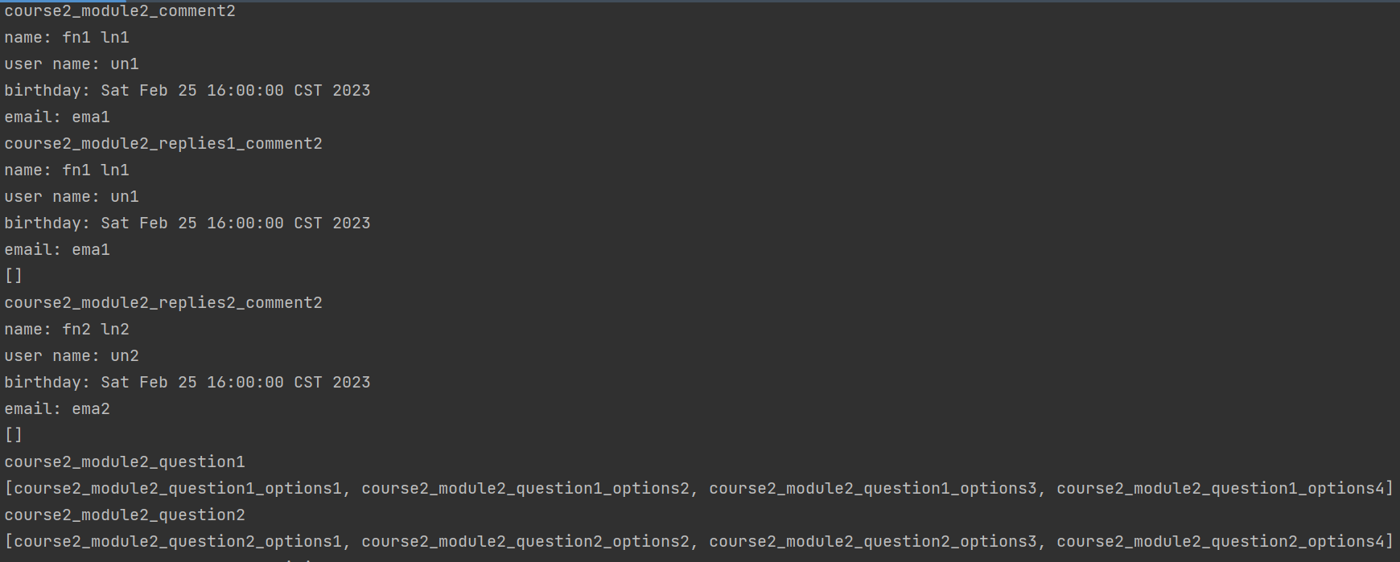
state:Pass
aboutLessonWriteToJson:

state:Pass
testAddCourseEmpty():
state:Pass
testDelCourseNotExisting():
state:Pass
testDelCourseExisting():

state:Pass
testAddCourseNonempty():
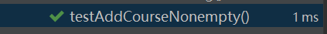
state:Pass
testWriteToJsonNonempty():
state:Pass
testWriteToJsonEmpty():
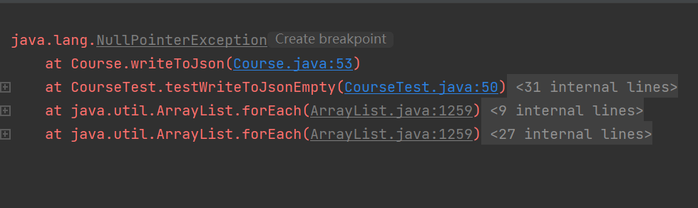
state:Failed
testWriteToJsonNonempty():
state:Pass
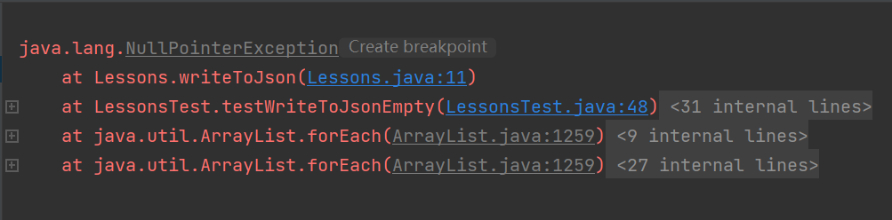
testWriteToJsonEmpty():

state:Failed
testAddLessonsNonempty():
state:Pass
testWriteToJsonNonempty():
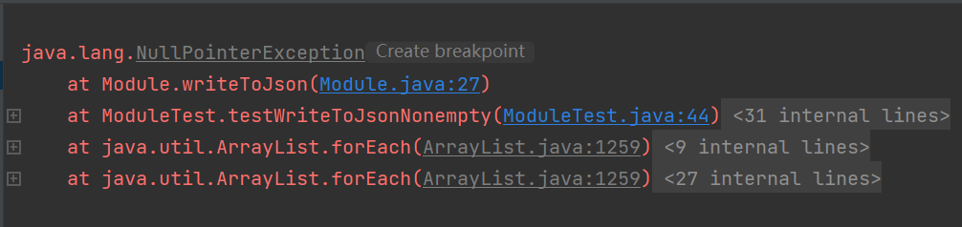

state:Failed
testAddLessonsEmpty():
state:Pass
testWriteToJsonEmpty():
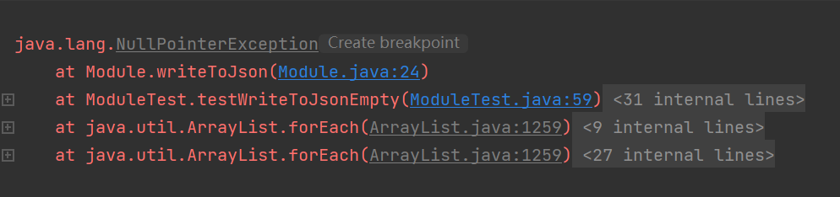
state:Failed
testWriteToJsonNonempty():
state:Pass
testWriteToJsonEmpty():
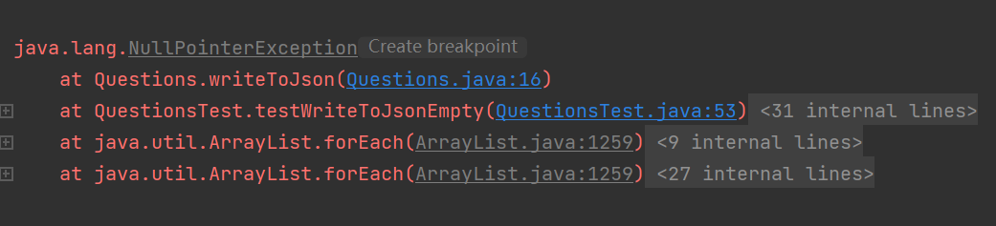
state:Failed
testWriteToJsonNonempty():
state:Pass
testWriteToJsonEmpty():
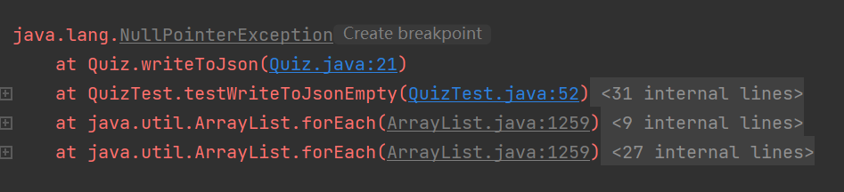
state:Failed
testAddUnconfirmedEmpty():
state:Pass
testAddTeacherNonempty():
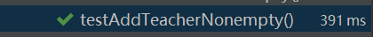
state:Pass
testAddUnconfirmedNonempty():
state:Pass
testAddTeacherEmpty():

state:Pass
testAddStudentNonempty():
state:Pass
testAddStudentEmpty():
state:Pass
testWriteToJsonNonempty():
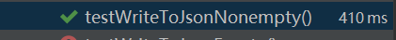
state:Pass
testWriteToJsonEmpty():
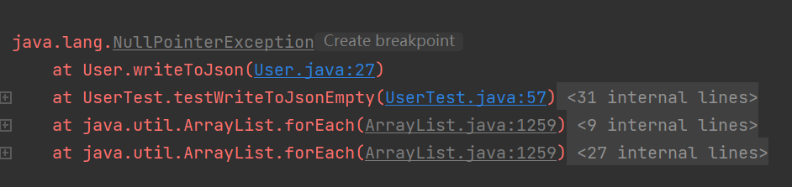
state:Failed

