MA323 Lab-02 Report
Pavan Kumar A
210123043

Q1)
Linear congruence generator:
x_{i+1} = (ax_{i}+b) mod m
u_{i} = x_{i}/m
a = 1597, b = 1, m = 244944

(I) Plot for N = 1000 values:
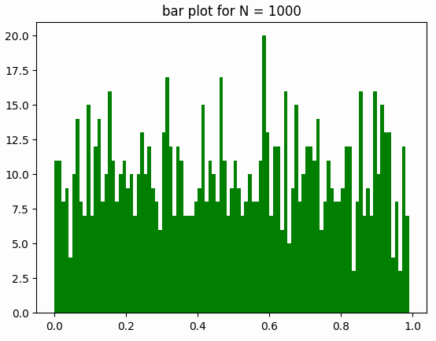
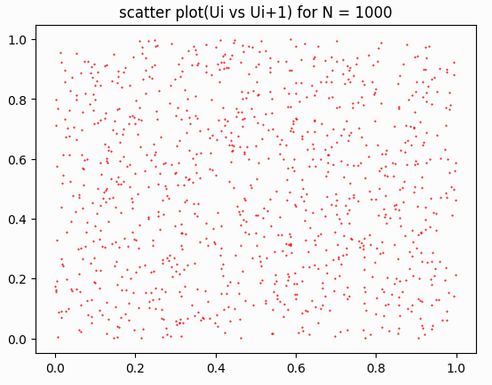

(II) Plot for N = 10000 values:
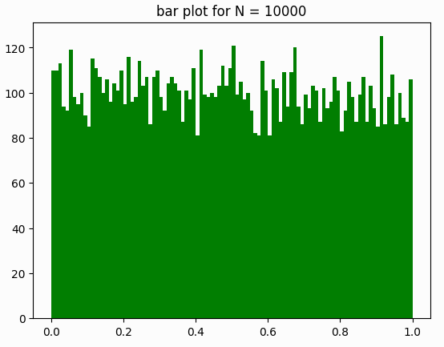
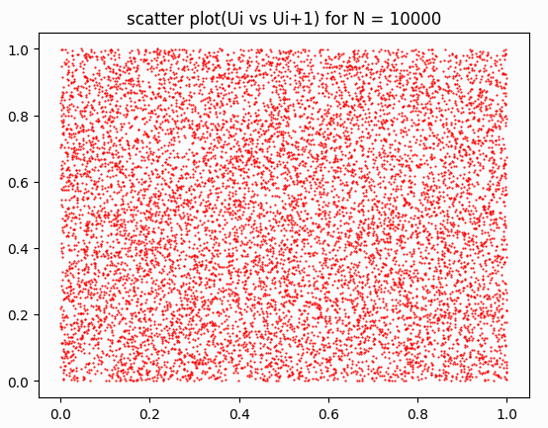

(III) Plot for N = 100000 values:
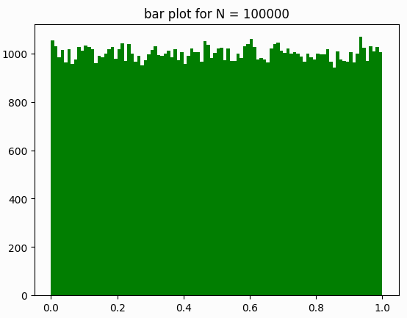
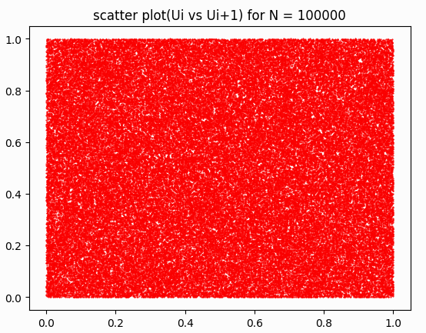

Observations:
- As seen in the scatter plot, since the U_{i}’s do not follow any pattern, they are almost completely random, hence the random generator behaves as a good random generator.

Q2)
CDF: F(x) = 1 – e^{-x/θ}
Assume Mean (θ) = π

(I) Distribution of X for N = 10 values:

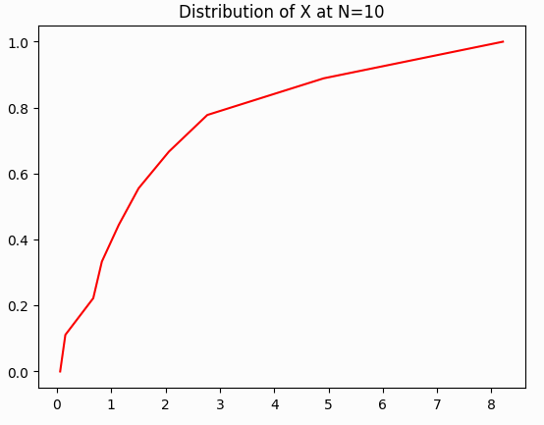

(II) Distribution of X for N = 100 values:

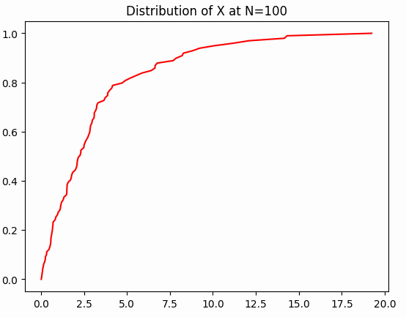

(III) Distribution of X for N = 1000 values:

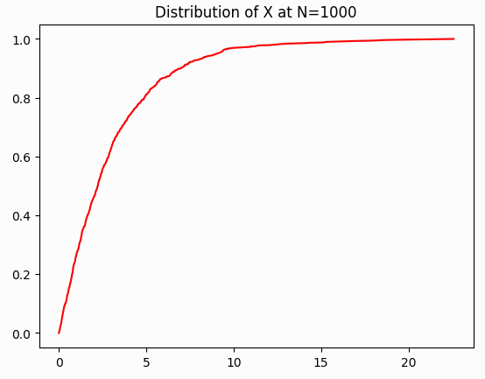

(IV) Distribution of X for N = 10000 values:

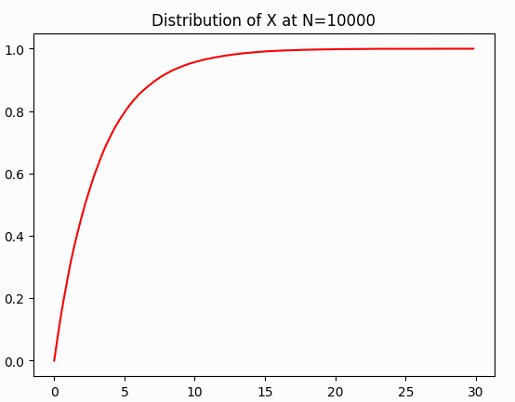

(V) Distribution of X for N = 100000 values:
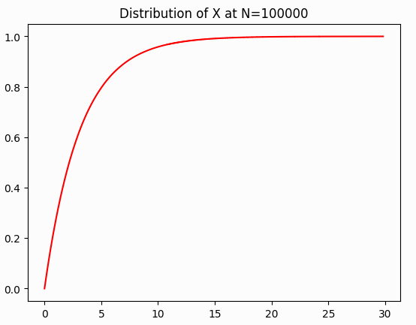

Actual Distribution:
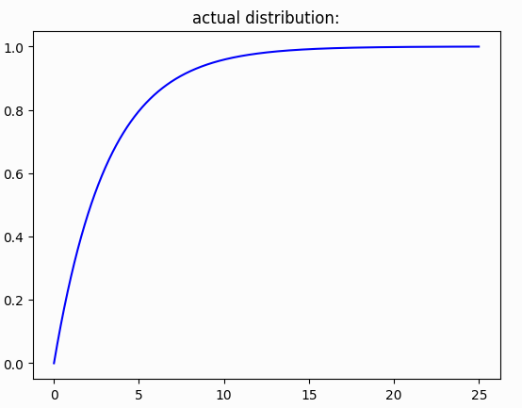

N | Sample Mean | Sample Variance
10 | 2.2305096009221885 | 5.842095983802902
100 | 3.2247396125776895 | 11.98085780828704
1000 | 3.081161111374821 | 9.59241179375116
10000 | 3.1563771607678928 | 10.017771389934223
100000 | 3.1416862866656436 | 9.85951207447013

Actual Mean = 3.141592653589793
Actual Variance = 9.869604401089358

Observations:
- As we increase the number of values generated the mean and variance of the generated numbers converge to the actual mean and variance.
- The distribution of X is identical to the CDF (F(x)) which shows the inverse transform method.

Q3)
CDF: F(x) = 2/π sin⁻¹(x^{1/2})

(I) Distribution of X for N = 10 values:
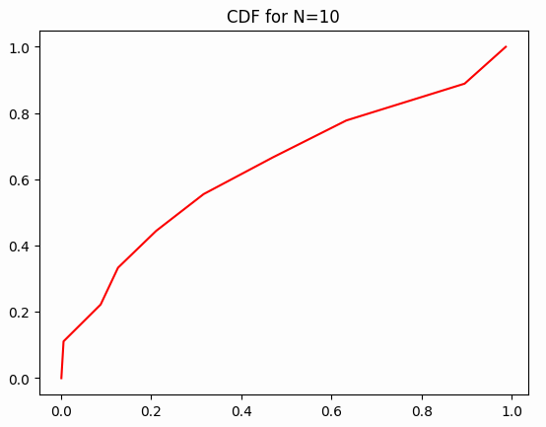

(II) Distribution of X for N = 100 values:

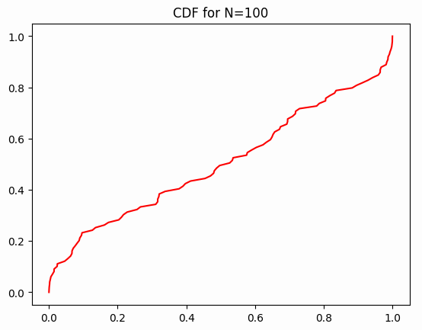

(III) Distribution of X for N = 1000 values:

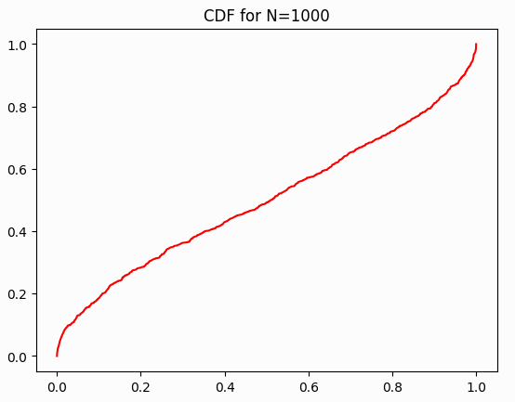

(IV) Distribution of X for N = 10000 values:

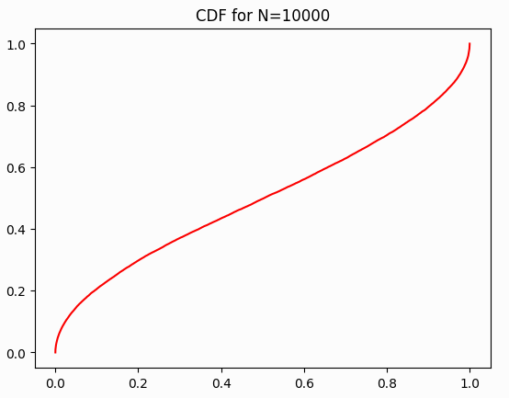

(V) Distribution of X for N = 100000 values:

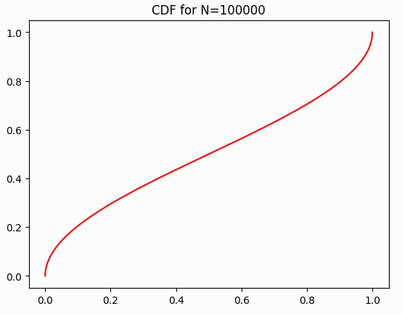

Actual Distribution:

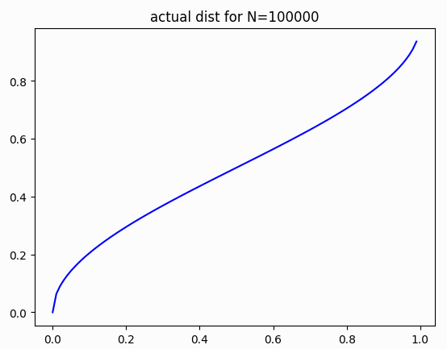

N | Sample Mean | Sample Variance
10 | 0.37347798353615164 | 0.11717232248515157
100 | 0.4945329062603193 | 0.12066235544391767
1000 | 0.4989849034206795 | 0.11906164185832245
10000 | 0.500682895969179 | 0.12555147882558407
100000 | 0.4998735233307937 | 0.12507022069752055

Q4)

Frequencies of values generated by discrete random number generation:

Ranges | Frequencies
1-1000 | 10026
1001-2000 | 10015
2001-3000 | 9958
3001-4000 | 9960
4001-5000 | 10159
5001-6000 | 9898
6001-7000 | 9946
7001-8000 | 10062
8001-9000 | 10083
9001-10000 | 9893

