Lab 3 Report
Pavan Kumar A
210123043

1)
PDF: f(x) = 20x(1-x)³
g(x) = 1
c = 135/64

(a)
Average iterations needed to generate a sample will be equal to 2.1053, which is equal to c. This is because the expectation of rejection rate is equal to c, i.e., the acceptance rate is 1/c.

(b)
Mean of samples generated = 0.335459325709939
Expectation of PDF = 1/3(0.333333)

(c)
Approximate value of P(0.25 ≤ X ≤ 0.75) = 0.6226
Exact value found using _{0.25}∫¹ f(x)dx - _{0.75}∫¹ f(x)dx = 0.6171875

(d)
Average number of iterations needed = 2.1053 which is same as
the value obtained in (a).

(e)

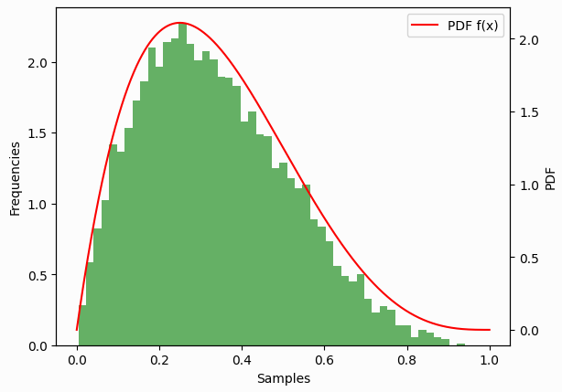
(f)

C | Sample Mean | Iterations Required
135/64 | 0.335459325709939 | 2.1053
10 | 0.335896600659936 | 10.0441
30 | 0.333035164980590 | 30.3009

The mean of the samples generated are similar but the average number of iterations required to generate each sample will be equal to the c the taken in each case.

2)
α = 2
PDF: f(x) = e/2(e-1) * x * e^(-x)
g(x) = 1
c = 1/2(e-1) (0.20988)

Sample mean obtained = 0.6067682395808399

