MA323 Lab08 Report
Pavan Kumar A
210123043

Q1)
Strata:
S=0, S = 1, S=2, S=3, S=4, S=5, S>=6

For stratum S = 0, we know for sure that the total rainfall(X) is X<5
So, we take only 2 samples from that stratum.
We decide the number of samples for the other strata in the proportion to P(S = s) / (1 – P(S=0)).
We get the following number of sample count for the strata for different values of n.
For N = 100

S | 0 | 1 | 2 | 3 | 4 | 5 | >=6
n | 2 | 16 | 24 | 23 | 17 | 9 | 9

For N = 10000

S | 0 | 1 | 2 | 3 | 4 | 5 | >=6
n | 2 | 1668 | 2448 | 2366 | 1715 | 995 | 786

Results:
Monte Carlo Simulation:
N | Estimated Probability | 99% Confidence Interval
100 | 0.38 | (0.254973, 0.505027)
10000 | 0.3732 | (0.360742, 0.385658)

Stratification Simulation:

N | Estimated Probability | 99% Confidence Interval
100 | 0.334378 | (0.212857, 0.455898)
10000 | 0.373266 | (0.360808, 0.385725)

Q2)
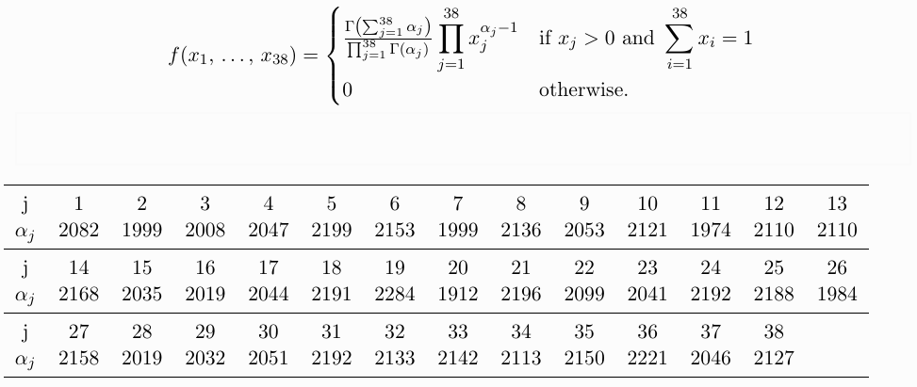
To estimate μ we repeatedly sample Y∈[0, ∞)³⁸ and averaging f(Y). Here we condition on Y₁₉.

Given that Y₁₉ = y₁₉ , the probability that Y₁₉ is largest is

h(y₁₉ ) = ∏³⁸_{j=1,j≠19}G_{αj} (y₁₉)

where G_{α} (x) = ₀∫^{x} e^{-y} y^{α−1} dy/Γ(α)

The required probability estimate is 0.6287263668298718 in this case

Q3)
The difference estimator is given by:
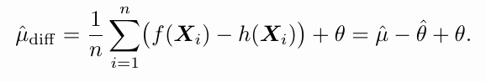

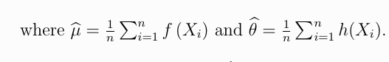
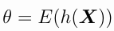

β optimal given by:
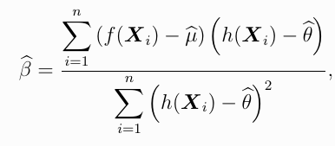

which is estimated as 4.728878352837489e-07
For 10000 samples, Estimated mean = 12.113945174400321 with 99% confidence interval - (8.140334157192198, 16.087556191608442)
With Parameters: (0, 5), (0, 5), (0, 5), (0, 5), (0, 5)

