MA323 Lab09 Report
Pavan Kumar A
210123043

1a)

Since E₁₀ has 4,8,9 as predecessors,
E₁₀ = T₁₀ + max(E₄,E₈,E₉)

E₄ = T₄ + E₂ = T₄ + T₂ + T₁

Similarly,
E₈ = T₈ + T₃ + T₁
E₉ = max(E₅, E₆, E₇) + T₉

∴ E₁₀ = T₁₀+max(T₄ + T₂ + T₁ ,
max(T₈ + T₃ + T₁,
T₉ + max(T₅ + T₂ + T₁,
max(T₆ + T₃ + T₁,
T₇ + T₃ + T₁))))

1b,c,d)

Taking sample size, n = 10000

Using Simple Monte Carlo yields an estimated mean E₁₀ as 18.1153

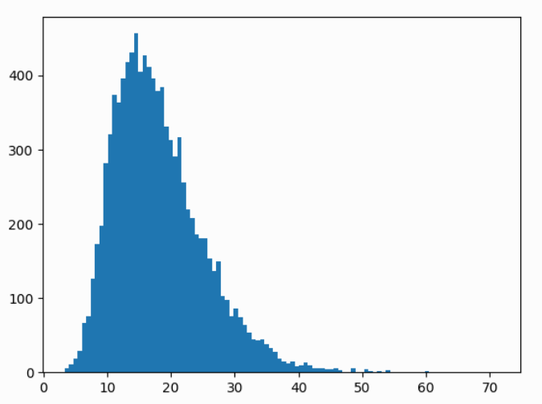
Histogram of E₁₀ samples generated

The graph is positively skewed, and skewness measured = 1.0737, this means that the probabilities of values greater than the mean are very small.

The estimated probability = 0.0001 (1 E₁₀ greater than 70)
The Standard deviation of the probability = 0.009

The standard deviation is very high, thus this is an unreliable method for sampling the probability.
Also if we used a different seed, the number of E₁₀>70 might’ve been 0, this is another reason this method is unreliable.

1e)

To Estimate probability using importance method:

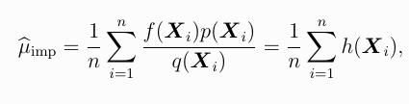

which in this case is (Note that X is 10-dimensional):
p(X) =
q(X) =
f(X) = (Indicator for when E₁₀ > 70)
∴

Where I is indicator function for even E₁₀ > 70
θ_{j} is the mean time of the i’th process
λ_{j} = κ*θ_{j}

The product calculated is the likeliness ratio(weight).

Estimated probability using Importance method=2.879x10⁻⁵
Standard Deviation = 0.00086
Estimated Sample Size = 3.2701

The sample size is too small, this is because multiplying 4 to all the means is causing too much of a distortion. Thus this sampling is unreliable.

1f,g,h)

The formula for calculating the probability will remain same, except that when j∈{3, 5, 6, 7, 8, 9}, κ=1

κ | Estimated Probability | Number of E₁₀>70 | Standard Deviation | 99% Confidence Interval for probability | Estimated Sample  Size
3 | 3.04889x10⁻⁵ | 1447 | 0.00017206 | [2.6049x10⁻⁵, 3.4927x10⁻⁵] | 917.95
4 | 2.82657x10⁻⁵ | 3142 | 0.00014025 | [2.4647x10⁻⁵, 3.1884x10⁻⁵] | 327.47
5 | 3.38229x10⁻⁵ | 4793 | 0.00017824 | [2.9224x10⁻⁵, 3.8422x10⁻⁵] | 141.05

Since only the processes on critical path, I.e, {1,2,4,10}, contribute to E₁₀, while the the rest do not contribute as much, so we do not have to increase the mean for all the T_{j}, that is the reason the estimated sample sizes here are greater than the value obtained in (e).

κ=5 has the smallest estimated sample size and
the 99% confidence interval of probability = [2.9224x10⁻⁵, 3.8422x10⁻⁵]

