MA323 Lab10 Report
Pavan Kumar A
210123043

Q1)
Using Van Der Corput Algorithm, the sequence would be
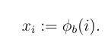

Where,
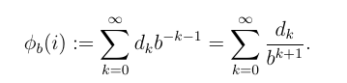

where i is given by:

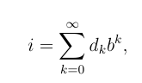

The sequence generated:

[0.5, 0.25, 0.75, 0.125, 0.625, 0.375, 0.875, 0.0625, 0.5625, 0.3125, 0.8125, 0.1875, 0.6875, 0.4375, 0.9375, 0.03125, 0.53125, 0.28125, 0.78125, 0.15625, 0.65625, 0.40625, 0.90625, 0.09375, 0.59375]

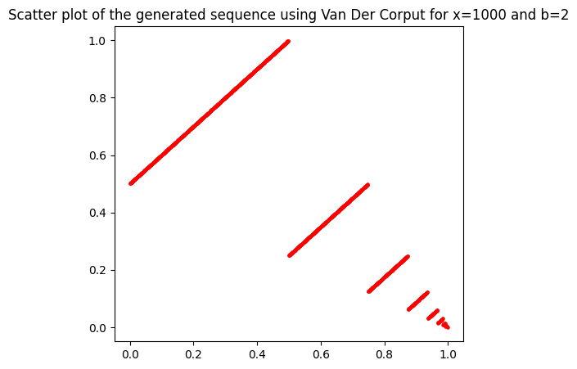

Observations:
- The points form a set of lines parallel to y=x, thus the points are not uniformly distributed.
- Since the Van Der Corput sequence is deterministic, the values generated do not follow pseudo-random properties.

Q2)
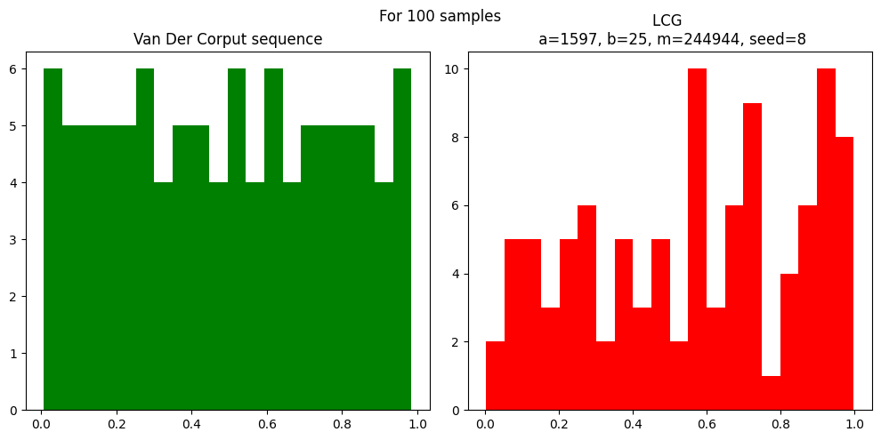
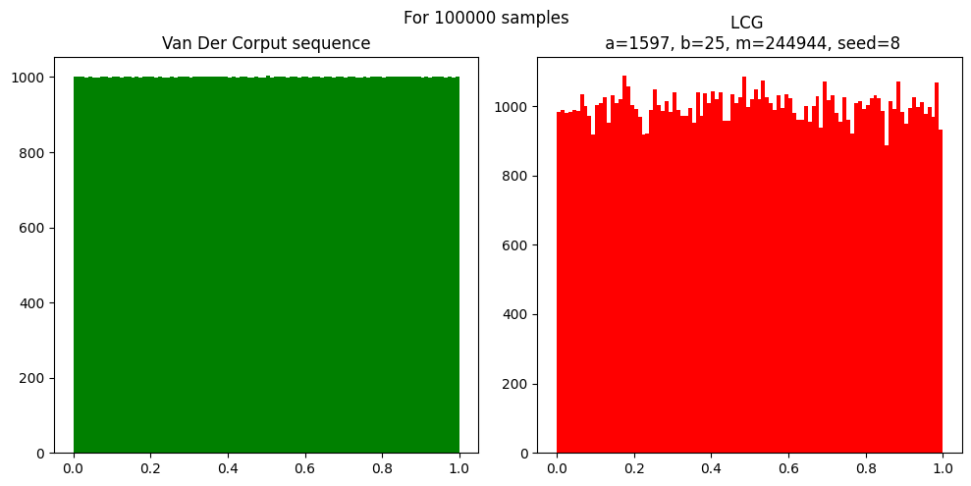
Observations:
- The sequence generated using Van Der Corput is more uniformly distributed than LCG.
- The proportion of points in an interval is proportional to the size of the interval.

Q3)
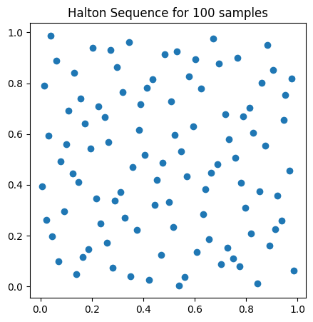
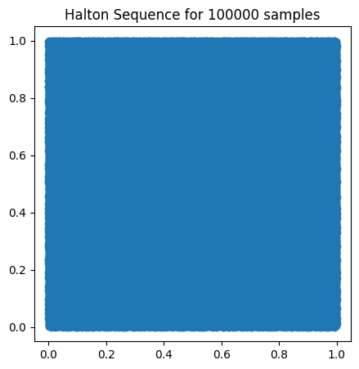

Observations:
We can see that the values generated are very evenly distributed with no observable gaps in R² even thought they are not random, I.e, they are deterministic.

