Lab-4 Report
Pavan Kumar A
210123043

1)
(a)

Box Muller:
Samples | Mean | Variance
100 | -0.2501 | 1.0638
10000 | -0.0028 | 1.0178

Margsalia and Bray:
Samples | Mean | Variance
100 | 0.0091 | 1.0821
10000 | 0.0055 | 1.0074

(b)
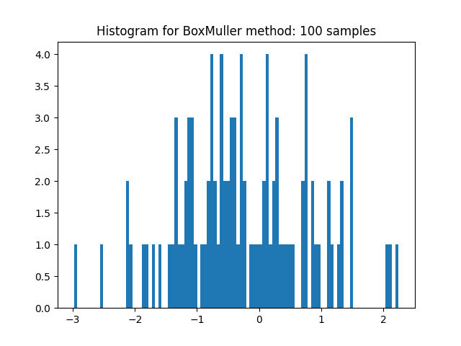
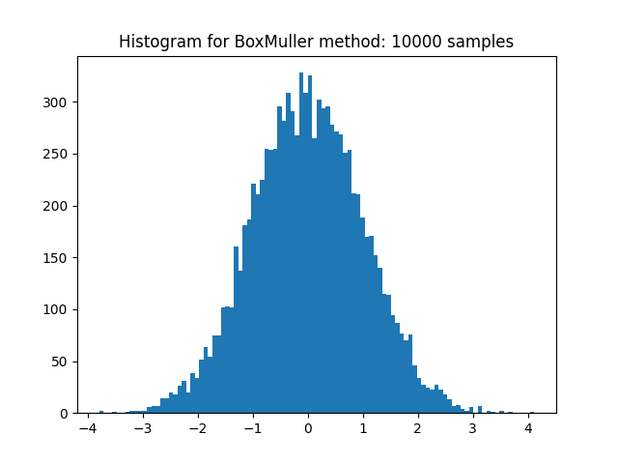

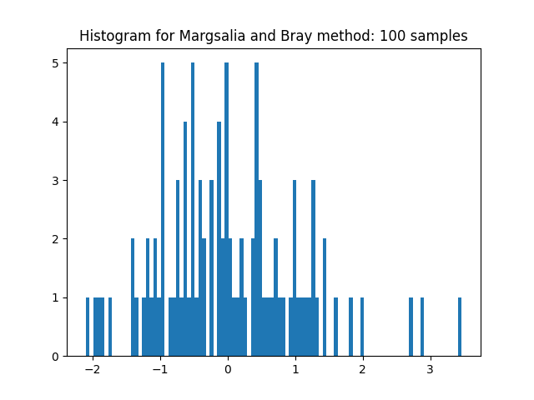
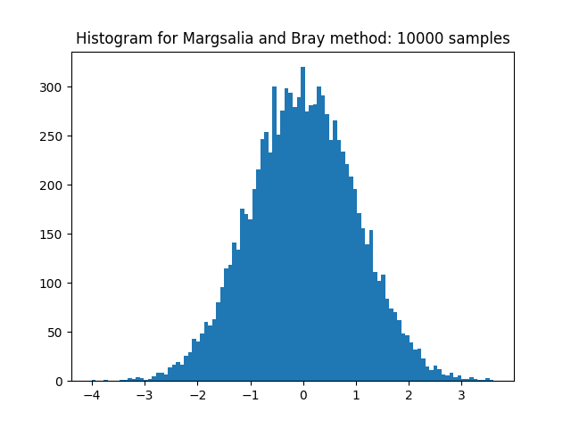
(c)

Mean = 0 and Variance = 5
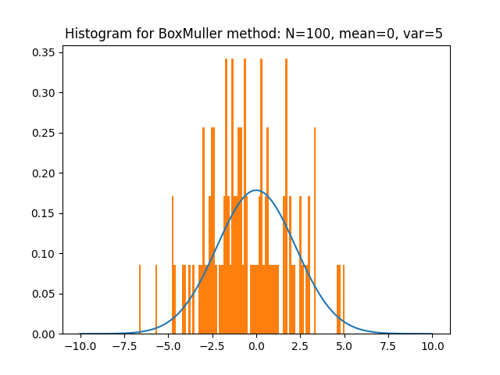
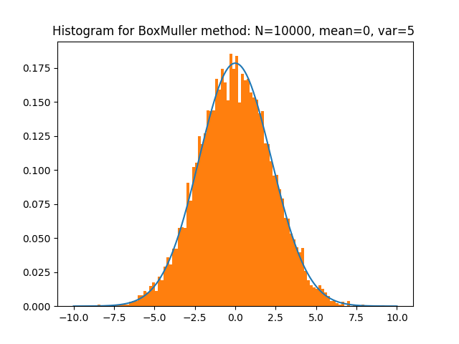

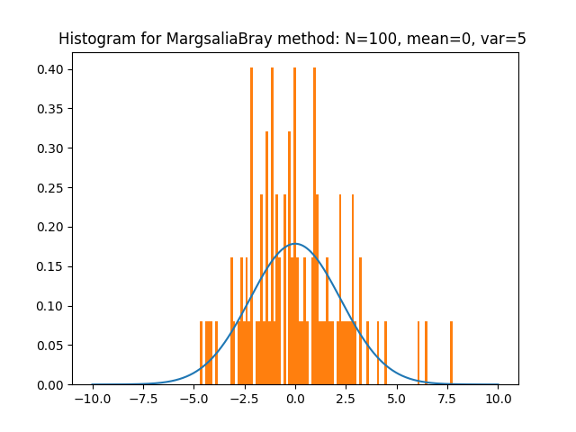
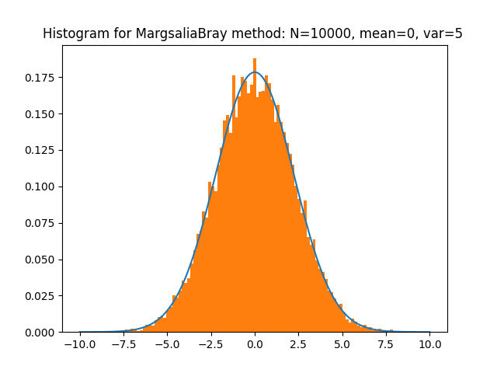

Mean = 5 and Variance = 5
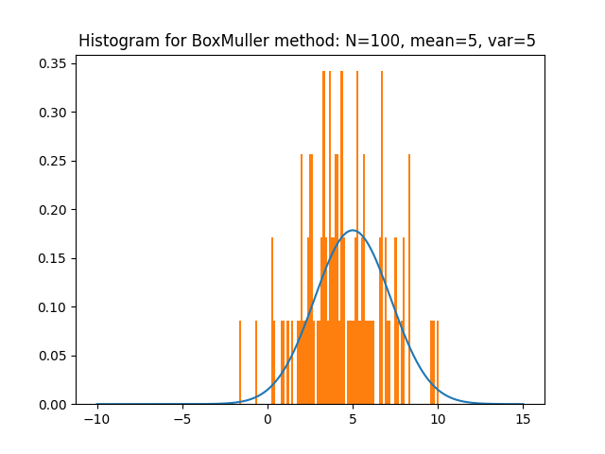
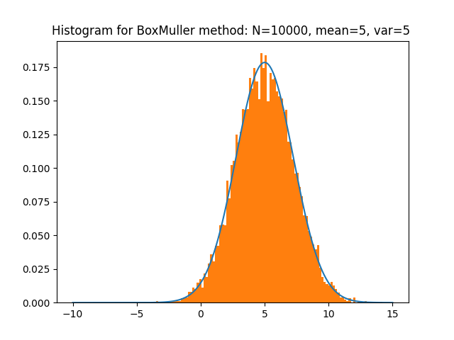

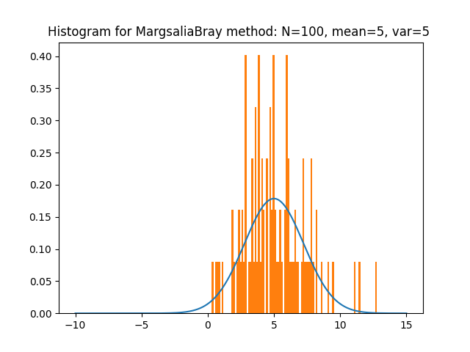
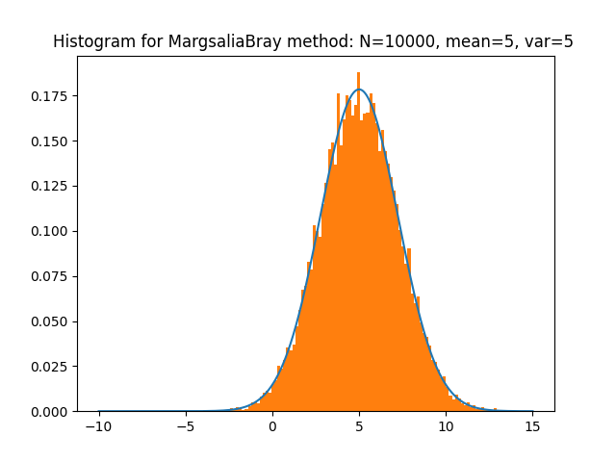
2)
Method | Samples | Time
Box Miller | 100 | 0.000145s
Margsalia and Bray | 100 | 0.000192s
Box Miller | 10000 | 0.009504s
Margsalia and Bray | 10000 | 0.017189s

Observations:
- Box Miller is faster because it does not use acceptance rejection, it takes O(N) time.
- Whereas Margsalia and Bray method is slower because for each sample it rejects on average ~0.214*N samples, thus it takes longer than Box Miller Method.

3)
For 100 samples, portion of values rejected = 0.166667
For 10000 samples, portion of values rejected = 0.214947

1-π/4 = 0.214601

