MA323 Lab05 Report
Pavan Kumar A
210123043

1)
a = -0.5:

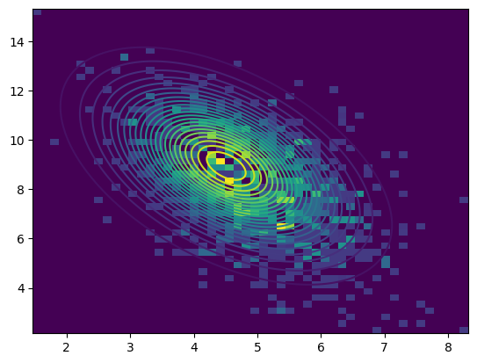

a = 0:

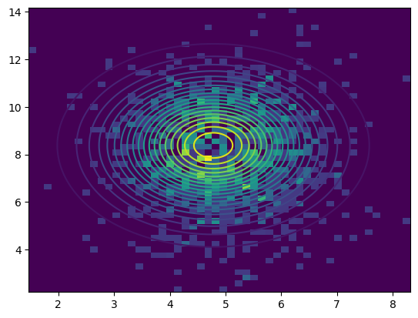

a = 0.5:
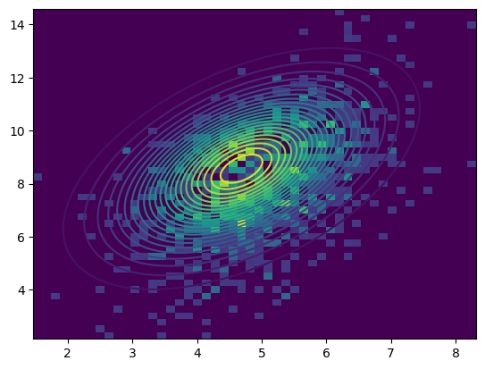

a = 1:

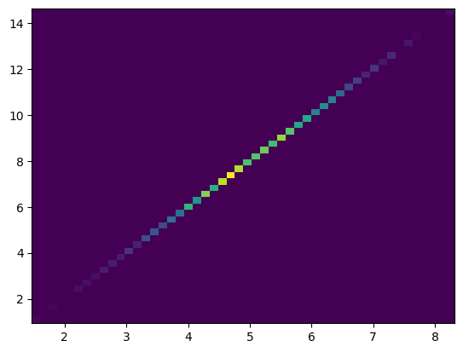

Observations:
- For a = -0.5 the spread of values is in direction parallel to y = -x.
- For a = 0 the spread of values is uniform
- For a = 0.5 the spread of values is in direction parallel to y= x.
- For a = 1, determinant of covariance matrix is 0, therefore its inverse does not exits, so we cannot draw its contour plot.

