

Smoking Cessation Support Platform

Software Requirement Specification

Project Code: <Code of the project>

Document Code: <Code of the document >– v<x.x>

**Ho Chi Minh, June 2025**

**TEAM MEMBERS**

1. Cao Thành Danh - SE194497
2. Nguyễn Tấn Đạt - SE194605
3. Nguyễn Công Thiên Ân - SE194544

Record of change

*A - Added M - Modified D - Deleted

|  |  |  |  |  |  |
| --- | --- | --- | --- | --- | --- |
| Effective Date | Changed Items |  | A* M, D | Change Description | New Version |
| 02/12/2016 | Initial |  | a | Add project over view |  |
|  |  |  |  |  |  |
|  |  |  |  |  |  |
|  |  |  |  |  |  |
|  |  |  |  |  |  |
|  |  |  |  |  |  |
|  |  |  |  |  |  |
|  |  |  |  |  |  |
|  |  |  |  |  |  |
|  |  |  |  |  |  |
|  |  |  |  |  |  |
|  |  |  |  |  |  |
|  |  |  |  |  |  |
|  |  |  |  |  |  |
|  |  |  |  |  |  |
|  |  |  |  |  |  |
|  |  |  |  |  |  |
|  |  |  |  |  |  |
|  |  |  |  |  |  |
|  |  |  |  |  |  |
|  |  |  |  |  |  |

SIGNATURE PAGE

**ORIGINATOR:** <Name> <Date>

<Position>

**REVIEWERS:** <Name> <Date>

<Position>

<Name, if it’s needed> <Date>

<Position>

**APPROVAL:** <Name> <Date>

<Position>

TABLE OF CONTENTS

1 Introduction 5

1.1 Purpose 5

1.2 Definitions, Acronyms 5

1.3 References 5

2 Overall Description 7

2.1 Product Perspective 5

2.2 Business Process 5

2.3 User classes 5

3 FUNCTIONAL Requirements 8

3.1 Use Case Diagram 8

3.2 Use Case Specifications 8

3.3 State Diagrams 9

3.2 Data flow Diagram 8

3.2 Logical Data Model 8

4 NON-FUNCTIONAL Requirements 10

4.1 Usability 10

4.2 Reliability 10

4.3 Performance 10

4.4 Reusability 11

4.5 Scalability 11

5 Supporting Information 13

# Introduction

## Purpose

The **Smoking Cessation Support Platform** is a comprehensive digital solution designed to empower individuals in their journey to quit smoking and lead healthier lives. Developed to assist both individuals and communities, the platform provides a centralized environment where users can access reliable information, engage in personalized quit plans, and receive professional guidance throughout the cessation process. The homepage introduces the mission of the platform, featuring motivational content, success stories, and a public leader-board to celebrate progress and achievements.

A core function of the system is its ability to assess users’ current smoking habits, including daily cigarette consumption, smoking frequency, and associated costs. Based on this data, users can create or customize structured quit plans that outline motivations, stages, start dates, and target cessation goals. The platform offers intelligent recommendations and progress tracking, enabling users to monitor smoke-free days, health improvements, and money saved over time.

To keep users motivated, the platform delivers periodic notifications with encouragement and reminders of their quitting reasons. As users reach milestones, the system awards achievement badges (e.g., “1-Day Smoke-Free” or “100K Saved”) This community space encourages peer-to-peer motivation, allowing members to exchange experiences and advice.

Professional support is also a key feature, with the ability to schedule online consultations with certified coaches for personalized guidance. The platform supports the management of membership packages, allowing users to register, subscribe, and access premium features.

For administrators, the system includes tools for managing user profiles,, feedback and ratings, as well as much more. A robust dashboard and reporting system provides actionable insights, helping stakeholders measure success rates, user engagement, and the overall effectiveness of smoking cessation initiatives.

## Scope

The Quit Smoking Support System is a platform website that helps users track and manage their quitting process. The platform provides features such as:

1. Introduce background information, achievement rankings, experience sharing blog.
2. Register an account, choose a membership package and pay online.
3. Record current smoking status.
4. Create and customize a smoking plan.
5. Track smoking cessation progress and statistics.
6. Reminder notifications.
7. Communicate with a coach to get advice.
8. Manage subscriptions, reviews, feedback, personal profiles.
9. Dashboard and report analysis.

## Definitions, Acronyms

|  |  |
| --- | --- |
| **Terminology** | **Definition** |
| SCCP | Smoking Cessation Support Platform |
| UI | User Interface |
| UX | User Experience |
| DB | Database |
| MVP | Minimum Viable Product |
| API | Application Programming Interface |
| UC | Use Case — a functional interaction between a system and an actor |
| UC-G## | Use Case for Guest |
| UC-M## | Use Case for Member |
| UC-C## | Use Case for Coach |
| UC-A## | Use Case for Admin |
| BS | Business Rule |
| CRUD | Create, Read, Update, Delete |

UI User Interface – Giao diện người dùng

UX User Experience – Trải nghiệm người dùng

DB Database – Cơ sở dữ liệu

MVP Minimum Viable Product – Sản phẩm khả thi tối thiểu

API Application Programming Interface – Giao diện lập trình ứng dụng

Dashboard Bảng điều khiển, nơi hiển thị thông tin thống kê và báo cáo

## References

As society continues to confront the ongoing health and social consequences of tobacco use, there is a growing demand for innovative, accessible, and evidence-based smoking cessation support. This platform offers community health organizations, wellness initiatives, and public agencies a powerful tool to implement and manage quit-smoking programs at scale. By leveraging digital engagement, personalized support, and data-driven insights, the system enhances outreach efforts, improves participant outcomes, and fosters long-term behavior change.

The platform also opens pathways for sustainable operation through flexible monetization strategies, including institutional memberships, public health grants, and collaborative partnerships. Optional premium features and tailored support packages can be offered to organizations or individuals seeking enhanced services. Through this approach, the system not only promotes individual well-being but also contributes to broader public health goals in reducing tobacco dependence and its associated costs.

# Overall Description

## Product Perspective

The Smoking Cessation Support Platform is a standalone web-based system developed to assist individuals and organizations in quitting tobacco use. While not part of any existing software, it is designed for future integration with common APIs such as email and calendar services for reminders and scheduling.

The platform acts as a centralized hub, offering access to quit plans, self-assessments, counseling, progress tracking, and community support. It also supports membership management, payment integration, and data-driven reporting to help evaluate program effectiveness and improve user outcomes.

**Context diagram:**

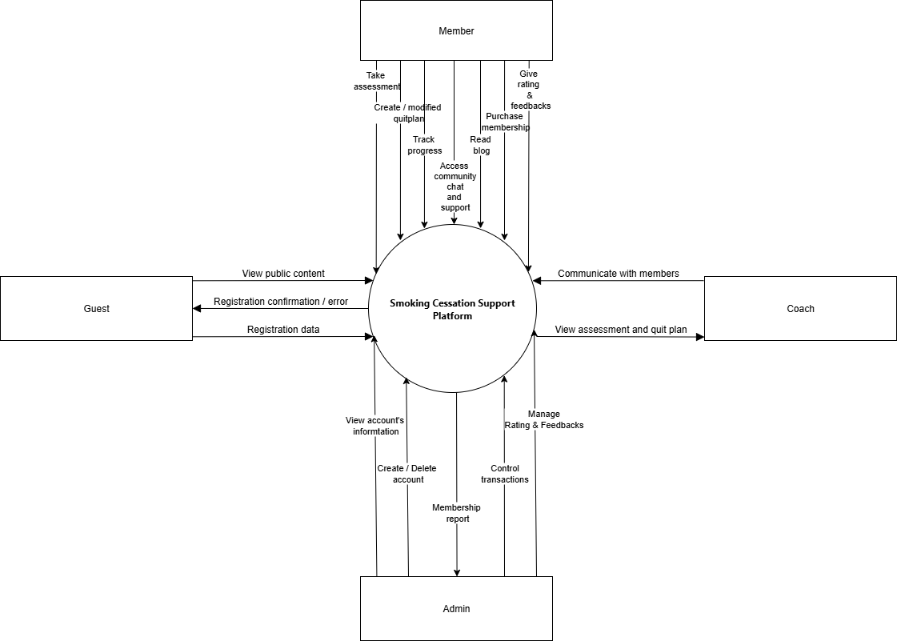

## Business Process

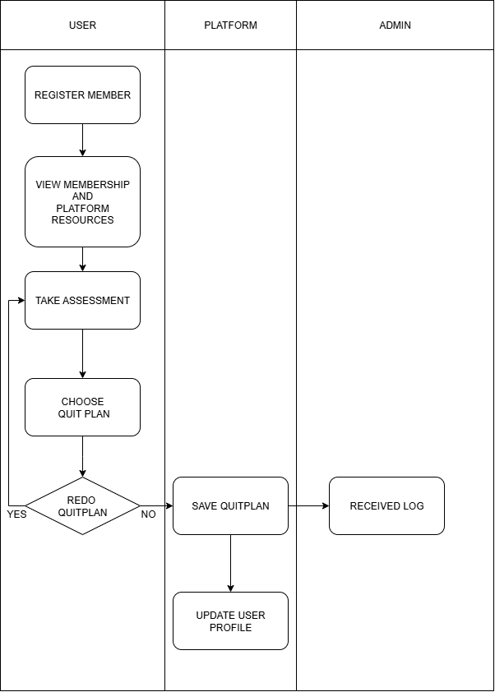

## User classes and characteristics

The system serves multiple types of users, each with distinct roles, access levels, and interaction needs. Below are the main user classes and their characteristics:

1. **Guest Users**
   * **Description**: Unregistered visitors who can browse public content.
   * **Access Rights**: View organizational information and membership overviews.
2. **Members (Registered Users)**
   * **Description**: Certified professionals providing counseling and support services.
   * **Access Rights**:

* **Basic :** Access to essential platform features, email support, and participation in the community forum.
* **VIP :**Includes all Basic features plus access to the Progress Tracker and exclusive resources for enhanced self-guided learning.
* **Premium :**Includes all VIP features, along with 1:1 live coaching sessions and priority support for personalized guidance and faster assistance.

1. **Coach**
   * **Description**: Certified professionals providing counseling and support services.
   * **Access Rights**: View and respond to member’s messages, and access user assessment results.
2. **Administrators**
   * **Description**: Internal staff responsible for maintaining and coordinating the core components of the Drug Prevention Support System.
   * **Access Rights**: Viewing monthly membership statistics, accessing detailed user account information, managing transfer records, and reviewing user ratings and feedback.

# FUNCTIONAL Requirements

## Use Cases Diagram

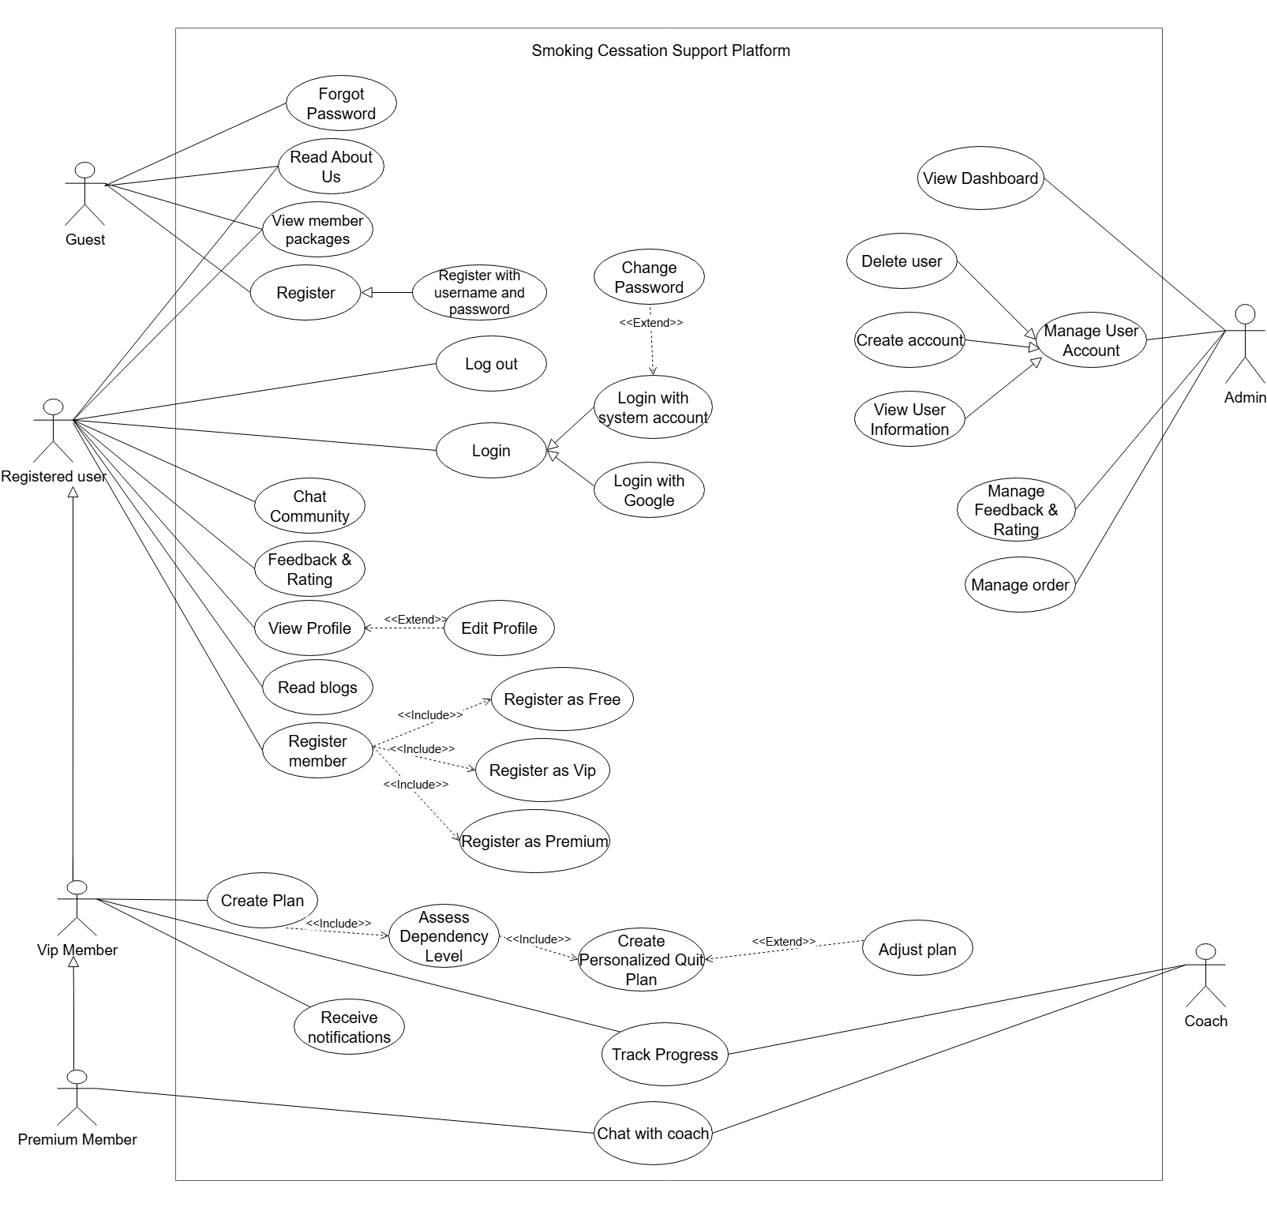

## Use Case Specifications



|  |  |  |  |  |
| --- | --- | --- | --- | --- |
| **USE CASE-n SPECIFICATION** | | | | |
| **Use-case No.** | <UC001> | **Use-case Version** | | <1.0> |
| **Use-case Name** | <Name> | | | |
| **Author** | <Members> | | | |
| **Date** | Dd/mm/yyyy | **Priority** | <High/Normal/Low> | |
| **Actor:**  *<Lit all actors>*  **Summary:**  *<Briefly describe the used case >*  **Goal:**  *<Briefly describe the goal of used case >*  **Triggers**  *<What does lead in using this case?>*  **Preconditions:**  *<List the required pre-conditions for using this case>*  **Post Conditions:**  *<List the required post-conditions for using this case>*  **Main Success Scenario:**  *<List the main steps for using this case to reach the goal successfully >*  **Alternative Scenario:**  *<List other steps for using this case to reach the goal in some alternative conditions >*  **Exceptions:**  *<List exceptions of this use case >*  **Relationships:**  *<List the relationships that use case relates to>*  **Business Rules:**  *<Any concern about the business>* | | | | |

## State Diagrams

## Data flow diagram

## Logical Data Model

#### 

# NON-FUNCTIONAL Requirements

## Usability

## Reliability

## Performance

## Re-usability

## Scalability

# Supporting Information

* **Technologies Used**: Thymeleaf Springboot(frontend), Spring Boot (backend), SQLServer (database).
* **Standards Followed**: SCORM/xAPI (e-learning), OWASP Top 10 (security), WCAG 2.1 (accessibility), ISO 25010 (software quality).
* **Tools**: Figma, Canvas (UI design), Draw.io (diagrams), Postman (API testing), GitHub (version control).
* **Additional Notes**: Future upgrades may include a mobile app, chatbot assistant, and enhanced analytics dashboard.