

**Smoking Cessation Support Platform**

Software Requirement Specification

Project Code: SWP391

Document Code:SWP391

**Ho Chi Minh, June 2025**

**TEAM MEMBERS**

1. Cao Thành Danh - SE194497
2. Nguyễn Tấn Đạt - SE194605
3. Nguyễn Công Thiên Ân - SE194544

Record of change

*A - Added M - Modified D - Deleted

|  |  |  |  |  |
| --- | --- | --- | --- | --- |
| **Effective Date** | **Changed Items** | **A* M, D** | **Change Description** | **New Version** |
| 10/06/2025 | Introduction, Description | A | Add introduction | 1.0 |
| 11/06/2025 | Functional Requirements | A | Add Use Case Diagram, Use Case  Specifications, State Diagrams | 1.1 |
| 14/06/2025 | Description | A | Add Product Perspective. | 1.2 |
| 15/06/2025 | Functional Requirements | A | Add Data Flow Diagrams, Logical  Data Model. | 1.3 |
| 16/06/2025 | Non-functional Requirements | A | Add non-functional requirements of the system. | 1.4 |
|  |  |  |  |  |
|  |  |  |  |  |
|  |  |  |  |  |
|  |  |  |  |  |
|  |  |  |  |  |
|  |  |  |  |  |
|  |  |  |  |  |
|  |  |  |  |  |
|  |  |  |  |  |
|  |  |  |  |  |
|  |  |  |  |  |

SIGNATURE PAGE

**ORIGINATOR:** <Name> <Date>

<Position>

**REVIEWERS:** <Name> <Date>

<Position>

<Name, if it’s needed> <Date>

<Position>

**APPROVAL:** <Name> <Date>

<Position>

TABLE OF CONTENTS

**1** **Introduction 5**

1.1 Purpose 5

1.2 Definitions, Acronyms 5

1.3 References 5

**2** **Overall Description 7**

2.1 Product Perspective 7

2.2 Business Process 7

2.3 User classes 7

**3** **FUNCTIONAL Requirements 8**

3.1 Use Case Diagram 8

3.2 Use Case Specifications 8

3.3 State Diagrams 9

3.4 Data flow Diagram 8

3.5 Logical Data Model 8

**4** **NON-FUNCTIONAL Requirements 10**

4.1 Usability 10

4.2 Reliability 10

4.3 Performance 10

4.4 Reusability 11

4.5 Scalability 11

**5** **Supporting Information 12**

# Introduction

## Purpose

The **Smoking Cessation Support Platform** is a comprehensive digital solution designed to empower individuals in their journey to quit smoking and lead healthier lives. Developed to assist both individuals and communities, the platform provides a centralized environment where users can access reliable information, engage in personalized quit plans, and receive professional guidance throughout the cessation process. The homepage introduces the mission of the platform, featuring motivational content, success stories, and a public leader-board to celebrate progress and achievements.

A core function of the system is its ability to assess users’ current smoking habits, including daily cigarette consumption, smoking frequency, and associated costs. Based on this data, users can create or customize structured quit plans that outline motivations, stages, start dates, and target cessation goals. The platform offers intelligent recommendations and progress tracking, enabling users to monitor smoke-free days, health improvements, and money saved over time.

To keep users motivated, the platform delivers periodic notifications with encouragement and reminders of their quitting reasons. As users reach milestones, the system awards achievement badges (e.g., “1-Day Smoke-Free” or “100K Saved”) This community space encourages peer-to-peer motivation, allowing members to exchange experiences and advice.

Professional support is also a key feature, with the ability to schedule online consultations with certified coaches for personalized guidance. The platform supports the management of membership packages, allowing users to register, subscribe, and access premium features.

For administrators, the system includes tools for managing user profiles,, feedback and ratings, as well as much more. A robust dashboard and reporting system provides actionable insights, helping stakeholders measure success rates, user engagement, and the overall effectiveness of smoking cessation initiatives.

## Scope

The Quit Smoking Support System is a platform website that helps users track and manage their quitting process. The platform provides features such as:

1. Introduce background information, achievement rankings, experience sharing blog.
2. Register an account, choose a membership package and pay online.
3. Record current smoking status.
4. Create and customize a smoking plan.
5. Track smoking cessation progress and statistics.
6. Reminder notifications.
7. Communicate with a coach to get advice.
8. Manage subscriptions, reviews, feedback, personal profiles.
9. Dashboard and report analysis.

## Definitions, Acronyms, and Abbreviations

|  |  |
| --- | --- |
| **Terminology** | **Definition** |
| SCCP | Smoking Cessation Support Platform |
| UI | User Interface |
| UX | User Experience |
| DB | Database |
| MVP | Minimum Viable Product |
| API | Application Programming Interface |
| UC | Use Case — a functional interaction between a system and an actor |
| UC-G## | Use Case for Guest |
| UC-M## | Use Case for Member |
| UC-C## | Use Case for Coach |
| UC-A## | Use Case for Admin |
| BS | Business Rule |
| CRUD | Create, Read, Update, Delete |

## References

As society continues to confront the ongoing health and social consequences of tobacco use, there is a growing demand for innovative, accessible, and evidence-based smoking cessation support. This platform offers community health organizations, wellness initiatives, and public agencies a powerful tool to implement and manage quit-smoking programs at scale. By leveraging digital engagement, personalized support, and data-driven insights, the system enhances outreach efforts, improves participant outcomes, and fosters long-term behavior change.

The platform also opens pathways for sustainable operation through flexible monetization strategies, including institutional memberships, public health grants, and collaborative partnerships. Optional premium features and tailored support packages can be offered to organizations or individuals seeking enhanced services. Through this approach, the system not only promotes individual well-being but also contributes to broader public health goals in reducing tobacco dependence and its associated costs.

# Overall Description

* ***Product Perspective***

The Smoking Cessation Support Platform is a standalone web-based system developed to assist individuals and organizations in quitting tobacco use. While not part of any existing software, it is designed for future integration with common APIs such as email and calendar services for reminders and scheduling.

The platform acts as a centralized hub, offering access to quit plans, self-assessments, counseling, progress tracking, and community support. It also supports membership management, payment integration, and data-driven reporting to help evaluate program effectiveness and improve user outcomes.

**Context diagram:**

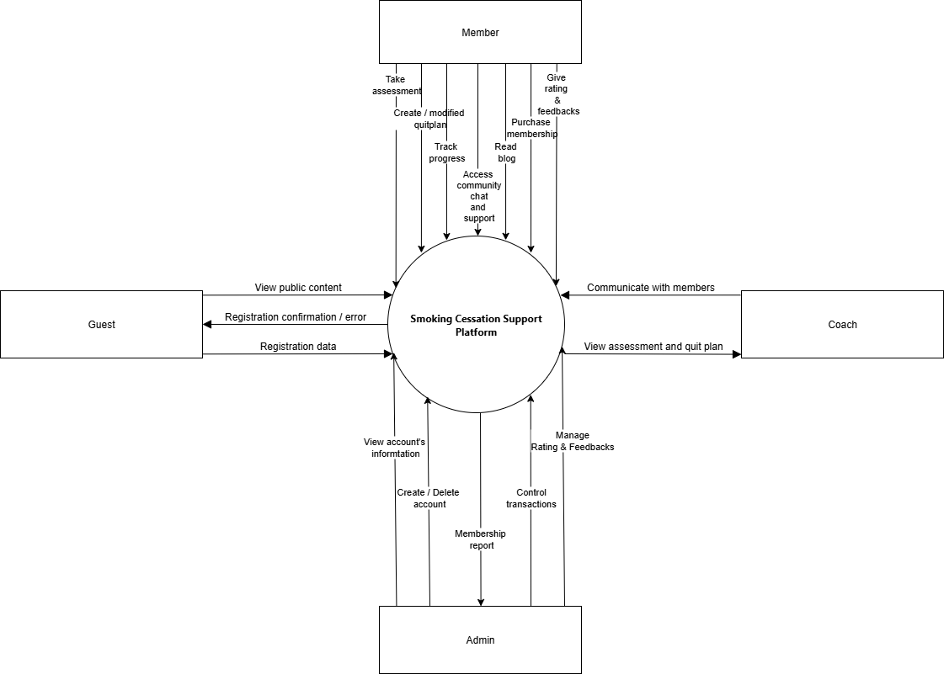

* ***Business Process***

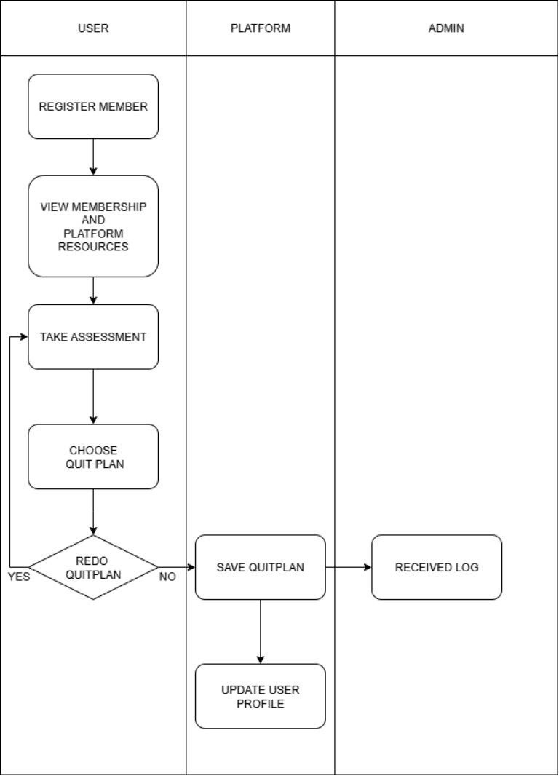

* ***User classes and characteristics***

The system serves multiple types of users, each with distinct roles, access levels, and interaction needs. Below are the main user classes and their characteristics:

* **Guest Users**
* **Description**: Unregistered visitors who can browse public content.
* **Access Rights**: View organizational information and membership overviews.
* **Members (Registered Users)**
* **Description**: Certified professionals providing counseling and support services.
* **Access Rights**:
* **Basic :** Access to essential platform features, email support, and participation in the community forum.
* **VIP :**Includes all Basic features plus access to the Progress Tracker and exclusive resources for enhanced self-guided learning.
* **Premium :**Includes all VIP features, along with 1:1 live coaching sessions and priority support for personalized guidance and faster assistance.
* **Coach**
* **Description**: Certified professionals providing counseling and support services.
* **Access Rights**: View and respond to member’s messages, and access user assessment results.
* **Administrators**
* **Description**: Internal staff responsible for maintaining and coordinating the core components of the Drug Prevention Support System.
* **Access Rights**: Viewing monthly membership statistics, accessing detailed user account information, managing transfer records, and reviewing user ratings and feedback.

# FUNCTIONAL Requirements

## Use cases diagram

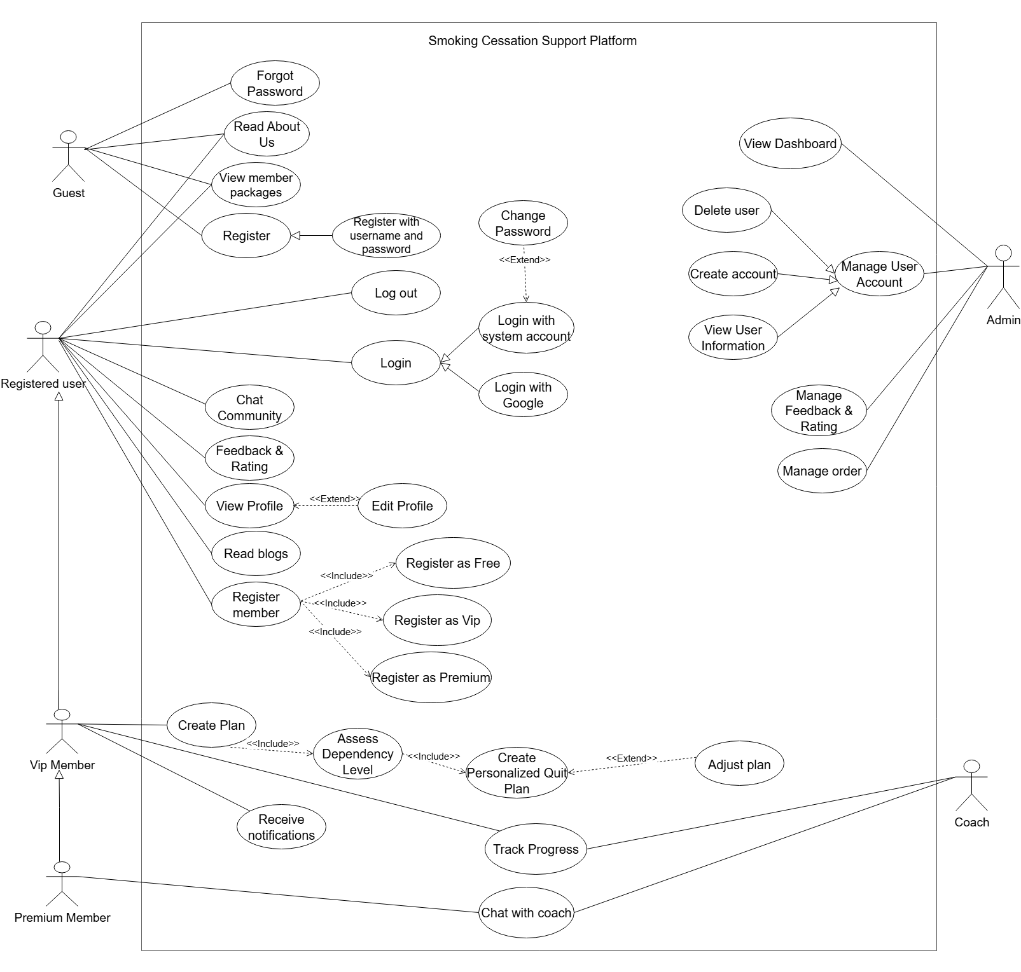

## Use case specifications

|  |  |  |  |  |
| --- | --- | --- | --- | --- |
| **USE CASE-n SPECIFICATION** | | | | |
| **Use-case No.** | <UC001> | **Use-case Version** | | <1.0> |
| **Use-case Name** | Login | | | |
| **Author** | Dat | | | |
| **Date** | 07/06/2025 | **Priority** | High | |
| **Actor:** *Guest*  **Summary:**  The Guest uses the login functionality to authenticate via a registered username/password or by using a third-party OAuth2 provider (e.g., Google).  **Goal:**  To authenticate and grant access to system features that require a logged-in user.  **Triggers**  The Guest clicks on the "Login" button on the homepage.  **Preconditions:**   * The Guest is not currently logged in. * For Username login: the account must already exist. * For Google OAuth2 login: the user must have a valid Google account.   **Post Conditions:**   * The user is successfully authenticated and redirected to dashboard page. * A session or access token is created. * If authentication fails, an appropriate error message is displayed and the user remains a Guest.   **Main Success Scenario:**  A. Login with Username/Password   * Guest clicks "Login". * The system displays a login form. * Guest enters their username and password, then clicks "Submit". * The system validates the credentials. * If valid, the system logs the user in and redirects to the homepage.   B. Login with Google OAuth2   * Guest clicks "Login with Google". * The system redirects to Google's authentication page. * Guest logs in using their Google account. * Google redirects back to the system with an authentication token. * The system verifies the token. * If valid, the user is logged in; if it's their first time, an account is automatically created.   **Alternative Scenario:**  Invalid username or password  → The system shows an error message: "Invalid username or password."  User cancels Google authorization  → The system shows an error message: "Google login canceled. Please try again."  First-time login via Google, no existing local account  → The system auto-creates a new user account using the email and basic profile info.  **Exceptions:**  Network error when communicating with Google → OAuth2 login fails.  Login form fails to submit due to browser or network issues.  Received OAuth2 token is invalid or expired → login denied.  **Relationships:**  Use case: Login (Account or Google)  Actor: Guest  **Business Rules:**   * Username must be unique. * Google accounts must not be banned in the system. * A single email address can only be associated with one system account | | | | |

|  |  |  |  |  |
| --- | --- | --- | --- | --- |
| **USE CASE-n SPECIFICATION** | | | | |
| **Use-case No.** | <UC001> | **Use-case Version** | | <1.0> |
| **Use-case Name** | Register Member | | | |
| **Author** | Dat | | | |
| **Date** | 08/06/2025 | **Priority** | High | |
| **Actor:** Registered User  **Summary:**  This use case allows a registered user to register as a member of the platform by selecting one of the available plans: Free, VIP, or Premium. Each type offers different levels of features and support.  **Goal:**  To enable the user to become an active member of the system by choosing a membership tier that suits their needs.  **Triggers**  The user navigates to the "Member" section after logging in.  **Preconditions:**  The user must be logged in.  **Post Conditions:**  The user becomes a member (Free, VIP, or Premium).  The system updates the user’s role and permissions accordingly.  The user is redirected to the main member dashboard.  **Main Success Scenario:**   1. User selects "Register Member". 2. The system displays options: Free, VIP, Premium with descriptions and prices. 3. User selects one of the plans. 4. The system redirects to payment gateway. 5. Payment is processed successfully. 6. The system upgrades user status. 7. User receives confirmation and gains access to member-only features.   **Alternative Scenario:**  1: User selects Free Plan  → System immediately upgrades status without payment.  2: User selects VIP or Premium, but cancels payment  → User remains at the Registered User level. Message shown: "Registration incomplete".  3: User is already a member  → System displays message: "You are already registered as a member."  **Exceptions:**  Payment fails → Show error and allow user to retry.  **Relationships:**  Includes: Register as Free, Register as VIP, Register as Premium  Depends on: Payment System  **Business Rules:**   * Each user can only be one member type at a time. * Premium and VIP accounts must complete successful payment to activate. * Membership can be upgraded later | | | | |

|  |  |  |  |  |
| --- | --- | --- | --- | --- |
| **USE CASE-n SPECIFICATION** | | | | |
| **Use-case No.** | <UC001> | **Use-case Version** | | <1.0> |
| **Use-case Name** | Create plan | | | |
| **Author** | Danh | | | |
| **Date** | 10/06/2025 | **Priority** | High | |
| **Actor**: VIP Member, PREMIUM Member  **Summary:**  This use case allows a VIP Member and PREMIUM Member to create a personalized quit smoking plan tailored to their smoking habits and dependency level. The plan includes daily goals, motivational messages, and progress tracking.  **Goal:**  To allow VIP Members or PREMIUM Member to generate a customized quit plan based on their inputs and system recommendations.  **Triggers**  VIP Member or PREMIUM Member clicks on “View Plan” after becoming a membe**r.**  **Preconditions:**  The user must be a VIP Member or PREMIUM Member .  The user must be logged in.  **Post Conditions:**  A quit plan is created and stored in the system.  The user is redirected to view or track the plan.  **Main Success Scenario:**   1. VIP Member navigates to "Create Plan" page. 2. The system prompts the user to:   - Input daily cigarette usage.  - Select preferred quit date.  - Answer dependency-related questions.   1. The system includes the "Assess Dependency Level" use case. 2. Based on input, the system includes "Create Personalized Quit Plan". 3. A quit plan is generated with milestones and suggestions. 4. The user confirms the plan. 5. System saves the plan and redirects the user to the plan dashboard.   **Alternative Scenario:**  Alt 1: User cancels during plan creation  → No plan is saved. Return to dashboard with no changes.  Alt 2: User has an existing plan  → System asks to overwrite or keep the existing one.  **Exception**:  Question fails -> Can’t create plan  **Relationships:**  Includes:Assess Dependency Level, Create Personalized Quit Plan  Extends: None  Related to: Track Progress, Adjust Plan  **Business Rules:**   * VIP Members and PREMIUM Member can create quit plans. * A user can have only one active quit plan at a time. | | | | |

|  |  |  |  |  |
| --- | --- | --- | --- | --- |
| **USE CASE-n SPECIFICATION** | | | | |
| **Use-case No.** | <UC001> | **Use-case Version** | | <1.0> |
| **Use-case Name** | Track Progress | | | |
| **Author** | Danh | | | |
| **Date** | 08/06/2025 | **Priority** | High | |
| **Actor:** VIP Member, Premium Member  **Summary:**  This use case allows members to track their progress in following their quit smoking plan. The system provides visual indicators, statistics, and motivational feedback to reflect the user’s performance over time.  **Goal:**  To help users monitor their success and stay motivated throughout their smoking cessation journey.  **Triggers**  The user opens the "Track Progress" section.  **Preconditions:**  The user must be a VIP or Premium Member.  The user must already have an active quit plan.  **Post Conditions:**  The user views updated progress based on their input or system tracking.  **Main Success Scenario:**   1. User navigates to "Track Progress". 2. System displays:   - Days smoke-free  - Milestones achieved  - Daily/weekly statistics (e.g., cigarettes avoided, money saved)   1. User can optionally:   - Mark a relapse or success   1. System updates progress status and stores new data.   **Alternative Scenario:**  Alt 1: No quit plan available  → System redirects to "View Plan" page.  **Exception**:  No plan -> Can’t view track progress  **Relationships:**  Depends on: Quit Plan  Includes: Update daily status, View statistics  Related to: Adjust Plan, Chat with Coach  **Business Rules:**   * Progress is calculated based on user inputs and initial plan. | | | | |

|  |  |  |  |  |
| --- | --- | --- | --- | --- |
| **USE CASE-n SPECIFICATION** | | | | |
| **Use-case No.** | <UC001> | **Use-case Version** | | <1.0> |
| **Use-case Name** | Chat with Coach | | | |
| **Author** | An | | | |
| **Date** | 15/06/2025 | **Priority** | High | |
| **Actor:** Premium Member, Coach  **Summary:**  This use case enables Premium Members to communicate directly with their assigned coach through a private chat interface.  **Goal:**  To provide Premium Members with real-time or asynchronous support from certified coaches to improve their chances of quitting successfully.  **Triggers**  The Premium Member clicks on "Chat with Coach".  The coach receives a message notification or initiates a conversation.  **Preconditions:**  The user must be a Premium Member.  The user must be logged in.  **Post Conditions:**  A message is successfully sent, received, and stored.  The coach may respond or follow up based on the user's needs.  **Main Success Scenario:**   1. Premium Member opens the “Chat with Coach” interface. 2. The system loads the conversation history. 3. User types a message and clicks "Send". 4. The system saves the message and notifies the coach. 5. Coach views the message and replies via the same interface.   **Alternative Scenario:**  Alt 1: Coach is offline  → Message is queued and coach is notified to reply later.  **Exceptions:**  Network failure while sending message → Can’t send.  **Relationships:**  Extends: Track Progress  Includes: Send message, View message history  **Business Rules:**   * Only Premium Members are allowed to chat with coaches. * Messages are stored securely and only visible to the member and their assigned coach. | | | | |

|  |  |  |  |  |
| --- | --- | --- | --- | --- |
| **USE CASE-n SPECIFICATION** | | | | |
| **Use-case No.** | <UC001> | **Use-case Version** | | <1.0> |
| **Use-case Name** | Manage User Account (Admin) | | | |
| **Author** | An | | | |
| **Date** | 18/06/2025 | **Priority** | High | |
| **Actor:** Admin  **Summary:**  This use case allows the Admin to view, update, and manage all user accounts in the system, including their roles and membership types. It ensures proper control over platform users.  **Goal:**  To maintain system integrity and user safety by enabling administrators to manage user access, roles.  **Triggers**  Login by account for admin  **Preconditions:**  The Admin must be logged in with valid credentials.  The Admin has system privileges to manage users.  **Post Conditions:**  User account is successfully updated, deactivated, deleted, or given a new role.  Changes are reflected in the system and may affect the user's access rights immediately.  **Main Success Scenario:**   1. Admin logs into the system. 2. Admin opens "Manage Users". 3. System displays a list of all user accounts with details (name, email, role, status, membership type).   **Alternative Scenario:**  Alt 1: Admin tries to delete a user with active plan  → System warns: "User has an active plan. Are you sure you want to delete?"  Alt 2: Admin views user details only  **Exceptions:**  Database update failure → Show error: "Could not save changes. Try again later."  **Relationships:**  Includes: View user list, create user , delete user  **Business Rules:**   * Only Admins can manage user accounts. | | | | |

## State diagram

3.3.1. Membership State Diagram

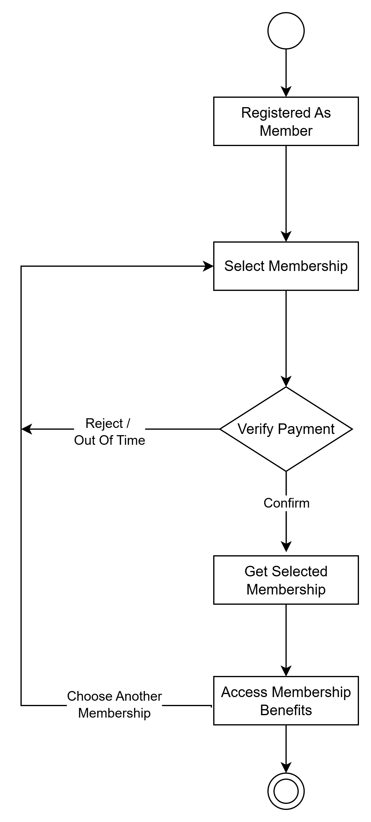

3.3.2. User State Diagram

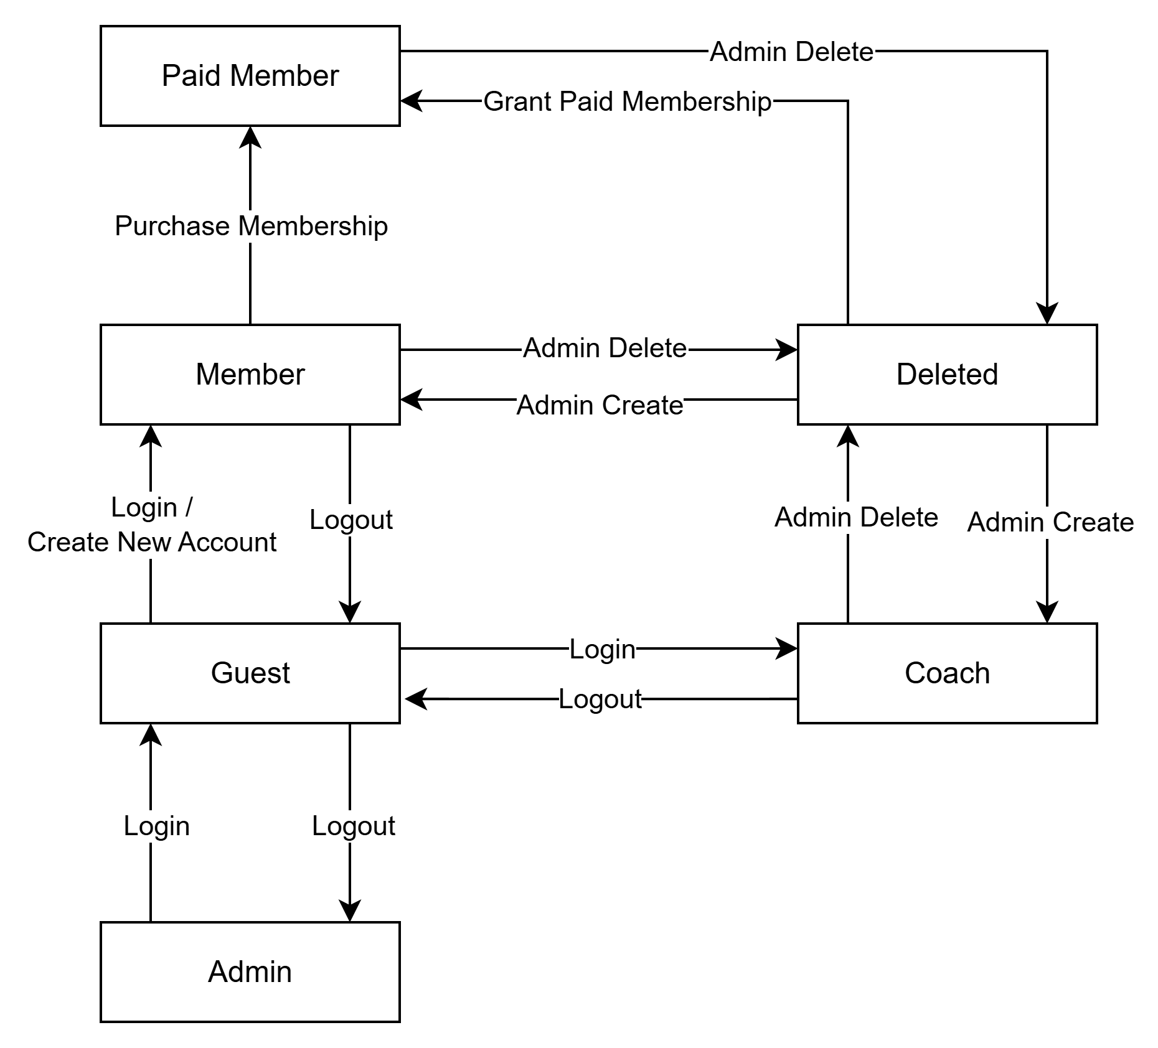

3.3.3. Quit Plan State Diagram

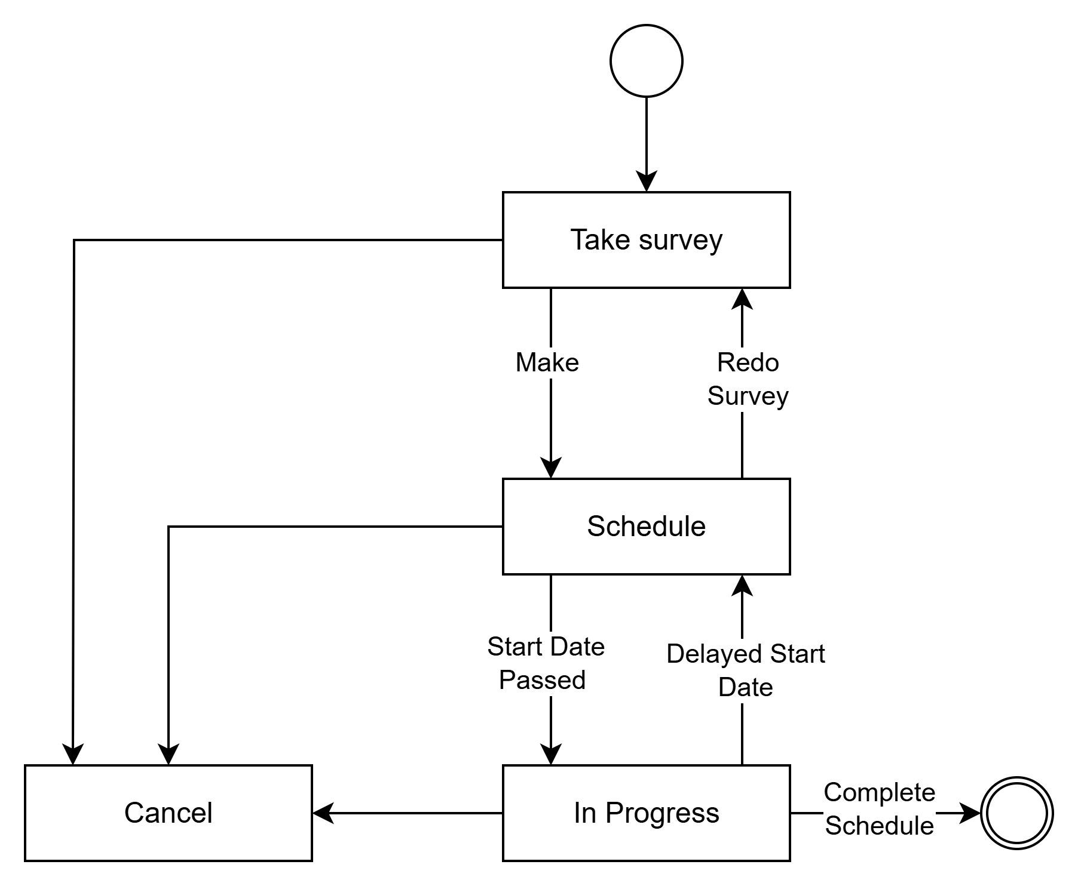

## Data flow diagram

## Logical data model

…………………

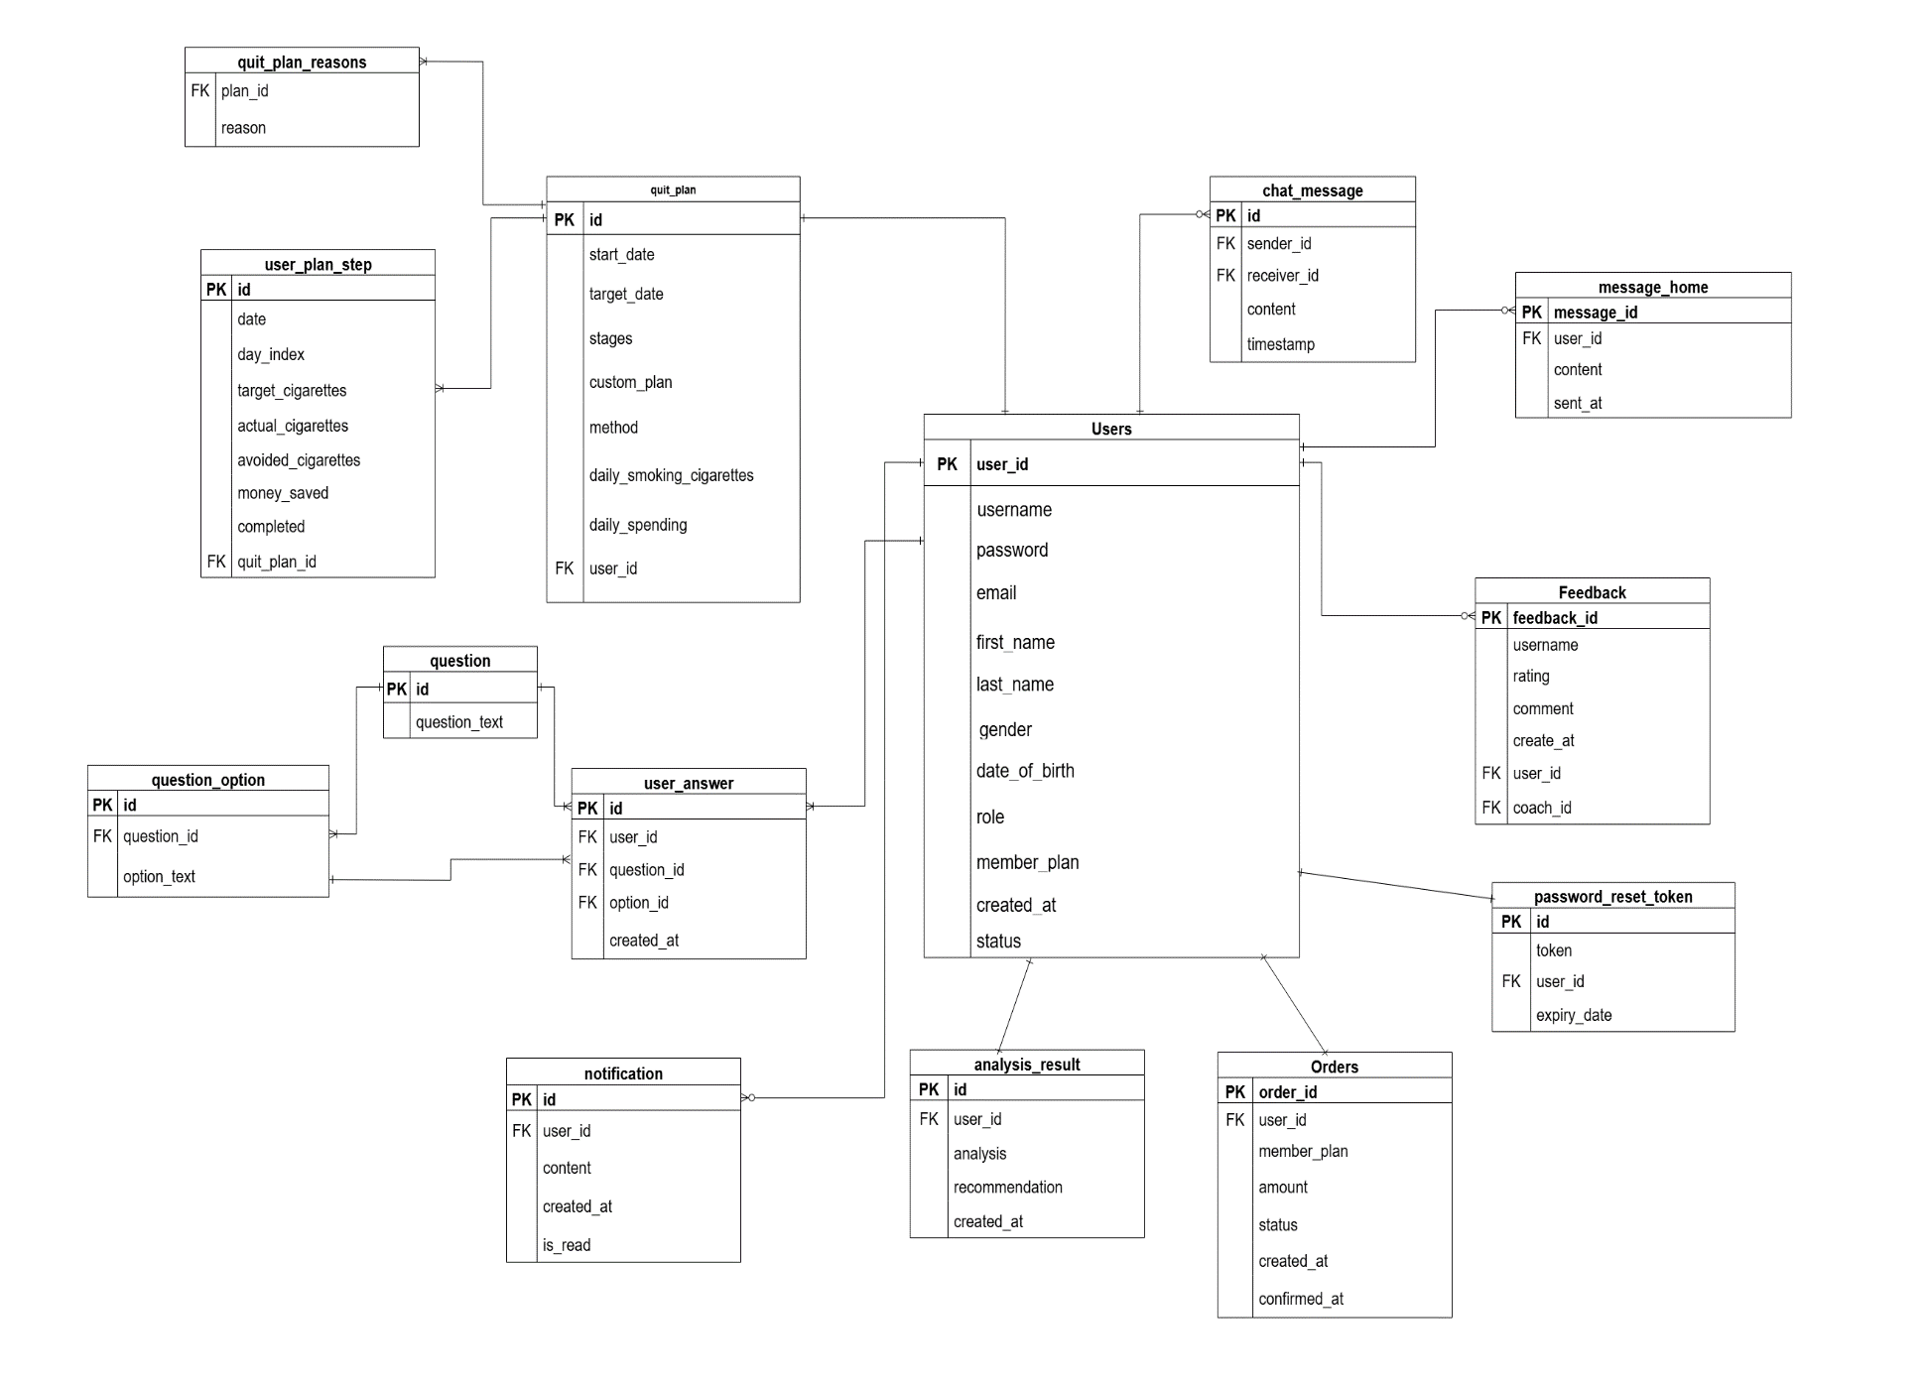

# NON-FUNCTIONAL Requirements

## Usability

* The system should have a user-friendly interface that is easy to navigate for all user roles (Guest, Member, Coach, Admin).
* Users should be able to complete key tasks (e.g., register, login, create plan) within 3 clicks.
* Clear error messages and success indicators should be shown to guide users.

## Reliability

* The system should be available 99.9% of the time, excluding scheduled maintenance.
* In case of system failure, user data must not be lost, and recovery should happen automatically within 5 minutes.
* All important transactions (e.g., payment, plan creation) must be logged for integrity checks.

## Performance

* The system should load all main pages within 2 seconds under normal conditions.
* It should support at least 50 concurrent users without significant performance degradation.
* Chat and progress tracking features should respond in real-time or near real-time (<1 second delay).

## Re-usability

* Core components (e.g., authentication, payment, plan generation) should be built as reusable modules.
* Code should follow modular structure to allow future integration with mobile apps or third-party services.
* Coaches and admin features share common components (user management), promoting reusability.

## Re-usability

* The system must be scalable to support increasing numbers of users.
* Infrastructure should be cloud-ready and support horizontal scaling (e.g., database sharding, load balancers).
* Plan generation and messaging services should be stateless and easily deployable across multiple servers.

## Supportability

* Coding Standards: The system shall follow standard Java coding conventions for backend (Spring Boot) and HTML/CSS/JavaScript with Thymeleaf for frontend.
* Naming Conventions: Use camelCase for Java variables/methods, kebab-case for URLs, and PascalCase for class names.
* Class Libraries: Prioritize using official and trusted open-source libraries such as Spring Boot, Spring Data JPA, and Thymeleaf.

## Design Constraints

* Programming Languages: Java (Spring Boot) for backend; HTML/CSS/JavaScript with Thymeleaf for frontend.
* Architecture: 3-layer architecture (Controller – Service – Repository) with MVC design pattern.
* Database: SQL Server.

## Interfaces

* **User Interfaces:**

Must be responsive and user-friendly on desktop.

Key screens include: Home, Register/Login, Leaderboard, Quit Plan, Chat, and User Profile.

* **Software Interfaces:**

Communicates with the database through Spring Data JPA.

* **Communications Interfaces:**

Use WebSocket for real-time alerts.

# Supporting Information

* **Technologies Used**: Thymeleaf Springboot(frontend), Spring Boot (backend), SQLServer (database).
* **Tools**: Figma, Canvas (UI design), Draw.io (diagrams), Postman (API testing), GitHub (version control).
* **Additional Notes**: Future upgrades may include a mobile app, chatbot assistant, and enhanced analytics dashboard.