seq2seq是把词转化成向量的应用

根据飞机在云上_ 推导出 飞,
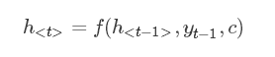

google seq2seq安装：
cd seq2seq

# Install package and dependencies
pip install -e .

python -m unittest seq2seq.test.pipeline_test

需要修改文件seq2seq/contrib/seq2seq/helper.py

#from tensorflow.contrib.distributions.python.ops import bernoulli
#from tensorflow.contrib.distributions.python.ops import categorical
from tensorflow.python.ops.distributions import bernoulli
from tensorflow.python.ops.distributions import categorical

