GLOBAL EQUITY RESEARCH | INITIATION TEAR SHEET  Infosys Limited (NSE: INFY)  IT Services & Digital Transformation | India Large-Cap Desk  Current Price (CMP): ₹1,037.70 | MCap: ₹4,21,123 Cr ($50.7B) | Shares: 405.8 Cr | Date: September 2026 | RECOMMENDATION: BUY  12M Target Price: ₹1,315.00 (+26.7% Upside)  Methodology: DCF (11.7% WACC, 4.5% g) | Rating Framework: Buy > +15%
INVESTMENT THESIS: RESILIENT CASH MACHINE AT A CYCLICAL TROUGH
1. Structurally Defensible Margins at Equilibrium Floor (~21% EBIT): Operating margins contracted from FY21 COVID highs of 24.5% as travel and compensation normalized. In FY26, margins stabilized at 20.9% (EBITDA 23.7%). Supported by Project Maximus cost optimization, 76%+ offshore delivery, and rising Topaz AI deployment, margins have reached a cyclical floor with 40–80 bps expansion potential.
2. Cash Generation Engine & Capital Return Commitment (>85% FCF Returned): Asset-light operations (capex ~1.5% of revenue) yield pristine cash conversion (CFO/PAT 105% 10-year average). Infosys generated ₹31,259 Cr in FCF in FY26 and disbursed ₹39,786 Cr across dividends and buybacks. Liquid reserves stand at ₹59,088 Cr ($7.1B) with zero funded debt.
3. Asymmetric Valuation Gap vs Peers (Trading Below -1σ Band at 14.3x P/E): At ₹1,037.70, INFY trades at just 14.3x TTM P/E (and 13.4x FY27E EPS), representing an unwarranted 48% discount to TCS (27.5x) and a 41% discount to HCLTech (24.2x), despite matching TCS's ROE profile (31.7%) and outpacing peer median revenue growth (+9.6% in FY26 vs peer 5.5%).
KEY FINANCIAL SUMMARY & VALUATION METRICS (₹ CRORE)
Metric | FY24A | FY25A | FY26A | FY27E | FY28E | FY29E
Revenue from Operations (₹ Cr) | 153,670 | 162,990 | 178,650 | 192,049 | 207,413 | 222,969
Revenue YoY Growth (%) | 4.7% | 6.1% | 9.6% | 7.5% | 8.0% | 7.5%
Operating Profit (EBITDA ₹ Cr) | 36,425 | 39,236 | 42,280 | 45,708 | 49,779 | 53,513
EBITDA Margin (%) | 23.7% | 24.1% | 23.7% | 23.8% | 24.0% | 24.0%
Consolidated PAT (₹ Cr) | 26,233 | 26,713 | 29,440 | 31,732 | 34,807 | 37,645
Diluted EPS (₹) | 63.39 | 64.44 | 72.55 | 78.19 | 85.77 | 92.76
P/E Multiple (at CMP ₹1,037.70) | 16.4x | 16.1x | 14.3x | 13.3x | 12.1x | 11.2x
EV / EBITDA (at CMP ₹1,037.70) | 10.2x | 9.5x | 8.8x | 8.1x | 7.5x | 6.9x
Return on Equity (ROE %) | 29.8% | 27.9% | 31.7% | 31.2% | 31.5% | 31.3%
Free Cash Flow (FCF ₹ Cr) | 23,009 | 33,457 | 31,259 | 33,185 | 36,412 | 39,320
Dividend Yield (%) | 3.4% | 3.9% | 3.7% | 4.0% | 4.4% | 4.8%
CHARTS: 10-YEAR VALUATION MULTIPLE DISCONNECT & PEER BENCHMARKING
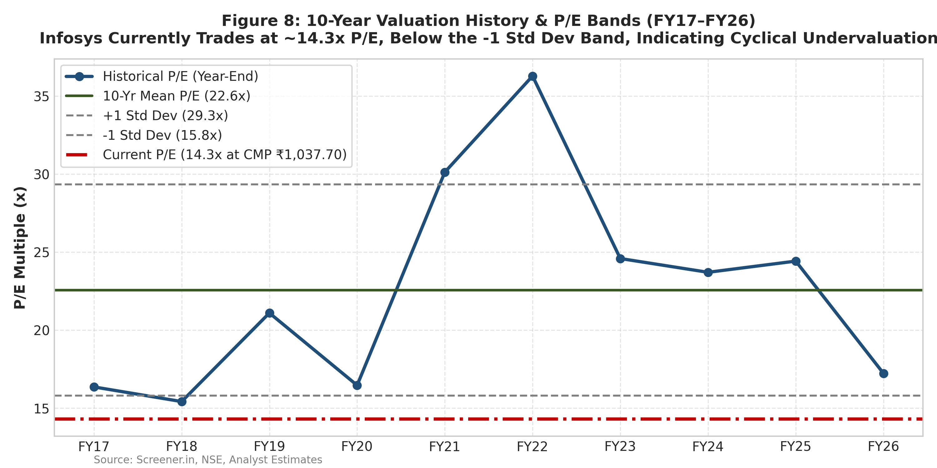 | 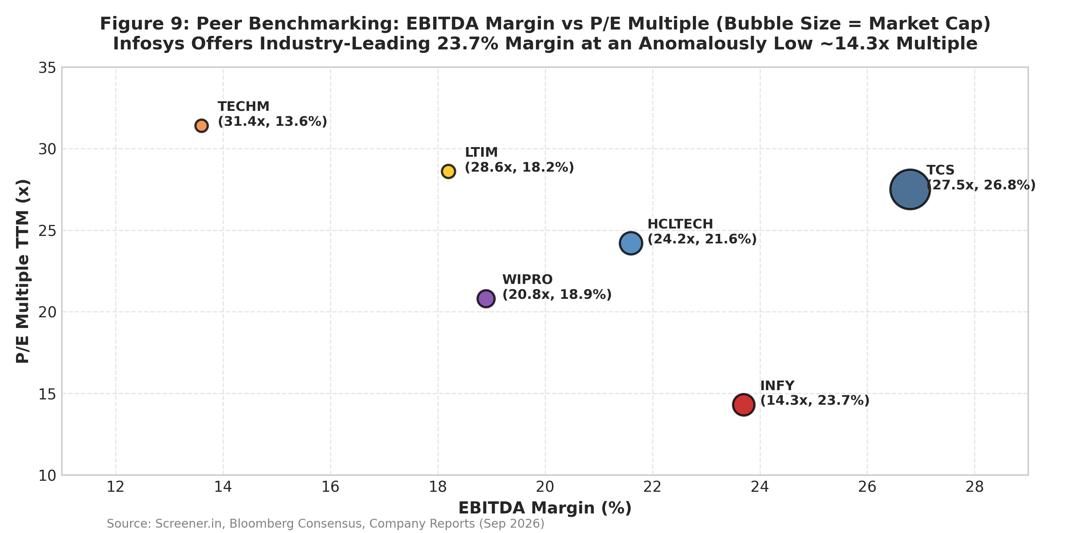
Valuation Synthesis & Implied Values  • Fundamental DCF (Base Case): ₹1,315 (+26.7%)  WACC 11.72% (Rf 7.05%, Beta 0.85, ERP 5.50%), Terminal g 4.5%.  • Peer Comps Multiple (Median 19.0x P/E): ₹1,485 (+43.1%)  • Probability-Weighted Target: ₹1,328 (+28.0%)  Bear (20% @ ₹1,120), Base (60% @ ₹1,315), Bull (20% @ ₹1,540).  • Reverse DCF: Current ₹1,037.70 prices in only 3.2% terminal growth. | Key Downside Investment Risks  1. Discretionary Spending Delays: US BFSI & Retail pause in tech capex.  2. AI Deflation & Pricing Pass-Through: Rapid coding automation diluting fixed-price billing volumes before revenue capture.  3. Currency Headwinds: Sharp INR appreciation vs USD (>₹80/$) compressing margins by ~30 bps per 1% change.  4. Regulatory & Visa Tightening: H-1B restriction proposals under US trade policies elevating onshore delivery costs.
Disclaimer: This is an independent educational research project prepared by a student candidate using publicly available information. It is not investment advice and is not affiliated with or endorsed by any financial institution. Ratings: BUY (>+15%), HOLD (-5% to +15%), SELL (<-5%).

