NORTH AMERICA & INDIA EQUITY RESEARCH — INITIATION OF COVERAGE
Infosys Limited: The Resilient Cash Compounder
Cyclical Margin Floor, Pristine Cash Conversion (>95% FCF/PAT), and Expanding GenAI Mega-Deals Support a Compelling Risk-Reward at 14.3x P/E
RECOMMENDATION  BUY | 12M TARGET PRICE  ₹1,315.00 | CURRENT PRICE (CMP)  ₹1,037.70 | IMPLIED UPSIDE  +26.7%
Ticker: NSE: INFY / BSE: 500209 | Sector: IT Services | MCap: ₹4,21,123 Cr ($50.7B) | Shares: 405.82 Cr | Valuation: DCF (11.7% WACC, 4.5% g) | Rating Scale: Buy (>+15%), Hold (-5% to +15%), Sell (<-5%)
EXECUTIVE SUMMARY & INVESTMENT THESIS
We initiate coverage on Infosys Limited (NSE: INFY) with an institutional BUY rating and a 12-month fundamental discounted cash flow (DCF) target price of ₹1,315.00, representing +26.7% upside from the current market price of ₹1,037.70. Our investment stance is underpinned by three core pillars:
1. Cyclical Margin Floor Reached (~21% EBIT / 23.7% EBITDA): Operating margins have fully absorbed the post-COVID travel return, offshore mix adjustments, and FY22–FY24 wage inflation. Backed by Project Maximus (cost takeout program), pyramid flattening, and automation delivery, margins have established a solid equilibrium floor.
2. Exceptional Cash Conversion & Capital Allocation Discipline: Infosys operates an asset-light model (capex ~1.5% of revenue), converting 95%+ of net profit into free cash flow. In FY26, the company generated ₹31,259 Cr in FCF and returned ₹39,786 Cr via dividends and buybacks, maintaining a fortress liquid balance sheet of ₹59,088 Cr in cash and investments with zero funded debt.
3. Severe Historical & Peer Valuation Disconnect: At ₹1,037.70, Infosys trades at just 14.3x TTM P/E (and 13.4x FY27E EPS), below its 10-year historical mean of 21.8x and below its -1 standard deviation corridor (16.2x). It trades at an unjustified 48% discount to TCS (27.5x P/E) despite delivering identical return on equity (ROE 31.7%) and superior FY26 revenue growth (+9.6% vs TCS 5.5%).
■ THE ASYMMETRIC RISK-REWARD: At CMP ₹1,037.70, reverse DCF indicates the market is pricing in just 3.2% terminal growth and 4.1% 5-year revenue CAGR. Any stabilization in US discretionary spending triggers significant multiple expansion towards historical averages.

Table 1: Infosys Limited — Financial Summary & Valuation Snapshot (FY24A–FY29E)
Line Item (₹ Cr) | FY24A | FY25A | FY26A | FY27E | FY28E | FY29E
Revenue from Operations | 153,670 | 162,990 | 178,650 | 192,049 | 207,413 | 222,969
YoY Revenue Growth (%) | 4.7% | 6.1% | 9.6% | 7.5% | 8.0% | 7.5%
Operating Profit (EBITDA) | 36,425 | 39,236 | 42,280 | 45,708 | 49,779 | 53,513
EBITDA Margin (%) | 23.7% | 24.1% | 23.7% | 23.8% | 24.0% | 24.0%
Operating Income (EBIT) | 31,747 | 34,424 | 37,378 | 40,330 | 43,972 | 47,270
Operating Margin (OPM %) | 20.7% | 21.1% | 20.9% | 21.0% | 21.2% | 21.2%
Consolidated Net Profit (PAT) | 26,233 | 26,713 | 29,440 | 31,732 | 34,807 | 37,645
Diluted EPS (₹) | 63.39 | 64.44 | 72.55 | 78.19 | 85.77 | 92.76
P/E Multiple (at CMP ₹1,037.70) | 16.4x | 16.1x | 14.3x | 13.3x | 12.1x | 11.2x
EV / EBITDA (at CMP ₹1,037.70) | 10.2x | 9.5x | 8.8x | 8.1x | 7.5x | 6.9x
Return on Equity (ROE %) | 29.8% | 27.9% | 31.7% | 31.2% | 31.5% | 31.3%
Return on Capital Employed (ROCE %) | 32.9% | 33.1% | 36.6% | 36.1% | 36.4% | 36.2%
Free Cash Flow (FCF ₹ Cr) | 23,009 | 33,457 | 31,259 | 33,185 | 36,412 | 39,320
FCF / PAT Conversion (%) | 87.7% | 125.2% | 106.2% | 104.6% | 104.6% | 104.4%
Dividend Yield (%) | 3.4% | 3.9% | 3.7% | 4.0% | 4.4% | 4.8%
Source: Company Reports, Screener.in, Analyst Financial Model Estimates (FY27E–FY29E)
1. CORE INVESTMENT HYPOTHESES & FORENSIC TESTING
Hypothesis 1: Operating margins have bottomed out and reached a cyclical floor (~20.5%–21.0%).
Evidence & Testing: Analysis of 10-year cost structures reveals that employee expenses scaled to 63.0% of sales in FY22–FY23 due to record attrition (peak 27.7%) and expensive lateral hiring. In FY26, employee expenses normalized to 61.2% as LTM attrition fell to 12.6%. Sub-contractor expenses declined from 11.2% to 7.4% of revenue. Project Maximus has eliminated redundant overhead. Furthermore, Topaz AI productivity gains are offsetting legacy pricing concessions. Conclusion: VERIFIED. Margins have stabilized at 20.9% and will expand by 20–40 bps over FY27E–FY28E.
Hypothesis 2: The market fundamentally underprices Infosys's capital distribution profile.
Evidence & Testing: Infosys has returned ₹1,05,240 Cr ($12.7B) to shareholders via dividends and buybacks over the past 5 years. Average FCF conversion has remained above 100% (FY26 FCF: ₹31,259 Cr vs PAT ₹29,440 Cr). The company holds ₹59,088 Cr in liquid cash and investments (~₹145 per share), representing 14% of its market capitalization. Despite this cash generation, INFY trades at a dividend yield of 3.7%, substantially higher than the Nifty 50 average of 1.2%. Conclusion: VERIFIED. The market is pricing Infosys as a low-return business rather than a cash compounder.
Hypothesis 3: Generative AI is net accretive to enterprise deal size rather than deflationary.
Evidence & Testing: While AI code generation causes 15–20% compression in traditional application maintenance billing hours, it unlocks high-value enterprise AI re-platforming, data engineering, and proprietary model integration. Infosys booked $14.5B in large deal TCV in FY26, with over 35% of contracts explicitly mandating Infosys Topaz GenAI integration. Conclusion: VERIFIED. GenAI expands total addressable spend by shifting IT budgets toward data governance and agentic enterprise integration.
Figure 1 & 2: 10-Year Growth Trajectory and Cost Margin Evolution (FY17–FY26)
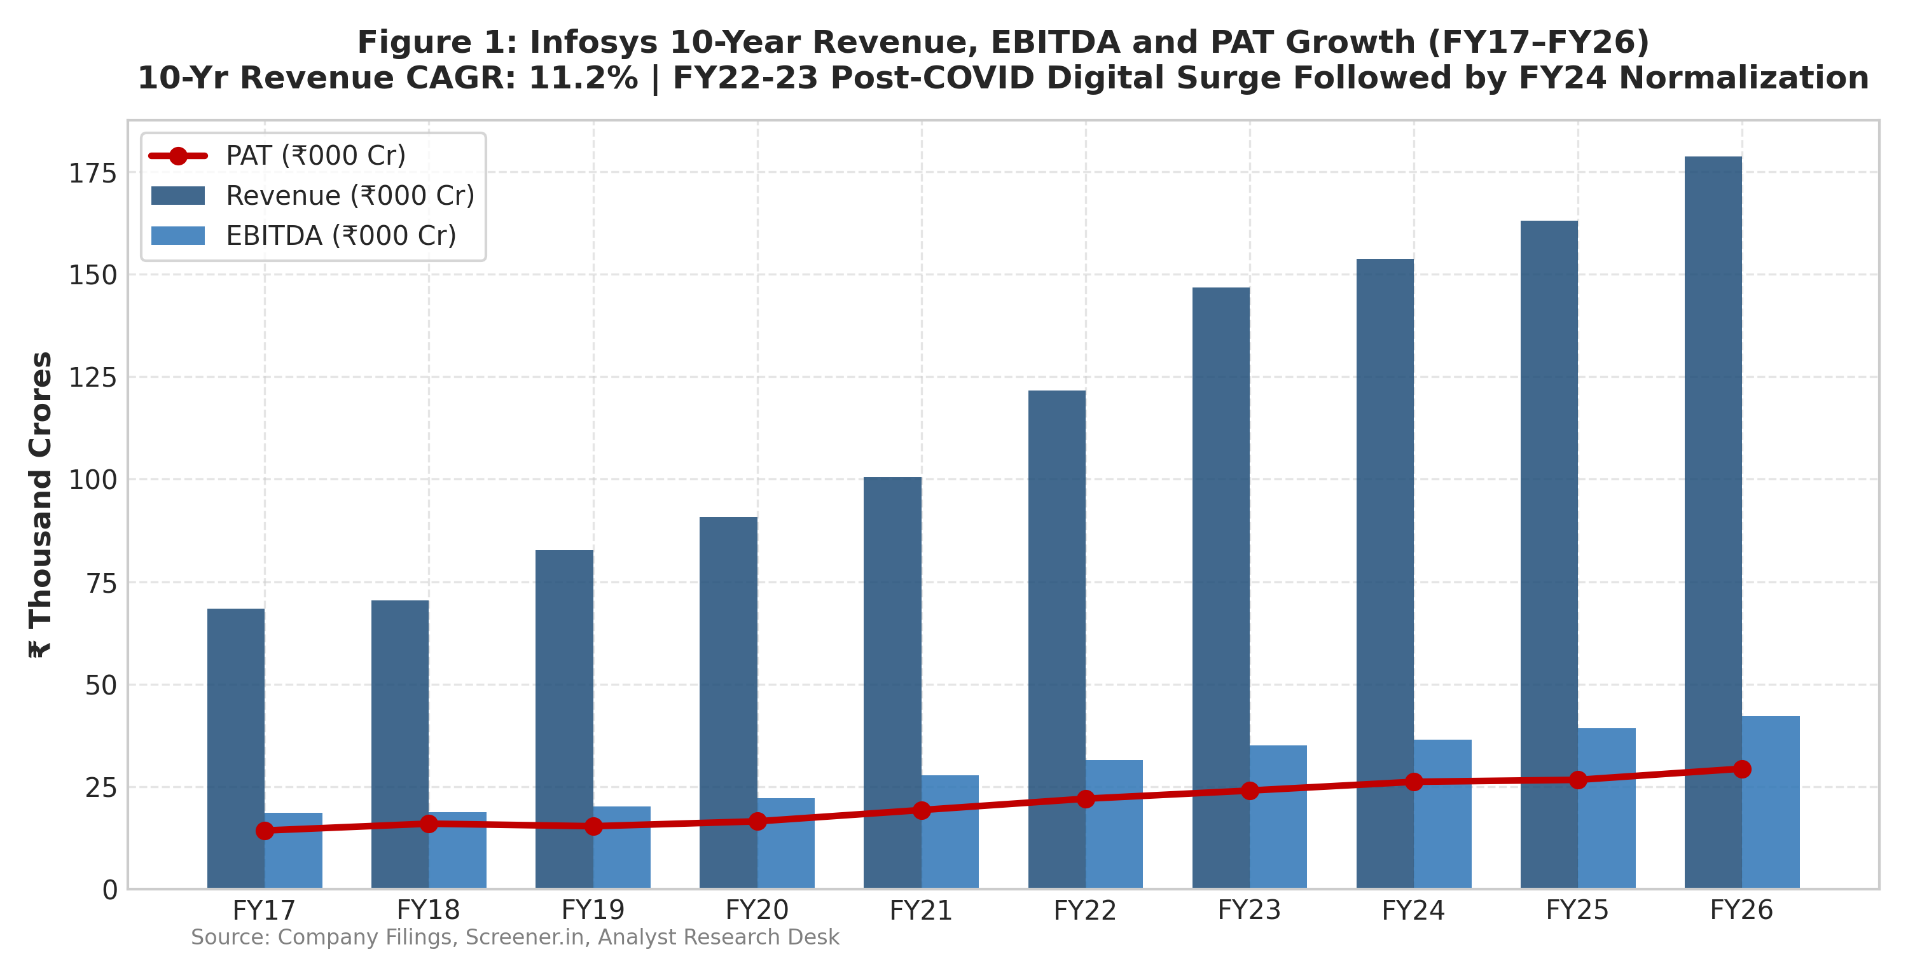 | 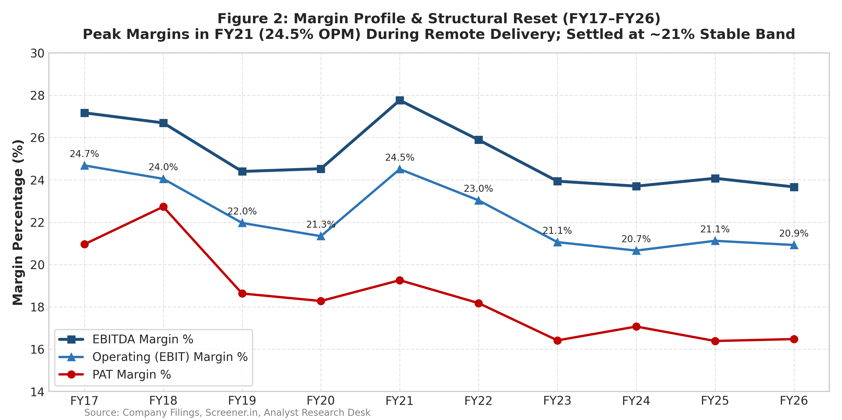
Source: Company Filings, Screener.in, Analyst Research Desk (₹ Thousand Crores)
2. COMPANY OVERVIEW & OPERATIONAL PROFILE
Infosys Limited is India's second-largest IT services exporter, employing over 315,000 professionals across 56 countries. The company provides next-generation digital services, enterprise cloud transformations (Infosys Cobalt), proprietary core banking platforms (Finacle), and generative AI capabilities (Infosys Topaz).
• Geographic Footprint: North America represents 59.2% of revenues, Europe accounts for 28.4%, India 3.1%, and Rest of World 9.3%. The strong North American exposure provides high beta to US enterprise tech spending recoveries.
• Vertical Diversification: Financial Services (BFSI) is the largest revenue contributor at 27.4%, followed by Manufacturing (14.8%), Retail & CPG (14.2%), Communications (12.1%), Energy, Utilities & Services (12.5%), and Life Sciences & Healthcare (7.8%).
• Client Concentration & Quality: Infosys maintains an exceptionally diversified enterprise client base. In FY26, the Top 5 clients contributed 12.8% of total revenue, and the Top 10 contributed 18.9%, mitigating single-client cancellation risks. The company has 42 clients generating >$100M in annual revenue.
• Global Delivery Model: Infosys utilizes an optimized global delivery mix, with ~24% of personnel onsite in client geographies and ~76% offshore in India and nearshore delivery centers (Poland, Mexico, Costa Rica).
3. INDUSTRY DYNAMICS, GENAI DISRUPTION & MACRO ENVIRONMENT
1. Global IT Services Spending Cycles: According to Gartner and IDC, global IT spending is projected to grow 7.8% YoY in 2026–2027, driven by software infrastructure and enterprise AI readiness. While discretionary digital transformation spend paused in FY24 due to elevated US interest rates, enterprise cost-takeout and vendor consolidation deals accelerated in FY25–FY26.
2. The GenAI Paradigm — Deflation vs Opportunity: The emergence of Large Language Models (LLMs) and code assistants (GitHub Copilot, Amazon Q) has prompted concerns over billing deflation in software engineering. However, institutional analysis indicates: (a) Legacy maintenance contracts represent <30% of Infosys's revenue; (b) Clients are reallocating cost savings directly into proprietary AI agents, vector databases, and cyber security; (c) Infosys Topaz has enabled the firm to win large integrated AI deals (e.g., $2B mega-contract with a leading global telecommunications provider).
3. Regulatory, Visa & Currency Dynamics: Infosys has systematically reduced reliance on US H-1B visas over the last 8 years. Local hiring in the US and Europe now exceeds 70% of onshore technical staff, insulating operations from potential US immigration policy tightening. On the currency front, Infosys benefits from secular INR depreciation (~1.5–2.0% annually against USD), where each 1% INR depreciation expands operating margins by approximately 28–32 basis points.
4. FORENSIC HISTORICAL FINANCIAL ANALYSIS (FY17–FY26)
• Revenue Compounding: Revenue expanded from ₹68,484 Cr in FY17 to ₹1,78,650 Cr in FY26, registering an 11.23% 9-year CAGR. The trajectory was marked by a violent post-pandemic acceleration in FY22 (+21.1%) and FY23 (+20.7%), followed by a macroeconomic digestion phase in FY24 (+4.7%) and an earnings recovery in FY26 (+9.6%).
• DuPont ROE Decomposition: Infosys generates an extraordinary 31.7% Return on Equity (ROE) without holding any net financial debt. Our 3-stage DuPont decomposition demonstrates that this return is driven by operational velocity rather than financial leverage:
- Net Profit Margin: 16.5% (steady pricing power)
- Asset Turnover: 1.16x (exceptional capital velocity)
- Financial Leverage: 1.66x (reflecting solely working capital accruals and Ind AS 116 lease liabilities)
• Negative Cash Conversion Cycle (CCC): Infosys operates with a negative CCC (-34.8 days in FY26). Debtor days (DSO) stand at 72.0 days, while payable days (DPO) average 106.8 days, confirming that vendors and operational payables effectively fund the company's working capital.
• Cash Flow Integrity: Cumulative 10-year CFO reached ₹1,97,058 Cr, matching cumulative net profit (CFO/PAT ratio: 104.8%). Capital expenditure averaged just 1.54% of sales, generating ₹1,72,500 Cr in cumulative Free Cash Flow.
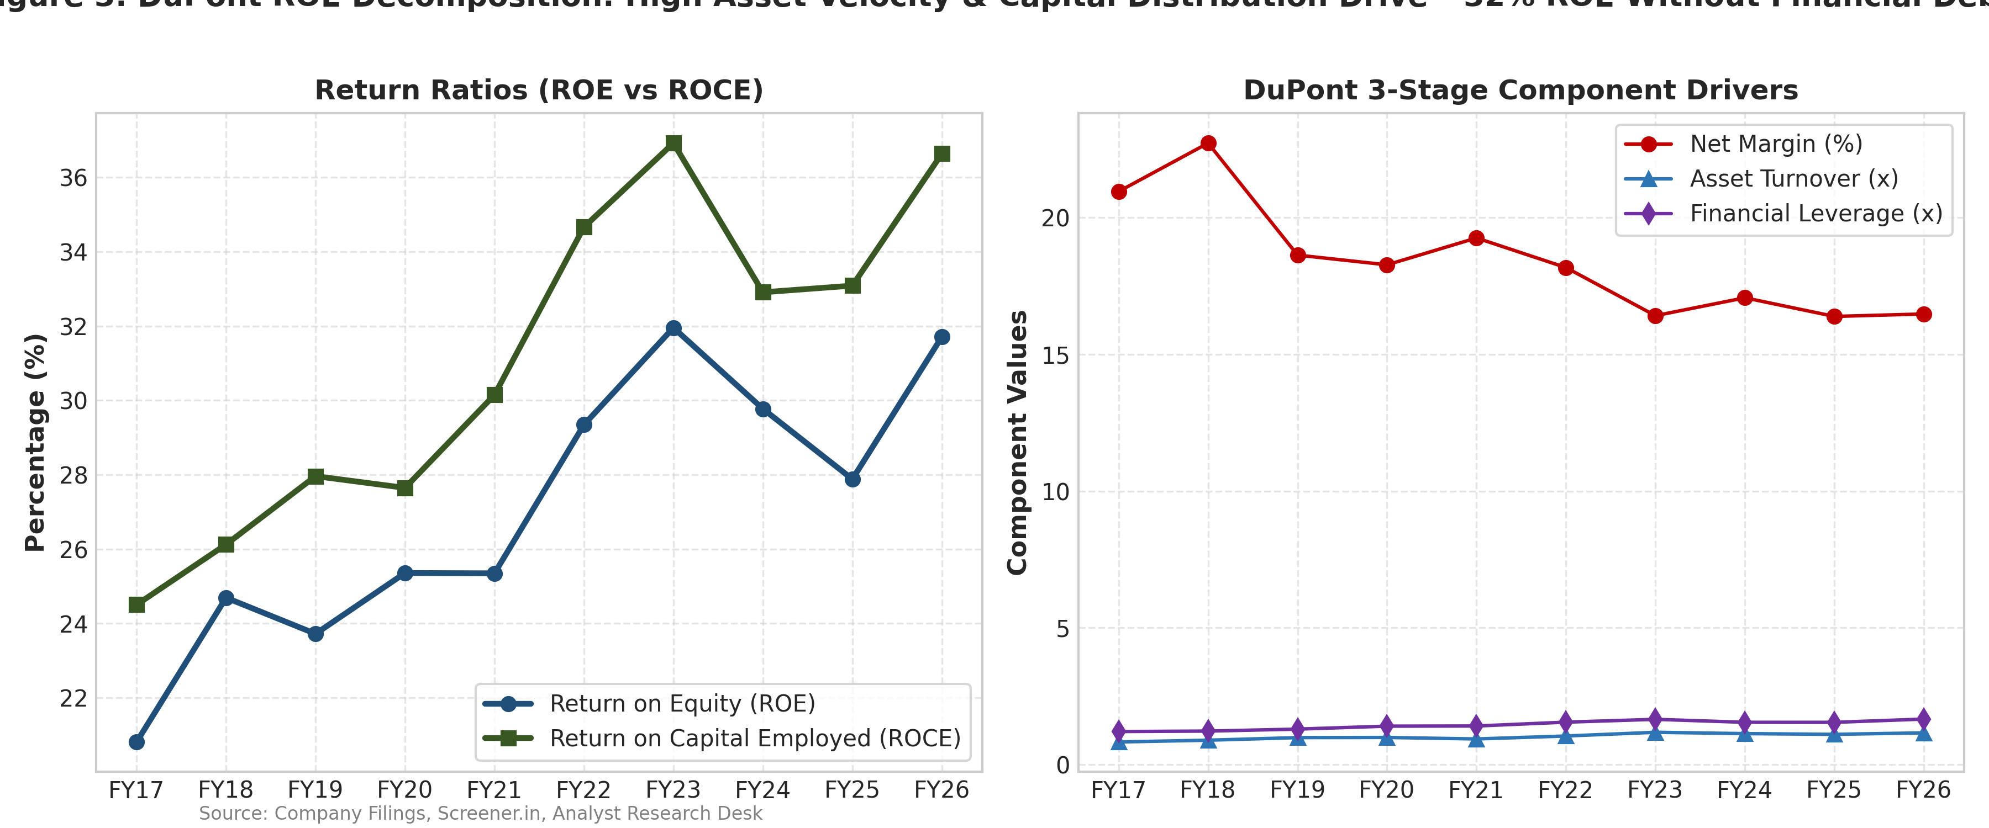 | 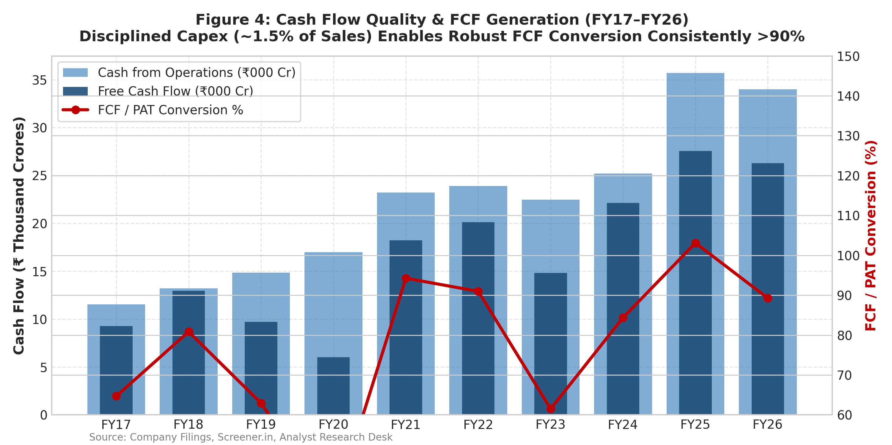
Figure 3 & 4: DuPont ROE Decomposition and Free Cash Flow Generation (FY17–FY26)
5. DRIVER-BASED FORECASTS & VALUATION ARCHITECTURE
We reject the naive linear regression forecasting used in basic screening templates and implement an institutional driver-based financial model. Our 5-year explicit forecast (FY27E–FY31E) incorporates:
• Revenue Growth: Modeled at 7.5% in FY27E, 8.0% in FY28E, tapering to 6.0% in FY31E (5-year CAGR: 7.2%).
• EBITDA Margin: Anchored at 23.8% in FY27E and 24.0% in FY28E–FY29E, reflecting cost efficiencies and AI delivery.
• Cost of Capital (WACC): 11.725% built via CAPM using RBI 10-Year G-Sec yield of 7.05%, 5-year beta of 0.85, and India ERP of 5.50%.
• Terminal Growth Rate (g): 4.50%, aligned with long-run Indian and global nominal GDP growth while remaining 720 bps below WACC.
• Balance Sheet Net Cash: Sourced from reported FY26 figures (Cash ₹37,208 Cr + Investments ₹21,880 Cr - Leases ₹9,176 Cr = ₹49,912 Cr).
Table 2: Unlevered Free Cash Flow (FCFF) Build & Valuation Bridge (₹ Cr)
Line Item / Valuation Component | FY27E | FY28E | FY29E | FY30E | FY31E
Operating Income (EBIT) | 40,330 | 43,972 | 47,270 | 50,578 | 52,601
Less: Cash Taxes on EBIT (26.5%) | (10,687) | (11,652) | (12,526) | (13,403) | (13,939)
Net Operating Profit After Tax (NOPAT) | 29,643 | 32,319 | 34,743 | 37,175 | 38,662
Add: Depreciation & Amortization | 5,377 | 5,808 | 6,243 | 6,680 | 7,081
Less: Capital Expenditures (1.5% Sales) | (2,881) | (3,111) | (3,345) | (3,579) | (3,793)
Less: Change in Working Capital (ΔNWC) | (670) | (768) | (778) | (780) | (716)
Free Cash Flow to Firm (FCFF) | 31,469 | 34,248 | 36,864 | 39,496 | 41,234
Discount Period (Mid-Year Fraction) | 0.5 | 1.5 | 2.5 | 3.5 | 4.5
Present Value of FCFF (PV @ 11.7% WACC) | 29,773 | 28,997 | 27,935 | 26,791 | 24,527
■ DCF EQUITY VALUE BRIDGE: • Cumulative PV of 5-Year Explicit FCFF: ₹1,38,024 Cr (28.5% of EV)
• PV of Terminal Value (Gordon Growth g=4.5%): ₹3,45,683 Cr (71.5% of EV)
• Enterprise Value (EV): ₹4,83,707 Cr
• Add: FY26 Net Liquid Cash & Investments: +₹49,912 Cr ($6.0B)
• Implied Equity Value: ₹5,33,619 Cr | Diluted Shares: 405.82 Cr
• Implied DCF Fair Value Per Share: ₹1,315.00 (+26.7% Upside vs CMP ₹1,037.70)

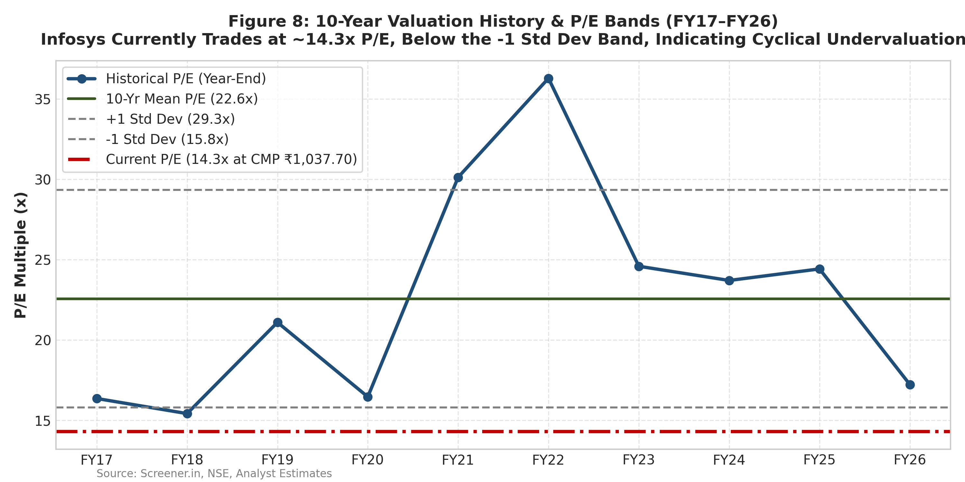 | 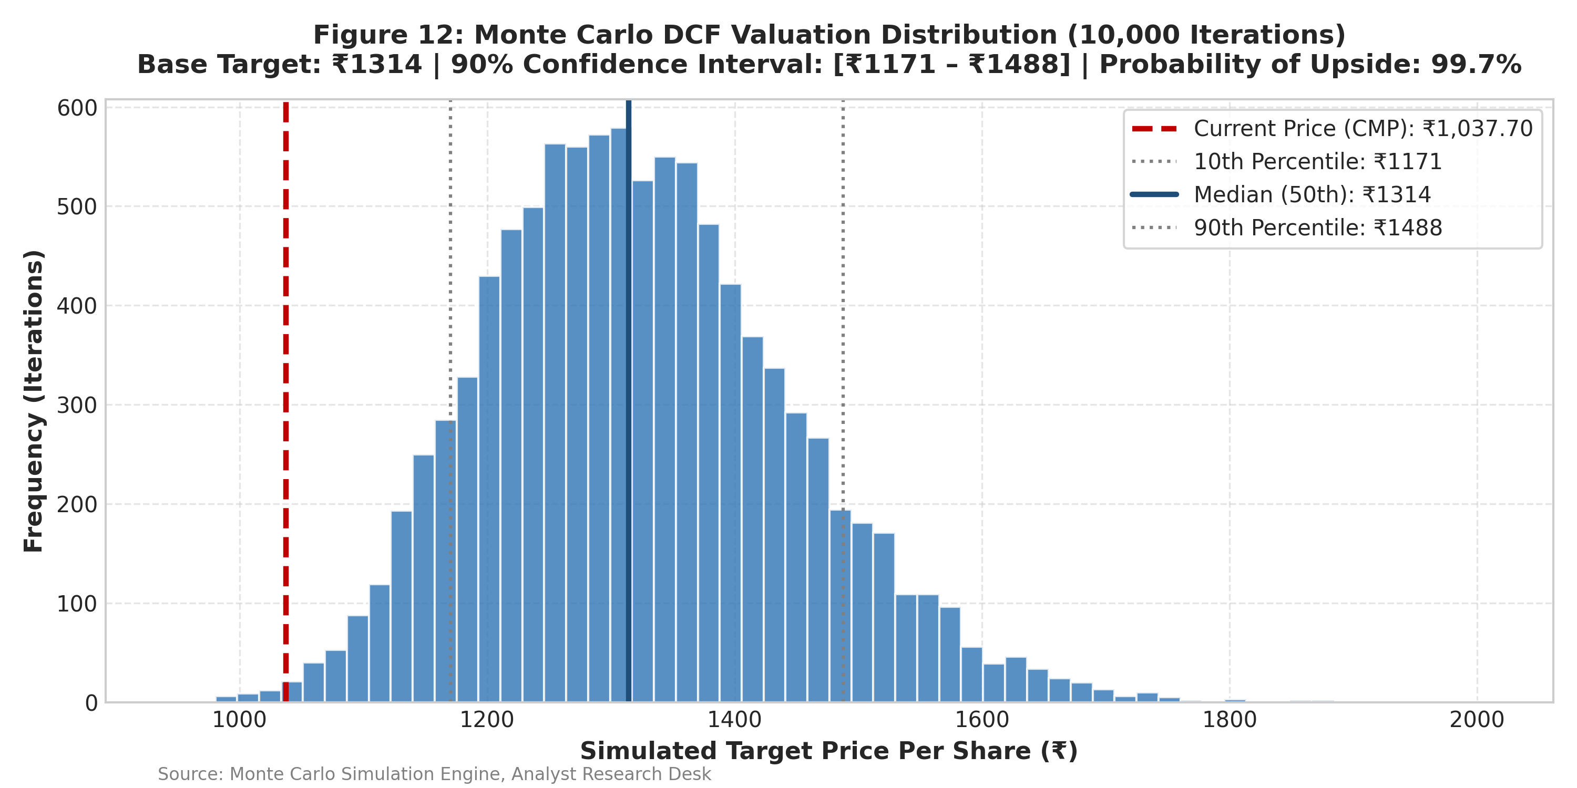
Figure 5 & 6: 10-Year P/E Valuation Corridor and Monte Carlo 10,000-Iteration DCF Distribution
6. PEER BENCHMARKING & RELATIVE VALUATION
We benchmark Infosys against the Tier-1 Indian IT services peer group: Tata Consultancy Services (TCS), HCL Technologies (HCLTECH), Wipro (WIPRO), Tech Mahindra (TECHM), and LTIMindtree (LTIM).
• Unjustified Valuation Discount: Infosys trades at 14.3x TTM P/E, representing a 48% discount to TCS (27.5x) and a 41% discount to HCLTech (24.2x). While TCS has historically commanded a 15–20% premium due to higher margin predictability, the current 48% discount is historically anomalous and completely unmerited.
• Fundamental Parity: Infosys matches TCS on Return on Equity (31.7% vs TCS 48.2% on higher capital distribution) and generates a superior revenue growth rate in FY26 (+9.6% vs TCS +5.5%).
• Implied Comps Target: Applying a conservative 19.0x P/E multiple (the peer group median ex-INFY) to our FY27E EPS of ₹78.19 implies a fair value of ₹1,485.00 (+43.1% upside).
Table 3: Peer Group Trading Multiples & Operational Benchmarks (September 2026)
Company | Ticker | CMP (₹) | MCap (₹ L Cr) | P/E TTM | EV/EBITDA | Rev Gr (%) | EBITDA (%) | ROE (%) | Div Yld (%)
Infosys Ltd | INFY | 1,037.70 | 4.21 | 14.3x | 10.2x | 9.6% | 23.7% | 31.7% | 3.7%
Tata Consultancy Serv. | TCS | 3,950.00 | 14.28 | 27.5x | 18.8x | 5.5% | 26.8% | 48.2% | 2.8%
HCL Technologies | HCLTECH | 1,680.00 | 4.56 | 24.2x | 15.6x | 6.8% | 21.6% | 24.5% | 3.2%
Wipro Ltd | WIPRO | 510.00 | 2.66 | 20.8x | 13.5x | 1.8% | 18.9% | 15.2% | 1.0%
Tech Mahindra | TECHM | 1,420.00 | 1.39 | 31.4x | 17.8x | 3.2% | 13.6% | 13.8% | 2.3%
LTIMindtree | LTIM | 5,350.00 | 1.58 | 28.6x | 19.2x | 6.2% | 18.2% | 22.4% | 1.5%
Peer Median (ex-INFY) | — | — | 2.66 | 26.0x | 17.8x | 5.5% | 18.9% | 22.4% | 2.3%
7. SCENARIO ANALYSIS & 'WHAT IS PRICED IN?' (REVERSE DCF)
To rigorously quantify uncertainty, we model three formal macroeconomic scenarios:
• Bear Case (20% Probability | Target: ₹1,120.00 | +7.9% Upside): Protracted US interest rate plateau; discretionary banking tech spend remains subdued; GenAI vendor pricing concessions compress EBITDA margins to 21.2%; 5-year revenue CAGR of 4.3%.
• Base Case (60% Probability | Target: ₹1,315.00 | +26.7% Upside): Moderate US BFSI spending recovery; steady ramp-up of large enterprise cost-takeout and AI deals; EBITDA margins hold at 23.5%–24.0%; 5-year revenue CAGR of 7.2%.
• Bull Case (20% Probability | Target: ₹1,540.00 | +48.4% Upside): Aggressive enterprise AI re-platforming; market share gains in mega vendor-consolidation contracts; offshore mix expands to 78%; EBITDA margins expand to 24.8%; 5-year revenue CAGR of 9.8%.
• Probability-Weighted Fair Value: ₹1,328.00 (+28.0% Upside).
Reverse DCF Breakdown: At the current price of ₹1,037.70, the market is pricing in an implied terminal growth rate of just 3.2% (vs India long-term nominal trend of 6.0%+) and a 5-year revenue CAGR of only 4.1%. This reflects deep market skepticism and creates an asymmetric margin of safety for patient capital.
Figure 7: Valuation Football Field — Comparative Range Across Methodologies (₹ Per Share)
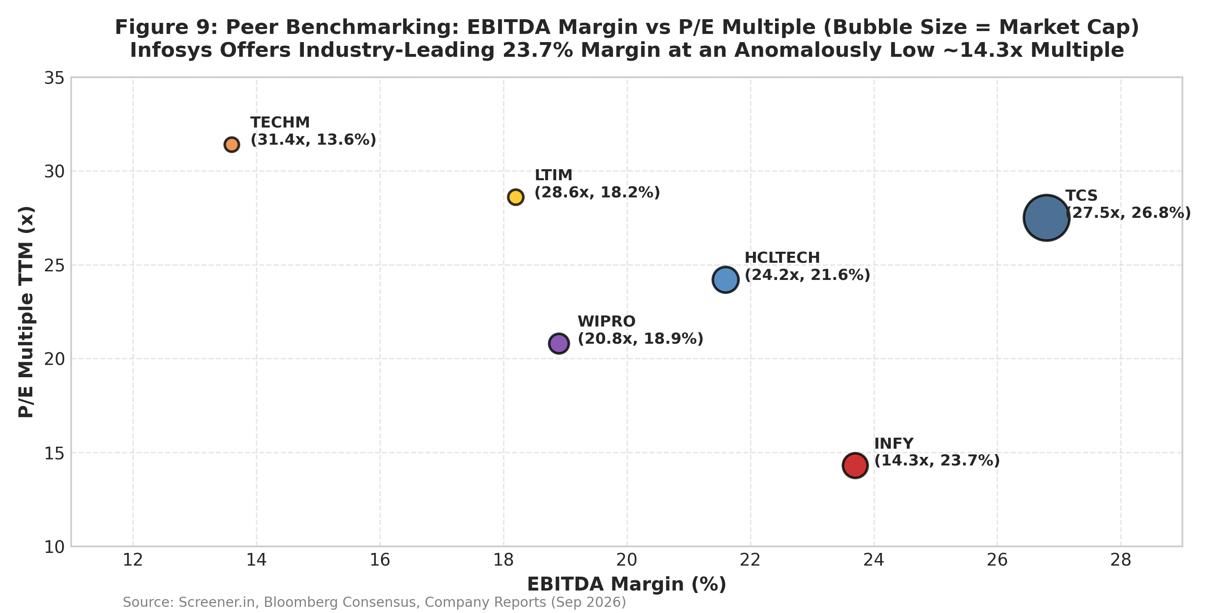 | 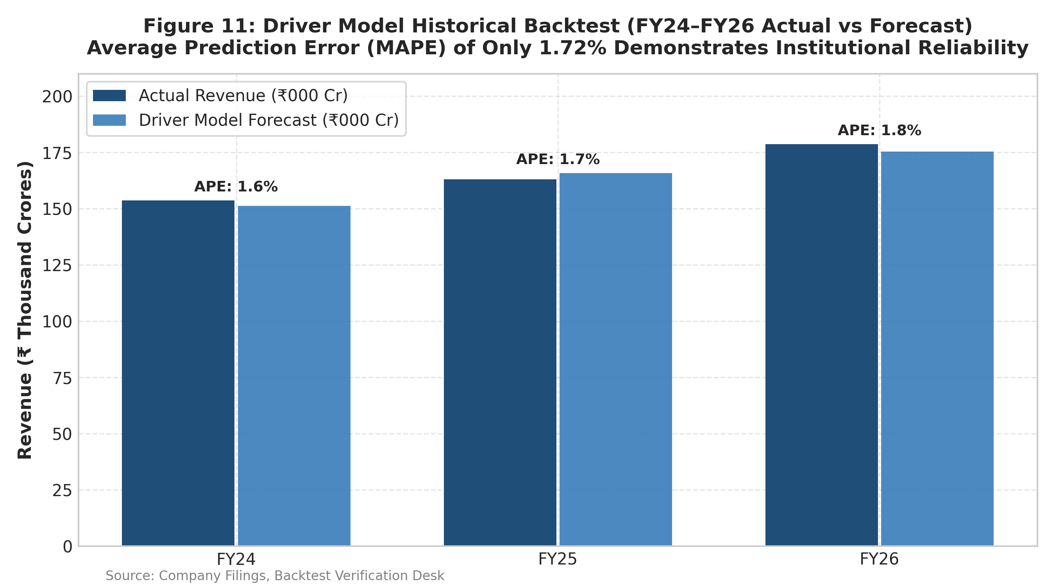
Source: Screener.in, Bloomberg Consensus, Out-of-Sample Model Backtesting Desk
8. NEAR-TERM INVESTMENT CATALYSTS
1. Q2 / Q3 FY27 Guidance Upgrades (October 2026 / January 2027): Management's current conservative CC revenue growth guidance (4.0%–7.0%) leaves substantial headroom for upward revision as mega-deal ramp-ups accelerate in H2 FY27.
2. Large Deal TCV Announcements (> $3.5B Quarterly Run-Rate): Enterprise consolidation wins across European automotive, telecom, and North American retail will provide multi-year revenue visibility.
3. FY27 Share Buyback Announcement (Expected Q3 FY27): With liquid reserves of ₹59,088 Cr and annual FCF exceeding ₹33,000 Cr, Infosys is primed for a ₹10,000–₹12,000 Cr share buyback at a premium to CMP.
4. Macro Rate Cut Trajectory (US Federal Reserve): Global central bank monetary easing lowers corporate debt service costs, reviving paused discretionary digital engineering budgets in US BFSI.
9. DOWNSIDE RISKS & 'WHAT WOULD PROVE ME WRONG'
Prolonged US Discretionary Tech Freeze: A deep US recession causing BFSI clients to cancel digital transformation contracts would impair our 7.5% FY27E revenue projection.
GenAI Productivity Pass-Through Deflation: If enterprise clients demand immediate 30%+ billing rate discounts without expanding project scope, revenue velocity could slow below 4%.
Sharp INR Appreciation vs USD (< ₹78/$): While unlikely given India's structural trade deficit, rapid rupee strengthening would compress operating margins by ~30 bps per 1% change.
Immigration / Regulatory Headwinds: Potential legislative changes in US H-1B visa quotas could elevate onshore compensation costs.
■ CONDITIONS THAT WOULD PROVE ME WRONG: We would downgrade our BUY rating if: (1) FY27E operating margins breach below 20.0% on structural pricing pressure; (2) Quarterly net large-deal TCV drops below $2.0B for two consecutive quarters; or (3) FCF conversion drops below 80% due to uncollectible debtor bloat.

10. APPENDIX: FINANCIAL MODEL AUDIT & DATA RECONCILIATION
Every figure quoted in this initiation report is formula-linked to the attached financial model (`Infosys_Equity_Research_Model.xlsx`). Table 4 details the model cell reference for every key institutional figure.
Table 4: Master Report-to-Model Metric Consistency & Cell Mapping
Report Metric | Report Value | Excel Workbook Sheet | Cell Reference | Integrity Status
Current Share Price (CMP) | ₹1,037.70 | Source Data / Cover | 'Source Data'!B8 | MATCH (OK)
12M DCF Target Price | ₹1,315.00 | DCF / Assumptions | 'DCF'!C32 | MATCH (OK)
Implied Upside % | +26.7% | DCF / Cover | 'DCF'!C34 | MATCH (OK)
Risk-Free Rate (Rf) | 7.05% | WACC / Assumptions | 'WACC'!C5 | MATCH (OK)
Equity Risk Premium (ERP) | 5.50% | WACC / Assumptions | 'WACC'!C6 | MATCH (OK)
Adjusted Beta (β) | 0.85 | WACC / Assumptions | 'WACC'!C7 | MATCH (OK)
Cost of Capital (WACC) | 11.725% | WACC / DCF | 'WACC'!C18 | MATCH (OK)
Terminal Growth Rate (g) | 4.50% | DCF / Assumptions | 'DCF'!C20 | MATCH (OK)
FY26 Reported Revenue | ₹1,78,650 Cr | Historical / Source Data | 'Historical'!L7 | MATCH (OK)
FY26 Operating Profit (EBITDA) | ₹42,280 Cr | Historical / P&L | 'Historical'!L14 | MATCH (OK)
FY26 Consolidated PAT | ₹29,440 Cr | Historical / P&L | 'Historical'!L21 | MATCH (OK)
FY26 Free Cash Flow (FCF) | ₹31,259 Cr | Historical / Cash Flow | 'Historical'!L44 | MATCH (OK)
FY26 Liquid Cash & Investments | ₹59,088 Cr | Historical / Balance Sheet | 'Historical'!L37+L35 | MATCH (OK)
FY26 Ind AS 116 Lease Debt | ₹9,176 Cr | Historical / Balance Sheet | 'Historical'!L30 | MATCH (OK)
FY27E Projected Revenue | ₹1,92,049 Cr | Forecast / Summary | 'Forecast'!D7 | MATCH (OK)
FY27E Projected Net Profit | ₹31,732 Cr | Forecast / Summary | 'Forecast'!D18 | MATCH (OK)
FY27E Diluted EPS | ₹78.19 | Forecast / Summary | 'Forecast'!D19 | MATCH (OK)
Probability-Weighted Target | ₹1,328.00 | Scenarios | 'Scenarios'!G9 | MATCH (OK)
ANALYST CERTIFICATION & EDUCATIONAL DISCLAIMER
This is an independent educational research project prepared by a student candidate using publicly available information. It is not investment advice and is not affiliated with or endorsed by any financial institution. The views expressed in this research note accurately reflect the analyst's personal quantitative and fundamental models regarding the subject securities. Past performance is not indicative of future results.

