# Graylog | Open Source Log Management

https://www.graylog.org/

使用 nxlog filebeat winlogbeat sysudp tcp 等等等等形式

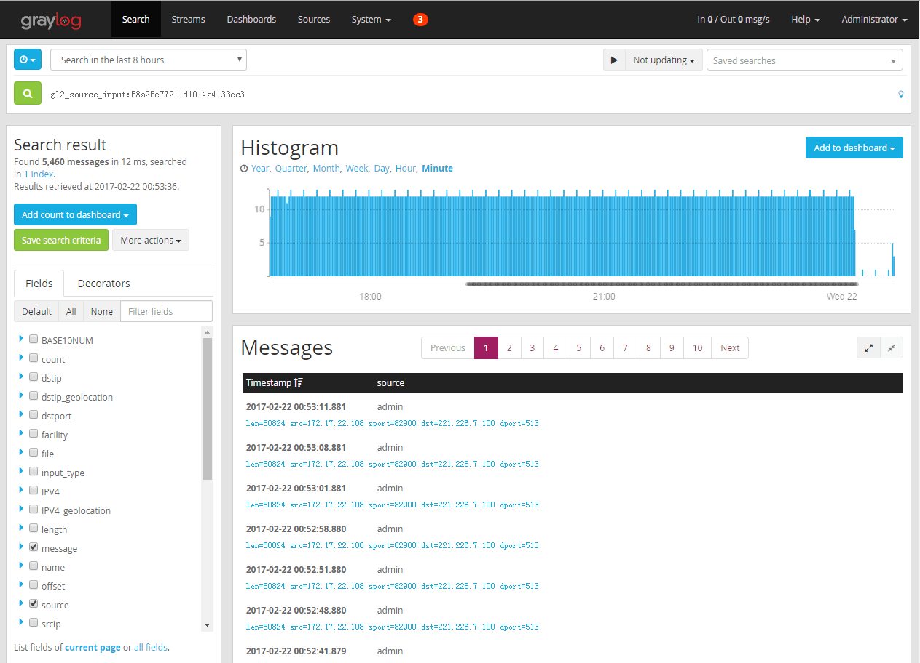

# Graylog2/graylog2-server: Free and open source log management

https://github.com/Graylog2/graylog2-server