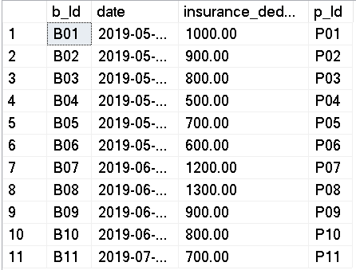

This table is in 1nf as there are no multi values columns

This table is in 2nf as there is only one primary key

This table is in 3nf as there as the non primary columns can’t relate to another columns

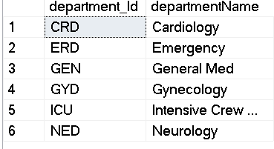

This table is in 1nf as there are no multi values columns

This table is in 2nf as there is only one key

This table is in 3nf as there is only one other column

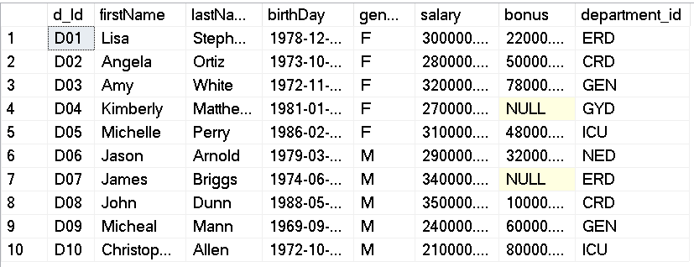

This table is in 1nf as there are no multi values columns

This table is in 2nf as there is only one key

This table is in 3nf as there is no transitive functional dependency

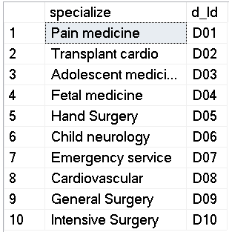

This table is in 1nf as there are no multi values columns

This table is in 2nf as there is only one key

This table is in 3nf as there is only one other column

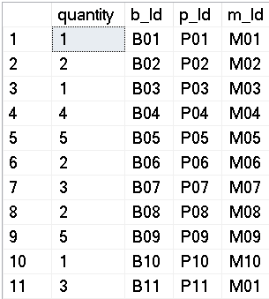

This table is in 1nf as there are no multi values columns

This table is in 2nf as although it is composite primary key, the partial key can’t determine any values

This table is in 3nf as there is no column that is dependent on anything other than primary key

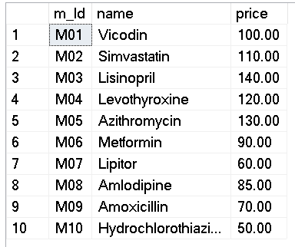

This table is in 1nf as there are no multi values columns

This table is in 2nf as there is only one primary key

This table is in 3nf as there is no transitive functional dependency

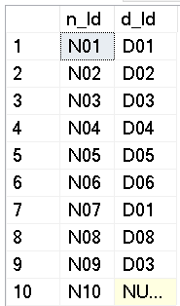

This table is in 1nf as there are no multi values columns

This table is in 2nf as there are just two foreign keys

This table is in 3nf as there are only two columns

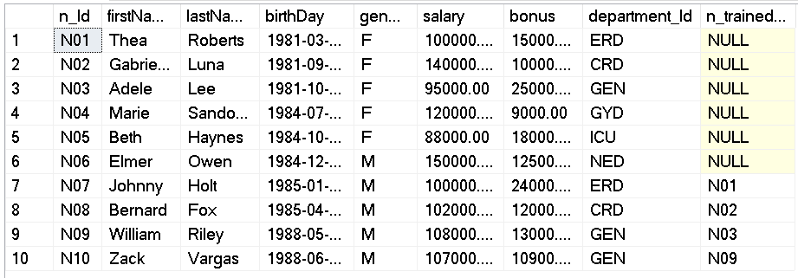

This table is in 1nf as there are no multi values columns

This table is in 2nf as there is only one primary key

This table is in 3nf as there is no column except the primary key that can show other values.

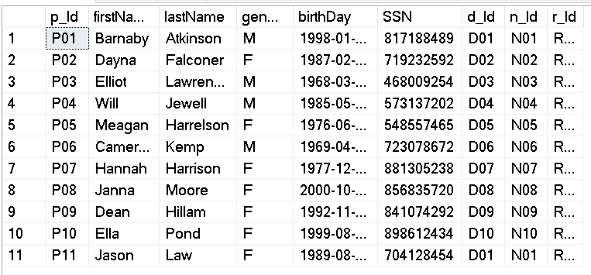

This table is in 1nf as there are no multi values columns

This table is in 2nf as there is no partial functional dependency

This table is in 3nf as there is no transitive functional dependency

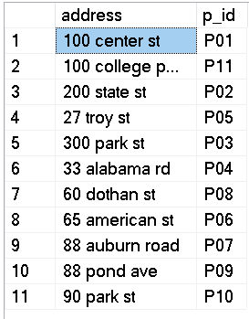

This table is in 1nf as there are no multi values columns

This table is in 2nf as there is no partial functional dependency

This table is in 3nf as there is no transitive functional dependency

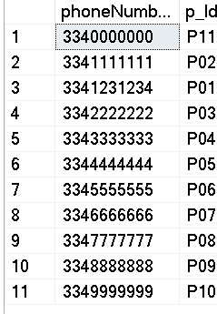

This table is in 1nf as there are no multi values columns

This table is in 2nf as there is no partial functional dependency

This table is in 3nf as there is no transitive functional dependency

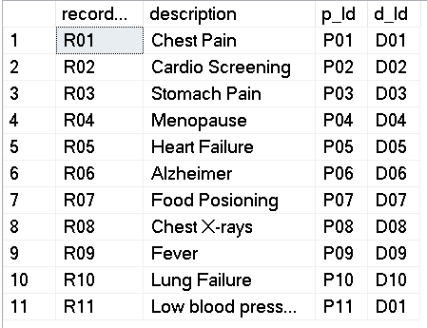

This table is in 1nf as there are no multi values columns

This table is in 2nf as there is no partial functional dependency

This table is in 3nf as there is no transitive functional dependency

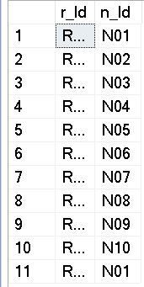

This table is in 1nf as there are no multi values columns

This table is in 2nf as there is no partial functional dependency

This table is in 3nf as there is no transitive functional dependency