Лабораторная работа №1
студента группы ИТ – 42
Манукова Давида Альбертовича

Выполнение: __________ Защита: __________

ПОСТРОЕНИЕ ИМИТАЦИОННЫХ МОДЕЛЕЙ СИСТЕМ МАССОВОГО ОБСЛУЖИВАНИЯ
Цель работы: построение имитационной модели системы массового обслуживания, параметры которой являются детерминированными величинами.
Ход работы
Вариант 9
- Составил графическую схему СМО.
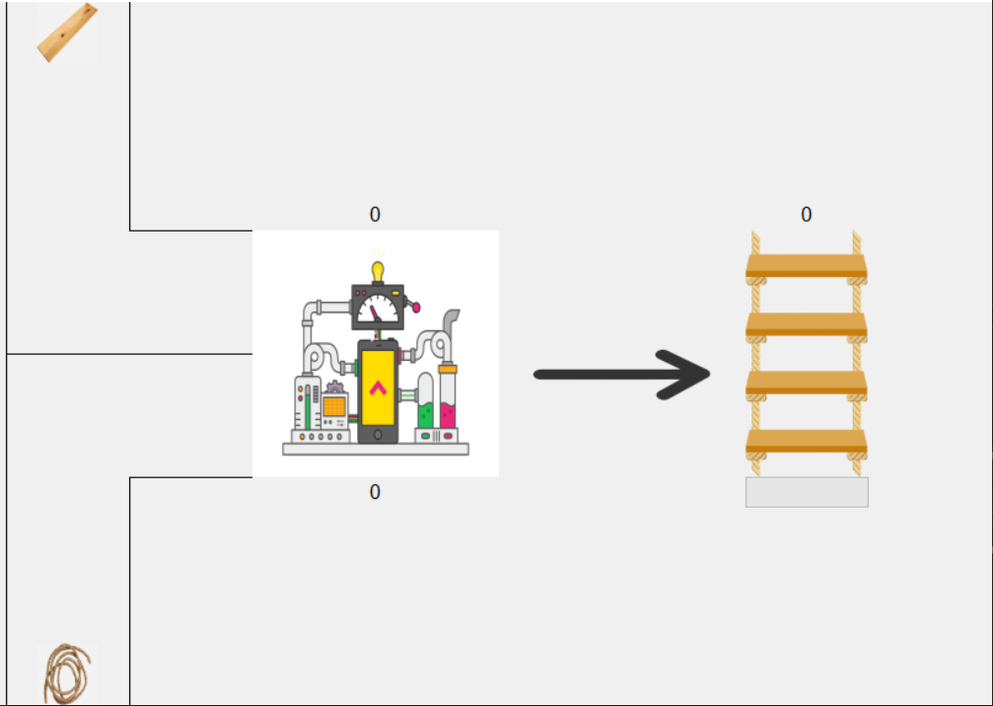
- В системе наблюдаются следующие функциональные действия:
ФД1 – ФД2: заполнение секций конвейера;
ФД3: сборка;
ФД4: выгрузка готового товара.
В состав модели включим следующие активности:
Ак1-Ак2: заполнение секций конвейера;
Ак3: начало сборки;
Ак4: выгрузка готового товара.
Содержание активностей
Условные обозначения: V1 – объем секции №1; V2 – объем секции №2; N1 – текущее кол-во досок в секции №1; N2 – текущее кол-во веревок в секции №2; Tсб – время сборки; Coming_Wood – кол-во досок, приходящих через каждые t секунд; Coming_Rope – кол-во веревок, приходящих через каждые t секунд; Prod_Wood - кол-во досок, необходимое для сборки; Prod_Rope – кол-во веревок, необходимое для сборки.
А | Описание | Условие запуска | Алгоритм
АК1 | Заполнение секции №1 | N1 < V1 | N1 += Coming_Wood
АК2 | Заполнение секции №2 | N2 < V1 | N2 += Coming_Rope
АК3 | Сборка | N1 >= V1 & N2 >= V2 | Progress_bar = t₀ + 1/Tсб
АК4 | Выгрузка готового товара | Progress_bar = 100% | N1 = N1 – Prod_Wood  N2 = N2 – Prod_Rope

- Блок-схема
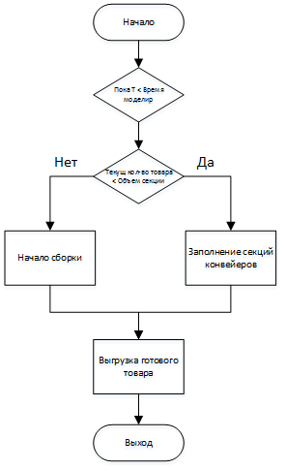
- Реализовал имитационную модель с использованием языка C#.
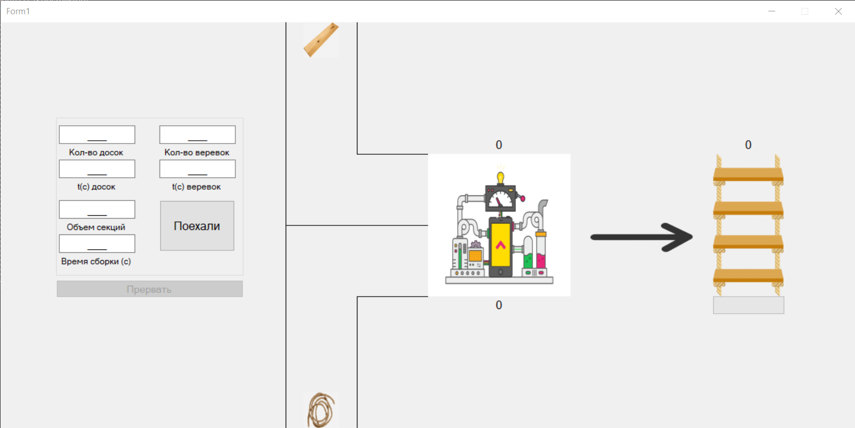
Листинг
using System;
using System.Collections.Generic;
using System.ComponentModel;
using System.Data;
using System.Drawing;
using System.Linq;
using System.Text;
using System.Threading;
using System.Threading.Tasks;
using System.Windows.Forms;

namespace LW_1
{
public partial class Form1 : Form
{
static PictureBox pbProduction;
static PictureBox pbStairs;
static PictureBox pbWood;
static PictureBox pbRope;
static Label lblStairsCount;
static Label lblWoodCount;
static Label lblRopeCount;
static FsProgressBar progBarStairs;
CancellationTokenSource source;
int sectionsValue;
int timeValue;
int woodValue;
int woodtimeValue;
int ropeValue;
int ropetimeValue;

//static MaskedTextBox mtbSectionsValue;
//static MaskedTextBox mtbTimeValue;

public Form1()
{
InitializeComponent();
this.ClientSize = new Size(1200, 570);
}

private void Form1_Load(object sender, EventArgs e)
{
pbProduction = new PictureBox();
pbProduction.Size = new Size(200, 200);
pbProduction.Location = new Point(600, 185);
pbProduction.Image = Properties.Resources.Production;
pbProduction.SizeMode = PictureBoxSizeMode.StretchImage;
pbProduction.Enabled = false;

pbStairs = new PictureBox();
pbStairs.Size = new Size(100, 200);
pbStairs.Location = new Point(1000, 185);
pbStairs.Image = Properties.Resources.Rope_Stairs;
pbStairs.SizeMode = PictureBoxSizeMode.StretchImage;

PictureBox pbPointer = new PictureBox();
pbPointer.Size = new Size(150, 100);
pbPointer.Location = new Point(825, 250);
pbPointer.Image = Properties.Resources.Pointer;
pbPointer.SizeMode = PictureBoxSizeMode.StretchImage;

lblStairsCount = new Label();
lblStairsCount.Size = new Size(40, 25);
lblStairsCount.Location = new Point(1030, 160);
lblStairsCount.Font = new Font(lblStairsCount.Font.Name, 12, lblStairsCount.Font.Style);
lblStairsCount.TextAlign = ContentAlignment.MiddleCenter;
lblStairsCount.Text = "0";

lblWoodCount = new Label();
lblWoodCount.Size = new Size(200, 25);
lblWoodCount.Location = new Point(600, 160);
lblWoodCount.Font = new Font(lblStairsCount.Font.Name, 12, lblStairsCount.Font.Style);
lblWoodCount.TextAlign = ContentAlignment.MiddleCenter;
lblWoodCount.Text = "0";

lblRopeCount = new Label();
lblRopeCount.Size = new Size(200, 25);
lblRopeCount.Location = new Point(600, 385);
lblRopeCount.Font = new Font(lblStairsCount.Font.Name, 12, lblStairsCount.Font.Style);
lblRopeCount.TextAlign = ContentAlignment.MiddleCenter;
lblRopeCount.Text = "0";

pbWood = new PictureBox();
pbWood.Size = new Size(50, 50);
pbWood.Location = new Point(425, 0);
pbWood.Image = Properties.Resources.Wood;
pbWood.SizeMode = PictureBoxSizeMode.StretchImage;

pbRope = new PictureBox();
pbRope.Size = new Size(50, 50);
pbRope.Location = new Point(425, 520);
pbRope.Image = Properties.Resources.Rope;
pbRope.SizeMode = PictureBoxSizeMode.StretchImage;

progBarStairs = new FsProgressBar();
progBarStairs.Size = new Size(100, 25);
progBarStairs.Location = new Point(1000, 385);
progBarStairs.Style = ProgressBarStyle.Blocks;

this.Controls.Add(pbProduction);
this.Controls.Add(pbStairs);
this.Controls.Add(pbPointer);
this.Controls.Add(lblStairsCount);
this.Controls.Add(pbWood);
this.Controls.Add(pbRope);
this.Controls.Add(lblWoodCount);
this.Controls.Add(lblRopeCount);
this.Controls.Add(progBarStairs);
//this.Controls.Add(mtbSectionsValue);
//this.Controls.Add(mtbTimeValue);

lblWoodCount.TextChanged += label_textChanged;
lblRopeCount.TextChanged += label_textChanged;
pbProduction.EnabledChanged += pbProduction_EnabledChanged;

}

private void Form1_Paint(object sender, PaintEventArgs e)
{

Graphics g = e.Graphics;
Pen mainPen = new Pen(Color.Black);
Point[] pointsUp = new Point[]
{
new Point(500, 0),
new Point(500, 185),
new Point(600, 185),
//new Point(700, 200),
//new Point(1000, 200),
};
Point[] pointsDown = new Point[]
{
new Point(500, 570),
new Point(500, 385),
new Point(600, 385),
//new Point(700, 370),
//new Point(1000, 370),
};
Point[] pointsCntrLine = new Point[]
{
new Point(400, 285),
new Point(600, 285)
};
g.DrawLines(mainPen, pointsUp);
g.DrawLines(mainPen, pointsDown);
g.DrawLines(mainPen, pointsCntrLine);
g.DrawLine(mainPen, new Point(400, 0), new Point(400, 570));
g.Dispose();
}

private async void mvmntWood(PictureBox pbWood)
{
Point startPos = pbWood.Location;
int y_dist = 0;
int x_dist = pbWood.Location.X;
try
{
await Task.Delay(woodtimeValue*1000, source.Token);
if (Convert.ToInt32(lblWoodCount.Text) < sectionsValue)
{
while (pbWood.Location.Y != 210)
{
y_dist++;
pbWood.Location = new Point(pbWood.Location.X, y_dist);
};
while (pbWood.Location.X != 550)
{
x_dist++;
pbWood.Location = new Point(x_dist, pbWood.Location.Y);
};
if (pbWood.Location.X >= 550 && pbWood.Location.Y >= 210)
{
lblWoodCount.Text = (Convert.ToInt32(lblWoodCount.Text) + woodValue).ToString();
pbWood.Location = startPos;

this.mvmntWood(pbWood);
}
}
}
catch (Exception)
{
return;
}
}
private async void mvmntRope(PictureBox pbRope)
{
Point startPos = pbRope.Location;
int y_dist = 520;
int x_dist = pbRope.Location.X;
try
{
await Task.Delay(ropetimeValue*1000, source.Token);
if (Convert.ToInt32(lblRopeCount.Text) < sectionsValue)
{
while (pbRope.Location.Y != 310)
{
y_dist--;
pbRope.Location = new Point(pbRope.Location.X, y_dist);
};
while (pbRope.Location.X != 550)
{
x_dist++;
pbRope.Location = new Point(x_dist, pbRope.Location.Y);
}
if (pbRope.Location.X >= 550 && pbRope.Location.Y >= 310)
{
lblRopeCount.Text = (Convert.ToInt32(lblRopeCount.Text) + ropeValue).ToString();
pbRope.Location = startPos;
this.mvmntRope(pbRope);
}
}
}
catch (Exception)
{
return;
}
}
private void label_textChanged(object sender, EventArgs e)
{
if (Convert.ToInt32(lblWoodCount.Text) >= sectionsValue && Convert.ToInt32(lblRopeCount.Text) >= sectionsValue)
{
pbProduction.Enabled = true;
}
}

async private void pbProduction_EnabledChanged(object sender, EventArgs e)
{
try
{
if (pbProduction.Enabled == true)
{
for (int i = 0; i < timeValue; i++)
{
await Task.Delay(1000, source.Token);
progBarStairs.Value++;
}
lblStairsCount.Text = (Convert.ToInt32(lblStairsCount.Text) + 1).ToString();
pbProduction.Enabled = false;
progBarStairs.Value = 0;
lblWoodCount.Text = (Convert.ToInt32(lblWoodCount.Text) - sectionsValue).ToString();
lblRopeCount.Text = (Convert.ToInt32(lblRopeCount.Text) - sectionsValue).ToString();
mvmntWood(pbWood);
mvmntRope(pbRope);
}
}
catch (Exception)
{
return;
}

}
private void buttonStart_Click(object sender, EventArgs e)
{
source = new CancellationTokenSource();
sectionsValue = Convert.ToInt32(mtbSectionsValue.Text);
timeValue = Convert.ToInt32(mtbTimeValue.Text);
woodValue = Convert.ToInt32(mtbWoodValue.Text);
woodtimeValue = Convert.ToInt32(mtbWoodTimeValue.Text);
ropeValue = Convert.ToInt32(mtbRopeValue.Text);
ropetimeValue = Convert.ToInt32(mtbRopeTimeValue.Text);
progBarStairs.Maximum = timeValue;
mvmntWood(pbWood);
mvmntRope(pbRope);
groupBox1.Enabled = false;
buttonTerminate.Enabled = true;
}
private void buttonTerminate_Click(object sender, EventArgs e)
{
source.Cancel();
groupBox1.Enabled = true;
buttonTerminate.Enabled = false;
foreach (MaskedTextBox item in Controls.OfType<MaskedTextBox>())
{
item.Text = "0";
}
lblStairsCount.Text = "0";
progBarStairs.Value = 0;
pbProduction.Enabled = false;
}
}
}

