WinWin Travel - Backend Test Task
Project Overview
Two Spring Boot microservices with PostgreSQL, JWT authentication, and Docker containerization.
- Service A (auth-api): Handles user registration/login and protected text processing
- Service B (data-api): Transforms text (reverses uppercase strings)
- PostgreSQL: Stores users and processing logs
Tech Stack
Java 17 - Core language
Spring Boot 3.x - Application framework
Spring Security - Authentication & authorization
JWT - Token-based authentication
Spring Data JPA - Database ORM
PostgreSQL – Database
BCrypt - Password hashing
Docker & Docker Compose - Containerization
Maven - Build tool

UML Diagram
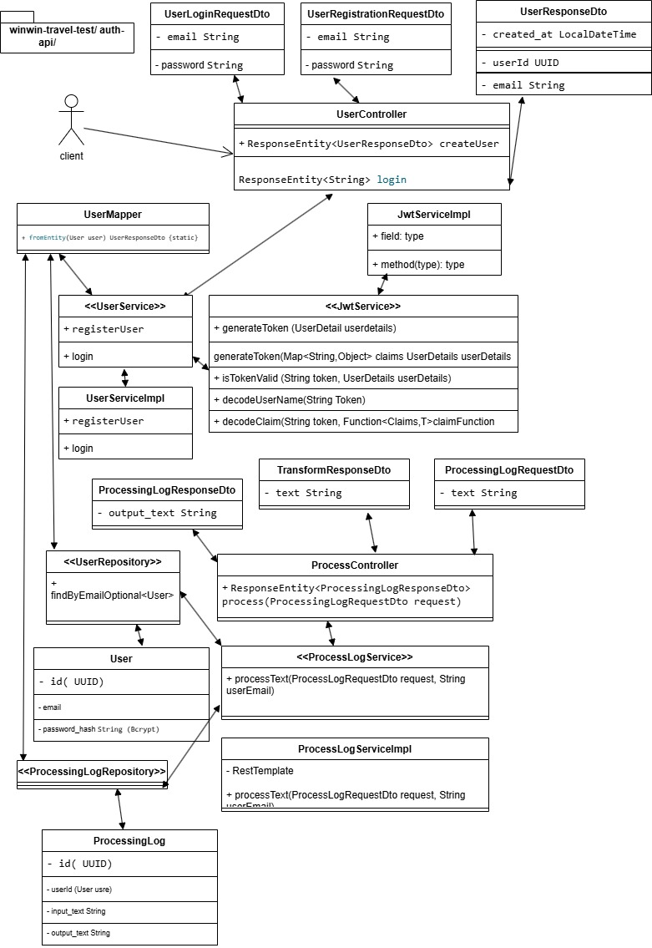

Configuration
auth-api/application.properties
onegreenline
properties
spring.application.name=auth-api
spring.datasource.url=${POSTGRES_URL:jdbc:postgresql://localhost:5432/winwin}
spring.datasource.username=${POSTGRES_USER:postgres}
spring.datasource.password=${POSTGRES_PASSWORD:bunty}
spring.datasource.driver-class-name=org.postgresql.Driver
spring.jpa.hibernate.ddl-auto=update
server.port=8080

# JWT Configuration
application.jwt.secret=${JWT_SECRET:404E635266556A586E3272357538782F413F4428472B4B6250645367566B5970}
application.jwt.expiration=86400000

# Internal Token for Service B
app.internal-token=${INTERNAL_TOKEN:winwin-internal-secret-token-2026}
app.data-api.url=${DATA_API_URL:http://data-api:8081}
data-api/application.properties
properties
spring.application.name=data-api
server.port=8081
app.internal-token=${INTERNAL_TOKEN:winwin-internal-secret-token-2026}
Docker Setup
auth-api/Dockerfile
dockerfile
FROM openjdk:17-jdk-slim
WORKDIR /app
COPY target/*.jar app.jar
EXPOSE 8080
ENTRYPOINT ["java", "-jar", "app.jar"]
data-api/Dockerfile
dockerfile
FROM openjdk:17-jdk-slim
WORKDIR /app
COPY target/*.jar app.jar
EXPOSE 8081
ENTRYPOINT ["java", "-jar", "app.jar"]
docker-compose.yml
yaml
version: '3.8'
services:
postgres:
image: postgres:15-alpine
container_name: winwin-postgres
environment:
POSTGRES_DB: winwin
POSTGRES_USER: postgres
POSTGRES_PASSWORD: bunty
TZ: UTC
ports:
- "5432:5432"
volumes:
- postgres_data:/var/lib/postgresql/data
networks:
- winwin-network
healthcheck:
test: ["CMD-SHELL", "pg_isready -U postgres"]
interval: 10s
timeout: 5s
retries: 5

auth-api:
build: ./auth-api
container_name: winwin-auth-api
environment:
POSTGRES_URL: jdbc:postgresql://postgres:5432/winwin
POSTGRES_USER: postgres
POSTGRES_PASSWORD: bunty
JWT_SECRET: 404E635266556A586E3272357538782F413F4428472B4B6250645367566B5970
INTERNAL_TOKEN: winwin-internal-secret-token-2026
DATA_API_URL: http://data-api:8081
TZ: UTC
ports:
- "8080:8080"
depends_on:
postgres:
condition: service_healthy
networks:
- winwin-network

data-api:
build: ./data-api
container_name: winwin-data-api
environment:
INTERNAL_TOKEN: winwin-internal-secret-token-2026
TZ: UTC
ports:
- "8081:8081"
networks:
- winwin-network

networks:
winwin-network:
driver: bridge

volumes:
postgres_data:
Database Schema

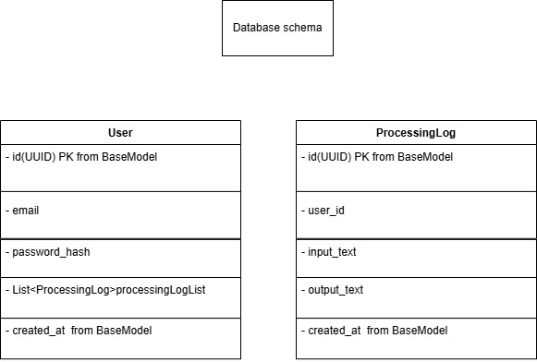

Winwin travel authapi database schema

API Endpoints
Service A (auth-api) - http://localhost:8080
1. Register User
POST /api/auth/register
Content-Type: application/json
Request:
{
"email": "abhi@mail.com",
"password": "123456"
}

Response: 201 Created
{
"userId": "550e8400-e29b-41d4-a716-446655440000",
"email": "abhi@mail.com",
"createdAt": "2026-03-14T12:00:00"
}
2. Login
POST /api/auth/login
Content-Type: application/json
Request:
{
"email": "abhi@mail.com",
"password": "123456"
}

Response: 200 OK
eyJhbGciOiJIUzI1NiJ9... (JWT token)
3. Process Text (Protected)
POST /api/process
Authorization: Bearer <JWT_TOKEN>
Content-Type: application/json
Request:
{
"text": "hello world"
}

Response: 200 OK
{
"output_text": "DLROW OLLEH"
}
Service B (data-api) - http://localhost:8081
1. Transform Text (Internal only)
POST /api/transform
Request:
{
"text": "hello"
}

Response: 200 OK
{
"text": "OLLEH"
}
🔄 Transform Logic
Service B transforms text in two steps:
- UPPERCASE the input text
- REVERSE the uppercase text
Examples:
- "hello" → "HELLO" → "OLLEH"
- "world" → "WORLD" → "DLROW"
- "hello world" → "HELLO WORLD" → "DLROW OLLEH"
Quick Start
Prerequisites
- Java 17 or higher
- Maven
- Docker & Docker Compose
- PowerShell (for test scripts)
Step 1: Clone and Build
bash
# Build Service A
mvn -f auth-api/pom.xml clean package -DskipTests

# Build Service B
mvn -f data-api/pom.xml clean package -DskipTests
Step 2: Start with Docker Compose
docker-compose up -d --build
Step 3: Verify Services
docker-compose ps
All services should show "Up" or "Healthy" status.
Features Implemented
User registration with BCrypt password hashing
JWT authentication with 24-hour expiration
Protected endpoints requiring valid JWT
Service-to-service communication with internal token
Text transformation (uppercase + reverse)
PostgreSQL database integration
Processing log storage with user reference
Docker containerization with docker-compose
Proper exception handling with global handlers
Input validation on all endpoints
Environment variables for all secrets
Health checks for PostgreSQL dependency
Security Features
Password Security: BCrypt hashing for all passwords
JWT Authentication: Stateless authentication with signed tokens
Internal Token: Service-to-service communication authentication
No Secret Logging: Sensitive data never logged
Environment Variables: All secrets injected via environment
Input Validation: All endpoints validate input data
SQL Injection Prevention: JPA/Hibernate parameterized queries
Notes
- JWT tokens expire after 24 hours
- Email addresses must be unique
- All timestamps are in UTC
- Service B transforms: UPPERCASE → REVERSE
- Database schema auto-creates with Hibernate ddl-auto=update
📧 Contact
For questions or issues:
- Project: WinWin Travel Task
- Author: Nourth Arvinder Pal Singh
- Date: March 17, 2026

