Manual

**Overview**

Our game, “The Dragon Within”, is an Open-world turn based RPG. In short, this game is about battle strategy, story, character progression and management of inventory. The main “fun” of this game is about exploration, story and freedom to play in different ways.

Talking to people is the best way to progress through the game as they will often give hints and where to go and what to do. Talking to NPCs (Non-playable characters) will progress you through the game and trigger certain events for examples: Teleportation through boat, trade items, trigger optional dialogue and characters to your team.

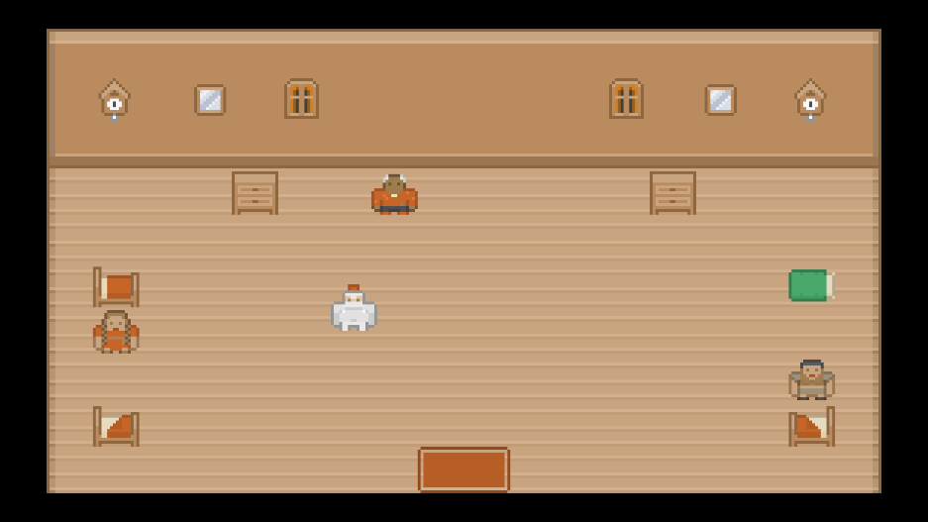There are two main aspects of the game: The open world, and the battle system. The open world is non-combat and purely for progression of story, picking up objects and talking to NPCs. When you are in the battle-system you will take turns between the player team and NPCs to attack. The battle system is entered randomly through footsteps when you are in a hostile world.

**Instructions**

A

W

D

**Character**

* W (Move up)
* A (Move left)
* S (Move down)
* D (Move right)
* E (Interact/Next sentence)
* Y (Yes to option)

S

* 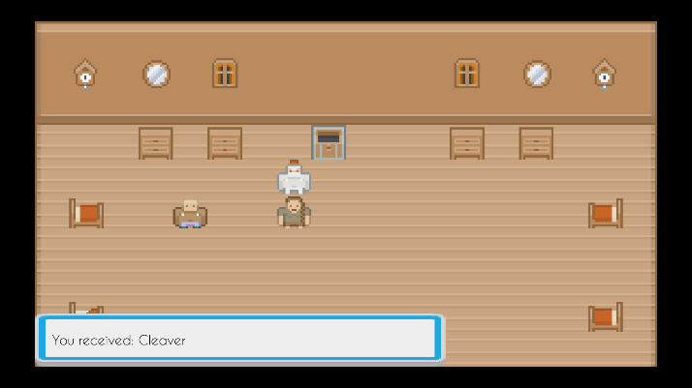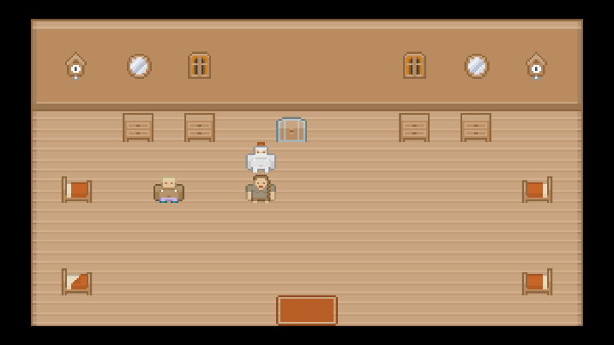N (No to option)

**Menus**

* W (Select menu item up)

E

* A (Select menu item left)
* S (Select menu item down)
* D (Select menu item right)
* E (Use selected menu

item)

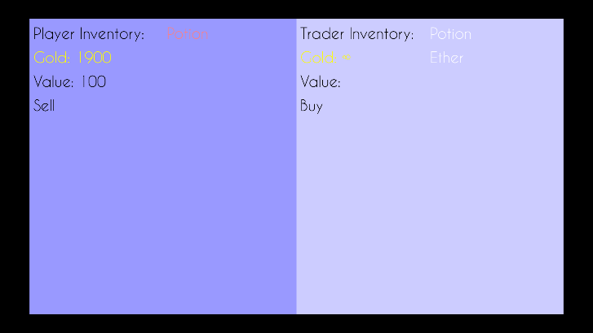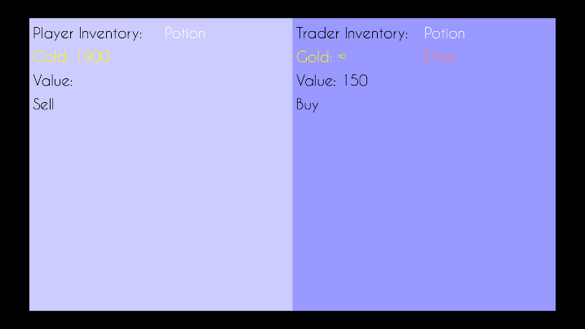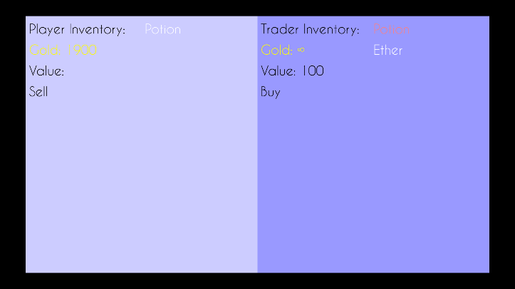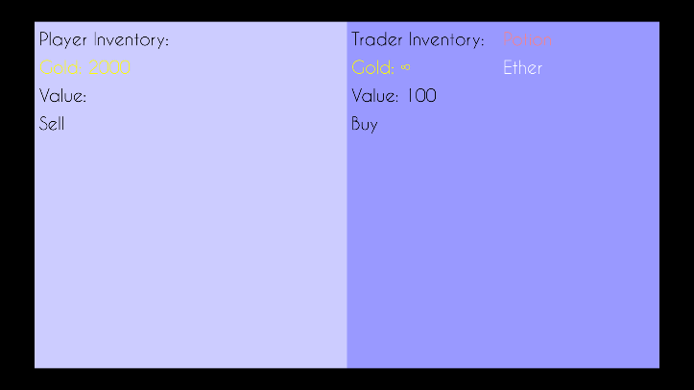

D

A

W

S

E