Saturday, 31 January 2026

Networking knowledge

- Network Group of connected devices. Devices need to find each other on a network to establish communications using unique address and IP etc. Two types of networks over which devices connect : LAN and WAN
- Hub – A network device that broadcast information to every device on the network
- Switch – Makes connection between specific devices on a network by sending and receiving data between them. More secure than hub
- Router – Network device that connects multiple networks together.
- Modems – Connects your router to the internet and brings internet access to the LAN
- Virtualisation tools are pieces of software that perform network operations. They carry out operations that would normally be completed by physical devices such as hub,switch,router etc and they are offered by cloud service providers. Opportunities for cost savings and scalability.

Network devices
Network devices maintain information and services for users of a network. These devices connect over wired and wireless connections. After establishing a connection to the network, the devices send data packets. The data packets provide information about the source and the destination of the data. This is how the information is sent and received via different devices on a network.
The network is the overall infrastructure that allows devices to communicate with each other. Network devices are specialised vehicles like routers and switches that manage what is being sent and received over the network. Additionally, devices like computers and phones connect to the network via network devices.
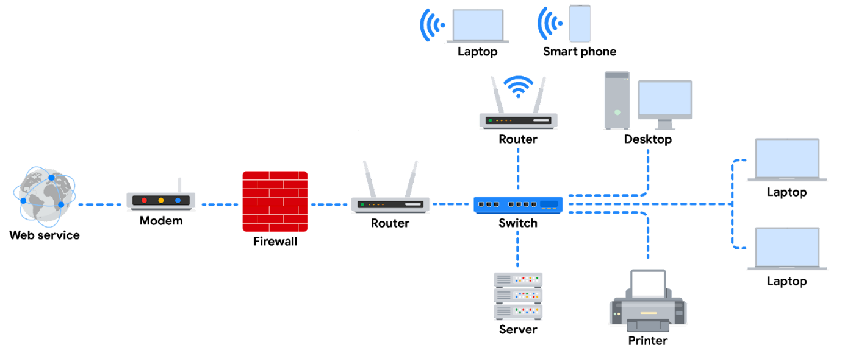
Note: In this diagram, a router connects to the internet through a modem, which is provided by your internet service provider (ISP). The firewall is a security device that monitors incoming and outgoing traffic on your network. The router then directs traffic to the devices on your home network, which can include computers, laptops, smartphones, tablets, printers, and other devices. You can imagine here that the server is a file server. All devices on this network can access the files in this server. This diagram also includes a switch which is an optional device that can be used to connect more devices to your network by providing additional ports and Ethernet connections. Additionally, there are 2 routers connected to the switch here for load balancing purposes which will improve the performance of the network.
Devices and desktop computers
Most internet users are familiar with everyday devices, such as personal computers, laptops, mobile phones, and tablets. Each device and desktop computer has a unique MAC address and IP address, which identify it on the network. They also have a network interface that sends and receives data packets. These devices can connect to the network via a hard wire or a wireless connection.
Firewalls
A firewall is a network security device that monitors traffic to or from your network. It is like your first line of defence. Firewalls can also restrict specific incoming and outgoing network traffic. The organisation configures the security rules of the firewall. Firewalls often reside between the secured and controlled internal network and the untrusted network resources outside the organisation, such as the internet. Remember, though, firewalls are just one line of defence in the cybersecurity landscape.
Servers
Servers provide information and services for devices like computers, smart home devices, and smartphones on the network. The devices that connect to a server are called clients. Clients send requests to the server for information and services. The server performs the requests for the clients. Common examples include DNS servers that perform domain name lookups for internet sites, file servers that store and retrieve files from a database, and corporate mail servers that organise mail for a company.

Hubs and switches
Hubs and switches both direct traffic on a local network. A hub is a device that provides a common point of connection for all devices directly connected to it. Hubs additionally repeat all information out to all ports. From a security perspective, this makes hubs vulnerable to eavesdropping. For this reason, hubs are not used as often on modern networks; most organisations use switches instead. Hubs are more commonly used for a limited network setup like a home office.
Switches are the preferred choice for most networks. A switch forwards packets between devices directly connected to it. They analyse the destination address of each data packet and send it to the intended device. Switches maintain a MAC address table that matches MAC addresses of devices on the network to port numbers on the switch and forwards incoming data packets according to the destination MAC address. Switches are a part of the data link layer in the TCP/IP model. Overall, switches improve performance and security.
Routers
Routers connect networks and direct traffic, based on the IP address of the destination network. Routers allow devices on different networks to communicate with each other. In the TCP/IP model, routers are a part of the network layer. The IP address of the destination network is contained in the IP header. The router reads the IP header information and forwards the packet to the next router on the path to the destination. This continues until the packet reaches the destination network. Routers can also include a firewall feature that allows or blocks incoming traffic based on information in the transmission. This stops malicious traffic from entering the private network and damaging the local area network.
Modems and wireless access points
Modems usually connect your home or office with an internet service provider (ISP). ISPs provide internet connectivity via telephone lines or coaxial cables. Modems receive transmissions or digital signals from the internet and translate them into analog signals that can travel through the physical connection provided by your ISP. Usually, modems connect to a router that takes the decoded transmissions and sends them on to the local network.
Note: Enterprise networks used by large organisations to connect their users and devices often use other broadband technologies to handle high-volume traffic, instead of using a modem.
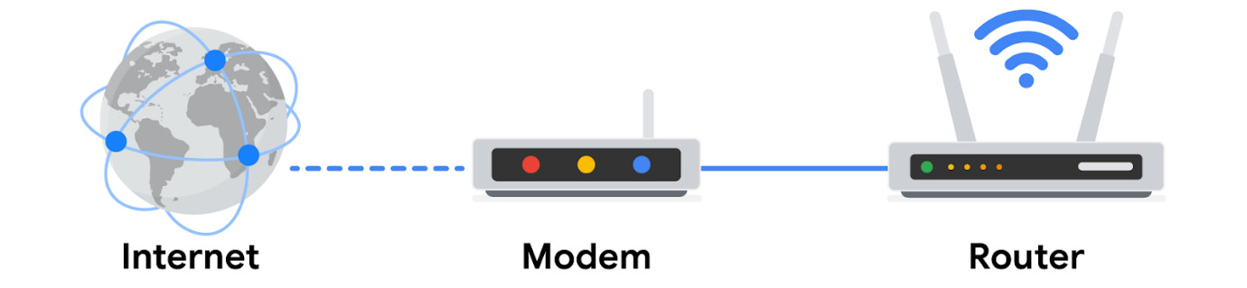
Wireless access point
A wireless access point sends and receives digital signals over radio waves creating a wireless network. Devices with wireless adapters connect to the access point using Wi-Fi. Wi-Fi refers to a set of standards that are used by network devices to communicate wirelessly. Wireless access points and the devices connected to them use Wi-Fi protocols to send data through radio waves where they are sent to routers and switches and directed along the path to their final destination.

Network Communication

- Data packet – It is a basic unit of information that travels from one device to another within the network. The data is sent as a packet that contains info on where it is going, where its coming from and the contents.
It contains a header that includes the IP and the MAC Address of the destination device. It also includes a protocol number that tells the receiving device what to do with the info in the packet.
The body contains the message that needs to be transmitted to the receiving device.
The footer signals to the receiving device that the packet is finished.
The movement of a data packet across the internet can signal how well the network is performing. Network performance can be measured by bandwidth.
- Bandwidth – The amount of data a device receives every second. Calculated by dividing the quantity of data by the time in seconds.
- Speed refers to the rate at which data packets are received or downloaded
- Irregular speed and bandwidth could be an indication of attack.
- Packet sniffing – Capturing and inspecting data packets across the network.

- TCP/IP – It stands for Transmission Control Protocol and Internet Protocol. It is the standard model used for network communication.
- TCP – It is an internet communication protocol that allows two devices to form a connection and stream data. It includes a set of instructions to organise data so it can be sent across a network.
- IP – It is a set of standards used for routing and addressing data packets as they travel between devices on a network.Included in the IP protocol is the IP address that addresses that functions as an address for each private network.

- Port – It is a software based location that organises the sending and receiving of data between devices on a network. Ports divide network traffic into segments based on the service they will perform between the two devices. The computers sending and receiving these data segments know how to prioritise and process these segments based on their port number.
- Data packets include instructions that tell the receiving device what to do with the information. These instructions come in the form of port numbers. Port numbers allow computers to split network traffic and prioritise the operations they will perform with the data. Common port numbers are :
  - Port 25 – email
  - Port 443 – Secure Internet Communication
  - Port 20 – Large file transfers

As a security professional, it's important that you understand the TCP/IP model because it describes the functions of various network protocols. The TCP/IP model is based on the TCP/IP protocols suite that includes all network protocols that support the main TCP/IP protocol.

The TCP/IP model
The TCP/IP model is a framework used to visualise how data is organised and transmitted across a network. This model helps network engineers and network security analysts conceptualise processes on the network and communicate where disruptions or security threats occur.
The TCP/IP model has four layers: the network access layer, internet layer, transport layer, and application layer. When troubleshooting issues on the network, security professionals can analyse which layers were impacted by an attack based on what processes were involved in an incident.
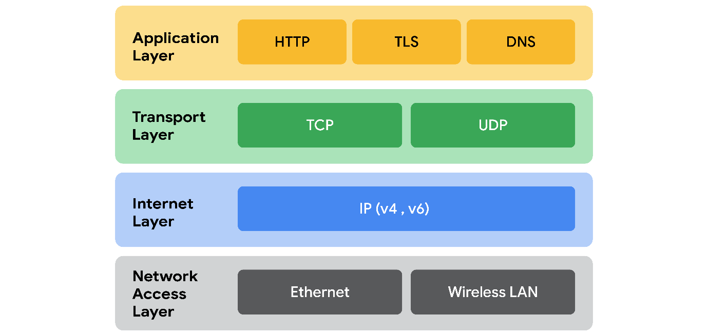
Network access layer
The network access layer deals with the creation of data packets and their transmission across a network. This layer corresponds to the physical hardware involved in network transmission. Hubs, modems, cables, and wiring are all considered part of this layer. The address resolution protocol (ARP) is part of the network access layer. Since MAC addresses are used to identify hosts on the same physical network, ARP is needed to map IP addresses to MAC addresses for local network communication.
Internet layer
The internet layer, sometimes referred to as the network layer, is responsible for ensuring the delivery to the destination host, which potentially resides on a different network. It ensures IP addresses are attached to data packets to indicate the location of the sender and receiver. The internet layer also determines which protocol is responsible for delivering the data packets and ensures the delivery to the destination host. Here are some of the common protocols that operate at the internet layer:
- Internet Protocol (IP). IP sends the data packets to the correct destination and relies on the Transmission Control Protocol/User Datagram Protocol (TCP/UDP) to deliver them to the corresponding service. IP packets allow communication between two networks. They are routed from the sending network to the receiving network. TCP in particular retransmits any data that is lost or corrupt.
- Internet Control Message Protocol (ICMP). The ICMP shares error information and status updates of data packets. This is useful for detecting and troubleshooting network errors. The ICMP reports information about packets that were dropped or that disappeared in transit, issues with network connectivity, and packets redirected to other routers.
Transport layer
The transport layer is responsible for delivering data between two systems or networks and includes protocols to control the flow of traffic across a network. TCP and UDP are the two transport protocols that occur at this layer.
Transmission Control Protocol
The Transmission Control Protocol (TCP) is an internet communication protocol that allows two devices to form a connection and stream data. It ensures that data is reliably transmitted to the destination service. TCP contains the port number of the intended destination service, which resides in the TCP header of a TCP/IP packet.
User Datagram Protocol
The User Datagram Protocol (UDP) is a connectionless protocol that does not establish a connection between devices before transmissions. It is used by applications that are not concerned with the reliability of the transmission. Data sent over UDP is not tracked as extensively as data sent using TCP. Because UDP does not establish network connections, it is used mostly for performance sensitive applications that operate in real time, such as video streaming.
Application layer
The application layer in the TCP/IP model is similar to the application, presentation, and session layers of the OSI model. The application layer is responsible for making network requests or responding to requests. This layer defines which internet services and applications any user can access. Protocols in the application layer determine how the data packets will interact with receiving devices. Some common protocols used on this layer are:
- Hypertext transfer protocol (HTTP)
- Simple mail transfer protocol (SMTP)
- Secure shell (SSH)
- File transfer protocol (FTP)
- Domain name system (DNS)
Application layer protocols rely on underlying layers to transfer the data across the network.

TCP/IP model versus OSI model
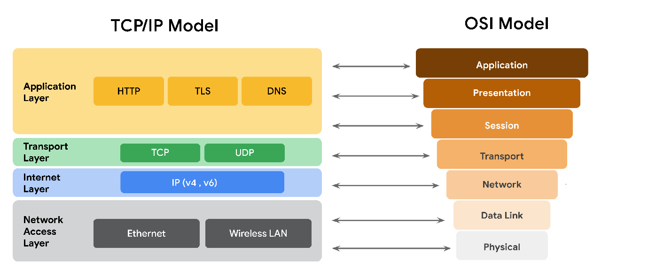
The OSI visually organises network protocols into different layers. Network professionals often use this model to communicate with each other about potential sources of problems or security threats when they occur.
The TCP/IP model combines multiple layers of the OSI model. There are many similarities between the two models. Both models define standards for networking and divide the network communication process into different layers. The TCP/IP model is a simplified version of the OSI model.

The OSI model
The 4-layer TCP/IP model is a condensed form of the OSI (open Systems Interconnection) model, which is made up of 7 layers. The OSI model will provide a more in depth understanding of the processes that occur at each layer. We will work backwards from layer seven to layer one, going from the processes that involve direct user interaction with the network to those that involve the physical connection to the internet via network components like cables and switches. This reading will also review the main differences between the TCP/IP and OSI models.

The TCP/IP model vs. the OSI model
The TCP/IP model is a framework used to visualise how data is organised and transmitted across a network. This model helps network engineers and security analysts conceptualise processes on the network and communicate where disruptions or security threats occur.
The TCP/IP model has four layers: the network access layer, internet layer, transport layer, and application layer. When analysing network events, security professionals can determine what layer or layers an attack occurred in based on what processes were involved in the incident.
The OSI model is a standardised concept that describes the seven layers computers use to communicate and send data over the network. Network and security professionals often use this model to communicate with each other about potential sources of problems or security threats when they occur.
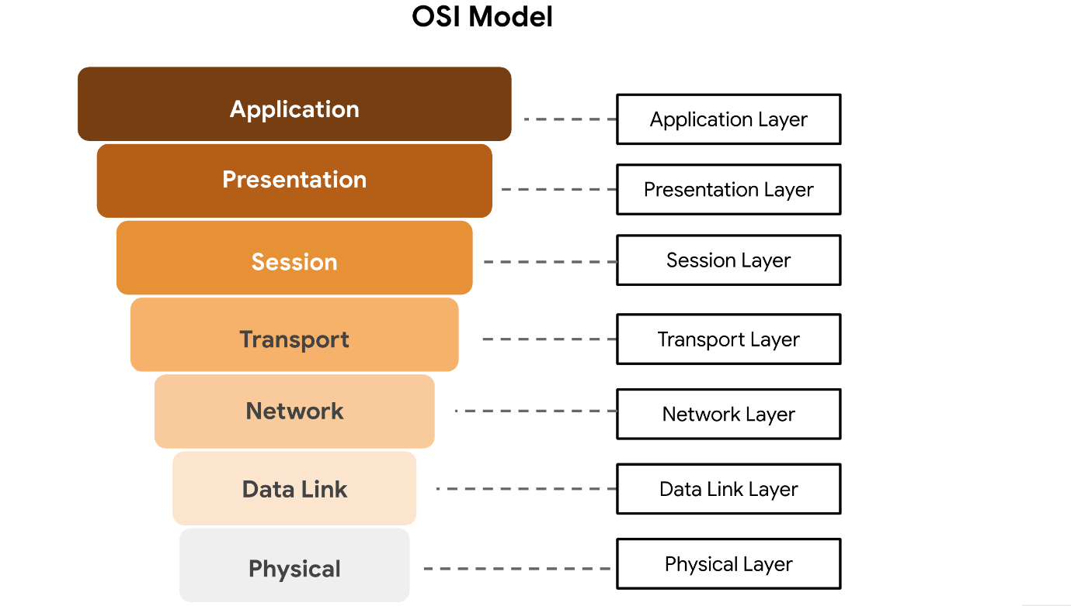

Layer 7: Application layer
The application layer includes processes that directly involve the everyday user. This layer includes all of the networking protocols that software applications use to connect a user to the internet. This characteristic is the identifying feature of the application layer—user connection to the internet via applications and requests.
An example of a type of communication that happens at the application layer is using a web browser. The internet browser uses HTTP or HTTPS to send and receive information from the website server. The email application uses simple mail transfer protocol (SMTP) to send and receive email information. Also, web browsers use the domain name system (DNS) protocol to translate website domain names into IP addresses which identify the web server that hosts the information for the website.
Layer 6: Presentation layer
Functions at the presentation layer involve data translation and encryption for the network. This layer adds to and replaces data with formats that can be understood by applications (layer 7) on both sending and receiving systems. Formats at the user end may be different from those of the receiving system. Processes at the presentation layer require the use of a standardised format.
Some formatting functions that occur at layer 6 include encryption, compression, and confirmation that the character code set can be interpreted on the receiving system. One example of encryption that takes place at this layer is SSL, which encrypts data between web servers and browsers as part of websites with HTTPS.
Layer 5: Session layer
A session describes when a connection is established between two devices. An open session allows the devices to communicate with each other. Session layer protocols keep the session open while data is being transferred and terminate the session once the transmission is complete.
The session layer is also responsible for activities such as authentication, reconnection, and setting checkpoints during a data transfer. If a session is interrupted, checkpoints ensure that the transmission picks up at the last session checkpoint when the connection resumes. Sessions include a request and response between applications. Functions in the session layer respond to requests for service from processes in the presentation layer (layer 6) and send requests for services to the transport layer (layer 4).
Layer 4: Transport layer
The transport layer is responsible for delivering data between devices. This layer also handles the speed of data transfer, flow of the transfer, and breaking data down into smaller segments to make them easier to transport. Segmentation is the process of dividing up a large data transmission into smaller pieces that can be processed by the receiving system. These segments need to be reassembled at their destination so they can be processed at the session layer (layer 5). The speed and rate of the transmission also has to match the connection speed of the destination system. TCP and UDP are transport layer protocols.
Layer 3: Network layer
The network layer oversees receiving the frames from the data link layer (layer 2) and delivers them to the intended destination. The intended destination can be found based on the address that resides in the frame of the data packets. Data packets allow communication between two networks. These packets include IP addresses that tell routers where to send them. They are routed from the sending network to the receiving network.
Layer 2: Data link layer
The data link layer organises sending and receiving data packets within a single network. The data link layer is home to switches on the local network and network interface cards on local devices.
Protocols like network control protocol (NCP), high-level data link control (HDLC), and synchronous data link control protocol (SDLC) are used at the data link layer.
Layer 1: Physical layer
As the name suggests, the physical layer corresponds to the physical hardware involved in network transmission. Hubs, modems, and the cables and wiring that connect them are all considered part of the physical layer. To travel across an ethernet or coaxial cable, a data packet needs to be translated into a stream of 0s and 1s. The stream of 0s and 1s are sent across the physical wiring and cables, received, and then passed on to higher levels of the OSI model.

- Internet Protocol Address – Unique String of characters that identifies a location of a device on the internet. Each device on the internet has a unique address. Two types :
  - IP version 4 or IPv4 – These addresses are written a four, 1,2 or 3 digit numbers separated by a decimal point. In the early days all addresses were IPv4.
  - IP version 6 or IPv6 – They are made up of 32 characters. The length allows for more devices to be connected to the internet without running out of addresses as quickly as IPv4.
- These can be either public or private. Your ISP provider assigns a public IP address that is connected to your geographic location. When network communication goes out from your device on the internet, they all have the same public facing address.
Private IP address are only seen by other devices on the same LAN. This means that al the devices on your home network can communicate with each other using unique IP addresses that the rest of the internet cant see
- MAC address – It is a unique alphanumeric identifier that is assigned to each physical device on a network. When a switch receives a packet, it reads the MAC address of the destination device and maps it to a port. It then keeps this info in a MAC address table

Operations at the network layer
Functions at the network layer organise the addressing and delivery of data packets across the network from the host device to the destination device. This includes directing the packets from one router to another router across the internet, till it reaches the internet protocol (IP) address of the destination network. The destination IP address is contained within the header of each data packet. This address will be stored for future routing purposes in routing tables along the packet’s path to its destination.
All data packets include an IP address. A data packet is also referred to as an IP packet for TCP connections or a datagram for UDP connections. A router uses the IP address to route packets from network to network based on information contained in the IP header of a data packet. Header information communicates more than just the address of the destination. It also includes information such as the source IP address, the size of the packet, and which protocol will be used for the data portion of the packet.

Format of an IPv4 packet
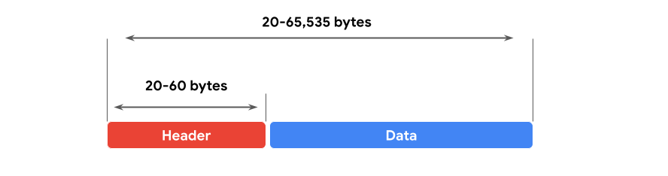
An IPv4 packet is made up of two sections, the header and the data:
- An IPv4 header format is determined by the IPv4 protocol and includes the IP routing information that devices use to direct the packet. The size of the IPv4 header ranges from 20 to 60 bytes. The first 20 bytes are a fixed set of information containing data such as the source and destination IP address, header length, and total length of the packet. The last set of bytes can range from 0 to 40 and consists of the options field.
- The length of the data section of an IPv4 packet can vary greatly in size. However, the maximum possible size of an IPv4 packet is 65,535 bytes. It contains the message being transferred over the internet, like website information or email text.
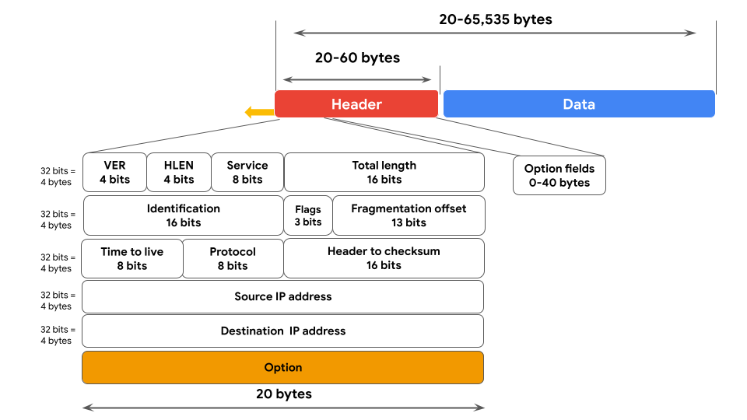
There are 13 fields within the header of an IPv4 packet:
- Version (VER): This 4 bit component tells receiving devices what protocol the packet is using. The packet used in the illustration above is an IPv4 packet.
- IP Header Length (HLEN or IHL): HLEN is the packet’s header length. This value indicates where the packet header ends and the data segment begins.
- Type of Service (ToS): Routers prioritise packets for delivery to maintain quality of service on the network. The ToS field provides the router with this information.
- Total Length: This field communicates the total length of the entire IP packet, including the header and data. The maximum size of an IPv4 packet is 65,535 bytes.
- Identification: IPv4 packets can be up to 65, 535 bytes, but most networks have a smaller limit. In these cases, the packets are divided, or fragmented, into smaller IP packets. The identification field provides a unique identifier for all the fragments of the original IP packet so that they can be reassembled once they reach their destination.
- Flags: This field provides the routing device with more information about whether the original packet has been fragmented and if there are more fragments in transit.
- Fragmentation Offset: The fragment offset field tells routing devices where in the original packet the fragment belongs.
- Time to Live (TTL): TTL prevents data packets from being forwarded by routers indefinitely. It contains a counter that is set by the source. The counter is decremented by one as it passes through each router along its path. When the TTL counter reaches zero, the router currently holding the packet will discard the packet and return an ICMP Time Exceeded error message to the sender.
- Protocol: The protocol field tells the receiving device which protocol will be used for the data portion of the packet.
- Header Checksum: The header checksum field contains a checksum that can be used to detect corruption of the IP header in transit. Corrupted packets are discarded.
- Source IP Address: The source IP address is the IPv4 address of the sending device.
- Destination IP Address: The destination IP address is the IPv4 address of the destination device.
- Options: The options field allows for security options to be applied to the packet if the HLEN value is greater than five. The field communicates these options to the routing devices.
Difference between IPv4 and IPv6
As the internet grew, it became clear that all of the IPv4 addresses would eventually be depleted; this is called IPv4 address exhaustion. At the time, no one had anticipated how many computing devices would need an IP address. IPv6 was developed to mitigate IPv4 address exhaustion and other related concerns.
Some of the key differences between IPv4 and IPv6 include the length and the format of the addresses. IPv4 addresses are made up of four decimal numbers separated by periods, each number ranging from 0 to 255. Together the numbers span 4 bytes, and allow for up to 4.3 billion possible addresses. An example of an IPv4 address would be: 198.51.100.0. IPv6 addresses are made of eight hexadecimal numbers separated by colons, each number consisting of up to four hexadecimal digits. Together, all numbers span 16 bytes, and allow for up to 340 undecillion addresses (340 followed by 36 zeros). An example of an IPv6 address would be: 2002:0db8:0000:0000:0000:ff21:0023:1234.
Note: to represent one or more consecutive sets of all zeros, you can replace the zeros with a double colon "::", so the above IPv6 address would be "2002:0db8::ff21:0023:1234."

There are also some differences in the layout of an IPv6 packet header. The IPv6 header format is much simpler than IPv4. For example, the IPv4 Header includes the IHL, Identification, and Flags fields, whereas the IPv6 does not. The IPv6 header only introduces the Flow Label field, where the Flow Label identifies a packet as requiring special handling by other IPv6 routers.
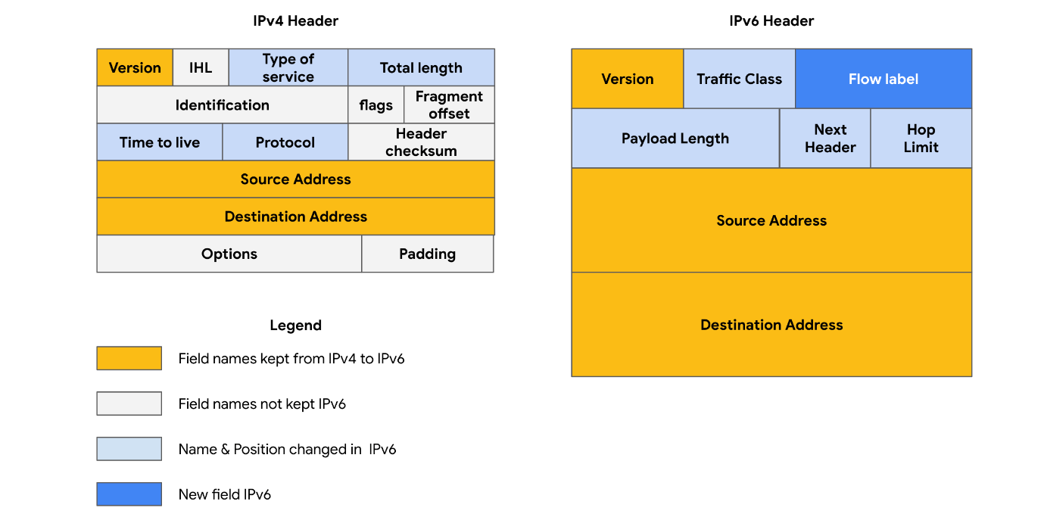
There are some important security differences between IPv4 and IPv6. IPv6 offers more efficient routing and eliminates private address collisions that can occur on IPv4 when two devices on the same network are attempting to use the same address.

Network Protocols
- Network Protocols – They are a set of rules used by two or more devices on a network to describe the order of delivery and the structure of data.
  - TCP – Transmission Control Protocol – TCP is an internet communications protocol that allows devices to form a connection and stream data. E.g – You go and type in a websites address. Before you gain access to the website, your device will establish communications with a web server. This communication uses TCP
TCP also verifies both devices before allowing any further communication to take place. This is often referred to as a handshake. Once communication is established using a TCP handshake, a request is made to the network. The request is then approved and we are sent back the data packets with the requested info.
  - ARP – Address Resolution Protocol – It is a network protocol used to determine the MAC address of the next router or device on the path. It ensures that the data gets to the right place.
  - HTTPS – Hypertext Transfer Protocol Secure – It is a network protocol that provides a secure method of communication between clients and website servers. It allows your web browser to securely send a request for a webpage and receive the same as a response. It uses SSL i.e. Secure Sockets Layer and TLS i.e. Transport Layer Security. Data is encrypted and kept secure from malicious actors.
  - DNS – Domain Name System – It is a network protocol that translates internet domain names to IP address. It sends the domain name and the web address to a DNS server that retrieves the IP address of the website you were trying to access. This IP address is included as a destination address for the data packets travelling to the websites web server.

Overview of network protocols
A network protocol is a set of rules used by two or more devices on a network to describe the order of delivery and the structure of data. Network protocols serve as instructions that come with the information in the data packet. These instructions tell the receiving device what to do with the data. Protocols are like a common language that allows devices all across the world to communicate with and understand each other.
Three categories of network protocols
Network protocols can be divided into three main categories: communication protocols, management protocols, and security protocols. There are dozens of different network protocols, but you don’t need to memorise all of them. Here are some of the important ones.
Communication protocols
Communication protocols govern the exchange of information in network transmission. They dictate how the data is transmitted between devices and the timing of the communication. They also include methods to recover data lost in transit. Here are a few of them.
- Transmission Control Protocol (TCP) is an internet communication protocol that allows two devices to form a connection and stream data. TCP uses a three-way handshake process. First, the device sends a synchronise (SYN) request to a server. Then the server responds with a SYN/ACK packet to acknowledge receipt of the device's request. Once the server receives the final ACK packet from the device, a TCP connection is established. In the TCP/IP model, TCP occurs at the transport layer.
- User Datagram Protocol (UDP) is a connectionless protocol that does not establish a connection between devices before a transmission. This makes it less reliable than TCP. But it also means that it works well for transmissions that need to get to their destination quickly. For example, one use of UDP is for sending DNS requests to local DNS servers. In the TCP/IP model, UDP occurs at the transport layer.
- Hypertext Transfer Protocol (HTTP) is an application layer protocol that provides a method of communication between clients and website servers. HTTP uses port 80. HTTP is considered insecure, so it is being replaced on most websites by a secure version, called HTTPS that uses encryption from SSL/TLS for communication. However, there are still many websites that use the insecure HTTP protocol. In the TCP/IP model, HTTP occurs at the application layer.
- Domain Name System (DNS) is a protocol that translates internet domain names into IP addresses. When a client computer wishes to access a website domain using their internet browser, a query is sent to a dedicated DNS server. The DNS server then looks up the IP address that corresponds to the website domain. DNS normally uses UDP on port 53. However, if the DNS reply to a request is large, it will switch to using the TCP protocol. In the TCP/IP model, DNS occurs at the application layer.

Management Protocols
The next category of network protocols is management protocols. Management protocols are used for monitoring and managing activity on a network. They include protocols for error reporting and optimising performance on the network.
- Simple Network Management Protocol (SNMP) is a network protocol used for monitoring and managing devices on a network. SNMP can reset a password on a network device or change its baseline configuration. It can also send requests to network devices for a report on how much of the network’s bandwidth is being used up. In the TCP/IP model, SNMP occurs at the application layer.
- Internet Control Message Protocol (ICMP) is an internet protocol used by devices to tell each other about data transmission errors across the network. ICMP is used by a receiving device to send a report to the sending device about the data transmission. ICMP is commonly used as a quick way to troubleshoot network connectivity and latency by issuing the “ping” command on a Linux operating system. In the TCP/IP model, ICMP occurs at the internet layer.
Security Protocols
Security protocols are network protocols that ensure that data is sent and received securely across a network. Security protocols use encryption algorithms to protect data in transit. Below are some common security protocols.
- Hypertext Transfer Protocol Secure (HTTPS) is a network protocol that provides a secure method of communication between clients and website servers. HTTPS is a secure version of HTTP that uses secure sockets layer/transport layer security (SSL/TLS) encryption on all transmissions so that malicious actors cannot read the information contained. HTTPS uses port 443. In the TCP/IP model, HTTPS occurs at the application layer.
- Secure File Transfer Protocol (SFTP) is a secure protocol used to transfer files from one device to another over a network. SFTP uses secure shell (SSH), typically through TCP port 22. SSH uses Advanced Encryption Standard (AES) and other types of encryption to ensure that unintended recipients cannot intercept the transmissions. In the TCP/IP model, SFTP occurs at the application layer. SFTP is used often with cloud storage. Every time a user uploads or downloads a file from cloud storage, the file is transferred using the SFTP protocol.

Network Address Translation
The devices on your local home or office network each have a private IP address that they use to communicate directly with each other. However, in order for the devices with private IP addresses to communicate with the public internet, they need to have a single public IP address that represents all devices on the LAN to the public. For outgoing messages, the router can replace a private source IP address with its public IP address and perform the reverse operation for responses. This process is known as Network Address Translation (NAT) and it generally requires a router or firewall to be specifically configured to perform NAT. NAT is a part of layer 2 (internet layer) and layer 3 (transport layer) of the TCP/IP model.
Private IP Addresses | Public IP Addresses
- Assigned by the router  - Unique only within private network  - No cost to use  - Address ranges:  - 10.0.0.0-10.255.255.255  - 172.16.0.0-172.31.255.255  - 192.168.0.0-192.168.255.255 | - Assigned by ISP and IANA  - Unique address in global internet  - Costs to lease a public IP address  - Assignable address ranges:  - 1.0.0.0-9.255.255.255  - 11.0.0.0-126.255.255.255  - 128.0.0.0-172.15.255.255  - 172.32.0.0-192.167.255.255  - 192.169.0.0-233.255.255.255

Dynamic Host Configuration Protocol
Dynamic Host Configuration Protocol (DHCP) is in the management family of network protocols. DHCP is an application layer protocol used on a network to configure devices. It works with the router to assign a unique IP address to each device and provide the addresses of the appropriate DNS server and default gateway for each device. DHCP servers operate on UDP port 67 while DHCP clients operate on UDP port 68.
Address Resolution Protocol
By now, you are familiar with IP and MAC addresses. You’ve learned that each device on a network has a public IP address, a private IP address, and a MAC address that identify it on the network. A device’s IP address may change over time, but its MAC address is permanent because it is unique to a device's network interface card. The MAC address is used to communicate with devices within the same network, but sometimes, the MAC address is unknown. This is why the Address Resolution Protocol (ARP) is needed. ARP is mainly a network access layer protocol in the TCP/IP model used to translate the IP addresses that are found in data packets into the MAC address of the hardware device.
Each device on the network performs ARP and keeps track of matching IP and MAC addresses in an ARP cache. ARP does not have a specific port number since it is a layer 2 protocol and port numbers are associated with the layer 7 application layer.
Telnet
Telnet is an application layer protocol that is used to connect with a remote system. Telnet sends all information in clear text. It uses command line prompts to control another device similar to secure shell (SSH), but Telnet is not as secure as SSH. Telnet can be used to connect to local or remote devices and uses TCP port 23.
Secure shell
Secure shell protocol (SSH) is used to create a secure connection with a remote system. This application layer protocol provides an alternative for secure authentication and encrypted communication. SSH operates over the TCP port 22 and is a replacement for less secure protocols, such as Telnet.
Post office protocol
Post office protocol (POP) is an application layer (layer 4 of the TCP/IP model) protocol used to manage and retrieve email from a mail server. POP3 is the most commonly used version of POP. Many organisations have a dedicated mail server on the network that handles incoming and outgoing mail for users on the network. User devices will send requests to the remote mail server and download email messages locally. If you have ever refreshed your email application and had new emails populate in your inbox, you are experiencing POP and internet message access protocol (IMAP) in action. Unencrypted, plaintext authentication uses TCP/UDP port 110 and encrypted emails use Secure Sockets Layer/Transport Layer Security (SSL/TLS) over TCP/UDP port 995. When using POP, mail has to finish downloading on a local device before it can be read. After downloading, the mail may or may not be deleted from the mail server, so it does not guarantee that a user can sync the same email across multiple devices.
Internet Message Access Protocol (IMAP)
IMAP is used for incoming email. It downloads the headers of emails and the message content. The content also remains on the email server, which allows users to access their email from multiple devices. IMAP uses TCP port 143 for unencrypted email and TCP port 993 over the TLS protocol. Using IMAP allows users to partially read email before it is finished downloading. Since the mail is kept on the mail server, it allows a user to sync emails across multiple devices.
Simple Mail Transfer Protocol
Simple Mail Transfer Protocol (SMTP) is used to transmit and route email from the sender to the recipient’s address. SMTP works with Message Transfer Agent (MTA) software, which searches DNS servers to resolve email addresses to IP addresses, to ensure emails reach their intended destination. SMTP uses TCP/UDP port 25 for unencrypted emails and TCP/UDP port 587 using TLS for encrypted emails. The TCP port 25 is often used by high-volume spam. SMTP helps to filter out spam by regulating how many emails a source can send at a time.
Protocols and port numbers
Remember that port numbers are used by network devices to determine what should be done with the information contained in each data packet once they reach their destination. Firewalls can filter out unwanted traffic based on port numbers. For example, an organisation may configure a firewall to only allow access to TCP port 995 (POP3) by IP addresses belonging to the organisation.
Protocol | Port
DHCP | UDP port 67 (servers)  UDP port 68 (clients)
ARP | none
Telnet | TCP port 23
SSH | TCP port 22
POP3 | TCP/UDP port 110 (unencrypted)  TCP/UDP port 995 (encrypted, SSL/TLS)
IMAP | TCP port 143 (unencrypted)  TCP port 993 (encrypted, SSL/TLS)
SMTP | TCP/UDP Port 25 (unencrypted)
SMTPS | TCP/UDP port 587 (encrypted, TLS)

Introduction to wireless communication protocols
Many people today refer to wireless internet as Wi-Fi. Wi-Fi refers to a set of standards that define communication for wireless LANs. Wi-Fi is a marketing term commissioned by the Wireless Ethernet Compatibility Alliance (WECA). WECA has since renamed their organisation Wi-Fi Alliance.
Wi-Fi standards and protocols are based on the 802.11 family of internet communication standards determined by the Institute of Electrical and Electronics Engineers (IEEE). So, you might also see Wi-Fi referred to as IEEE 802.11.
Wi-Fi communications are secured by wireless networking protocols. Wireless security protocols have evolved over the years, helping to identify and resolve vulnerabilities with more advanced wireless technologies.

Wired Equivalent Privacy
Wired equivalent privacy (WEP) is a wireless security protocol designed to provide users with the same level of privacy on wireless network connections as they have on wired network connections. WEP was developed in 1999 and is the oldest of the wireless security standards.
WEP is largely out of use today, but security analysts should still understand WEP in case they encounter it. For example, a network router might have used WEP as the default security protocol and the network administrator never changed it. Or, devices on a network might be too old to support newer Wi-Fi security protocols. Nevertheless, a malicious actor could potentially break the WEP encryption, so it’s now considered a high-risk security protocol.
Wi-Fi Protected Access
Wi-Fi Protected Access (WPA) was developed in 2003 to improve upon WEP, address the security issues that it presented, and replace it. WPA was always intended to be a transitional measure so backwards compatibility could be established with older hardware.
The flaws with WEP were in the protocol itself and how the encryption was used. WPA addressed this weakness by using a protocol called Temporal Key Integrity Protocol (TKIP). WPA encryption algorithm uses larger secret keys than WEPs, making it more difficult to guess the key by trial and error.
WPA also includes a message integrity check that includes a message authentication tag with each transmission. If a malicious actor attempts to alter the transmission in any way or resend at another time, WPA’s message integrity check will identify the attack and reject the transmission.
Despite the security improvements of WPA, it still has vulnerabilities. Malicious actors can use a key reinstallation attack (or KRACK attack) to decrypt transmissions using WPA. Attackers can insert themselves in the WPA authentication handshake process and insert a new encryption key instead of the dynamic one assigned by WPA. If they set the new key to all zeros, it is as if the transmission is not encrypted at all.
Because of this significant vulnerability, WPA was replaced with an updated version of the protocol called WPA2.
WPA2 & WPA3
WPA2
The second version of Wi-Fi Protected Access—known as WPA2—was released in 2004. WPA2 improves upon WPA by using the Advanced Encryption Standard (AES). WPA2 also improves upon WPA’s use of TKIP. WPA2 uses the Counter Mode Cipher Block Chain Message Authentication Code Protocol (CCMP), which provides encapsulation and ensures message authentication and integrity. Because of the strength of WPA2, it is considered the security standard for all Wi-Fi transmissions today. WPA2, like its predecessor, is vulnerable to KRACK attacks. This led to the development of WPA3 in 2018.
Personal
WPA2 personal mode is best suited for home networks for a variety of reasons. It is easy to implement, initial setup takes less time for personal than enterprise version. The global passphrase for WPA2 personal version needs to be applied to each individual computer and access point in a network. This makes it ideal for home networks, but unmanageable for organisations.
Enterprise
WPA2 enterprise mode works best for business applications. It provides the necessary security for wireless networks in business settings. The initial setup is more complicated than WPA2 personal mode, but enterprise mode offers individualised and centralised control over the Wi-Fi access to a business network. This means that network administrators can grant or remove user access to a network at any time. Users never have access to encryption keys, this prevents potential attackers from recovering network keys on individual computers.
WPA3
WPA3 is a secure Wi-Fi protocol and is growing in usage as more WPA3 compatible devices are released. These are the key differences between WPA2 and WPA3:
- WPA3 addresses the authentication handshake vulnerability to KRACK attacks, which is present in WPA2.
- WPA3 uses Simultaneous Authentication of Equals (SAE), a password-authenticated, cipher-key-sharing agreement. This prevents attackers from downloading data from wireless network connections to their systems to attempt to decode it.
- WPA3 has increased encryption to make passwords more secure by using 128-bit encryption, with WPA3-Enterprise mode offering optional 192-bit encryption.

