AT&T Developer Program

**Titanium Mobile SDK Extension for the AT&T API Platform**

Installation and Setup Guide

|  |  |
| --- | --- |
| Revision Date | November 03, 2012 |

Legal Disclaimer

This document and the information contained herein (collectively, the "**Information**") is provided to you (both the individual receiving this document and any legal entity on behalf of which such individual is acting) ("**You**" and "**Your**") by AT&T, on behalf of itself and its affiliates ("**AT&T**") for informational purposes only. AT&T is providing the Information to You because AT&T believes the Information may be useful to You. The Information is provided to You solely on the basis that You will be responsible for making Your own assessments of the Information and are advised to verify all representations, statements and information before using or relying upon any of the Information. Although AT&T has exercised reasonable care in providing the Information to You, AT&T does not warrant the accuracy of the Information and is not responsible for any damages arising from Your use of or reliance upon the Information. You further understand and agree that AT&T in no way represents, and You in no way rely on a belief, that AT&T is providing the Information in accordance with any standard or service (routine, customary or otherwise) related to the consulting, services, hardware or software industries.

AT&T DOES NOT WARRANT THAT THE INFORMATION IS ERROR-FREE. AT&T IS PROVIDING THE INFORMATION TO YOU "AS IS" AND "WITH ALL FAULTS." AT&T DOES NOT WARRANT, BY VIRTUE OF THIS DOCUMENT, OR BY ANY COURSE OF PERFORMANCE, COURSE OF DEALING, USAGE OF TRADE OR ANY COLLATERAL DOCUMENT HEREUNDER OR OTHERWISE, AND HEREBY EXPRESSLY DISCLAIMS, ANY REPRESENTATION OR WARRANTY OF ANY KIND WITH RESPECT TO THE INFORMATION, INCLUDING, WITHOUT LIMITATION, ANY REPRESENTATION OR WARRANTY OF DESIGN, PERFORMANCE, MERCHANTABILITY, FITNESS FOR A PARTICULAR PURPOSE OR NON-INFRINGEMENT, OR ANY REPRESENTATION OR WARRANTY THAT THE INFORMATION IS APPLICABLE TO OR INTEROPERABLE WITH ANY SYSTEM, DATA, HARDWARE OR SOFTWARE OF ANY KIND. AT&T DISCLAIMS AND IN NO EVENT SHALL BE LIABLE FOR ANY LOSSES OR DAMAGES OF ANY KIND, WHETHER DIRECT, INDIRECT, INCIDENTAL, CONSEQUENTIAL, PUNITIVE, SPECIAL OR EXEMPLARY, INCLUDING, WITHOUT LIMITATION, DAMAGES FOR LOSS OF BUSINESS PROFITS, BUSINESS INTERRUPTION, LOSS OF BUSINESS INFORMATION, LOSS OF GOODWILL, COVER, TORTIOUS CONDUCT OR OTHER PECUNIARY LOSS, ARISING OUT OF OR IN ANY WAY RELATED TO THE PROVISION, NON-PROVISION, USE OR NON-USE OF THE INFORMATION, EVEN IF AT&T HAS BEEN ADVISED OF THE POSSIBILITY OF SUCH LOSSES OR DAMAGES.

Table of Contents

[1. Introduction 4](#_Toc339632622)

[2. Architectural Overview 5](#_Toc339632623)

[3. Installation Guidelines and Notes 6](#_Toc339632624)

[4. Installing the Components 7](#_Toc339632625)

[4.1 Downloading Modules 7](#_Toc339632626)

[4.2 Installing Modules 8](#_Toc339632627)

[4.3 Using the Components 13](#_Toc339632628)

# Introduction

The AT&T Appcelerator Titanium Mobile SDK provides a simplified way for Titanium Mobile Developers to access the AT&T API platform services.

By significantly reducing the complexity of building applications that use the AT&T platform services, the AT&T Titanium Mobile SDK helps developers quickly bring robust Titanium mobile applications to market.

The AT&T Titanium Modules provide interfaces that facilitate access to the following AT&T platform APIs:

* SMS
* MMS
* WAP-PUSH
* SPEECH
* IN-APP MESSAGING
* NOTARY
* PAYMENT
* LOCATION
* OAUTH

**noteNote:** To learn more about the AT&T API platform, visit the AT&T Developer Program website [http://developer.att.com](http://developer.att.com/).

# Architectural Overview

The AT&T Titanium Mobile SDK contains two components that provide access to the AT&T platform APIs:

* **JavaScript Wrapper Library** - This component contains a set of JavaScript interfaces that complies with CommonJS specifications.
* **Native code library** - This component contains native code interfaces for use with both iOS and Android.

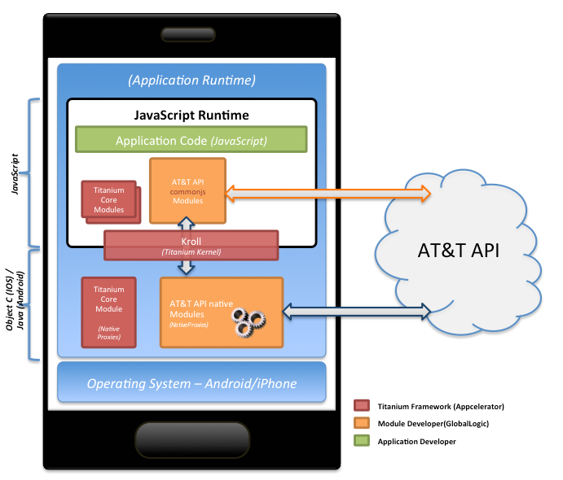

Figure 1: AT&T Titanium Mobile SDK Architecture

# Installation Guidelines and Notes

The following operating systems are supported by the AT&T Titanium Mobile SDK:

|  |  |  |
| --- | --- | --- |
| Operating System | Minimum Version | Maximum Version |
| Apple Mac OS X | 10.6.X (Snow Leopard) | 10.7 (Lion) |
| Windows XP  (all editions, except [Starter Edition](http://en.wikipedia.org/wiki/Windows_XP_editions#Starter_Edition)) | Service Pack 3 | Latest |
| Windows 7 | All | Latest |
| Ubuntu Linux | 10.04 LTS (Lucid Lynx) | 11.10 (Oneiric Ocelot) |

The following components are required to run Titanium Mobile SDK modules that access the AT&T API:

* Titanium Studio with a **minimum version of 2.1.2**. For more details, refer to the Titanium [Quick Start](https://wiki.appcelerator.org/display/guides/Quick+Start) guide.
* Titanium Mobile SDK with **version 2.x.**
* An internet connection. This is required so that the Titanium Mobile SDK modules can call the AT&T APIs.

Please note the following when using the AT&T Titanium Mobile SDK modules in this package:

* The Titanium Mobile SDK modules for iOS and Android in this package are designed to be used with Titanium Mobile SDK version 2.x. The modules *may not work* if an SDK with a version lower than this specified minimum version is used.
* All the APIs in the Titanium Mobile SDK are capable of working with the AT&T network. **Note**: Sending SMS, MMS, and other messages to phones outside of the AT&T network, on other carriers, is not supported.

# Installing the Components

## Downloading Modules

The following AT&T Titanium modules are available at [marketplace.appcelerator](https://marketplace.appcelerator.com/apps/3812?25485000):

* AT&T Titanium module for Android (**att-android-1.0.zip**)
  + Contains all of the necessary files to use this AT&T Titanium module in applications targeting the Android platform.
* AT&T Titanium module for iOS (**att-iphone-1.0.zip**)
  + Contains all of the necessary files to use this AT&T Titanium module in applications targeting the iOS platform.

To get started, download one of these module zip files to a local directory on your computer.

## Installing Modules

To install an AT&T Titanium module in an application, do the following:

1. Open Titanium Studio.
2. Create or open the Titanium mobile application in which you intend to use the downloaded AT&T Titanium module.
3. Open the Help menu, and click on the “Install Titanium module…” menu item as shown in the following figure.

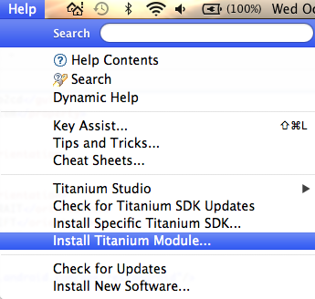

Figure 2- Help menu – Install Titanium Module

1. Select the module zip file in the “Install from URL” file selection box.
2. Under “Output Location”, select the radio button for “A mobile app” and select the name of a Titanium Mobile application. The following example (figure 3), shows the AT&T Titanium module for Android is being installed in the ATTTiKitchenSink application.

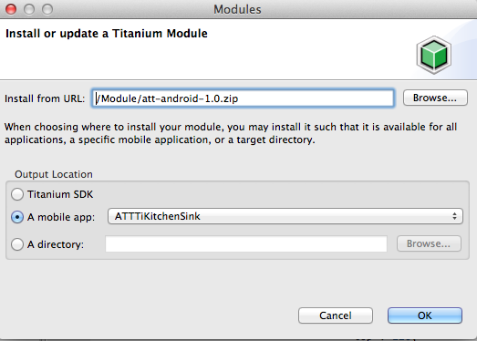

Figure 3- Install or Update a Titanium Module

1. A folder with the name “modules” will be created or updated in Project Explorer, under the name of the Titanium mobile app in which the module was installed. The “modules” folder contains files related to the installed modules. The following figure shows the file structure of the application in Project Explorer after the “modules” folder has been created.

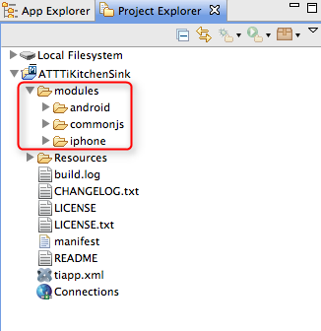

Figure 4: File structure of the application in Project Explorer after the “modules” folder has been created.

1. Open the **tiapp.xml** file for the project and switch to the Overview Tab. The “Modules” section is displayed as shown in the following figure.

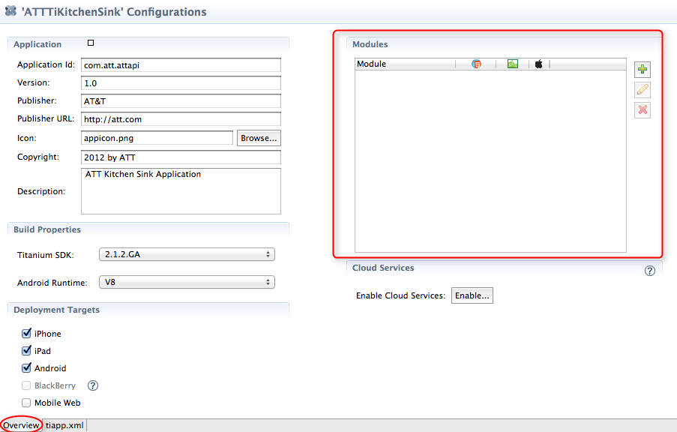

Figure 5- Modules section in the Overview Tab

1. Click on the 2012-10-10_14h33_51 button to add the settings for this module to the **tiapp.xml** file.
2. Select the **att [commonjs]** and **ti.api.att [android/ios]** modules, as shown in the following figure and click “OK”.

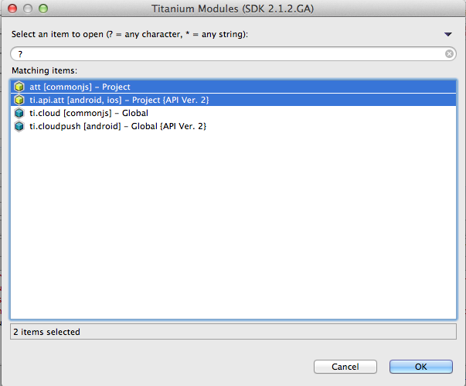

Figure 6- Selecting modules to be added

1. After the modules are added, they will be displayed in the “Modules” window section of the xml file as shown in the following figure. This section also displays the mobile environments which are supported by the selected modules.

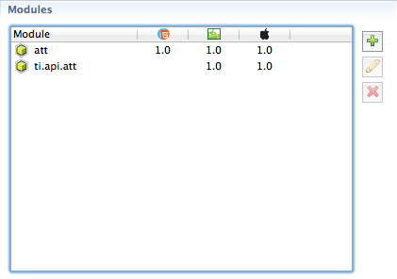

Figure 7 – The Modules window

## Using the Components

To load the module in your application, call the **require** function as shown in the following example:

Screen Shot 2012-10-10 at 12

After this line is added, the module will be included in the application whenever it is launched.

**noteNote:** To learn more about installing Titanium modules, refer to the following guide <http://docs.appcelerator.com/titanium/2.0/#!/guide/Using_Titanium_Modules>