# **Initial Setup Guide to Enable Capability of Adding New Design Guidelines via a Public Directory**

## Known Dependencies:

1. Notepad++
2. Git Bash (Depends on Notepad++)
3. Python 11 (req. per Doorstop-edit)
4. Doorstop
5. Doorstop-Edit (Improved GUI for Doorstop)
6. OneDrive Sync

## Assumptions:

Windows operating system 10 and 11 are known to be supported by following these guidelines. Trial on alternative systems has not been conducted.

For the purposes of this installation, Windows 10 (Home) will be used to capture screenshots.

## Setup Process:

1. Download and install Notepad++ from <https://notepad-plus-plus.org/downloads/>
   1. Purpose: Edit guidelines in a text editor.
   2. This is important to do before installing Git, as a default editor is requested.
   3. Default Values for installation are acceptable.
2. Download Git from <https://gitforwindows.org/>
   1. Purpose: Facilitates revision control aspect of design-guideline process
   2. BLUF: Custom value editor for “Notepad++”, all others default values.
   3. {TODO: Add Appendix for basic git commands}

* 1. After clicking “Download”, A prompt may pop-up to save the download file. Save to a convenient location.
  2. Double click on the file to run/execute the file to begin the installation process.

* 1. A general license agreement will display. Once ready, click “Next”
  2. Select a destination location. This location has worked for the purposes herein.

* 1. The default settings for the selected components have been shown to work:  
     (Note that the NEW Scalar function is selected but not shown in the screenshot)

* 1. Choose a Start Menu Folder for your use. It is recommended to use the default option for this step as well (“Git”).

* 1. Based on trial, Notepad++ is functional and useful as the default text editor. **Note that this is not a default value.**

(Only shows next if Notepad++ is installed. If it is greyed out then please see the instructions on installing Notepad++).

* 1. This defines how git will handle branching. {ToDO: See Appendix}. Recommended to “Let Git decide”

* 1. Use recommended values has been shown to work.  
     Graphical user interface, text, application, email

     Description automatically generated
  2. The following steps are all default values and recommended for guideline use:
     1. “use bundled OpenSSH”
     2. “Use the OpenSSL Library”
     3. “Checkout Windows-style, commit Unix-style line endings”
     4. “Use MinTTY”
     5. “Default” (fast-forward or merge) {TODO: Appendix Reference}
     6. “Git Credential Manager”
     7. “Enable file system caching”
     8. Configuring experimental option: None have been validated for this use.
  3. “INSTALL” – Click install to install the program.

1. Download and Install python (version >=3.11) from <https://www.python.org/downloads/>
   1. Select “Add Python.exe to Path” as seen below:

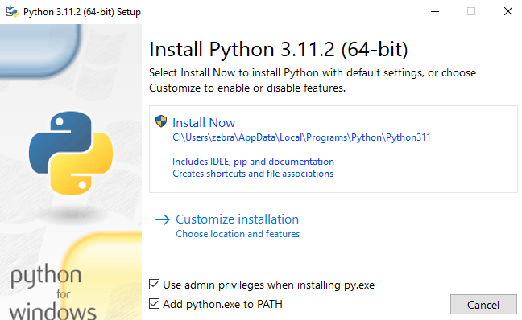

cv

cv

* 1. **NOTE: If Python.exe is not added to the PATH variable then it will have to be added later.**
  2. **It is not necessary to increase max limit of characters for this use.**

1. Open “Git Bash” Terminal and run the following commands:

“pip install doorstop”.

* 1. Purpose: Doorstop is the primary framework for the guidelines program. More information is available at https://doorstop.readthedocs.io/en/latest/.
  2. Pip is pythons package management tool**Text

     Description automatically generated**

1. “pip install doorstop-edit”
   1. Doorstop-edit is the primary graphic user interface that allows one to interact with the doorstop in a graphical way. Note, to interact via git-bash command line then please reference the documentation per line 4a above.
2. Sync the shared directory:
   1. If not already done, Download OneDrive to Computer
   2. Access OneDrive “Shared” Folder Online

* 1. “Add shortcut to my files”—This allows you to access the directory by the command line.

1. Use git bash to navigate to the shared folder:
   1. This is done by using the ‘cd’ command. Note cd means change directory.
   2. In my case:

I would type “cd ‘C:\Users\zebra\OneDrive\Guidelines’” as seen below:



Note also that this is a folder I can browse to in file explorer because the files are synched through OneDrive to File Explorer.

1. Your git-bash terminal should look something like this: 
   1. The (master) highlighting is indicating that this is the primary git branch (revision control).
2. By typing “doorstop-edit” in the OneDrive/Guidelines context you will be able to see the User Interface as seen below.
   1. Sometimes “Segmentation Error” will display – just type the doorstop-edit command again in that case.

1. Adding Guidelines:
   1. Right-click at bottom of tree and select “New Item”. Type in the Header to add a short description, and in the text to add the new guideline.
   2. NOTE: Sometimes when the middle frame of the program is expanded as it is below, there is some lag when typing. To avoid this, click the “Hamburger” icon in the top center of the screen to move to the “guideline” context when typing.

1. Search function: 