Second Interim Report — Simulating and controlling the HISPEC thermal system

Andrey Korolev · Mentor: Jake Zimmer · SURF 2026

Background and goal

HISPEC is a high-resolution infrared spectrograph being built for the Keck Observatory (radial-velocity measurements, exoplanet characterization, transit spectroscopy). Because those measurements are extremely sensitive to optical expansion, refractive-index changes, and detector drift, the instrument must stay thermally stable — the target is roughly 10 mK/hour, with a sub-millikelvin stretch goal — across a custom thermal-control system with 40 heater outputs and 80 temperature-sensor inputs (see Interim Report 1 for the hardware background).

My project is to model, simulate, and control this system. The defining constraint is that the hardware does not physically exist yet — it is still being built — so I cannot do system identification on the real device. The entire project therefore rests on an approximate, physics-based simulator that stands in for the real system: it lets me design and stress-test controllers now, so that when the hardware arrives the controllers are already close and only need refinement rather than ground-up tuning. The work over the past month falls into two threads: (1) building and validating that simulator, and (2) evolving the controller from a simple baseline to an optimal multivariable design.

Throughout, results are shown on a representative test assembly, CRYOSTAT_V2, which exposes 33 heaters and 72 sensors (28 controlled) — a subset of the full 40/80 channel count — linearized about a 55 K operating point.

Thread 1 — Building and validating the simulator

1.1 The pipeline

The simulator turns a CAD assembly into a solvable thermal model in three stages. All quantities below are the actual settings used to build CRYOSTAT_V2.

(a) Geometry → octree/voxel grid. The CAD assembly is voxelized with an adaptive octree so fine features get small cells and bulk material gets large ones. The build parameters were: minimum cell size 4 mm, maximum cell size 10 mm, maximum octree depth 12 (depth 9 actually reached), 64 sample points per cell for occupancy testing, and a trimesh BVH ray-containment backend. Adaptive refinement was enabled at material contrast (contrast ratio threshold 5), near contacts (within 10 mm), at boundaries, and around crowded and multi-surface components. The result for CRYOSTAT_V2 is 471,412 leaf cells (469,315 in the main connected body) joined by ≈1.08 million conduction edges (2.16 M off-diagonal entries in the sparse conduction Laplacian). Contact between touching parts is modeled with an interface conductance of 10,000 W·m⁻²·K⁻¹ applied where surfaces lie within a 2 mm detection distance (0.05 mm gap tolerance). Flex cables (FLEX components) were excluded.

(b) Material extraction and assignment. Each voxel carries density, heat capacity, conductivity, and emissivity. Because CAD appearance names are unreliable, a per-mesh material table (Materials.xlsx) is treated as authoritative and matched onto the octree leaves; a leaf inherits its parent component's material, with the dominant material accepted when it covers ≥95% of a cell. CRYOSTAT_V2 resolved to 14 distinct materials, e.g. 6061-T6 aluminum (ρ = 2700 kg·m⁻³, cp = 896 J·kg⁻¹·K⁻¹, k = 167 W·m⁻¹·K⁻¹, ε = 0.09), AISI 304 stainless (k = 16.2 W·m⁻¹·K⁻¹, ε = 0.35), 17-7PH stainless (k = 16 W·m⁻¹·K⁻¹), and copper. Getting this correct was a distinct piece of work — the whole simulation is only as good as its material assignment.

(c) Thermal network. The voxel grid becomes a lumped thermal graph: node i is a thermal mass with capacity C_i = ρ·cp·V_i, edges are conduction conductances G_ij built from the shared face area, cell sizes, and harmonic-mean conductivity, and exposed surfaces get a linearized radiation term referenced to 293.15 K. Heater and sensor nodes are detected by component-name substring (SAFE-HEATER for heaters, a fixed sensor part number for sensors), then paired (≤2 heaters per sensor, ≤50 mm apart). At cryogenic temperatures material properties vary strongly, so heat capacity and conductivity use temperature-dependent curves cp(T), k(T) sourced from NIST cryogenic data rather than room-temperature constants.

1.2 Validation against analytical references

Before trusting the simulator to design controllers, I checked that its heat transfer is actually correct. The solver has a built-in suite of experiments, each a small canonical geometry (typically a copper block or rod, e.g. a 100 × 20 × 20 mm bar with a 10 W heater, starting at 293.15 K) compared against an independent reference: either a closed-form analytical solution, or a high-accuracy adaptive Runge–Kutta (LSODA) integration of the same nonlinear ODE C(T) Ṫ = −L(T) T + P + εσA(T_env⁴ − T⁴) from the identical initial state and operators. To probe correctness rather than the deployed solver's default speed, I ran each experiment with the solver tightened to convergence: adaptive substep cap 512, per-step target ΔT 10⁻³ K, relative tolerance 10⁻¹¹, GPU path disabled. The error reported is the maximum absolute deviation from the reference over the run:

Experiment | Max abs. temperature error | Tolerance | Status
Insulated block, constant heating | 1.7×10⁻¹⁰ K | 5×10⁻² K | PASS
Two-node lumped conductance | 3.7×10⁻¹⁰ K | 1×10⁻⁷ K | PASS
One-dimensional prism conduction | 1.0 K | 3 K | PASS
One-dimensional distributed rod | ~10⁻¹³ K | 1×10⁻⁷ K | PASS
Radiation cooling (lumped) | 3.2×10⁻⁷ K | 5×10⁻¹ K | PASS
Temperature-dependent heating | 3.2×10⁻² K | 5×10⁻¹ K | PASS
Cryo regime (heater + radiation + cp(T)) | 1.8×10⁻⁴ K | 5×10⁻¹ K | PASS
Two-block thermal exchange | 5.7×10⁻² K | 5×10⁻² K | WARNING
Global energy conservation | 1.8×10⁻³ J | 36 J | PASS

The most important row is the cryo regime — heater input, radiation, and temperature-dependent cp(T) together, which is the actual HISPEC operating regime — where the simulator tracks the analytical reference to 1.8×10⁻⁴ K. Figure 5 overlays the simulated and analytical curves for that case and for radiation cooling; they are visually indistinguishable. The only non-PASS is the two-block exchange, which lands marginally over its 0.05 K tolerance (0.057 K) — a WARNING, not a failure. These results are in line with what I expected: with the solver well resolved, the simulation reproduces the physics to well within any tolerance that matters for control.

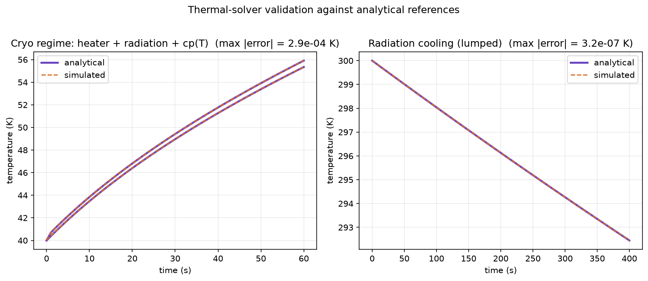

Figure 5. Simulated (dashed) vs. analytical (solid) temperature for the cryo regime and radiation-cooling experiments; max errors ~10⁻⁴ K and ~10⁻⁷ K.

1.3 The problem: hollow shells

The validation above is encouraging, but there is a significant caveat I uncovered while pushing the model further. The CAD imports used so far (GLB exports) drop the solid interiors of parts, leaving hollow shells. A shell has thin conduction cross-sections and a weak connection to the cold sink, so while the solver is correct (Section 1.2), the geometry it is solving on is not representative of the real instrument — absolute quantities like time constants and steady-state gains come out distorted (this shows up again in Thread 2). The source of the problem is the file format and how it tessellates solids: the build's own quality heuristic flagged this, scoring CRYOSTAT_V2 5/100 (grade D) largely on watertightness and occupancy warnings. The fix, now in progress, is a separate STEP / B-rep import path that fills solids correctly. Re-running the whole pipeline on solid-filled geometry is the main outstanding step to turn the current methodology demonstration into a quantitatively representative model.

Thread 2 — Controller design

2.1 Why the problem is multivariable

The control problem is naturally MIMO: heat from one heater reaches many sensors. Using the earlier, well-grounded model build, the steady-state heater→sensor gain matrix G (28 controlled sensors × 33 heaters; y = G u) is well-conditioned (condition number ≈ 37, entries 0.04–0.87 K/W) and shows that coupling is pervasive: on average 26.8 of the 33 heaters significantly influence each sensor (>10% of that sensor's strongest gain; median 28), and the relative gain array has a mean best-pairing value of 1.47 (1.0 would mean perfectly decoupled loops). Figure 4 shows the structure — clear dominant pairings, but with large off-diagonal coupling blocks. The system also has two structural difficulties carried over from Report 1: it is underactuated in sensor space (80 sensors, 40 heaters on the real device), and the heaters are one-sided actuators — they can only add heat, not remove it, so an overshoot must wait for passive or cryocooler cooling.

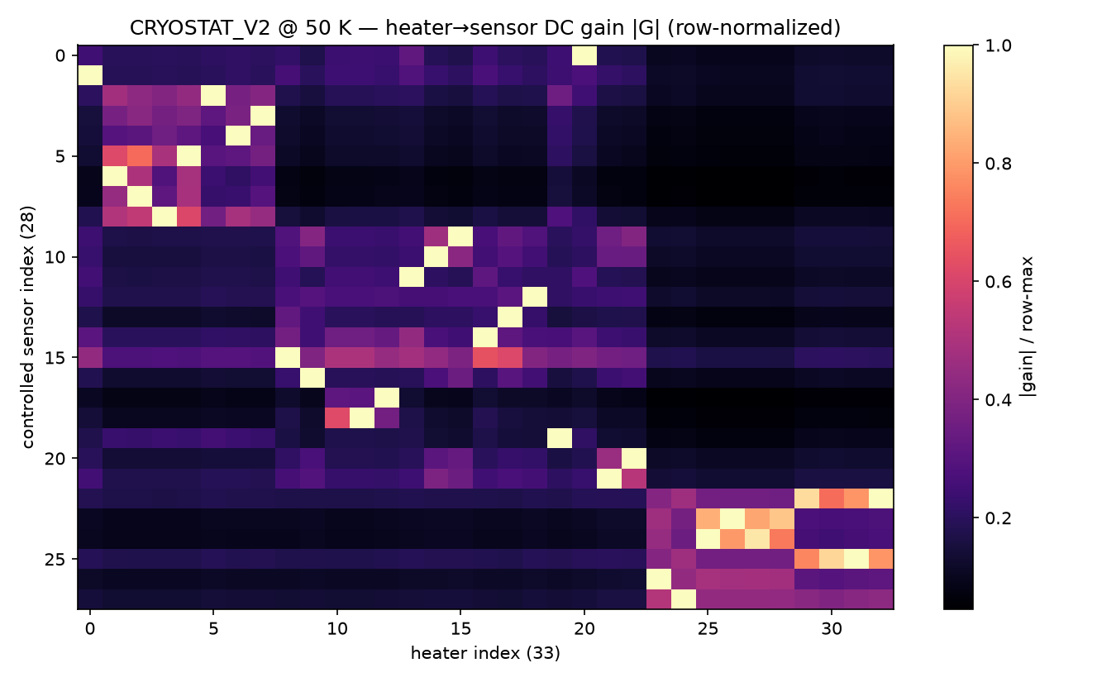

Figure 4. Row-normalized steady-state gain |G| (earlier well-conditioned build). The off-diagonal energy within each block is the cross-coupling that rules out independent single-loop control.

2.2 The controller evolution

SISO PID. The first attempt was the simplest thing that could work: an independent PID loop per heater/sensor pair. This is a useful baseline but, given the coupling above, each loop fights the others and it cannot hold a coordinated setpoint.

Decoupled MIMO PID. To account for the coupling, the next controller computed a desired correction in sensor space and mapped it to heater powers through the pseudoinverse of the gain matrix, u = G⁺ Δy. This works on paper, but the pseudoinverse can request negative or over-limit heater powers. Since real heaters must satisfy 0 ≤ u ≤ u_max, those commands have to be clamped — and once clamped, the applied heater vector is no longer the one the decoupling assumed, so the decoupling breaks down.

Constrained min-norm QP. To fix the clamping problem at its source, I moved to a controller that solves a small constrained quadratic program each step: produce the desired temperature-space correction as closely as possible while directly enforcing the heater constraints (and penalizing large jumps), rather than inverting and clamping afterward. (I also flagged fractional-order PID as a later robustness option for the slow thermal dynamics, following Jamil et al.)

The deeper issue. All of the above are built on the steady-state gain G, and G has two problems. First, it captures only the settled behavior, not the transient dynamics that actually govern control. Second — and more seriously for deployment — it is only as good as the model it comes from: on the real hardware it would require system identification I cannot yet perform, and it can be badly conditioned (the shell-geometry rebuild from Thread 1, for instance, degrades G from the well-behaved matrix above into a nearly rank-1, hugely ill-conditioned one). A controller whose core is a static, model-derived inverse is therefore fragile. This motivated moving to a controller built on the dynamics.

2.3 The LQR controller

From a giant plant to a small dynamic model. A dynamic controller needs a state-space model ẋ = A x + B u, y = C x, but the full thermal graph is ~469,000 states — far too large to design against or run on a microcontroller. I reduce it in two stages:

1. Modal reduction. Solve the generalized symmetric eigenproblem (L + diag(G_rad)) φ = λ C φ for the natural thermal modes by symmetric shift-invert (eigsh, shift σ ≈ 0), keeping the 120 slowest (largest time constants) and C-orthonormalizing them (ΦᵀCΦ = I); fast modes settle instantly on control timescales. Projecting onto these gives a 120-state model A_mod = −diag(λ), B_mod = ΦᵀF, C_out = SΦ.
2. Balanced truncation. Slow does not mean useful: a mode only matters if it actually connects a heater input to a sensor output. I solve the controllability and observability Lyapunov equations for the 120-state model, take the Hankel singular values from their gramian factors (each measuring a mode's joint controllability + observability), and apply square-root balancing to keep the top r = 30. The Hankel values (Fig. 1) fall off a cliff — down ~4 orders by mode 10 and to machine precision by mode ~45 — so 30 states capture essentially all of the input→output behavior. The reduced 30-state model reproduces the full model's steady-state gain to 1.3×10⁻³ and its step response to 1.5×10⁻³ (about 0.15%; Fig. 2), and is stable. This is the key result that makes everything downstream trustworthy: the model is small enough to run on the target microcontroller yet faithful to the real dynamics.

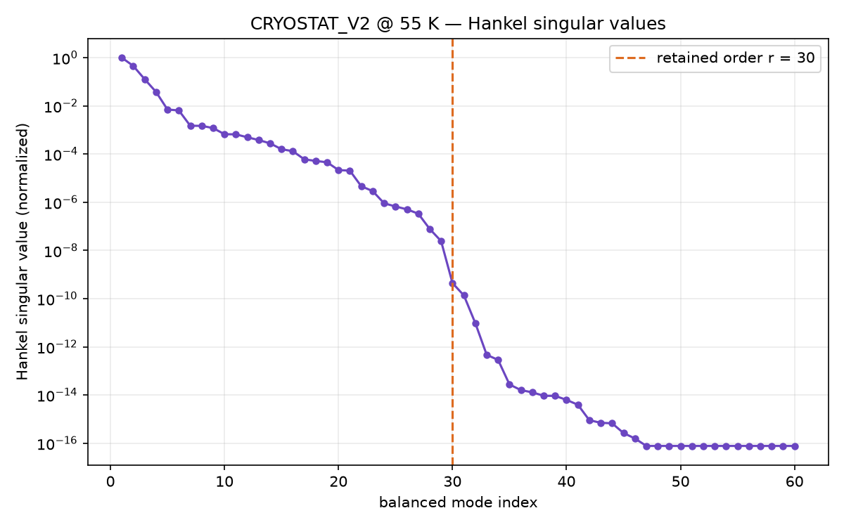

Figure 1. Hankel singular values (normalized); r = 30 (dashed) retains all meaningful input–output dynamics.

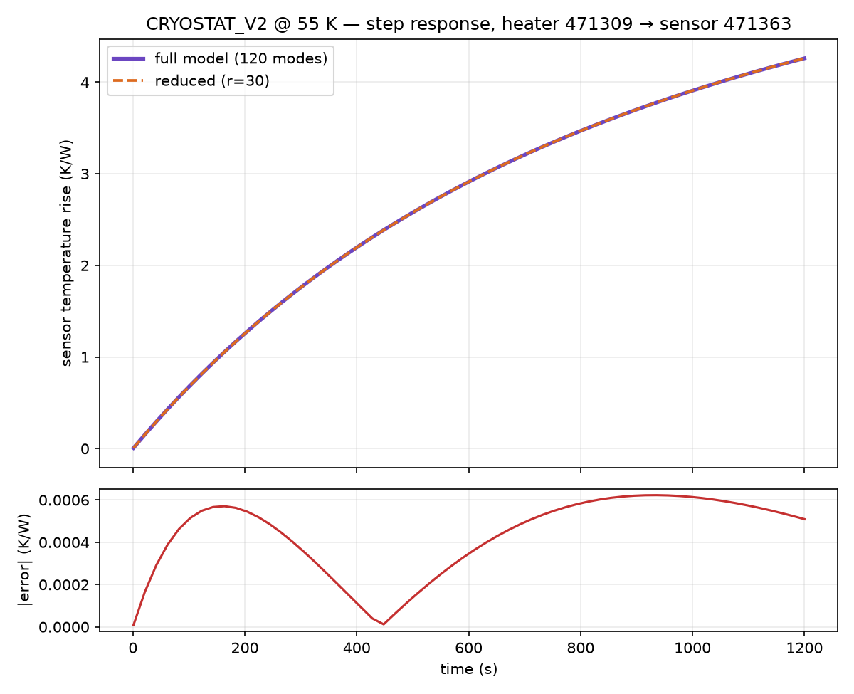

Figure 2. Full (120-mode) vs. reduced (r = 30) step response for the dominant heater→sensor pair; the reduction preserves the input–output map to ~0.15%.

The LQR design. On the 30-state model (linearized about T_op = 55 K) I design a linear-quadratic regulator: choose the feedback u = −K x that minimizes the cost ∫ (yᵀy + ρ uᵀu) dt, which trades tracking accuracy against heater effort. The gain K (33 × 30) comes from solving the associated algebraic Riccati equation, with effort weight ρ = 0.3. The supporting pieces use a Tikhonov regularization fraction of 10⁻³ for the static estimator and an integral gain of 0.08. Why LQR is the right tool here: it produces an optimal, fully coordinated multivariable law — every heater's command uses the entire state estimate, so the controller actively works with the cross-coupling instead of fighting it, which is exactly what independent PID loops cannot do. Figure 3 shows this directly: K is dense, and several heaters draw on shared modes. Around the LQR core sit three supporting pieces: a static state estimator that reconstructs the 30 states from the 72 sensor readings, a regularized steady-state feedforward that supplies the open-loop power to reach a setpoint, and an integral term that removes residual offset from model error and the uncertain radiation load.

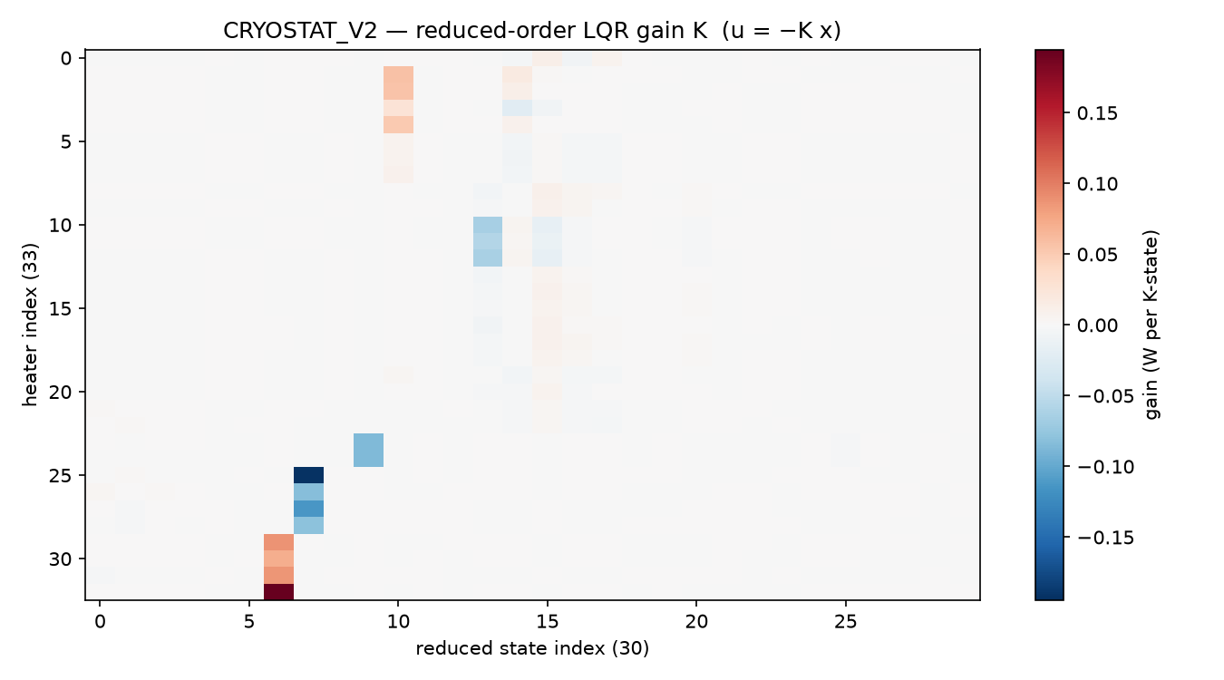

Figure 3. LQR feedback gain K (u = −Kx); its density shows genuinely coordinated multivariable control across all 33 heaters.

The main drawback — one-sided inputs. LQR is optimal for unconstrained, bidirectional inputs, but HISPEC's heaters can only add heat (u ≥ 0) and are capped (u ≤ u_max). When the ideal LQR command would be negative — i.e. the controller wants to cool — it simply cannot, and must wait for passive/cryocooler cooling; when it saturates high, the optimality guarantees no longer hold. Right now this is handled pragmatically with clamping, output slew-limiting, and integral anti-windup, but that is a patch on top of a controller that does not know about the constraint. The controller also inherits any error in the reduced model.

How I am addressing the deficiencies. Two directions:
• Adaptive feedforward — update the steady-state feedforward online so it absorbs model error and the (poorly known) radiation load instead of relying on a fixed, model-derived gain. This directly attacks the "G is unreliable" problem.
• Reduced-order MPC — model-predictive control on the same 30-state model, which handles the input constraints (0 ≤ u ≤ u_max, slew limits) explicitly and optimally rather than by clamping. This is the principled fix for the one-sided actuation, and the small reduced model is what makes MPC computationally feasible for on-board use.

Problems encountered, and remaining goals

Problems and how I am solving them.
• Hollow-shell geometry (Thread 1): the GLB import drops solids, so absolute numbers are unrepresentative. Being fixed with a STEP/B-rep solid-fill import.
• One-sided, constrained actuation (Thread 2): breaks LQR optimality; being addressed with adaptive feedforward and reduced-order MPC.
• Reliance on a model-derived gain without system identification: the whole approach exists precisely to sidestep sys-id on absent hardware, but it means the controllers must be robust to model error — hence the integral action now and adaptive feedforward next.

Goals for the remainder, and how they have changed. The immediate goals are: (1) re-run the pipeline on solid-filled STEP geometry for a representative model; (2) implement adaptive feedforward and a reduced-order MPC to handle the one-sided constraints properly; (3) add surface-to-surface radiative coupling and rebuild the conduction operator with k(T) at the operating point for higher fidelity; and (4) eventually validate against the real hardware once it exists. The emphasis has shifted since the start: the project began focused on getting a forward simulation to run with a basic PID, but as the coupling and constraint structure became clear, the center of gravity moved to model reduction and optimal, constrained multivariable control — and, in parallel, to improving the simulator's physical fidelity from shells to filled solids.

Figures generated from the CRYOSTAT_V2 model; see `docs/surf_report/make_figures.py` and the validation runner. Background and hardware details are in Interim Report 1.

