HeatTransferSim — User Guide
HeatTransferSim turns a CAD assembly into a lumped thermal model, simulates it closed-loop against a multi-input controller, and exports that controller as constants you can flash to a microcontroller.
This guide is written for someone who has the repository and needs to get a result out of it. Every screenshot is generated from the application's own widgets by tools/make_tutorial_screenshots.py, so the pictures cannot drift away from the software the way hand-cropped ones do.

Contents
- What the application is for
- Installing and launching
- The five tabs
- Finding anything: the help search
- Your first simulation
- The controller
- Exporting the controller
- Long runs
- Checking the solver
- Where files live
- When something goes wrong

1. What the application is for
A cryogenic instrument has many heaters and many temperature sensors, coupled through one metal structure. Turning on any heater moves every sensor. The problem this software exists to solve is: given the CAD, what commands should each heater receive to hold every sensor at its setpoint?
It answers that in three stages.
Stage | What it does | Where it lives
Build | CAD (GLB or STEP) → octree → a lumped RC thermal graph | octree_graph/, run via hts-build-graph
Simulate | Solve that graph forward in time with a controller in the loop | The application, graph_visualizer/
Deploy | Write the controller out as constants | hts-export-controller, or a button in the app

A short piece of vocabulary used throughout:
- Cell / node — one lumped mass at a uniform temperature. A graph has
hundreds of thousands of them.
- Graph — the whole network of cells and the conductances between them,
saved as a folder under graphs/.
- Heater / sensor — cells tagged with a role. Heaters take power in; sensors
are where temperature is measured and regulated.
- G — the DC gain matrix, in kelvin per watt. G[i][j] is how far sensor i
settles when heater j gets one watt. This matrix is the controller's model of the plant.

2. Installing and launching
Needs Python 3.11 or newer.
python -m pip install git+https://github.com/JustKorolev/HeatTransferSim
heattransfersim
That is the whole install: heattransfersim launches the application from any directory. If you intend to change the code, clone it and install in place instead:
git clone https://github.com/JustKorolev/HeatTransferSim
cd HeatTransferSim
python -m pip install -e ".[dev]"
Installing also puts the pipeline on your PATH as commands:
Command | Does
heattransfersim | Launch the application
hts-build-graph | CAD → octree → thermal graph
hts-run | Headless closed-loop run
hts-export-controller | Write the controller out as constants
hts-build-modal | Reduce a graph and design the modal LQR controller
hts-build-g | Solve the DC gain matrix G
hts-refresh-fast-load | Rebuild a graph's fast-load artifacts

These are the same modules the application launches as background jobs, so a command and the app's own subprocess run identical code.
If you need the STEP/B-rep build pipeline, it depends on OpenCASCADE, which has no pip wheel on any platform. GLB input needs nothing extra; for STEP, use conda:
conda env create -f environment.yml
conda activate heatsim
python -m pip install -e .
Note. The graph builder also needs embreex for fast ray tests. Without
it the build is roughly sixty times slower, so it fails fast rather than
appearing to hang. Pass --allow-slow-contains if you really want the slow
path.
The application does not create graphs. It loads ones that hts-build-graph has already written into graphs/.

3. The five tabs
Tab | Use it to
3D Octree Graph Editor | Look at the cells in 3D. Select them, tag heaters and sensors, assign materials, cut a cross-section through the assembly.
2D Network Graph | See the same graph as a flat network of conductive links. Read-only.
Heat Transfer Simulation | Run the model live with the controller in the loop, identify the plant, design and export the controller.
Thermal Validation | Drive the real solver against cases with a known answer and read the error.
Headless Run | Launch a long run as a separate process that survives closing the app.

In octree mode the geometry and topology are read-only. They come from CAD, so the app will not let you edit them; what you can change is the labelling — which cells are heaters, which are sensors, what material each part is, and what each one is connected to thermally.
The two simulation tabs deliberately share one control panel, built by one piece of code. If a setting exists on one, it exists in the same place on the other.

4. Finding anything: the help search
The application has roughly two hundred controls, most named for the control theory behind them rather than for what you are trying to do. Rather than hunting, press `Ctrl+F`.
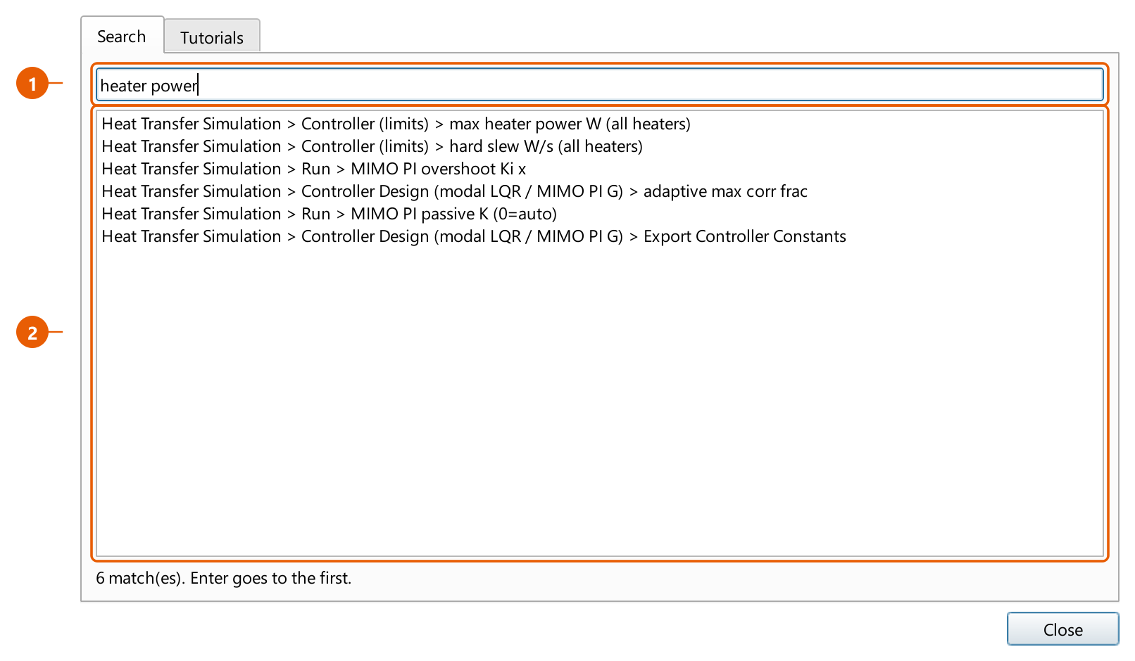
The help search, showing results for "heater power"
- Type what you want, in your own words. "heater power", "checkpoint",
"ambient", "firmware". Search runs as you type, so a prefix is enough.
- The results name the full path — tab, then section, then the control.
Click a result (or press Enter for the first one) and the application switches to the right tab, scrolls the control into the middle of the panel, and pulses an orange outline around it. You are looking at the control, not at a description of where it might be.
Every word you type has to match something, so adding a word narrows the list. heater alone returns a lot; heater slew returns one.
Press `F1` for the tutorials, which cover the same ground as this guide but inside the application:
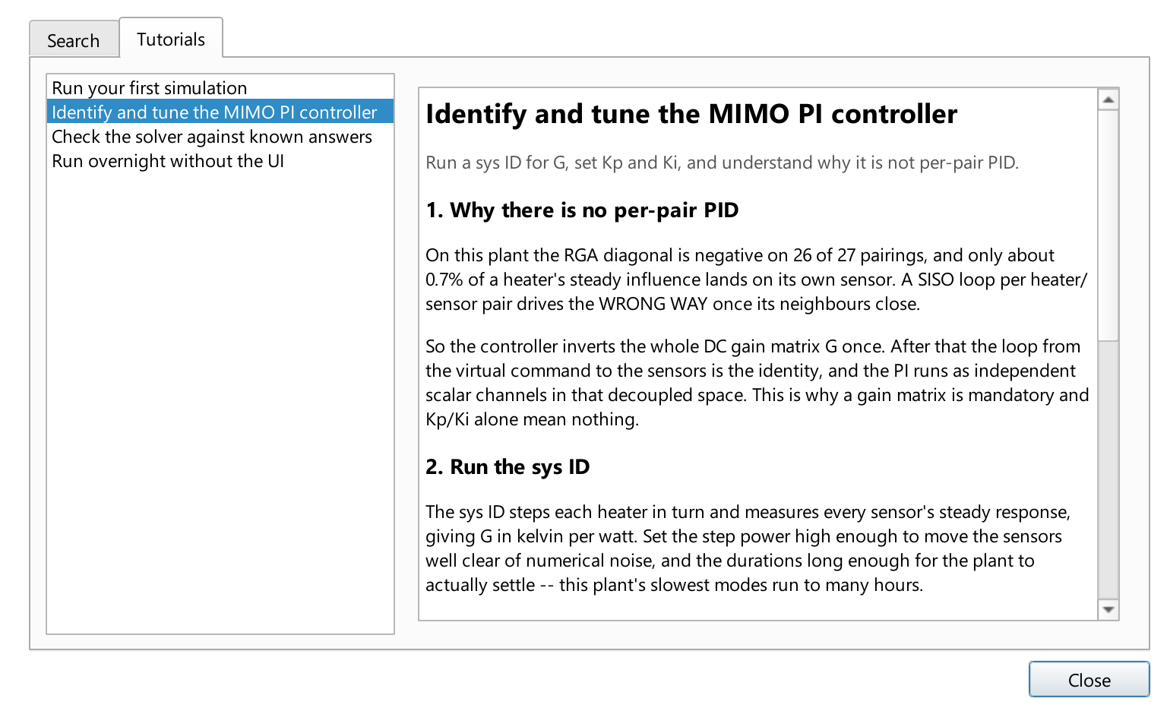
The tutorials, open at the controller walkthrough
Steps that mention a specific control carry a "Show me this control" link that reveals and flashes the real widget.

The menus
Menu | Holds
File | New / Open / Save / Save As, Export Controller Constants (Ctrl+E), Update Graph, Exit
View | The UI scale slider, larger/smaller text, dark mode
Help | Control search (Ctrl+F), tutorials (F1), About

View carries a live UI scale slider, 40% to 200%. Drag it and the whole interface resizes as you watch; Ctrl + and Ctrl - step it, Ctrl 0 returns to 100%. The setting is remembered between sessions.
It scales by font size rather than zooming a picture of the interface, so panels, rows and buttons all grow with the text instead of the text overflowing boxes that stayed the same size. The range goes well below 100% on purpose: on a display whose DPI Qt over-estimates, everything is already too large before the application gets a say, and the only useful correction is downward.

5. Your first simulation
Open the Heat Transfer Simulation tab and choose a graph from the dropdown at the top. Then work down the Run section.
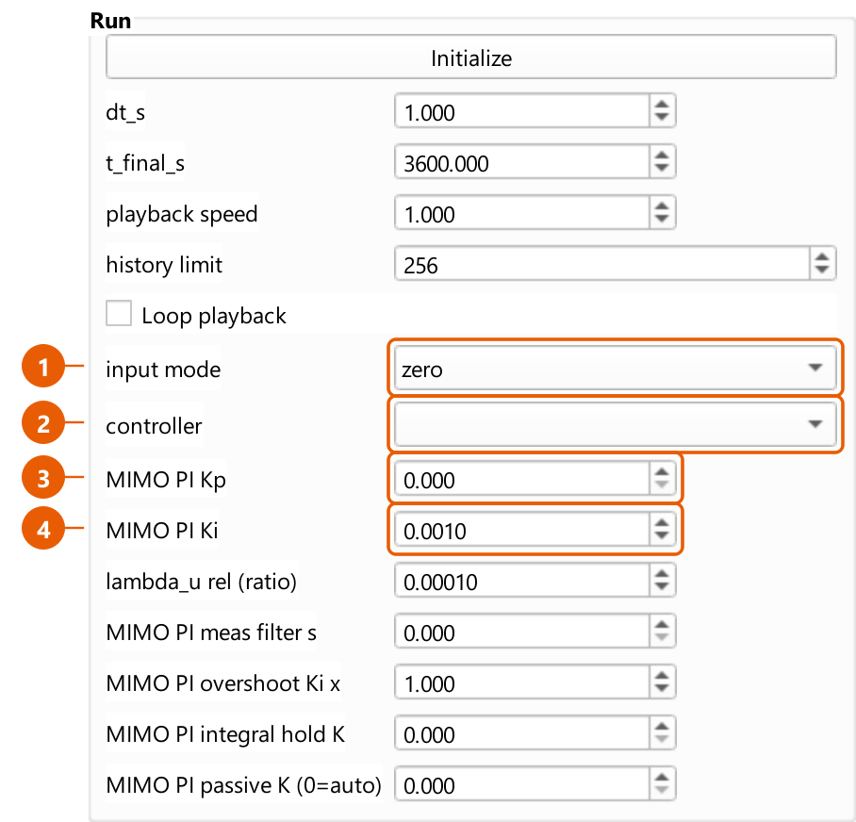
The Run section
- input mode — zero runs the plant with no heater input at all, which is
how you watch it drift to its passive equilibrium. heater_inputs is the one that closes the loop.
- controller — which scheme regulates the heaters. `(no controller
selected)` leaves them unregulated, so the run is open-loop apart from cryocoolers and any manual heaters.
- MIMO PI Kp — proportional gain, per controlled sensor.
- MIMO PI Ki — integral gain, per controlled sensor.
Above those, dt_s is the control period and t_final_s is how long the run covers in simulated seconds.
Press Initialize to build the operator matrices and prepare the solver, then Play. The 3D view recolours as the simulation advances.
**A graph above about 250,000 cells will warn you before it tries to draw
itself.** Live visualisation of a multi-million-cell model is slow and
memory-hungry. For anything long, use the Headless Run tab (section 8).

Environment
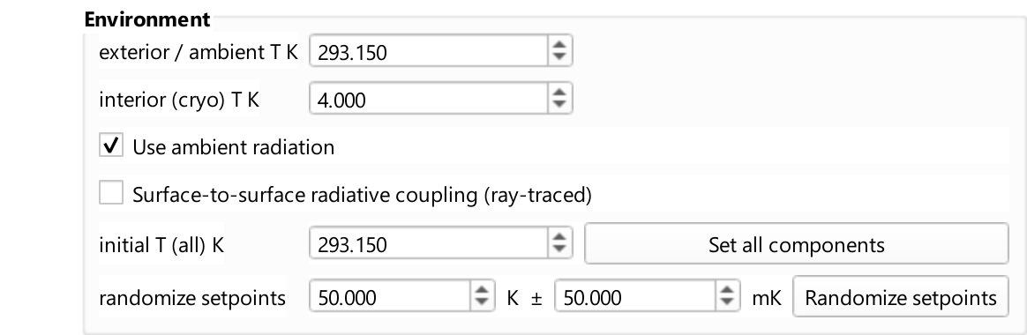
The Environment section
Two radiative backgrounds, and the distinction matters. The exterior is the room the outside of the assembly radiates to. The interior is the cryocooled vacuum enclosure the inner surfaces see. Which surfaces get which is decided by the view-factor classification; until that runs, everything radiates to the exterior.

Material properties
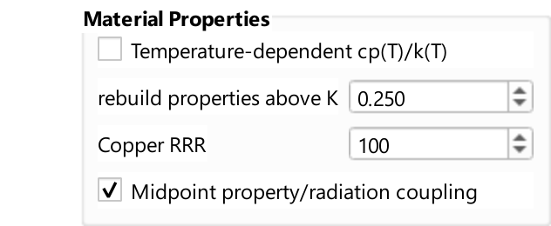
The Material Properties section
At cryogenic temperatures, specific heat and thermal conductivity are not constants — copper's conductivity varies by orders of magnitude between 4 K and room temperature. Turning on temperature-dependent properties makes the solver evaluate them at each cell's current temperature instead of using a single value.

Cryocooler
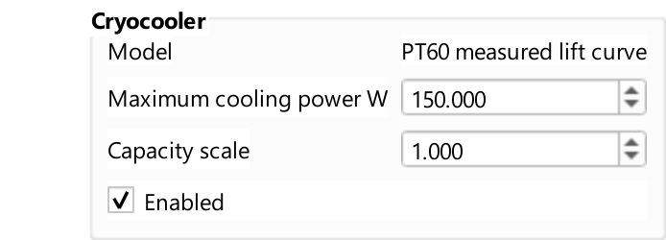
The Cryocooler section
The cooler is modelled by its lift curve: how much heat it removes as a function of its own tip temperature. It is not a fixed heat sink, and this is why "how much cooling do I have?" only has an answer once you know how cold the tip is.

6. The controller

Why it is not one PID per heater
The obvious design — pair each heater with its nearest sensor and give each pair a PID loop — does not work on this plant, and it is worth understanding why before you tune anything.
On the reference assembly, only about 0.7% of a heater's steady influence lands on its own sensor. The rest goes everywhere else. Worse, the relative gain array has a negative diagonal on 26 of 27 pairings: once the neighbouring loops close, a pair's loop drives in the wrong direction.
So the controller does not pair anything. It inverts the whole gain matrix G once. After that inversion, the loop from a virtual command to the sensors is the identity, and the PI runs as independent scalar channels in that decoupled space.
This is why a gain matrix is mandatory and why Kp and Ki alone do not define this controller.

Step one: identify the plant
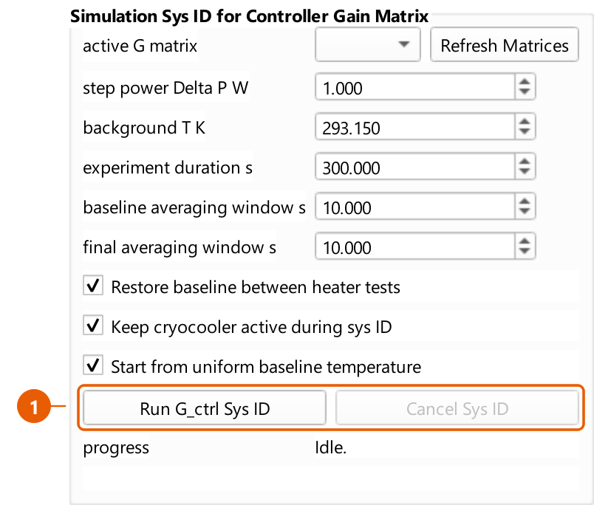
The Sys ID section
The sys ID steps each heater in turn and measures every sensor's steady response, producing G in kelvin per watt.
Two settings decide whether the result is any good:
- Step power must be large enough to move the sensors clear of numerical
noise.
- Durations must be long enough for the plant to actually settle. This plant's
slowest modes run to many hours; a test that stops early measures a transient and calls it a steady state.
The result is saved as a run folder under the graph's sys_id/.

Step two: set the gains
After decoupling, every channel has unit DC gain, which makes the tuning unusually direct:
- Ki = 1 / lambda, where lambda is the closed-loop time constant you want.
- Kp = tau / lambda.
Do not ask for a lambda faster than the plant's fastest retained mode. The model truncates the fast dynamics, so commanding faster than it excites behaviour the model does not contain. Starting at Kp = 0 gives feedforward plus integral, which is a reasonable place to begin; raise it if the approach is too sluggish.

Step three: the limits
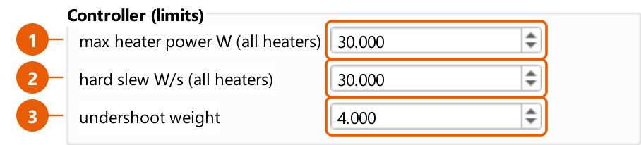
The Controller (limits) section
- max heater power W (all heaters) — a ceiling on every heater, not a
fallback for ones that lack a rating. A heater rated below it keeps its lower rating; a per-heater override in the run table beats it outright. 0 means no ceiling.
- hard slew W/s (all heaters) — the maximum rate of change of a heater's
commanded power. This models the driver electronics, not the thermal response, which is already in the model. At any sane dt it is non-binding. Lower it only to encode a real constraint: a rate limiter that binds costs phase margin and can drive oscillation.
- undershoot weight — how much more the allocator dislikes leaving a sensor
short of its target than pushing it past. 1.0 is symmetric. Symmetric is usually wrong here, because heating the coldest sensor necessarily overshoots a neighbour that is nearly right, and a symmetric objective scores that overshoot as badly as the cold it removes — so the command stops early.

The allocator
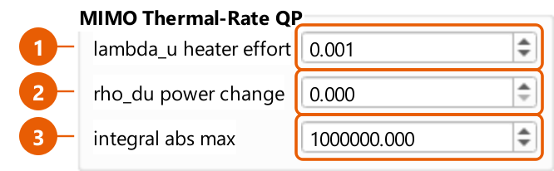
The MIMO Thermal-Rate QP section
Heater commands come from a bounded least-squares solve, not a raw matrix inversion. That matters when heaters saturate: the solver redistributes demand onto the unsaturated heaters instead of truncating each channel independently.
- lambda_u — how much the solve penalises control effort. Directions the
plant barely has cost enormous power for almost no temperature, and inverting through them makes the allocation flip between near-equivalent answers from step to step.
- rho_du — penalises changes in power between steps.
- integral abs max — a hard clamp on the accumulated integral.

7. Exporting the controller
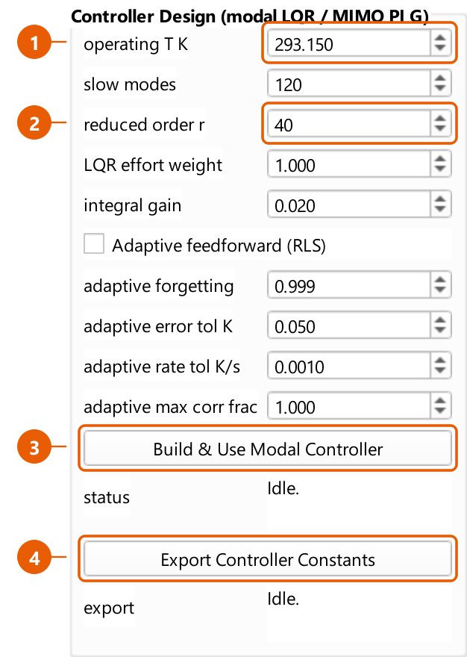
The Controller Design section
- operating T K — the temperature the plant is linearised about. Both
controller builds read this one field, so the modal artifact and the gain matrix describe the same linearisation and can be compared.
- reduced order r — how many states the reduced model keeps.
- Build && Use Modal Controller — runs the model reduction and LQR design in
the background, then loads the result.
- Export Controller Constants — writes the controller out.
The export produces two files:
File | For
controller_constants.h | Firmware. Dependency-free C, every array static const float, sized by #define.
controller_constants.json | Tooling, and reading back into the app.

Both carry the gain matrix G, its regularised inverse, per-sensor Kp/Ki and setpoints, per-heater power and slew limits, every loop-shaping constant, and provenance naming the gain matrix and commit they came from. The header states the control law in a comment block at the top.
The same export is available from the command line:
hts-export-controller --graph graphs/CRYOSTAT_V2
hts-export-controller --graph graphs/CRYOSTAT_V2 --list
Read the two warnings the export prints.
The application allocates power with a bounded solver that a microcontroller
generally will not carry, so the header ships a regularised inverse instead.
That substitution is exact only when the undershoot weight is 1 and no heater
is bounded. The export runs the real allocator at export time and tells you the
measured deviation in watts rather than claiming they agree.
If no passive reference is available, the header defines
PASSIVE_REFERENCE_UNKNOWN instead of emitting a zero, and tells the firmware
to latch it from a quiet plant. A zero there would silently bias every command.

8. Long runs
The Headless Run tab never loads a graph into the application window. That is the entire point of it: a multi-million-cell model will not fit beside the 3D viewer, and redrawing during an overnight run is wasted work. It lists graphs by reading a file header, launches the run as a detached process that survives closing the app, and monitors it by polling that run's own status file.
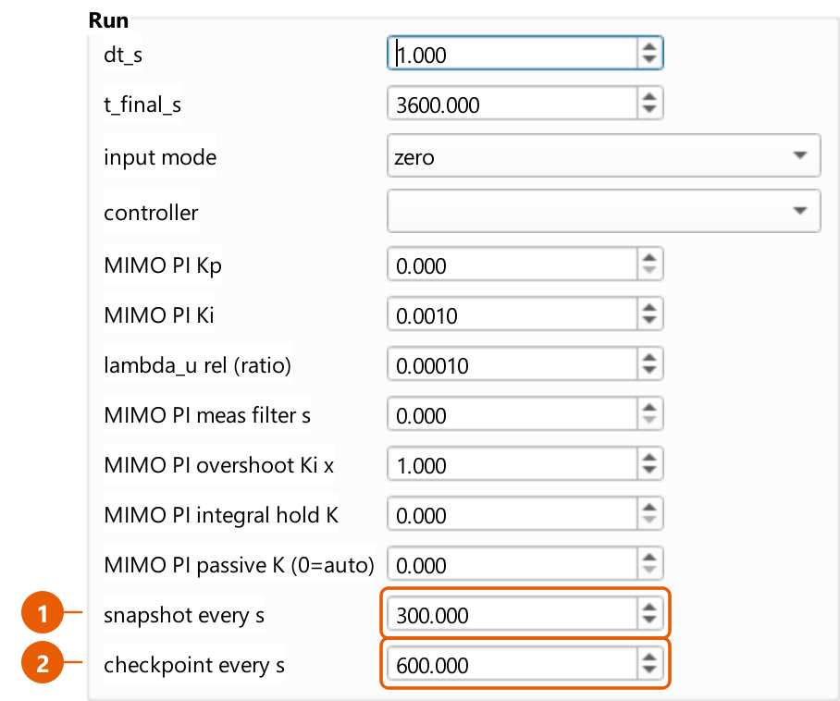
The Headless Run tab's Run section
- snapshot every s — how often the series you will plot is sampled.
- checkpoint every s — how often a full restart point is written.
The difference matters. Checkpoints are large — multiple megabytes on a big graph — and include the controller's integrator state so a resume genuinely continues the run rather than restarting it. The interval is a real trade-off between disk and how much you lose if the run dies.
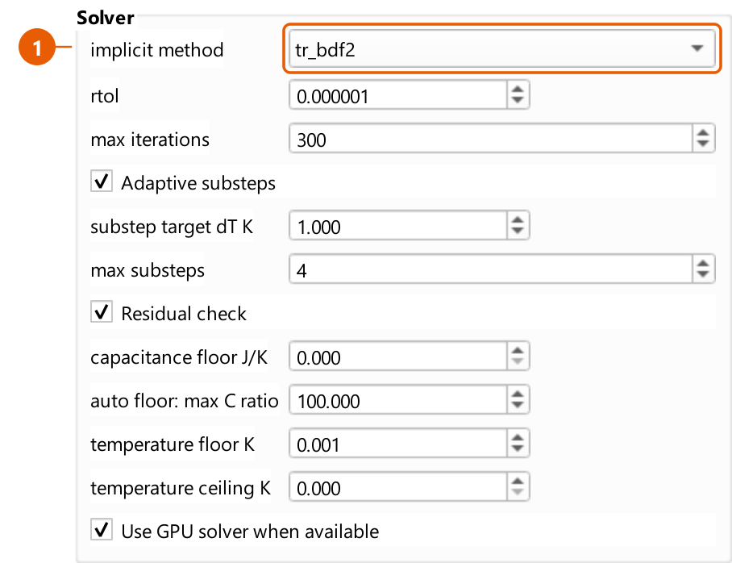
The Headless Run tab's Solver section
The solver settings are shown here and hidden on the live tab, because an overnight job is exactly where they decide whether the run converges or crawls. tr_bdf2 is the more accurate implicit method; backward_euler is more robust and more damped.
Each run writes simulations/<graph>/<timestamp>/ containing the series, plots, status.json, events.log, the exact parameters it ran with, and the checkpoints.
The same thing from a shell:
hts-run --graph graphs/CRYOSTAT_V2 --setpoint 80 --duration 3600 --dt 1

9. Checking the solver
The Thermal Validation tab drives the real solver — the same code path a production run uses — against cases whose answer is known independently: one-dimensional conduction, lumped radiation cooling, temperature-dependent heating, and a published experimental benchmark.
This is not a unit test suite. It reports the error against each reference so you can judge whether a modelling choice is good enough for what you are doing. Export Results writes the per-case error series to CSV, which is what you want when a change moves a number and you need to say by how much.

10. Where files live
graphs/<name>/ a built graph
graph.json cells, edges, roles, materials
nodes.csv fast-load index, written at BUILD time
C.npy, L.npy, G_rad.npy capacitance, Laplacian, radiation
simulation_parameters.json this graph's saved settings
sys_id/<run>/ identified gain matrices
controller_export/ exported controller constants

simulations/<graph>/<stamp>/ one run
status.json, events.log progress, and what happened
checkpoints/ restart points
plots/ figures
`nodes.csv` is written when the graph is built, not when you edit it.
Changes made in the application — cryocooler assignments, materials, roles — go
into graph.json. If you edit a graph and then want headless runs to load it
the fast way, press Update graph (or run hts-refresh-fast-load) to
regenerate nodes.csv. The application checks for staleness and falls back to
the slow loader rather than silently simulating a model with no heaters in it.
Neither graphs/ nor simulations/ is tracked in version control. Graphs are rebuilt from CAD; runs are reproducible from the graph plus their own saved parameters.

11. When something goes wrong
The controller is not doing anything. Check input mode is heater_inputs — in zero mode nothing drives the heaters. Then check a controller is selected: the placeholder row regulates nothing.
"MIMO PI gain matrix unavailable". The selected gain matrix does not match this graph, usually because it was identified on a different one. The node ids it names have to exist here. Re-run the sys ID.
Every sensor sits below setpoint while heaters idle. The classic symptom of a symmetric objective on a coupled plant. Raise the undershoot weight; see section 6.
A channel tracks badly no matter how you tune it. It may not be mistuned but unreachable — no non-negative heater command can serve it, because serving it would require cooling somewhere and heaters only heat. The run's diagnostics report reachability per sensor precisely so these two cases can be told apart.
A run stopped and `status.json` still says "running". That is a native crash, not a Python exception, so there is no traceback. Look for crash.log in the run folder: a low-level stack for every thread is written there as the process dies, and it is the only evidence there will be.
A graph build exits complaining about `embreex`. Install it. Without it the geometry tests are about sixty times slower, so the build refuses rather than appearing to hang. --allow-slow-contains overrides this.

Regenerating this guide's screenshots
python tools/make_tutorial_screenshots.py
Images are written to docs/user_guide/images/. Each one is captured from the application's own widgets, and the callouts are placed from the widgets' real geometry, so a renamed or moved control changes the picture rather than leaving a stale one behind. The script prints a warning if a control it wants to annotate no longer exists.
The 3D viewer is not captured by default: it needs a real OpenGL context, which is unavailable when rendering offscreen. Add --with-viewer on a machine with a display to include it.

