**Mood-board**

1. **Colors to be used:**

(Luxury Colors)

1. 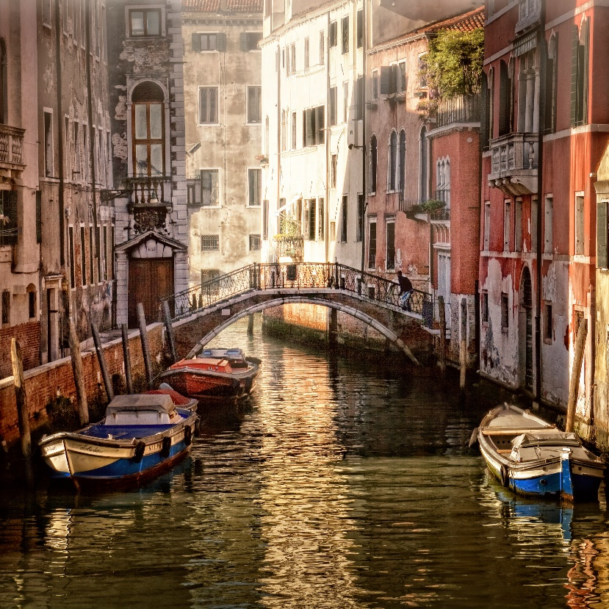**A mountain in the distance

   Description automatically generated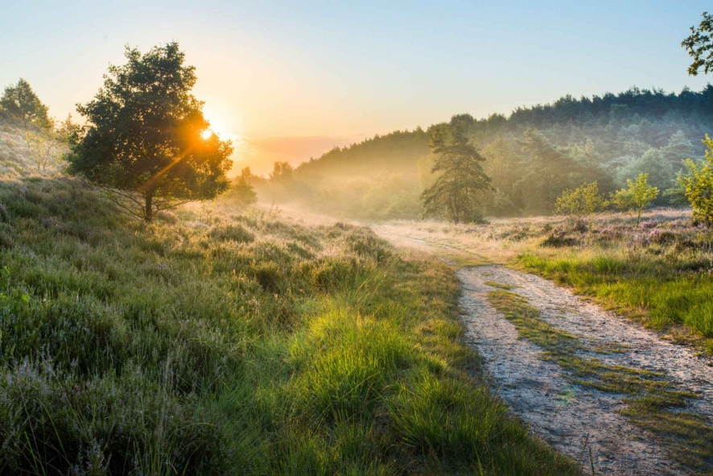Examples of images to be used:**
2. **Fonts:**

**Font Family: Poppins**