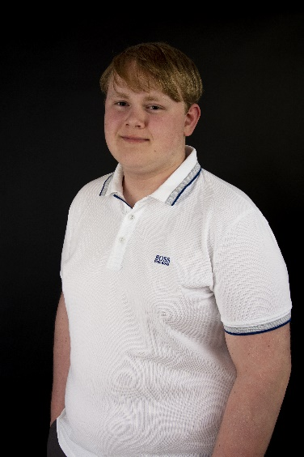**Curriculum vitae of Kornee Hartlief**

**Personal information**

**Name:** Kornee Hartlief

**Date of birth:** 25-03-2005

**Place of birth:** Delfzijl

**Address:** Sluisstraat 78

**Zip code :** 9581 JD Musselkanaal

**Country:** The Netherlands

**Nationality:**  Dutch

**marital status:** unmarried

**mobile number :** +31 6-29000841

**E- mail:** [kornee.w.hartlief@gmail.com](mailto:kornee.w.hartlief@gmail.com)

**Portfolio:** <https://justmegamedev.github.io/>

**Linked-in:**

**____________________________________________________________________________________**

**Introduction**

I'm Kornee Hartlief. I am currently studying Game-Development at Noorderpoort Groningen, this is a secondary vocational education on level 4 (highest) . I have chosen for Game-Development, because I think technology is the future. You learn something new every time, which why I find this is interesting.

____________________________________________________________________________________

**Diplomas Completed at**

Pre-vocational secondary education -

with certificate of technical engineering 2018 - 2021

Location: CSG Wesselgansfort Groningen (year 1, 2 & 3) –

SG Ubbo Emmius Engelandlaan Stadskanaal (year 3&4)

____________________________________________________________________________________

**Current education Started at**

Secondary vocational education-

Game -Developer: level 4 2021

Location: Noorderpoort Groningen

____________________________________________________________________________________

**Work experience From - To**

Cashier for COOP BV (supermarket) 2021 – present

All-round employee at De Schaapsberg (congress center) 2019 – present

____________________________________________________________________________________

**Personal characteristics**

Social, good collaboration, goal-oriented, honest, accurate, eager to learn, can work in a scrum environment