





MINI PROJECT REPORT
ON
Travel Management System using Microservices
Submitted in the partial fulfillment of the requirements for the award of the degree of
BACHELOR OF TECHNOLOGY IN
CYBER SECURITY & CYBER FORENSICS
Submitted by,
Ralph Joel - 01SU23CF016 Sophie Pereira - 01SU23CB036
Under the guidance of,
Mr. Yogesh Bandewar IBM Lecturer
Dept. of Cyber Security
2025-2026
DEPARTMENT OF CYBER SECURITY

SRINIVAS UNIVERSITY, MUKKA






SRINIVAS UNIVERSITY
INSTITUTE OF ENGINEERING & TECHNOLOGY MUKKA, MANGALURU-574146

Department of Cyber Security & Cyber Forensics

CERTIFICATE
This is to certify that the Technical Seminar entitled “Travel Management System using Microservices” is a bona fide work carried out by Ralph and Sophie bearing the USN 01SU23CF016 and 01SU23CB036 in the partial fulfillment for the award of Bachelor of Technology in Cyber Security & Cyber Forensics of the Srinivas University- Institute of Engineering & Technology during the year 2025-26. It is certified that all corrections/suggestions indicated for internal assessment have been incorporated in the report deposited in the department library. The mini project report has been approved as it meets the academic criteria outlined for the said degree

Name & Signature Name & Signature

Mr. Yogesh Bandewar Prof. Gaurav Prasad
(Project Coordinator) (HOD, Cyber Security)

-






SRINIVAS UNIVERSITY
INSTITUTE OF ENGINEERING & TECHNOLOGY MUKKA, MANGALURU-574146

Department of Cyber Security & Cyber Forensics

DECLARATION
We, Ralph Joel and Sophie Pereira the student of 6th semester, Bachelor of Technology in Cyber Security & Cyber Forensics of the Srinivas University- Institute of Engineering & Technology, Mukka, hereby declare that the mini project report entitled “Travel Management System using Microservices” has been successfully completed by us in partial fulfillment of the requirements for the award of degree in Bachelor of Technology in Cyber Security & Cyber Forensics of Srinivas University- Institute of Engineering & Technology and no part of it has been submitted for the award of degree or diploma in any university or institution previously.

Date: 22-03-2026
Place: Mukka

ABSTRACT
This project presents the design and development of a microservices-based travel management system aimed at demonstrating modern distributed application architecture. The system allows users to create and manage trips, organise destinations, simulate bookings, and receive notifications, all through a modular and scalable backend structure. Unlike traditional monolithic systems, the application is divided into independent services, each responsible for a specific functionality such as user management, trip handling, booking processing, and notification delivery. These services communicate through a centralized API Gateway using RESTful APIs, ensuring loose coupling and efficient request handling. The frontend is developed using React, providing an interactive user interface, while the backend is implemented using Node.js and Express.js. MongoDB is used for data persistence, particularly for managing trip-related information. Additional configurations such as CORS and environment variables are applied to ensure controlled access and secure system behaviour. The project highlights key concepts of microservices architecture including service isolation, scalability, and fault tolerance. It also demonstrates the practical application of network communication principles in distributed systems. Overall, the system serves as a functional prototype and a learning model for building scalable and maintainable web applications.

Keywords: Microservices Architecture, Travel Management System, API Gateway, REST APIs, MERN Stack, Distributed Systems, Node.js, MongoDB, React, Express.js, Service Isolation, Scalability

ACKNOWLEDGEMENT
It is our pleasure to acknowledge all those who have provided guidance, inspiration, and encouragement for the successful completion of our mini project.
First and foremost, our sincere thanks go to Mr. Yogesh Bandewar, Mini Project Coordinator, for coordinating the project process, offering timely suggestions, and being a constant source of motivation and assistance.
We are immensely grateful to Prof. Gaurav Prasad, Head of the Department of Cyber Security, for his constant encouragement and valuable support throughout the course of our studies.
We would also like to extend our heartfelt thanks to Dr. Ramakrishna N. Hegde, Dean, SUIET, for his guidance and for facilitating the smooth conduct of the Mini Project Demonstration.
We are deeply thankful to the Management of Srinivas University Institute of Engineering and Technology for providing us with the opportunity to undertake this project as part of the academic curriculum. Their vision and commitment to practical learning have made this experience possible.
We would also like to acknowledge the support and encouragement of all the faculty members of the Department of Cyber Security, whose teachings laid the foundation for this practical learning.
Last but not least, we thank our family and friends for their continuous moral support and encouragement during the entire period of the project and report preparation.
This Mini Project has been a truly enriching experience and a vital step in our professional development
Sl. No. | TITLE | Page No.
Chapter 1 | INTRODUCTION | 7
Chapter 2 | PROBLEM STATEMENT | 8
Chapter 3 | PROJECT OBJECTIVES | 9
Chapter 4 | SYSTEM ARCHITECTURE & IMPLEMENTATION | 10
Chapter 5 | TECHNOLOGIES USED | 13
Chapter 6 | METHODOLOGY | 15
Chapter 7 | IMPLEMENTATION | 17
Chapter 8 | RESULTS | 21
Chapter 9 | ADVANTAGES & LIMITATIONS | 27
Chapter 10 | FUTURE ENHANCEMENTS | 29
Chapter 11 | UML DIAGRAMS | 31
Chapter 12 | CONCLUSION | 35
Chapter 13 | REFERENCES
TABLE OF CONTENTS

LIST OF FIGURES

Fig No. | List Of Figures | Page No.
8.1 | User Registration Interface for Creating a New Account | 21
8.2 | User Login Page for Secure Access to the Application | 22
8.3 | Main Dashboard Displaying Overview of Travel Planning Features | 22
8.4 | Main Dashboard Displaying Overview of Travel Planning Features | 23
8.5 | Continuation of Trip Creation Showing Destination Addition and Planning | 23
8.6 | Trip Booking and Management Page for Viewing and Creating Bookings | 24
8.7 | Trip Notification Page for Sending Details via Real-Time Email | 24
8.8 | User Data Successfully Stored and Viewed in MongoDB Database | 25
8.9 | Trip Details Stored in MongoDB with Destination and Itinerary Data | 25
8.10 | Booking Information Stored and Retrieved from MongoDB | 26
8.11 | Trip Itinerary Details Sent via Email and Received Successfully | 26
11.1 | Use case diagram | 31
11.2 | Class diagram | 32
11.3 | Sequence diagram | 33
11.4 | Collaboration diagram | 34

Chapter-1

INTRODUCTION

The Travel Management System developed in this project is a microservices-based web application designed to simulate the core functionalities of a modern travel platform. The system enables users to create and manage trips, add destinations, and simulate booking and notification processes through a structured and modular backend. Unlike traditional monolithic applications, where all functionalities are tightly integrated into a single system, this project adopts a microservices architecture. The application is divided into independent services such as User Service, Trip Service, Booking Service, and Notification Service. Each service is responsible for a specific task and operates independently, improving flexibility and maintainability.

An API Gateway is used as the central entry point for all client requests. Instead of directly interacting with multiple services, the frontend communicates only with the gateway, which routes requests to the appropriate service. This simplifies the system design and provides better control over request handling and communication. The frontend is developed using React, which allows for dynamic user interaction and efficient rendering of components. The backend services are implemented using Node.js and Express.js, providing a lightweight and efficient environment for handling HTTP requests. MongoDB is used for storing trip-related data, offering flexibility in managing structured and semi-structured information.

Communication between services is carried out using RESTful APIs, ensuring a standard method of data exchange. Additionally, configurations such as CORS are applied to enable secure communication between the frontend and backend, especially since they operate on different ports. The system is designed with key principles such as modularity, scalability, and service independence. Each service can be developed, tested, and deployed separately, reducing the impact of changes and improving overall system reliability.

This project provides a practical understanding of how distributed systems function and highlights the importance of structured backend design in modern applications. It serves as a foundational implementation of microservices architecture in the context of a travel management system.

Chapter 2

PROBLEM STATEMENT

Traditional travel management systems are commonly developed using a monolithic architecture, where all functionalities such as user management, trip planning, booking, and notifications are combined into a single application. While this approach may work for small-scale systems, it becomes increasingly difficult to manage as the application grows in complexity and user demand increases.
One of the major issues with monolithic systems is the lack of scalability. When a specific feature, such as booking, experiences high demand, the entire application must be scaled instead of just the required component. This leads to inefficient resource usage and increased operational overhead. Additionally, tightly coupled components make it difficult to modify or update individual features without affecting other parts of the system, increasing the risk of system failure.
Maintenance and debugging also become challenging in such systems. Since all modules are interconnected, identifying the source of errors can be time-consuming and complex. Any failure in one part of the application may impact the entire system, reducing reliability and user experience.
Furthermore, most academic projects do not reflect modern industry practices, as they focus mainly on basic CRUD-based applications rather than distributed system design. This creates a gap between theoretical knowledge and real-world application development.
To overcome these limitations, there is a need for a system that is modular, scalable, and easier to maintain. This project addresses these challenges by designing a microservices-based travel management system, where each functionality is separated into independent services. By using an API Gateway and RESTful communication, the system ensures efficient interaction between services while maintaining flexibility and fault isolation.
This approach not only improves system performance and maintainability but also provides practical exposure to modern software architecture concepts.

Chapter 3

PROJECT OBJECTIVES

The main objective of this project is to design and develop a microservices-based travel management system that reflects modern backend development practices and demonstrates how distributed systems operate in real-world applications.
The project focuses on building a modular and scalable system where each functionality is handled by an independent service. This helps in improving system flexibility, maintainability, and performance.

Specific Objectives:
- To implement a microservices architecture using Node.js, where different services run independently on separate ports and handle specific functionalities of the application.
- To design and develop an API Gateway that acts as a single entry point for all client requests, handling routing and forwarding requests to the appropriate backend services.
- To develop independent backend services including:
  - User Service for managing user-related operations
  - Trip Service for handling trip creation, destination management, and itinerary data
  - Booking Service for simulating booking processes
  - Notification Service for generating alerts and responses after booking actions
The project aims to implement a structured communication system using RESTful APIs, enabling seamless interaction between the frontend and backend services through the API Gateway. A React-based frontend is integrated to provide a user-friendly interface, while MongoDB is used for storing and managing travel-related data, particularly within the Trip Service. This setup ensures efficient data handling and a clear separation between presentation and backend logic.
Additionally, the system is designed to demonstrate service independence, where each microservice can be developed and maintained without affecting others. It simulates real-world workflows such as trip planning, booking, and notifications, while applying key concepts like modularity, scalability, and distributed system design. The architecture also allows for future enhancements, making it easier to extend the system with features such as authentication, payment integration, and real-time updates.

Chapter-4

SYSTEM ARCHITECTURE & IMPLEMENTATION

Overview
The system is designed using a layered microservices architecture, where the application is divided into multiple independent services that communicate through a central API Gateway. This approach ensures that each component handles a specific responsibility, improving modularity and allowing the system to scale efficiently.
Unlike monolithic systems, where all functionalities are combined into a single codebase, this architecture separates concerns into distinct services. Each service runs on a different port and operates independently, making it easier to develop, test, and maintain individual components without affecting the entire system.

4.1 SYSTEM COMPONENTS
- Frontend (React Application):
The frontend serves as the user-facing layer of the system, built using React for dynamic and responsive interaction. It allows users to perform actions such as creating trips, viewing travel details, and initiating bookings. User inputs are captured, processed, and converted into HTTP requests, which are sent to the API Gateway. The frontend also handles displaying responses received from the backend in a structured and user-friendly format.
- API-Gateway:
The API Gateway acts as the central communication hub of the system. It receives all incoming requests from the frontend and routes them to the appropriate backend service based on the request path. By handling routing and request forwarding, it hides the internal structure of the system and prevents direct exposure of services. It also ensures smoother communication by managing request and response flow between client and services.
- User-Service:
The User Service is responsible for handling user-related operations such as storing and retrieving user information. It manages basic user data and provides a foundation for implementing authentication and authorization features in the future. Since it operates independently, changes to user-related logic do not affect other services.
- Trip-Service:
The Trip Service is the core component of the application, managing all travel-related data. It handles functionalities such as trip creation, destination management, and itinerary storage. This service uses MongoDB for data persistence, allowing efficient storage and retrieval of structured travel information.
- Booking-Service:
The Booking Service processes booking requests initiated by users. It validates incoming requests and generates confirmation responses. As a stateless service, it does not store any data, which allows it to handle multiple requests efficiently without additional overhead.
- Notification-Service:
The Notification Service is responsible for simulating alerts after specific actions, such as booking confirmations. It logs notification events and returns a response indicating successful processing. This service represents how real-world systems handle communication through email or SMS notifications.

4.2 SYSTEM WORKFLOW
- The process begins when the user interacts with the frontend interface by performing actions such as creating a trip or placing a booking request.
- The frontend collects the input and sends an HTTP request to the API Gateway using RESTful methods such as GET or POST.
- The API Gateway receives the request and analyzes the route to determine which backend service should handle it.
- Based on the request path, the gateway forwards the request to the appropriate microservice, ensuring proper routing.
- The selected service processes the request according to its functionality. This may involve data handling, validation, or interaction with the database.
- After processing, the service generates a response, typically in JSON format, containing the result of the operation.
- The response is sent back to the API Gateway, which acts as an intermediary layer.
- Finally, the API Gateway forwards the response to the frontend, where it is displayed to the user in a structured format.

4.3 ARCHITECTURAL FEATURES
- Modularity:
The system is divided into independent services, each responsible for a specific functionality. This separation simplifies development and allows individual components to be managed separately.
- Scalability:
Services can be scaled independently based on system demand. This ensures efficient resource usage and better performance under increased load.
- Loose-Coupling:
Each service communicates through APIs rather than direct connections, reducing dependency between components and allowing flexibility in development.
- Fault-Isolation:
A failure in one service does not impact the entire system. Other services continue to function, improving overall reliability.
- Centralized-Routing:
The API Gateway manages all incoming requests, providing a single point of communication and simplifying client-server interaction.
- Maintainability:
The modular structure makes it easier to debug, update, and extend the system without affecting other components.

Chapter-5

TECHNOLOGIES USED

The development of the Travel Management System involves the use of several modern web technologies, each contributing to different aspects of the application such as frontend design, backend processing, database management, and communication between services. These technologies are selected to support a scalable and modular microservices architecture.
- Node.js:
Node.js is used as the runtime environment for all backend services. It enables asynchronous and non-blocking execution, allowing the system to handle multiple requests efficiently. This is particularly useful in a microservices architecture where several services may be running simultaneously.
- Express.js:
Express.js is used as the backend framework to build RESTful APIs. It simplifies the process of defining routes, handling HTTP requests, and managing middleware. Each microservice is implemented using Express, allowing structured handling of different endpoints.
- React.js:
React.js is used for developing the frontend of the application. It provides a component-based structure that allows reusable UI elements and efficient rendering. React enables smooth user interaction and dynamic updates without reloading the entire page.
- MongoDB:
MongoDB is used as the database for storing travel-related data such as trips and destinations. Being a NoSQL database, it allows flexible schema design, which is useful for handling varying data structures in travel planning.
- Mongoose:
Mongoose is used as an Object Data Modeling (ODM) library for MongoDB. It helps in defining schemas, validating data, and interacting with the database in a structured way, making database operations more organized.
- Axios:
Axios is used for handling HTTP communication between the API Gateway and microservices. It allows sending and receiving requests in a simple and efficient manner, supporting features like request forwarding and response handling.

- dotenv:
The dotenv package is used to manage environment variables such as port numbers and database connection strings. This improves security by avoiding hardcoding sensitive information into the source code.
- CORS (Cross-Origin -Resource-Sharing):
CORS is configured to allow communication between the frontend and backend services running on different ports. It ensures that the browser permits requests across different origins while maintaining controlled access.
- Vite (Frontend-Tooling):
Vite is used as the build tool for the React frontend. It provides faster development server startup and efficient module bundling, improving overall development performance.

The combination of these technologies enables the system to function as a distributed application, supporting efficient communication, structured data handling, and scalable service design. Each component plays a specific role in ensuring that the application performs reliably while remaining easy to maintain and extend.

Chapter-6

METHODOLOGY

The project follows a client-server approach combined with microservices principles, where the system is divided into multiple independent components that interact through well-defined communication channels. The frontend acts as the client interface, handling user interactions and sending requests based on user actions. Instead of directly communicating with backend services, all requests are routed through an API Gateway, which serves as the central entry point of the system. This ensures that the client remains decoupled from the internal structure of the backend, making the system more secure and easier to manage.
On the server side, backend services operate independently, each responsible for a specific functionality such as user management, trip handling, booking, or notifications. These services process incoming requests, perform the required operations, and return responses without depending on other services. This independence allows the system to maintain flexibility, as changes in one service do not impact others. It also supports better scalability, since each service can be managed and deployed separately based on system requirements.

Working Method
The working method of the system is based on a structured request-response cycle that ensures smooth interaction between components. The frontend initiates communication by sending HTTP requests whenever a user performs an action, such as creating a trip or initiating a booking. These requests are directed to the API Gateway, which analyzes the request path and determines the appropriate service responsible for handling it.
Once the request is routed, the selected microservice processes the data according to its defined logic. For example, the Trip Service may store or retrieve data from the database, while the Booking Service may generate a confirmation response without persistent storage. After processing, the service sends a response back to the API Gateway, which then forwards it to the frontend. The frontend updates the user interface based on this response, completing the interaction cycle. This structured workflow ensures consistency in communication and reduces complexity in handling multiple services.

Key Practices
The system follows several key practices to ensure efficient and secure operation. Communication between components is carried out using REST APIs, which provide a standardized method for exchanging data through HTTP protocols. This ensures that all services follow a uniform structure for handling requests and responses, improving interoperability within the system.
Additionally, the use of environment variables allows sensitive information such as database connection strings and port configurations to be stored securely, rather than being hardcoded into the source code. Data management is also handled carefully, with persistent storage limited to services that require it, such as the Trip Service, while other services remain stateless to improve performance and reduce overhead.
Overall, this methodology ensures controlled communication, clear separation of responsibilities, and efficient system behaviour. It reflects real-world practices in distributed system design while maintaining simplicity suitable for implementation and understanding.

Chapter-7

IMPLEMENTATION

7.1 OVERVIEW
The system is implemented using a microservices-based approach, where multiple backend services are developed and deployed independently using Node.js and Express.js. Each service runs on a separate port and is responsible for handling a specific functionality within the application. This separation ensures that the system remains modular, scalable, and easy to maintain during development and testing. The frontend, developed using React, interacts with the backend exclusively through the API Gateway, ensuring that all communication is centralized. This prevents direct exposure of backend services and maintains a controlled request flow across the system. From a practical standpoint, the system runs multiple servers simultaneously, each representing a service. This setup mimics real-world distributed systems, where services operate independently but work together to complete user requests efficiently.

7.2 API GATEWAY
The API Gateway is implemented as a central routing server using Express.js. It listens for incoming requests from the frontend and forwards them to the appropriate microservice based on the request path. This ensures that all communication between client and services is handled in a structured and controlled manner. When a request is received, the gateway identifies the target service and forwards the request using an HTTP client. It then receives the response and sends it back to the frontend. This process hides internal service details and simplifies client-side logic. The gateway also handles CORS configuration, allowing communication between services running on different ports. This is essential for enabling frontend-backend interaction in a distributed environment.

Code Snippet 1: API Gateway Routing
const express = require('express');
const axios = require('axios');
const app = express();
app.use(express.json());
app.post('/trips', async (req, res) => {
try {
const response = await axios.post('http://localhost:5002/trips', req.body);
res.json(response.data);
} catch (err) {
res.status(500).json({ error: 'Service unavailable' });
}
});
app.listen(5000, () => console.log('API Gateway running'));

7.3 USER SERVICE
The User Service is implemented as an independent Express application responsible for managing user-related data. It defines endpoints for creating and retrieving user information and operates without direct dependency on other services.
Although currently limited to basic operations, the service is structured in a way that allows easy extension for authentication and security features. This makes it a foundational component for managing user identity within the system.

7.4 TRIP SERVICE
The Trip Service is the core of the system and handles all travel-related data. It is implemented using Express.js and connected to MongoDB using Mongoose for schema definition and database interaction.
When a user creates a trip, the request is routed through the API Gateway to this service, where it is processed and stored in the database. The use of MongoDB allows flexible storage of trip details such as destinations, duration, and descriptions.

Code Snippet 2: Mongoose Schema
const mongoose = require('mongoose');
const tripSchema = new mongoose.Schema({
name: String,

destination: String,
duration: Number,
description: String
});
module.exports = mongoose.model('Trip', tripSchema);

7.5 BOOKING SERVICE
The Booking Service is designed as a stateless service that processes booking requests and returns confirmation responses. It does not store any data, which allows it to remain lightweight and efficient.
When a booking request is received, the service validates the input and generates a response without interacting with a database. This demonstrates how certain services can operate independently without requiring persistent storage.

7.6 NOTIFICATION SERVICE
The Notification Service simulates the process of sending alerts after actions such as bookings. It receives requests from the API Gateway and generates a notification message in response.
Although it currently logs messages instead of sending real notifications, the service represents how external communication systems such as email or SMS can be integrated into the architecture.

Code Snippet 3: Notification Endpoint
app.post('/notify', (req, res) => {
console.log('Notification:', req.body.message);
res.json({ status: 'Notification sent' });
});

7.7 INTEGRATION
The integration of all services is achieved through the API Gateway, which acts as the communication bridge between the frontend and backend. Each service operates independently, but they are connected logically through a structured request-response cycle.
In a typical workflow, a user action triggers a sequence of operations across multiple services. For example, creating a trip involves interaction between the frontend, API Gateway, and Trip Service, while booking may involve both Booking and Notification Services. Despite this interaction, services do not directly communicate with each other, maintaining loose coupling.
This integration approach ensures that the system remains organized, scalable, and easy to extend. New services can be added without modifying existing ones, and individual components can be tested independently.

Chapter-8

RESULTS

The results were checked at different stages of using the application, like creating a trip, adding destinations, generating the itinerary, making bookings, and sending emails. In each case, the output matched what was expected, and the validations worked properly by stopping invalid inputs. The screenshots show how the data is handled and displayed step by step as the user interacts with the system.

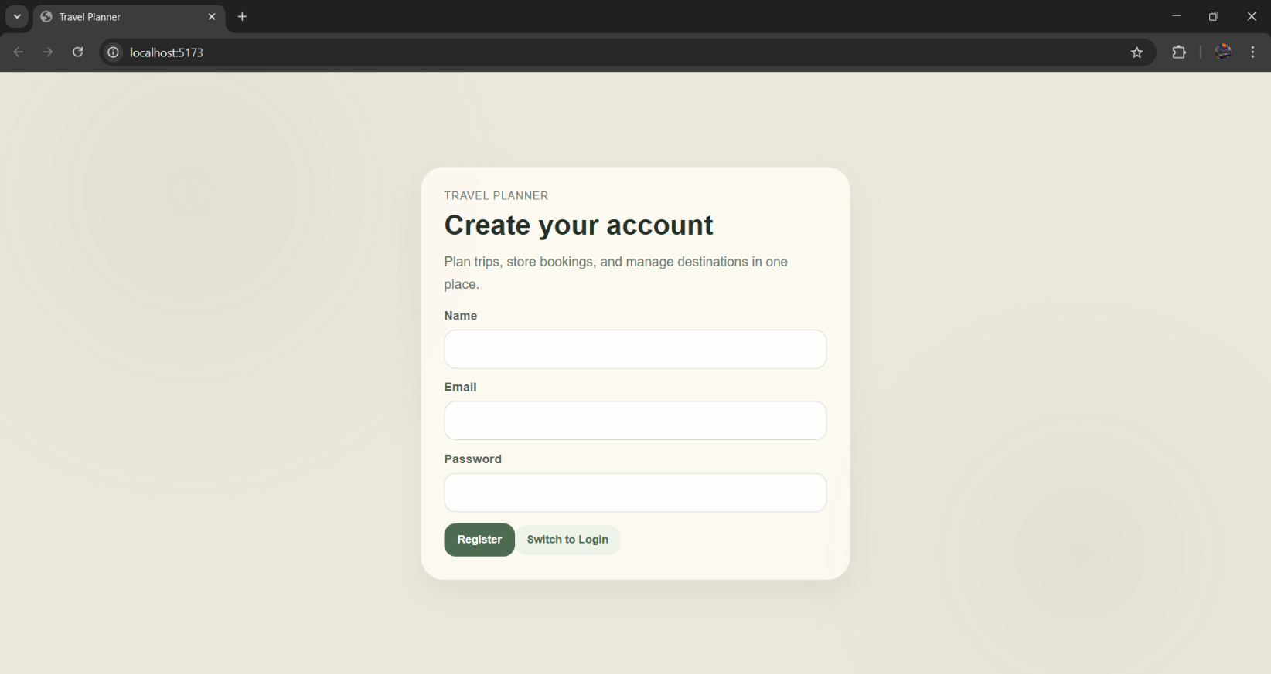
Fig.8.1 User Registration Interface for Creating a New Account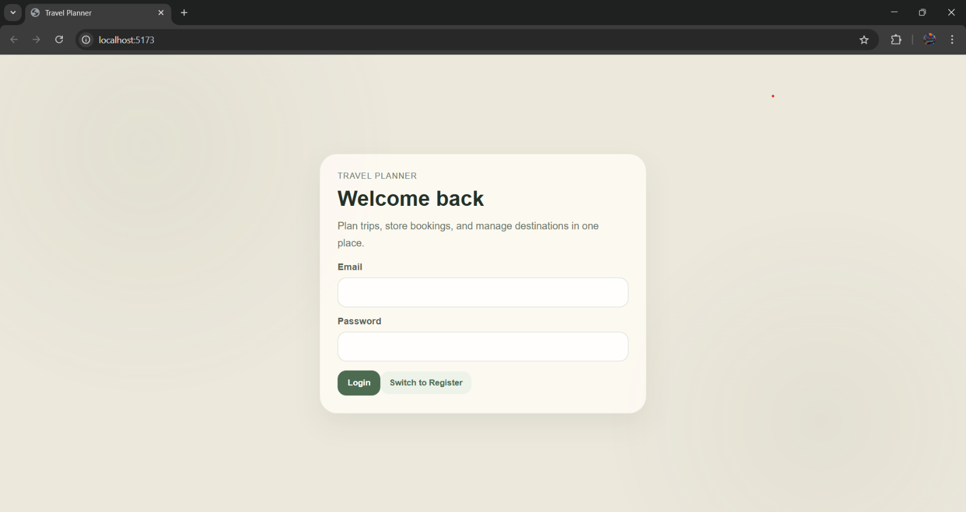
Fig.8.2: User Login Page for Secure Access to the Application

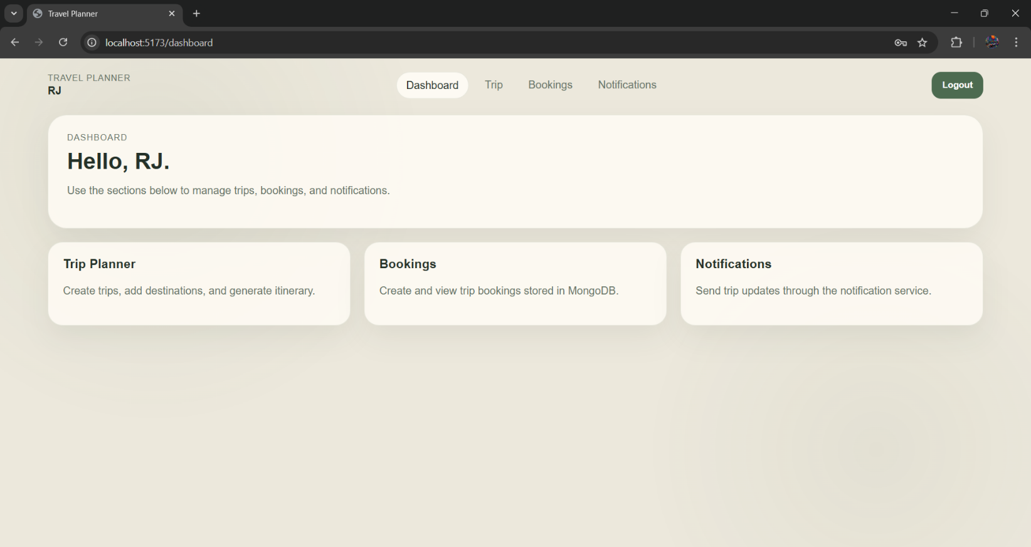
Fig.8.3: Main Dashboard Displaying Overview of Travel Planning Features

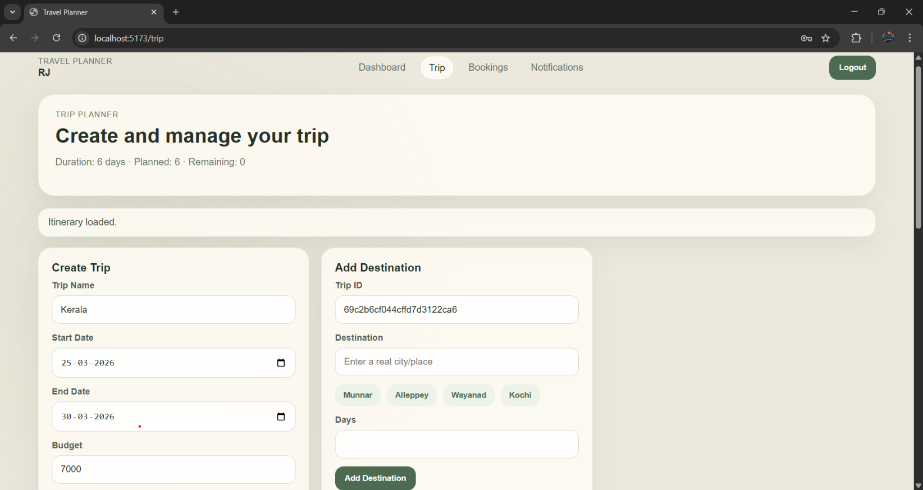
Fig.8.4: Main Dashboard Displaying Overview of Travel Planning Features

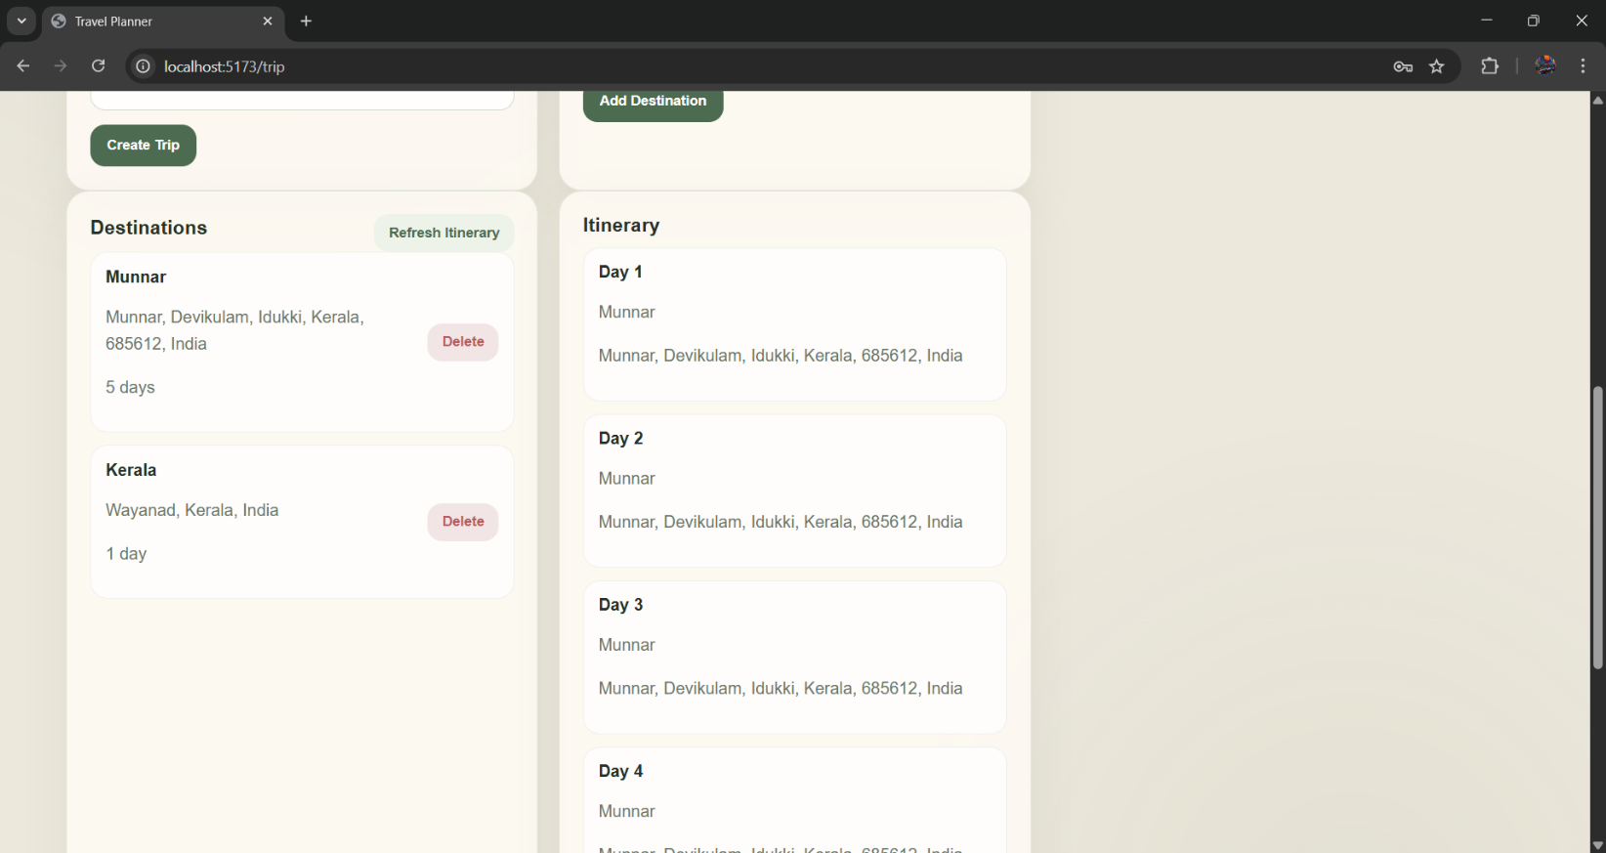
Fig.8.5: Continuation of Trip Creation Showing Destination Addition and Planning

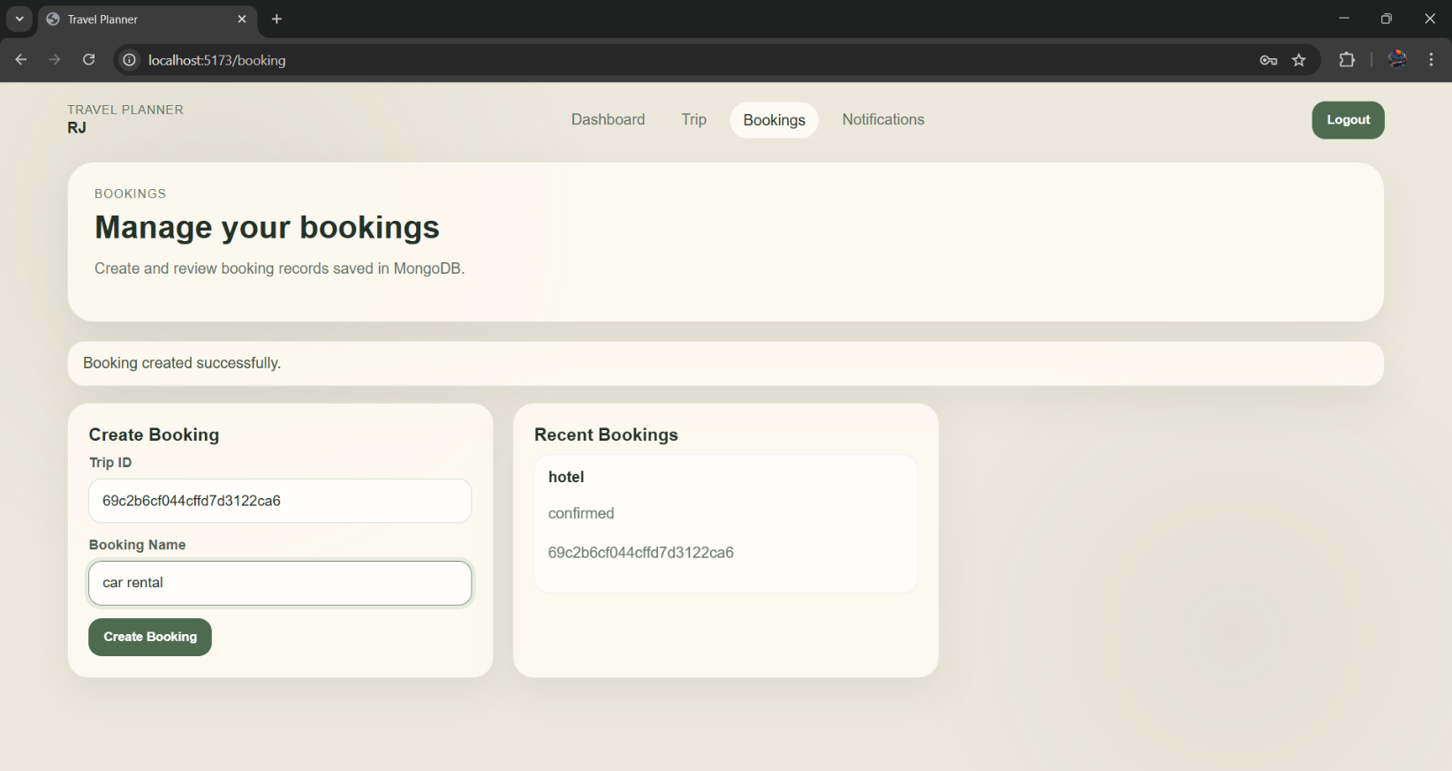
Fig.8.6: Trip Booking and Management Page for Viewing and Creating Bookings
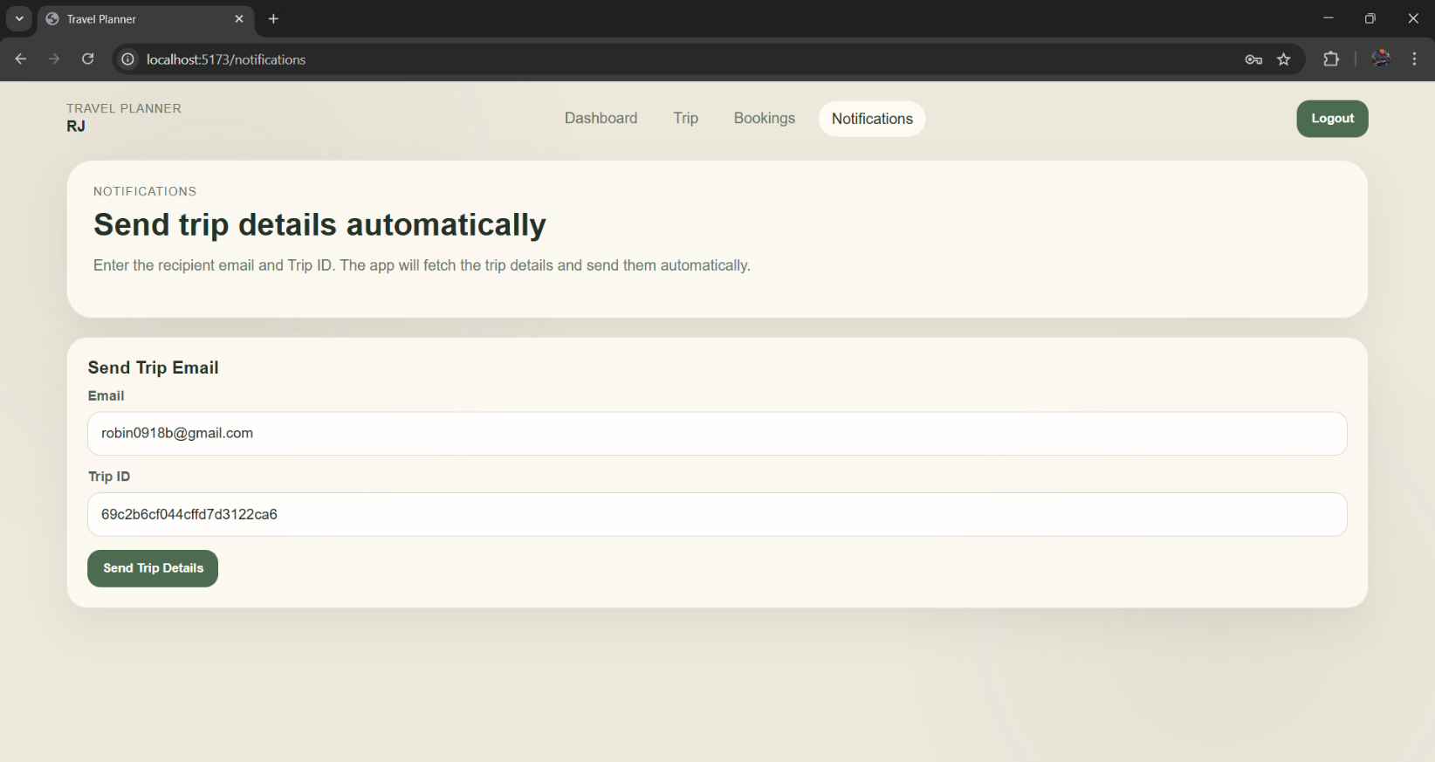
Fig.8.7: Trip Notification Page for Sending Details via Real-Time Email
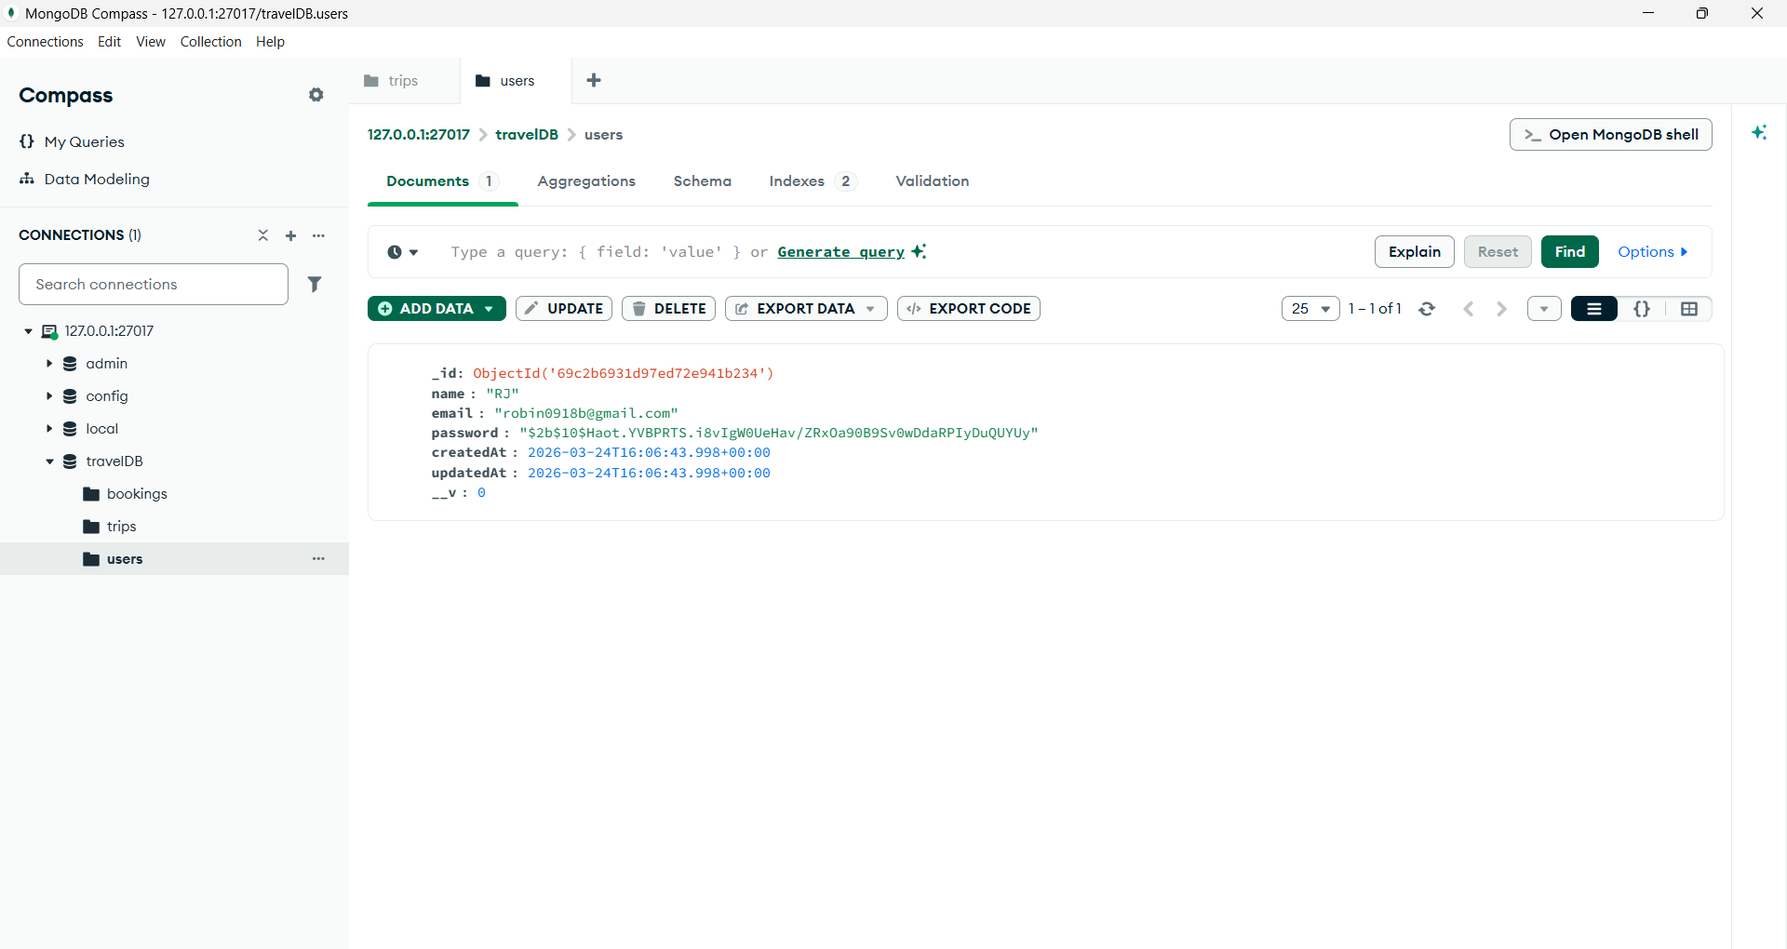
Fig.8.8: User Data Successfully Stored and Viewed in MongoDB Database

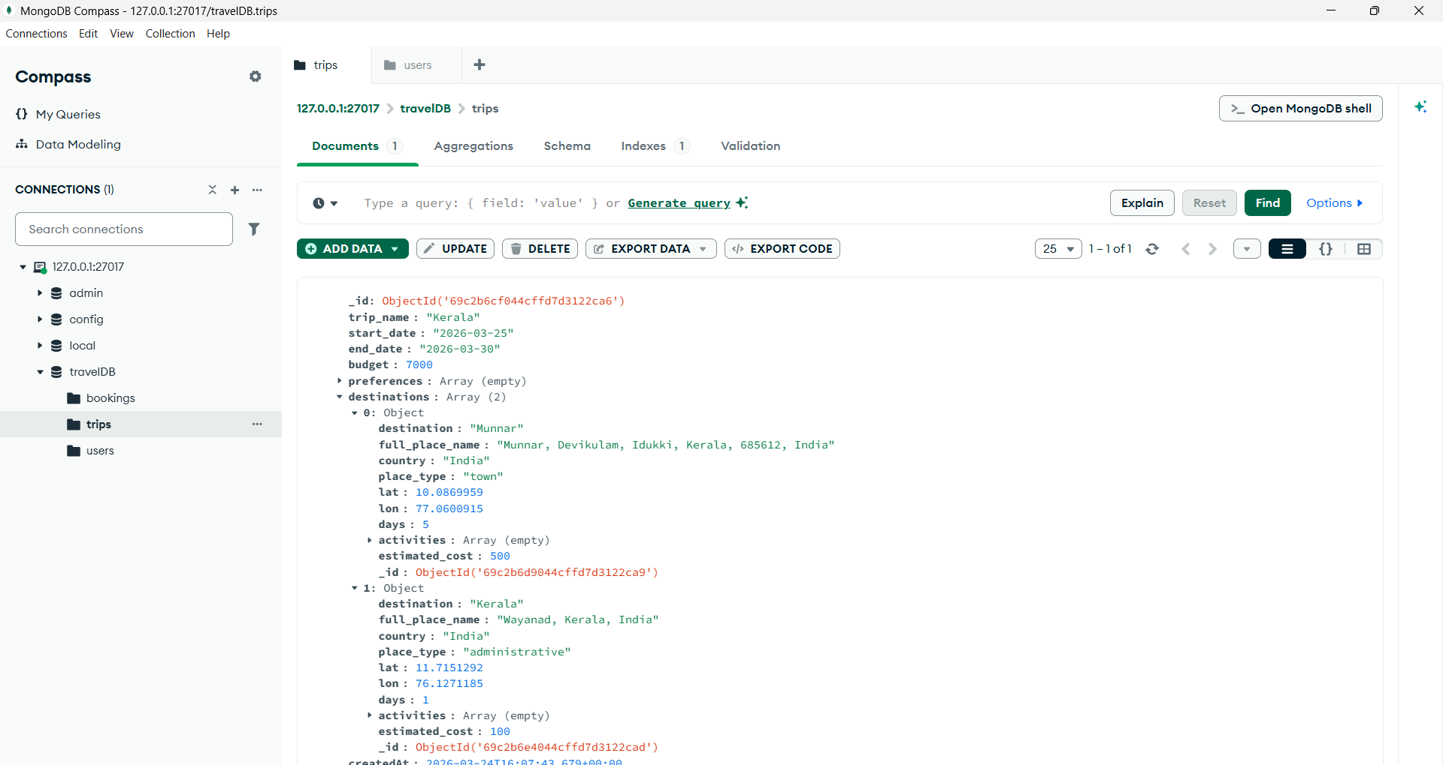
Fig.8.9: Trip Details Stored in MongoDB with Destination and Itinerary Data

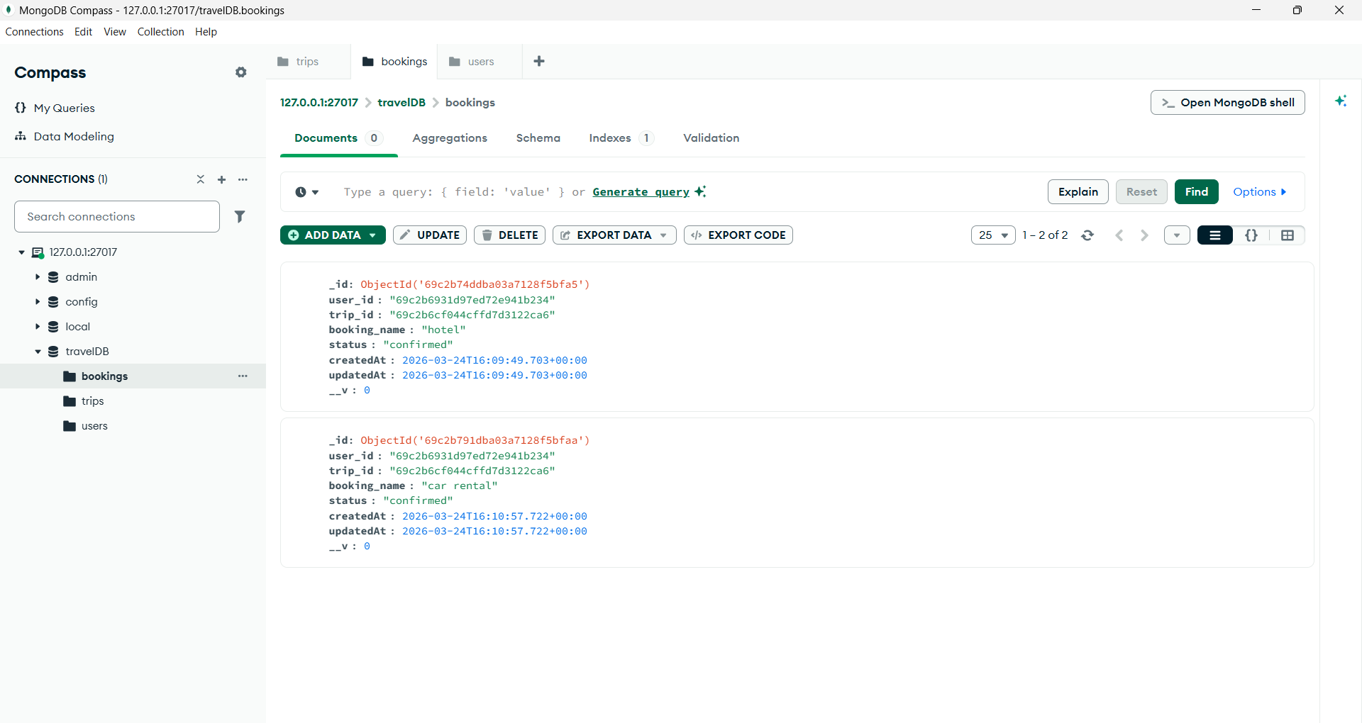
Fig.8.10: Booking Information Stored and Retrieved from MongoDB
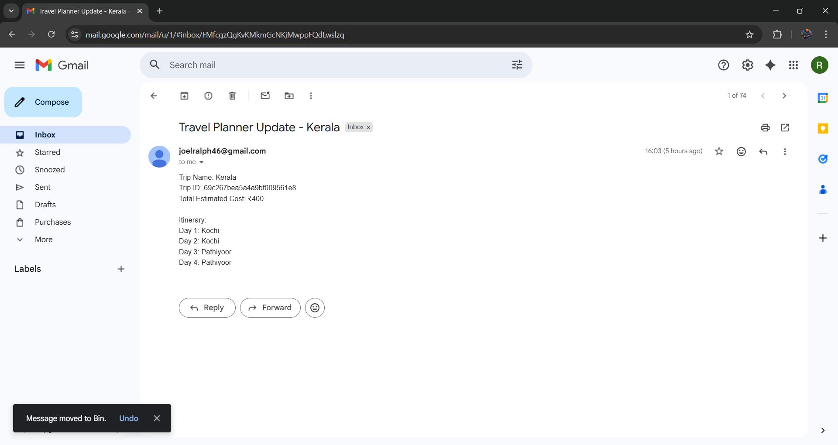
Fig.8.11: Trip Itinerary Details Sent via Email and Received Successfully

Chapter-9

ADVANTAGES & LIMITATIONS

Advantages
- Modular Design: The system is divided into independent services, each handling a specific functionality such as user management, trip handling, or booking. This separation makes the application easier to develop, test, and modify without affecting other components.
- Ease of Maintenance: Since each service operates independently, debugging and updating become simpler. Issues can be identified and fixed within a specific service without requiring changes across the entire system.
- Scalable Architecture: The microservices approach allows individual services to be scaled based on demand. For example, the Booking Service can be scaled separately during high traffic without increasing resources for the entire application.
- Fault Isolation: Failure in one service does not impact the entire system. Other services continue to function normally, which improves reliability and reduces system downtime.
- Technology Flexibility: Different services can be developed using different tools or frameworks if needed. Although this project uses a common stack, the architecture allows flexibility for future expansion.
- Real-World System Simulation: The project reflects modern industry practices by implementing distributed architecture and API-based communication, providing practical exposure to real-world system design.

Limitations
- Multiple Services Management: The system requires running multiple backend services simultaneously, which increases setup complexity and resource usage compared to a single application.
- Lack of Advanced Security: The current implementation does not include advanced security features such as authentication, authorization, or encryption, making it less secure for real-world deployment.
- Increased System Complexity: Compared to monolithic systems, microservices introduce additional complexity in terms of service coordination, routing, and debugging.

- Network Dependency: Since services communicate over HTTP, the system relies heavily on network communication. Any delay or failure in network requests can affect overall performance.
- Latency Between Services: Multiple API calls between services can introduce slight delays in response time, especially when handling chained operations.
- Deployment Challenges: Deploying and managing multiple services in different environments can be more difficult than deploying a single application, especially without containerization tools.

Chapter-10

FUTURE ENHANCEMENTS

The current implementation of the Travel Management System provides a functional foundation using microservices architecture. However, several enhancements can be incorporated to improve security, performance, and real-world applicability. These improvements would transform the system from a prototype into a production-ready application.
JWT-based authentication: One of the most important enhancements is the implementation of JWT. This would allow secure user login and session management by generating tokens for authenticated users. Each request to protected routes can then be validated using these tokens, ensuring that only authorized users can access specific functionalities. This adds a critical security layer that is currently missing in the system.
Real booking system with payment processing: Another major improvement is the integration of a proper payment processing. Instead of simulating bookings, the application can be extended to connect with external payment gateways, allowing users to complete actual transactions. This would involve handling payment validation, transaction status, and error scenarios, making the system more realistic and practical.
Real-time communication mechanisms: The Notification Service can also be enhanced by integrating mechanisms such as email or SMS notifications. By connecting to third-party APIs, the system can send booking confirmations and updates directly to users, improving user experience and making the application more interactive.
Docker for containerization: From a deployment perspective, the use of docker would significantly improve system portability and scalability. Each microservice can be packaged into its own container, ensuring consistent execution across different environments. This also simplifies deployment and makes it easier to manage services in production.
Logging and monitoring tools: To improve system reliability and debugging, some tools can be added. Logging helps track system activity and identify errors, while monitoring tools provide insights into service performance, uptime, and resource usage. This is essential for maintaining system stability in larger applications.

Security measures such as rate limiting and request validation: Finally, these can additionally be implemented to protect the system from misuse and potential attacks. Rate limiting restricts the number of requests a user can make within a specific time frame, while validation ensures that incoming data is safe and properly formatted.
Overall, these enhancements would make the system more secure, scalable, and aligned with real-world application standards, while also providing a deeper understanding of advanced system design concepts.

Chapter-11

UML DIAGRAMS

11.1 User-Case Diagram

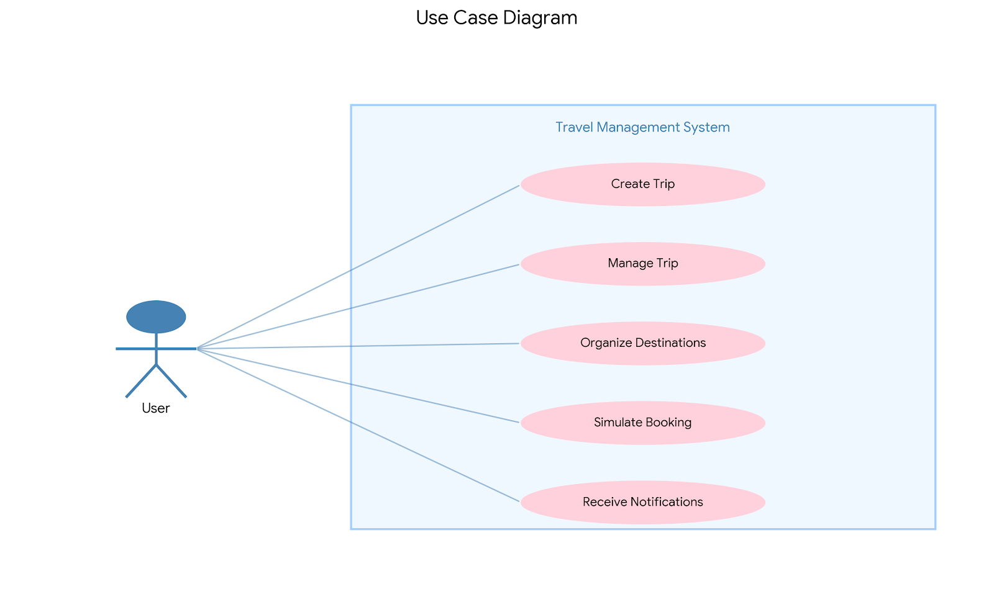

11.2 Class diagram

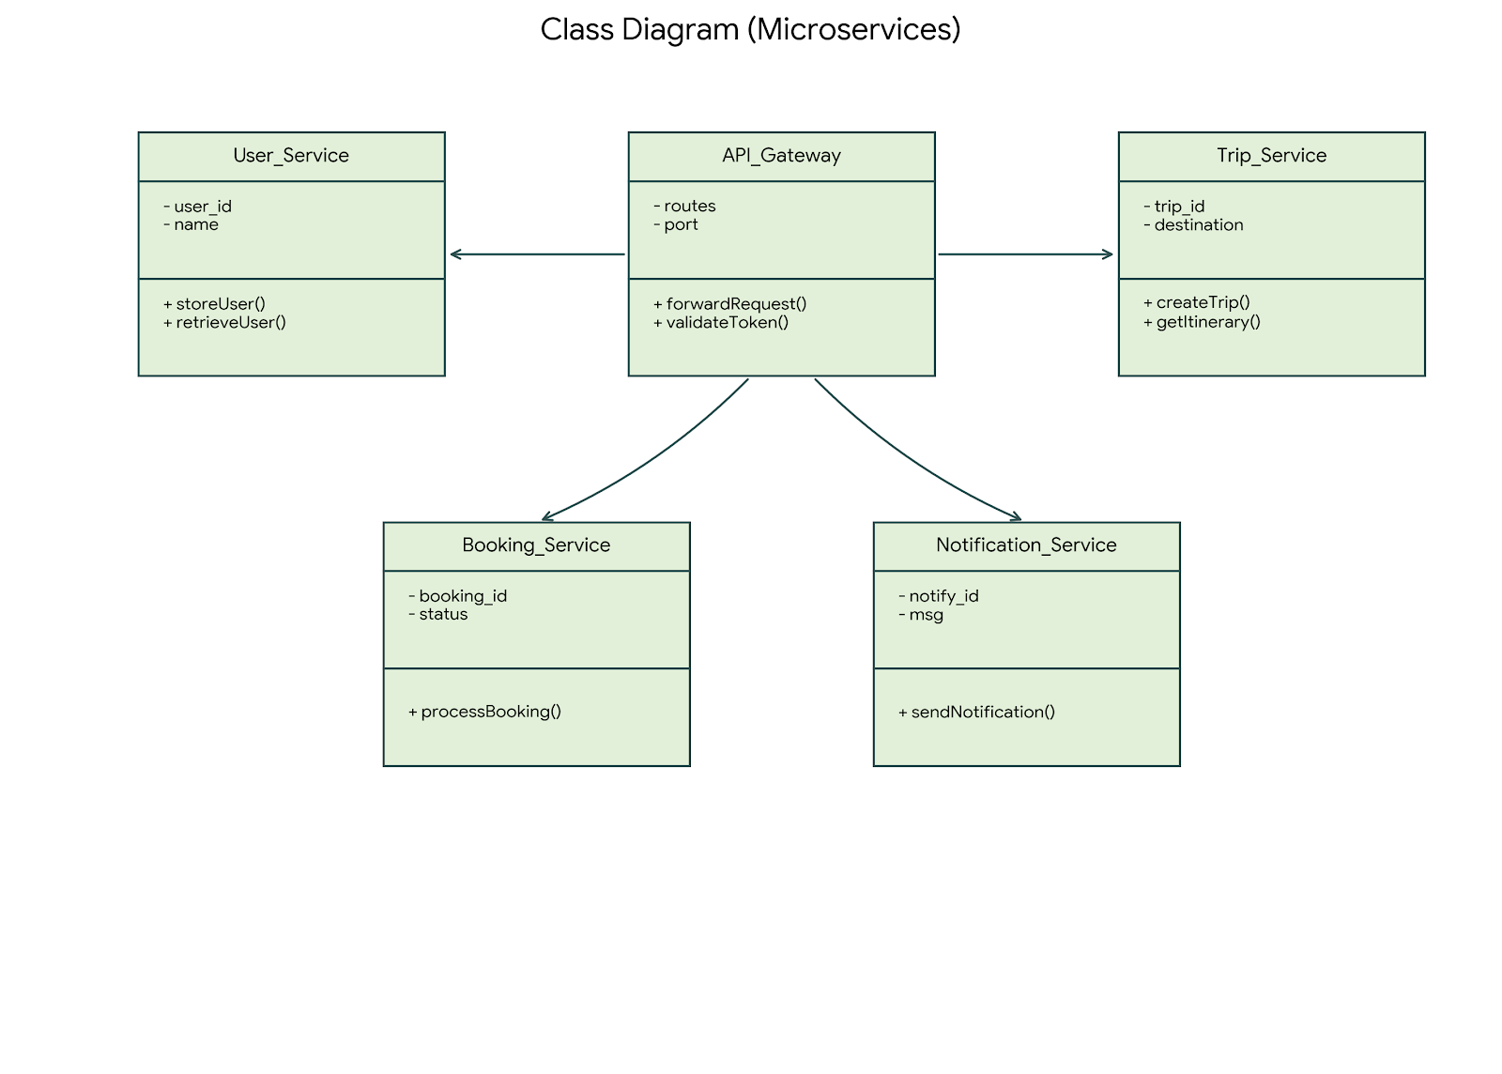

11.3 Sequence diagram

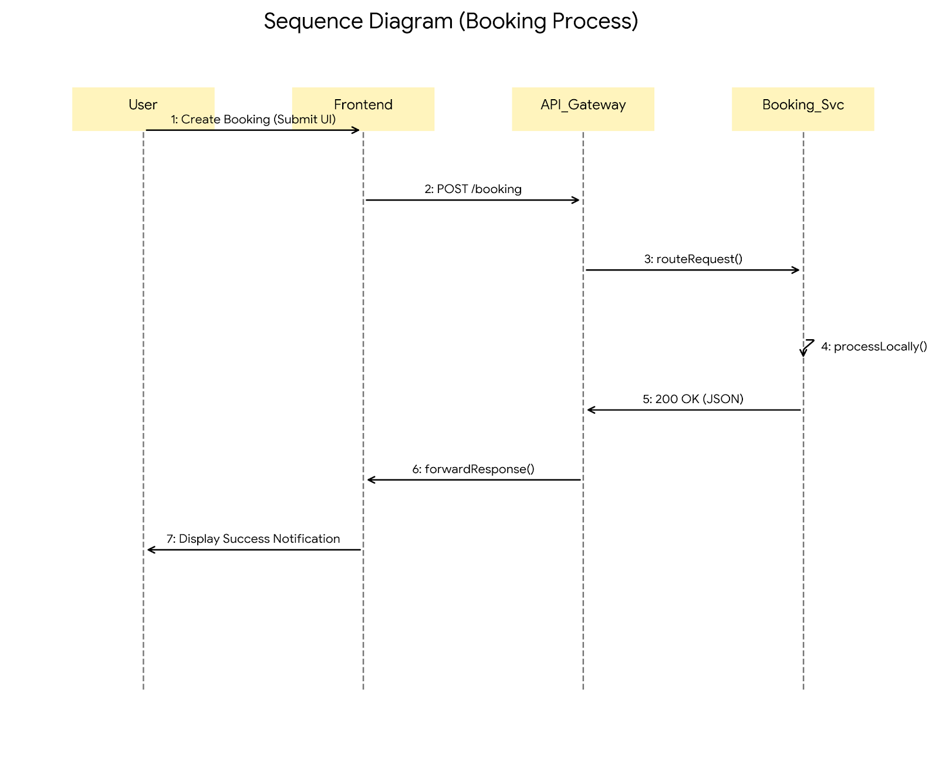

11.4 Collaboration diagram

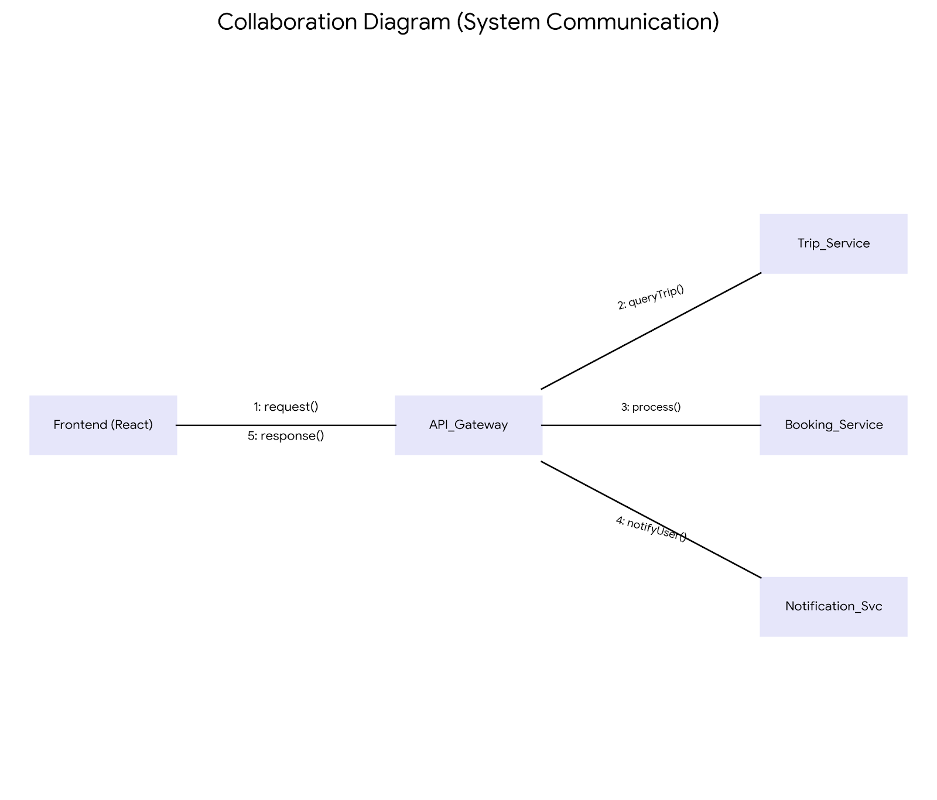

Chapter-12

CONCLUSION

The Travel Management System developed in this project successfully demonstrates the implementation of a microservices-based architecture for managing travel-related operations. By dividing the application into independent services—User Service, Trip Service, Booking Service, and Notification Service—the system achieves modularity, scalability, and maintainability, which are key challenges in traditional monolithic designs.

The integration of an API Gateway as a centralized entry point simplifies client-server communication and ensures controlled routing of requests to the appropriate backend services. The use of RESTful APIs enables seamless interaction between the frontend and backend components, while MongoDB provides flexible data persistence for trip-related information. The React-based frontend offers an intuitive and responsive user interface, allowing users to efficiently manage trips, destinations, and bookings.

Throughout the development process, the project highlighted the practical benefits of distributed system design, including service independence, fault isolation, and ease of maintenance. Each microservice was developed, tested, and operated independently, demonstrating how real-world applications can be structured to support growth and adaptability.

While the current implementation successfully meets the core objectives of the project, there remain opportunities for enhancement in areas such as security, payment integration, and containerized deployment. These improvements would further strengthen the system's readiness for production-level use.

In conclusion, this project serves as a comprehensive learning model for understanding and applying microservices architecture in web application development. It bridges the gap between theoretical knowledge and practical implementation, providing a solid foundation for future work in distributed systems and scalable application design.

Chapter-13

REFERENCES

Newman, S. (2021). Building Microservices: Designing Fine-Grained Systems. 2nd ed. O'Reilly Media.

Richardson, C. (2018). Microservices Patterns: With Examples in Java. Manning Publications.

Fowler, M. (2014). Microservices: A Definition of This New Architectural Term. [Online] Available at: https://martinfowler.com/articles/microservices.html

Banks, A., & Porcello, E. (2020). Learning React: Modern Patterns for Developing React Apps. 2nd ed. O'Reilly Media.

Subramanian, V. (2019). Pro MERN Stack: Full Stack Web Development with Mongo, Express, React, and Node. 2nd ed. Apress.

Chodorow, K. (2019). MongoDB: The Definitive Guide. 3rd ed. O'Reilly Media.

MDN Web Docs. (2025). Express/Node Introduction. [Online] Available at: https://developer.mozilla.org/en-US/docs/Learn/Server-side/Express_Nodejs/Introduction

Node.js Foundation. (2025). Node.js Documentation. [Online] Available at: https://nodejs.org/en/docs/

React Documentation. (2025). Getting Started with React. [Online] Available at: https://react.dev/learn

MongoDB, Inc. (2025). MongoDB Manual. [Online] Available at: https://www.mongodb.com/docs/

Axios Documentation. (2025). Axios HTTP Client. [Online] Available at: https://axios-http.com/docs/intro

Express.js Foundation. (2025). Express.js API Reference. [Online] Available at: https://expressjs.com/en/api.html

Vite Documentation. (2025). Vite Next Generation Frontend Tooling. [Online] Available at: https://vitejs.dev/guide/

Dragoni, N., et al. (2017). Microservices: How To Make Your Application Scale. In: Proceedings of the 11th International Conference on Advanced Software Engineering.

Thönes, J. (2015). Microservices: A Systematic Mapping Study. In: Proceedings of the 6th International Conference on Cloud Computing and Services Science.

Bass, L., Weber, I., & Zhu, L. (2015). DevOps: A Software Architect's Perspective. Addison-Wesley Professional.

Varia, J. (2010). Migrating to a Cloud-Native Architecture. Amazon Web Services White Paper.

