TaskFlow: A React Single-Page Task Manager
React Course Project Report

Sthashank Thapa
Department of Computer Science
React.js Course
Submitted to: Course Instructor

September 28, 2026

This report documents TaskFlow, a personal task manager (to-do application) developed as the final project for the React.js course. The application was chosen from Option 1 of the assignment brief, "Personal Task Manager (To-Do App)", and it goes beyond a simple to-do list by adding categories, priorities, due dates, sorting, search and a statistics view.
The report covers the project overview and objectives, the modules and features that were implemented, the technologies and tools used, the source code structure, the testing that was carried out, and the limitations of the work. Screenshots of the running application and a listing of the Git commit history are included so that the progress of the project can be verified. The report follows the Publication Manual of the American Psychological Association, Seventh Edition.

Project Overview and Objective
TaskFlow is a single-page application (SPA) that helps an individual plan, organise and track everyday work. The user opens the application and immediately sees a form for adding a task, a summary panel showing how many tasks are still outstanding, a toolbar for filtering, and the task list itself. Every task carries a title, an optional note, a category, a priority level and an optional due date.
The main objective of the project was to apply the core concepts taught in the course — components, props, state, hooks, event handling, and conditional and list rendering — in a complete and working application rather than in isolated tutorial exercises. A second objective was to write code that another developer could read and extend, which is why the logic is separated into reusable components, custom hooks and pure utility functions.

Objectives
The project was planned around the following objectives:
- Build a working to-do application that supports the full create, read, update and delete cycle for tasks.
- Demonstrate one-way data flow by passing task data and callback functions down from a parent component to reusable child components through props.
- Manage application state with the useState hook and synchronise that state with the browser using the useEffect hook.
- Persist the task list so that the data survives a page refresh, using a reusable useLocalStorage custom hook.
- Render the task list with Array.prototype.map() and provide a stable unique key for every item.
- Handle form input with controlled components, including validation of the title and due date before a task is saved.
- Use conditional rendering for empty states, error messages, the delete confirmation dialog and overdue highlighting.
- Implement client-side routing with React Router so that the application has more than one view.
- Produce a dark-themed, responsive user interface with clearly readable colours that also works in a light theme.
- Track development with Git using a meaningful, incremental commit history and document the project in a README file.

Modules and Features Implemented
The application was divided into the modules described in this section. Each module is described together with the React concepts it demonstrates and the files in which it is implemented.

Module 1: Project Setup and Design System
The project was created with the Vite build tool using the react template, which produced a working React project in a single command. A custom stylesheet was then written that replaces the default Vite styling. Instead of hard-coding colours in individual components, all colours, spacing values, border radii and shadows are declared once as CSS custom properties (design tokens) on the :root selector. Because every component reads from these variables, the entire interface can be switched between a dark palette and a light palette simply by setting a data-theme attribute on the html element.
The dark palette uses a near-black page background (#0b0d10) with bright, saturated accent colours — blue (#5b8cff), green (#2ee6a8), amber (#ffb020) and red (#ff6060) — so that status information and buttons remain clearly visible against the dark surface. The tokens are defined in src/index.css, and the theme switch is handled by src/hooks/useTheme.js.

Module 2: Persistence Layer (useLocalStorage Hook)
The useLocalStorage custom hook wraps the useState and useEffect hooks. On the first render it reads the stored value out of the browser’s localStorage and uses it as the initial state; on every later change the effect writes the new value back to localStorage as a JSON string. Because the hook is generic, the same code is reused for the task list, the active filters and the chosen theme.
All access to localStorage is wrapped in a try/catch block. If the browser has storage disabled, or the storage quota has been exceeded, the application logs a warning and keeps running in memory rather than crashing. This defensive approach prevents a storage failure from taking down the whole user interface.

Module 3: Task State and Actions (useTasks Hook)
Every action that can be performed on a task is written once inside the useTasks custom hook and returned as a function. The hook exposes addTask, updateTask, deleteTask, toggleTask, clearCompleted and reorderTasks. Each of these is wrapped in the useCallback hook so that its reference stays stable between renders, which prevents the memoised filtering in useFilters from being recomputed unnecessarily.
Keeping the actions in a hook rather than inside a component means the component tree receives ready-made functions through props, and the logic can be reasoned about and tested independently of the rendering layer.

Module 4: Task Form with Controlled Inputs and Validation
The TaskForm component contains five controlled inputs: the title, the notes, a category select, a priority select and a date input. A controlled input is an input whose current value is held in React state and updated through an onChange handler, rather than being left to the browser. This means the component always knows the exact contents of the form, which is what makes it possible to validate the data before it is submitted.
A single generic handleChange function is used for every field, which avoids repetition:
function handleChange(event) {
const { name, value } = event.target
setForm((current) => ({ ...current, [name]: value }))
if (error) setError('')
}

The handleSubmit function prevents the default form submission, trims the title and checks that it is not empty and does not exceed the maximum length of 80 characters. It also verifies that the due date is a real calendar date. If any check fails, an error message is stored in state and rendered below the form; if all checks pass, the values are handed to the parent component. The same component handles both adding a new task and editing an existing one: a useEffect copies the values of the task being edited into the form whenever the parent changes the editing target.

Module 5: Filtering, Searching and Sorting
The FilterBar component allows the user to narrow the list in four different ways at the same time: a status tab (All, Active or Completed), a category, a priority, and a free-text search term. A separate dropdown controls the sort order, offering manual order, newest first, oldest first, due date, priority and name.
The filter state itself is managed by the useFilters hook, which also computes the visible list. The actual filtering and sorting work is done by pure functions in src/utils/taskUtils.js. Keeping this logic outside the components has two advantages: the functions are easy to reason about because they do not depend on React, and the expensive computation is wrapped in useMemo so that the list is only recalculated when the tasks or the filters actually change.
The search field matches against the title, the notes and the category of a task, and the comparison is done on lower-cased strings so that the search is not case sensitive.

Module 6: Task List, Keys and Conditional Rendering
The TaskList component converts the array of tasks into visible rows using the map method. Each item is rendered with a stable key taken from the task’s unique id rather than its array index. This matters because it allows React to identify precisely which row has changed, added or been removed, which produces correct behaviour when a task is reordered by dragging, and preserves the internal state of a row.
{tasks.map((task) => (
<TaskItem
key={task.id}
task={task}
onToggle={onToggle}
onEdit={onEdit}
onDelete={onDelete}
/>
))}

Conditional rendering is used at several points in the application:
- TaskList returns the EmptyState component instead of a list when the array is empty. The EmptyState itself shows different wording and a "clear filters" button depending on whether the list is empty because there are no tasks, or because the active filters are hiding every task.
- ConfirmDialog returns null when it is closed, so the modal is not present in the document at all until a delete is requested.
- TaskItem applies extra CSS classes such as is-completed, is-overdue and is-dragging, so the overdue indicator and the drag feedback appear and disappear automatically.
- The move-up and move-down buttons are disabled when the task is already first or last in the list.
- The "Clear completed" button and the per-category breakdown are only rendered when there is at least one completed task.

Module 7: Categories, Priorities and Due Dates
Every task belongs to one of four categories — Work, Personal, Urgent or Study — rendered as a coloured CategoryBadge pill. The colour is chosen by a modifier class built from the category name, so a new category only needs one additional line of CSS. Priority is stored as one of low, medium or high and is shown with a matching label and colour.
The optional due date is stored as a plain "YYYY-MM-DD" string. Storing the date as text rather than as a Date object avoids the timezone conversion problems that occur when a Date instance is serialised to JSON and read back. The helper functions in src/utils/dateUtils.js parse that string into a Date at local midnight and compare it with the start of the current day, which correctly reports whether a task is overdue, due today or still upcoming. The label shown in the interface is generated from the same comparison, producing text such as "Overdue by 2 days", "Due today" or "Due in 5 days".

Module 8: Drag-and-Drop Reordering
Tasks can be reordered by dragging them with the mouse. The implementation uses the HTML5 drag and drop API that is built into the browser, so no third-party library such as react-beautiful-dnd was required. The TaskItem component sets the draggable attribute, and the parent Home page keeps the id of the task being dragged in state.
Two details are essential for the browser to accept the interaction. First, the onDragOver handler must call event.preventDefault(), otherwise the browser refuses the drop. Second, the dragged identifier must be placed in the dataTransfer object, because Firefox will not start a drag otherwise. When the task is dropped, the indices of the dragged task and the target task are located in the array with indexOf and the array is reordered with a small immutable helper.
Reordering is only offered while the sort option is set to Manual order, because a list that has been sorted by due date has a fixed order defined by the sort. A short hint under the toolbar tells the user which mode is active. For users who cannot drag and drop, every task also has move-up and move-down buttons, which perform exactly the same reordering through a keyboard-accessible path.

Module 9: Live Statistics and Progress
A summary panel sits directly beneath the form and shows the total number of tasks, how many are still remaining, how many are completed and how many are overdue, together with a progress bar for the completion percentage. All five figures are derived from the task array with a pure function called from useMemo, so the panel recalculates automatically on every change and no counter needs to be updated by hand.
A second view, reached through React Router, presents the same information as a set of key performance indicator cards together with a completion-rate bar and a per-category breakdown in which each category shows how many of its tasks are already done.

Module 10: Client-Side Routing
React Router was used to give the application more than one view without reloading the page. Three routes are declared in App.jsx: "/" renders the Home page, "/stats" renders the Statistics page, and "*" renders a NotFound page for any address that does not match. The navigation links in the header are built with the NavLink component, which automatically applies an active class to the link belonging to the current route.
The task state is deliberately lifted up into App so that both the Home page and the Statistics page receive the same list through props. A change made on one page is therefore immediately reflected in the statistics on the other, without any extra synchronisation code. Because a single-page application relies on the server always returning the entry file, a vercel.json file containing a rewrite rule is included so that the routes keep working after deployment.

Module 11: Responsive Styling and Accessibility
The layout adapts to smaller screens through media queries at 720 pixels and 640 pixels. On a wide screen the category, priority and due date inputs sit on a single row and the summary statistics are spread horizontally. On a narrow screen the form fields stack into a single column, the navigation links move onto their own row, and the summary statistics are compressed so that all four still fit on the screen.
Accessibility was considered throughout. Every input has an associated label element, all icon-only buttons carry both an aria-label and a title attribute, the status tabs use the tablist and tab roles, the progress bar exposes its value with role="progressbar" and the aria-valuenow attribute, and the confirmation dialog uses the alertdialog role with aria-modal set to true. A visible focus outline is provided for keyboard users, and the move-up and move-down buttons provide a path to reordering that does not depend on a mouse.

Technologies and Tools Used
The project deliberately keeps its dependency list short. Only one runtime library was added beyond React itself, so most of the work is plain JavaScript, JSX and CSS that can be read and understood without additional tooling.
Technology | Version | Role in the project
React | 19.x | Functional components, hooks and one-way data flow
React DOM | 19.x | Mounts the application into the page with createRoot
react-router-dom | 7.x | Client-side routing between the Tasks and Statistics views
Vite | 8.x | Development server with hot module replacement and the production build
@vitejs/plugin-react | 6.x | Compiles JSX and enables the React Fast Refresh plugin
OXLint | 1.x | Zero-configuration linter run through npm run lint
JavaScript (ES2022) | - | Application logic
JSX | - | Component markup
Plain CSS | - | Design tokens, layout, dark and light themes, media queries
HTML5 Drag and Drop | - | Reordering tasks without a library
Web Storage API | - | localStorage persistence of tasks, filters and theme

No CSS framework, component library, icon pack or state-management library is used. The icons are a small set of hand-written inline SVG elements defined in the Icon component, which keeps the rendering consistent and avoids another dependency. Git was used for version control throughout the project.

Source Code Structure
The source code is organised into folders by responsibility, following the structure recommended in the assignment brief. Components are reusable and self-contained, custom hooks hold the stateful logic, utilities contain pure functions, and pages are the route-level components.
taskflow-todo-app/
|-- .gitattributes Line-ending rules
|-- .gitignore Ignored files (node_modules, dist)
|-- .oxlintrc.json Linter configuration
|-- index.html Entry HTML document
|-- package.json Scripts and dependencies
|-- vercel.json Rewrite rule so React Router works on deploy
|-- vite.config.js Vite configuration
|-- README.md Project documentation
|-- docs/
| |-- TaskFlow-Project-Report.docx This report
| `-- screenshots/ Screenshots of the app
`-- src/
|-- main.jsx Connects App to the DOM with createRoot
|-- App.jsx Root: routes + shared task state
|-- App.css Page shell and shared page styles
|-- index.css Design tokens and base styles
|-- constants.js Categories, priorities, filters, keys
|-- components/
| |-- CategoryBadge.jsx/.css Coloured category pill
| |-- ConfirmDialog.jsx/.css Delete confirmation modal
| |-- EmptyState.jsx/.css Shown when the list is empty
| |-- FilterBar.jsx/.css Tabs, search, selects, sort
| |-- Header.jsx/.css Brand, navigation, theme toggle
| |-- Icon.jsx Inline SVG icon set
| |-- StatsPanel.jsx/.css Live counts and progress bar
| |-- TaskForm.jsx/.css Add / edit form
| |-- TaskItem.jsx/.css One task row
| `-- TaskList.jsx/.css List rendering with .map()
|-- hooks/
| |-- useFilters.js Filter state + visible list
| |-- useLocalStorage.js State synced with the browser
| |-- useTasks.js All task actions
| `-- useTheme.js Dark / light mode
|-- pages/
| |-- Home.jsx/.css Task manager page
| |-- NotFound.jsx 404 page
| `-- Stats.jsx/.css Statistics page
`-- utils/
|-- dateUtils.js Dates and due-date status
`-- taskUtils.js Filter, sort, stats, reorder

Component and Data-Flow Design
The application uses a strict one-way data flow, sometimes described as "lifting state up". The single source of truth for the task list is the useTasks hook, which is called in App.jsx. App passes the array of tasks and the action functions down to the Home page as props; Home passes them on to TaskList, and TaskList passes one task and the callbacks to each TaskItem. No child component ever writes to the task array directly — it always calls a function that was given to it as a prop, which is why every change flows back up and re-renders the whole tree from a single place.
App.jsx useTasks() -> [ tasks, addTask, updateTask, deleteTask,
toggleTask, clearCompleted, reorderTasks ]
|
+-- props: tasks, addTask, updateTask, deleteTask,
| toggleTask, clearCompleted, reorderTasks
v
Home.jsx useFilters(tasks) -> filters, setFilter, visibleTasks
|
+-- props: editingTask, onSubmit, onCancel
| v
| TaskForm.jsx
|
+-- props: filters, onChange, onReset, counts
| v
| FilterBar.jsx
|
+-- props: stats, onClearCompleted
| v
| StatsPanel.jsx
|
`-- props: tasks, onToggle, onEdit, onDelete, onMove,
onDragStart, onDragOver, onDrop, onDragEnd
v
TaskList.jsx tasks.map(...)
|
`-- props: task, onToggle, onEdit, onDelete
v
TaskItem.jsx -> CategoryBadge.jsx, Icon.jsx

Testing and Quality Verification
The application was verified in the browser both during development and after all features were complete. The table below lists the checks that were performed and the result obtained for each of them.
# | Test performed | Action | Expected result | Result
1 | Add a task | Typed a title, chose Work / High, clicked "Add task" | The task appears at the top of the list and the form clears | Pass
2 | Form validation | Clicked "Add task" with an empty title | An inline error "Please enter a task title." is shown and no task is created | Pass
3 | Edit a task | Clicked the pencil icon, changed the title, saved | The row shows the new title, the count does not change, the form resets | Pass
4 | Cancel editing | Clicked edit, then clicked "Cancel" | The form returns to "Add a new task" and no data is lost | Pass
5 | Complete / reopen | Clicked the round checkbox on a task | The title is struck through, the border turns green, counters update | Pass
6 | Delete a task | Clicked the bin icon | A confirmation dialog appears naming the task; deleting removes it, cancelling does not | Pass
7 | Status filter | Clicked the Active tab with 8 tasks, 2 completed | Exactly 6 tasks are shown and the tab label shows 6 | Pass
8 | Search | Typed "react" into the search box | Only matching tasks remain | Pass
9 | Combined filters | Filtered by category and priority together with the search term | Only tasks matching all conditions remain | Pass
10 | Empty state | Filtered until nothing matched | The "No tasks match your filters" panel and a "Clear all filters" button appear | Pass
11 | Sorting | Switched the sort option to Due date, Priority and Name | The list is ordered by the selected field, tasks without a due date last | Pass
12 | Reordering | Used the move-up / move-down buttons and drag and drop | The task changes position and the new order survives a refresh | Pass
13 | Persistence | Added and reordered tasks, then reloaded the page | The same list in the same order is restored | Pass
14 | Theme toggle | Clicked the theme button twice | The palette changes between dark and light and the choice is remembered | Pass
15 | Routing | Clicked "Statistics", then the browser Back button | The Statistics page and the Tasks page render without a full reload | Pass
16 | Unknown URL | Opened /does-not-exist | The NotFound page with a link back to the task list appears | Pass
17 | Overdue styling | Opened a task whose due date is in the past | A red border and a pulsing "Overdue by N days" label are shown | Pass
18 | Console output | Used every control and watched the browser console | No errors and no warnings are printed | Pass
19 | Production build | Ran npm run build | The build completes with no errors | Pass
20 | Linter | Ran npm run lint | No errors; only one advisory about synchronising form state with an effect | Pass
21 | Responsive layout | Resized the window to mobile widths | Form, toolbar and statistics stack without horizontal scrolling | Pass

During development the linter reported a single advisory warning suggesting that form state should not be synchronised with a useEffect call. The suggestion was not applied, because populating the form from a task selected in the list is a synchronisation between two separate parts of the user interface, which is precisely the situation the effect is intended to handle.

Screenshots of the Running Application
The following screenshots were captured from the development server while the application was running in the browser at a viewport width of 800 pixels. Three example tasks are created automatically the first time the application is opened, so the interface is not empty on first run.
Figure 1
Add Task Form, Live Summary Panel and Filter Bar
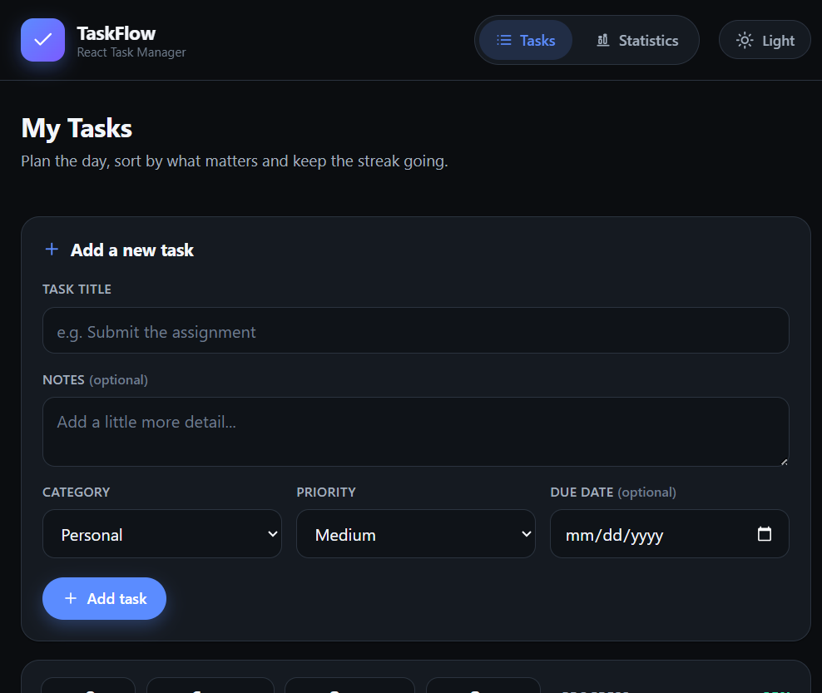
Note. The controlled form accepts a title, notes, category, priority and due date. The panel beneath it updates live, showing 8 total, 2 remaining, 2 completed and 2 overdue tasks.

Figure 2
Task List Showing Categories, Priorities, Due Dates and Reordering Controls
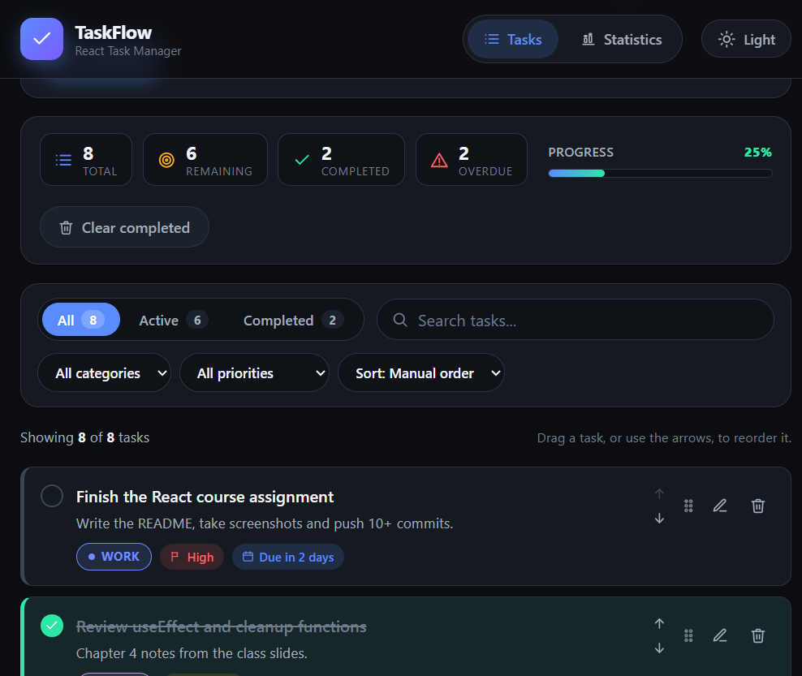
Note. Each row carries a coloured category pill, a priority label and a due-date label. The task with a past due date is outlined in red. The grip handle and the arrow buttons reorder a task; the bin icon deletes it.

Figure 3
Statistics Page With Key Performance Indicator Cards
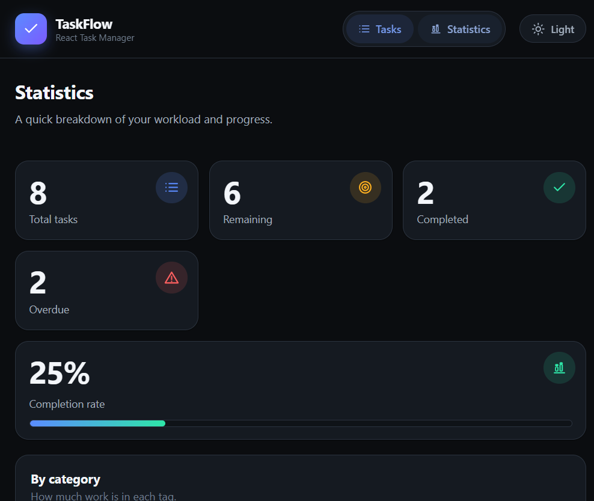
Note. The second route of the application. The completion rate is calculated as 2 completed out of 8 tasks, that is 25 percent.

Figure 4
Statistics Page With the Per-Category Breakdown
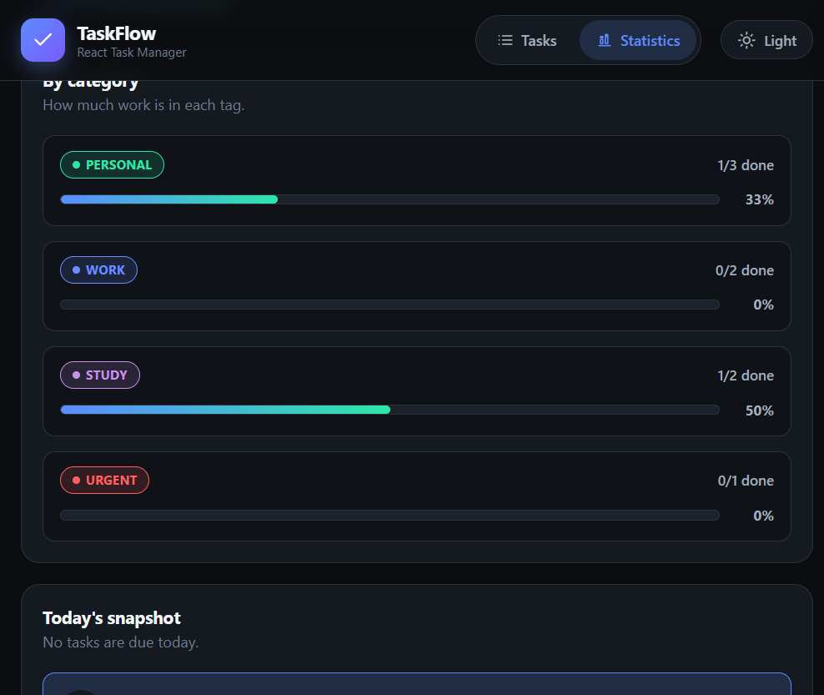
Note. Each category shows how many of its tasks are complete: Personal 1 of 3, Work 0 of 2, Study 1 of 2 and Urgent 0 of 1.

Figure 5
The Application Displayed in the Light Theme
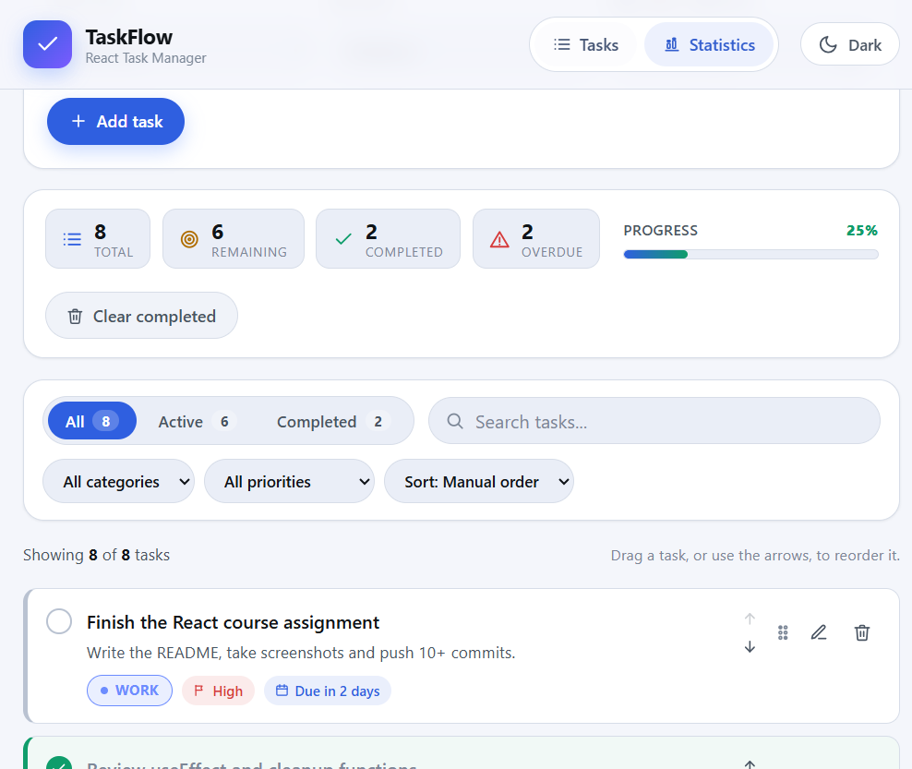
Note. The theme button in the header swaps the colour palette. Only the data-theme attribute on the html element changes, because every component reads its colours from CSS custom properties.

Figure 6
The Task List Filtered to Active Tasks Only
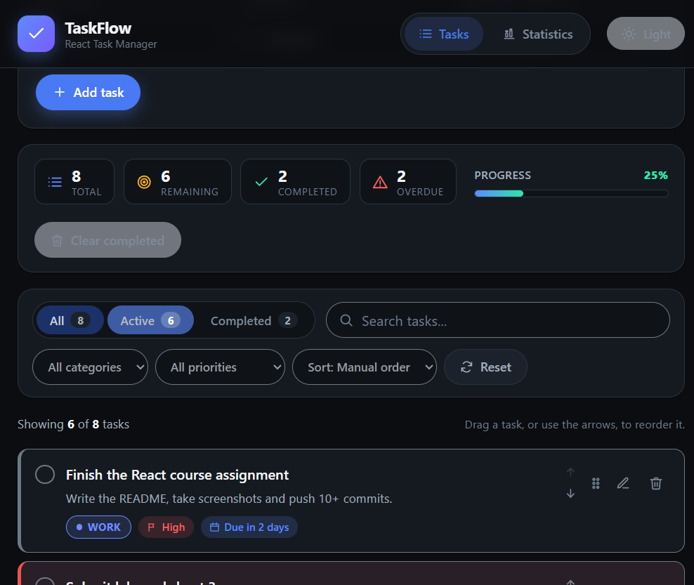
Note. Selecting the Active tab hides the two completed tasks and updates the count shown on the tab, demonstrating conditional list rendering driven by state.

Git Version Control
The project was developed with Git and pushed to a public repository. Each commit represents one meaningful, working step in the build, following the Conventional Commits convention so that the type of change (chore, style, feat or docs) is readable from the log. The history contains 17 commits, which is well above the eight to ten incremental commits required by the brief, and no commit contains unrelated changes.
Commit | Type | Description
4fc82aa | chore | Scaffold the Vite + React project and install dependencies
89698f9 | style | Add dark theme design tokens and global base styles
e84c310 | feat | Add shared constants and date formatting helpers
8fd8f48 | feat | Add the useLocalStorage hook to persist state in the browser
c8a3379 | feat | Add task filtering, sorting and statistics utilities
27ab2fc | feat | Add the useTasks and useFilters hooks for state management
726bc99 | feat | Add the useTheme hook for dark and light mode
ed84b12 | feat | Add the app shell with React Router navigation and the icon set
551d107 | feat | Add the task form with controlled inputs and validation
86c3fce | feat | Add the filter bar with status tabs, search and sorting
72707b4 | feat | Add the task item and category badge components
c55277e | feat | Add the task list, empty state and delete confirmation dialog
b69f52c | feat | Add the live statistics summary panel with a progress bar
1e97bc5 | feat | Build the home page with full task create, edit and delete
c3b12e8 | feat | Add drag and drop reordering with keyboard move controls
c932a80 | feat | Add the statistics page with the category breakdown and KPIs
1c7b8b9 | docs | Add the README with features, setup, structure and screenshots

Compliance with the Assignment Requirements
The following table maps each requirement from the assignment brief to the place in the project where it is satisfied.
Requirement | Where it is satisfied
Functional components only, no class components | Every file under src/components and src/pages defines a function component
At least four to five reusable components | Ten components: Header, TaskForm, FilterBar, TaskList, TaskItem, CategoryBadge, StatsPanel, EmptyState, ConfirmDialog and Icon
Props used for parent to child data flow | App.jsx to Home.jsx to TaskList.jsx to TaskItem.jsx, including callback props
At least one interactive feature with useState | The task list, filters, editing state, delete confirmation, drag state and the theme
At least one useEffect | useLocalStorage writes to localStorage; useTheme sets the data-theme attribute
List rendering with .map() and unique keys | TaskList.jsx maps the array and uses key={task.id}
A form with controlled inputs | TaskForm.jsx, with onChange and onSubmit and validation
Conditional rendering | EmptyState, ConfirmDialog returning null, overdue and completed classes, disabled buttons
React Router for more than one view | Routes /, /stats and * declared in App.jsx
Responsive layout | Media queries at 720 px and 640 px across the component stylesheets
No unused variables, imports or dead code | Unused Vite assets were deleted; verified with npm run lint
No console errors or warnings | Checked in the browser console while using every control
Meaningful Git commits | 17 incremental commits listed in the previous section
README with setup and screenshots | README.md at the root of the repository
LocalStorage persistence | useLocalStorage.js, used for tasks, filters and the theme
Live counts of remaining and completed tasks | StatsPanel.jsx and the summary on the statistics page

Conclusion
TaskFlow meets the objectives set out at the start of the project. The application runs without errors, provides the complete set of core features required by the brief — creating, editing, deleting and completing tasks, filtering by status, organising tasks into categories, persisting the data in the browser and showing live counts — and it also implements all three of the suggested stretch goals: drag and drop reordering, due dates with overdue highlighting, and a dark and light theme toggle.
From a technical point of view the project provided practical use of the concepts covered in class. The most useful lesson was that lifting state up to a common parent and passing it down as props makes an application predictable: because only the action functions ever modify the task array, the interface always reflects a single source of truth, and adding a new feature is a matter of adding a component rather than searching for the place where a variable is defined.
Custom hooks proved to be the mechanism that made the application clean. Moving the localStorage logic into useLocalStorage, the task actions into useTasks and the filter computation into useFilters meant that the components could stay short and focused on rendering, and it allowed the same persistence and theme code to be reused for three different pieces of state.
Several improvements would be worthwhile with more time, and are listed in the next section.

Limitations and Future Work
- Single device only. The data is stored in the browser’s localStorage, so there is no account, no server and no synchronisation between browsers or devices. Clearing the site data deletes the list permanently.
- No recurring tasks. A task can be given a due date but cannot be repeated daily, weekly or monthly.
- Reordering and sorting are mutually exclusive. Drag and drop is only enabled while the sort option is set to Manual order, because a sorted list has an order defined by the sort.
- No subtasks, attachments or comments. A task is a single flat record with one short note.
- No automated tests. The project was verified manually in the browser; a Vitest and React Testing Library suite would make future changes safer.
- No deployment. The application has not been deployed to Vercel, Netlify or GitHub Pages, so no live link is published. A vercel.json file containing a rewrite rule is included, which means deploying to Vercel requires no further configuration and keeps the /stats route working on a direct page load.
- Limited icon set. The icons are hand-written inline SVG elements covering only the icons the application needs.
- No PWA support. There is no service worker, so the application must be served over HTTP and cannot be installed to the home screen.

References
1. American Psychological Association. (2020). Publication manual of the American Psychological Association (7th ed.). https://doi.org/10.1037/0000165-000
2. Meta Open Source. (2025). React (Version 19) [Computer software]. https://react.dev
3. Meta Open Source. (2025). React Router [Computer software]. https://reactrouter.com
4. Vite. (2025). Vite: The frontend build tool [Computer software]. https://vite.dev
5. Mozilla Developer Network. (2025). Window: localStorage property. Mozilla Foundation. https://developer.mozilla.org/en-US/docs/Web/API/Window/localStorage
6. Mozilla Developer Network. (2025). HTML drag and drop API. Mozilla Foundation. https://developer.mozilla.org/en-US/docs/Web/API/HTML_Drag_and_Drop_API
7. Mozilla Developer Network. (2025). Array.prototype.map(). Mozilla Foundation. https://developer.mozilla.org/en-US/docs/Web/JavaScript/Reference/Global_Objects/Array/map
8. Mozilla Developer Network. (2025). Using custom properties (CSS variables). Mozilla Foundation. https://developer.mozilla.org/en-US/docs/Web/CSS/Using_CSS_custom_properties
9. Mozilla Developer Network. (2025). Using media queries for responsiveness. Mozilla Foundation. https://developer.mozilla.org/en-US/docs/Learn/CSS/CSS_media_queries/Using_media_queries_for_responsiveness
10. OpenJS Foundation. (2025). OXLint: A fast linter for JavaScript and TypeScript [Computer software]. https://oxc.rs
11. OpenAI. (2025). ChatGPT [Large language model]. https://chat.openai.com
12. Ecma International. (2023). ECMAScript 2023 language specification (ECMA-262, 14th ed.). https://ecma-international.org/publications-and-standards/standards/ecma-262/

Appendix A: Source Code Listing
The complete source code is stored in the public repository that accompanies this report. The two files below are reproduced here because they contain the central ideas of the project: the persistent state hook and the list rendering with keys.

A.1 src/hooks/useLocalStorage.js
import { useEffect, useState } from 'react'

export function useLocalStorage(key, initialValue) {
// 1. Read the saved value once, on the first render.
const [value, setValue] = useState(() => readFromStorage(key, initialValue))

// 2. Keep localStorage in sync with the state.
useEffect(() => {
try {
window.localStorage.setItem(key, JSON.stringify(value))
} catch (error) {
console.warn(`Could not save "${key}" to localStorage.`, error)
}
}, [key, value])

return [value, setValue]
}

function readFromStorage(key, initialValue) {
try {
const stored = window.localStorage.getItem(key)
if (stored === null) return initialValue
return JSON.parse(stored)
} catch (error) {
console.warn(`Could not read "${key}" from localStorage.`, error)
return initialValue
}
}

A.2 src/components/TaskList.jsx
export default function TaskList({
tasks,
onToggle,
onEdit,
onDelete,
onResetFilters,
hasActiveFilters,
draggingId,
onDragStart,
onDragOver,
onDrop,
onDragEnd,
onMove,
canReorder,
}) {
// Conditional rendering: nothing to show.
if (tasks.length === 0) {
return (
<EmptyState
hasActiveFilters={hasActiveFilters}
onResetFilters={onResetFilters}
/>
)
}

return (
<div className="task-list">
<ul className="task-list__items">
{tasks.map((task, index) => (
<TaskItem
key={task.id}
task={task}
onToggle={onToggle}
onEdit={onEdit}
onDelete={onDelete}
onMove={onMove}
isFirst={index === 0}
isLast={index === tasks.length - 1}
isDragging={draggingId === task.id}
canReorder={canReorder}
onDragStart={onDragStart}
onDragOver={onDragOver}
onDrop={onDrop}
onDragEnd={onDragEnd}
/>
))}
</ul>
</div>
)
}

A.3 src/utils/taskUtils.js (filtering and statistics)
export function filterAndSortTasks(tasks, filters) {
const search = filters.search.trim().toLowerCase()

const filtered = tasks.filter((task) => {
if (filters.status === 'active' && task.completed) return false
if (filters.status === 'completed' && !task.completed) return false
if (filters.category !== 'all' && task.category !== filters.category) return false
if (filters.priority !== 'all' && task.priority !== filters.priority) return false

if (search) {
const haystack = `${task.title} ${task.notes} ${task.category}`.toLowerCase()
if (!haystack.includes(search)) return false
}
return true
})

return sortTasks(filtered, filters.sortBy)
}

export function getTaskStats(tasks) {
const total = tasks.length
const completed = tasks.filter((task) => task.completed).length
const active = total - completed
const overdue = tasks.filter(
(task) => !task.completed && getDueDateStatus(task.dueDate) === 'overdue',
).length

return {
total,
completed,
active,
overdue,
percent: total === 0 ? 0 : Math.round((completed / total) * 100),
}
}

