TaskFlow — A Task Manager Built with React

Project Documentation

1. Project Introduction
TaskFlow is a single-page task manager built with React.js. It lets a user write down tasks, group them under categories, give them a priority and an optional due date, tick them off when they are finished, and see at a glance how much work is still left. Everything is saved inside the browser, so the list is still there the next time the page is opened. It solves the problem that almost every student faces: keeping track of everything that needs to be done without losing track of it. A paper list gets lost, and a plain to-do application is too limited once tasks need to be grouped or given deadlines, so TaskFlow sits in between and keeps only the information that actually matters, which tasks are active, which are overdue, and how far through the week the user is.
The project was chosen from Option 1 of the assignment brief, "Personal Task Manager (To-Do App)", because a task manager is a real problem rather than a made-up one, and because it needs every core concept from the course at once: components, props, state, hooks, forms, lists, conditional rendering and routing. It also left room to add features, so the three suggested stretch goals, drag-and-drop reordering, due dates with overdue highlighting, and a dark and light theme, were all implemented as well. The intended users are individuals, mainly students, who want a lightweight personal checklist that works offline and needs no account, and secondarily any developer who wants a small, readable React example showing how components, custom hooks and pure utility functions fit together in a real application.

2. Objectives
The objectives of this project were:
1. To build a working task manager in which tasks can be added, edited, deleted, marked as complete and reopened.
2. To structure the project into small reusable components instead of one large file, so that each part of the interface can be understood and changed on its own.
3. To pass data from a parent component down to child components using props, and to make sure that only one place in the application ever modifies the task list.
4. To manage application state with the useState hook and to synchronise that state with the browser using the useEffect hook.
5. To write a reusable custom hook that saves state to localStorage, so that the task list survives a page refresh.
6. To render the task list with the map method and to give every item a stable unique key.
7. To build a controlled form that collects the task data and validates it before anything is saved.
8. To use conditional rendering so that the interface only shows what is relevant, such as an empty state or an error message.
9. To give the application more than one view using React Router.
10. To produce a simple, dark-themed, responsive interface with clear, readable colours.
11. To track the work with Git using a meaningful, incremental commit history, and to document the project properly.

3. Technologies Used
The following technologies were used in this project.
Technology | Version | Purpose
React.js | 19.x | Building the interface with reusable components and hooks
React DOM | 19.x | Mounting the React application into the HTML page
React Router DOM | 7.x | Navigation between the Tasks page and the Statistics page
JavaScript (ES2022) | - | All application logic, written as functions and objects
JSX | - | Writing the markup of each component inside JavaScript
HTML | - | The single page shell in index.html
CSS3 | - | Styling, the dark and light themes, and media queries for responsiveness
Vite | 8.x | Development server with hot reload, and the production build
@vitejs/plugin-react | 6.x | Compiling JSX and enabling React Fast Refresh
localStorage (Web Storage API) | - | Saving the task list, the filters and the theme in the browser
HTML5 Drag and Drop API | - | Reordering tasks by dragging, with no extra library
Git | 2.x | Version control and the commit history
OXLint | 1.x | Linting the source code with npm run lint

No CSS framework, component library, icon pack or state-management library is used. The icons are a small set of hand-written inline SVG elements, and the styling is plain CSS, so the project has very few dependencies and every line of code can be read without learning a third-party tool first.

4. System Requirements

4.1 Software Requirements
- Operating system: Windows 10 or 11, macOS, or any modern Linux distribution.
- Node.js version 18 or newer. Node.js 20 or newer is recommended.
- npm version 9 or newer, which is installed together with Node.js.
- A code editor such as Visual Studio Code. Any editor that saves plain text files will work.
- A modern web browser such as Google Chrome, Mozilla Firefox, Microsoft Edge or Safari. The layout is tested in Chromium-based browsers and Firefox.
- Git, only if the commit history is to be reproduced. Git 2.x is used here.

4.2 Hardware Requirements
- Processor: any modern dual-core or better processor. A 64-bit processor running at 1 GHz or above is enough.
- RAM: 4 GB is sufficient. 8 GB gives a smoother development experience.
- Storage: roughly 250 MB of free disk space for Node.js, the project folder and the dependencies.
- Internet connection: only needed once, to download the Node.js packages with npm install. The application itself runs entirely offline afterwards.

5. Project Features
TaskFlow provides the following features.

5.1 Core Features
- Add task. The user fills in a title, an optional note, a category, a priority and an optional due date. The new task appears at the top of the list and the form clears itself ready for the next one.
- Edit task. Pressing the pencil icon loads the current values into the same form, changes the heading to Edit task and turns the submit button into Save changes. Cancel discards the edit.
- Delete task. Pressing the bin icon opens a confirmation dialog that names the task. Nothing is removed until Delete is confirmed, so a mis-click cannot lose work.
- Complete and reopen. The round button on the left of a task toggles it between active and completed. A completed task is struck through and its left border turns green.
- Filter by status. Three tabs, All, Active and Completed, sit above the list. Each shows how many tasks it contains, and the counts update immediately.
- Organise into categories. Every task belongs to one of four categories: Work, Personal, Urgent or Study, shown as a small coloured tag on the task.
- Search. Typing in the search box filters the list as the user types. The title, the notes and the category are all searched, ignoring capital letters.
- Filter by priority. The list can be narrowed to Low, Medium or High priority tasks.
- Persist with localStorage. The tasks, the filters and the chosen theme are all written to the browser, so a refresh or closing the tab loses nothing.
- Live task counts. A panel above the list always shows the totals, how many are remaining, completed and overdue, plus a progress bar for the completion percentage.

5.2 Stretch Goal Features
- Drag-and-drop reordering. Each task can be picked up by its grip handle and dropped anywhere in the list. Up and down arrow buttons are also provided, so reordering works with a keyboard as well as a mouse.
- Due dates with visual indicators. A due date is optional. When one is set the task shows a short label such as Due today, Due tomorrow or Overdue by 3 days, and any task that is both unfinished and late is highlighted in red.
- Dark and light theme. A button in the header switches the whole interface between the two palettes. The choice is remembered for the next visit.

5.3 Additional Features
- Sorting. The list can be sorted by manual order, newest, oldest, due date, priority or name. Tasks without a due date always sort to the bottom.
- Statistics page. A second page reached through React Router shows the totals as cards, a completion-rate bar, and a breakdown of how much of each category is finished.
- Clear completed. A single button removes every finished task at once.
- Sample tasks. Three example tasks are loaded the very first time the application is opened so that the interface is not empty on first run.
- Not found page. Any address that does not match a route shows a simple 404 page with a link back to the task list.

6. Project Structure
The source code is organised into folders by responsibility, as shown below.
taskflow-todo-app/
|-- .gitattributes
|-- .gitignore
|-- .oxlintrc.json
|-- index.html Entry HTML page
|-- package.json Scripts and dependencies
|-- vercel.json Rewrite rule for deployment
|-- vite.config.js Vite configuration
|-- README.md Project documentation
|-- public/
| `-- favicon.svg The brand mark shown on the tab
|-- docs/
| |-- TaskFlow-Project-Documentation.docx
| `-- screenshots/ The 10 screen captures used above
`-- src/
|-- main.jsx Connects App to the DOM
|-- App.jsx Root: routes and shared task state
|-- App.css
|-- index.css Design tokens and base styles
|-- constants.js Categories, priorities, filters, keys
|-- components/ Reusable components
| |-- Header.jsx / .css Brand, navigation, theme button
| |-- TaskForm.jsx / .css Add and edit form
| |-- FilterBar.jsx / .css Tabs, search, selects, sort
| |-- TaskList.jsx / .css List rendering with map()
| |-- TaskItem.jsx / .css One task row
| |-- CategoryBadge.jsx / .css Coloured category tag
| |-- StatsPanel.jsx / .css Live counts and progress bar
| |-- EmptyState.jsx / .css Shown when the list is empty
| |-- ConfirmDialog.jsx / .css Delete confirmation
| `-- Icon.jsx Inline SVG icons
|-- hooks/ Custom hooks
| |-- useLocalStorage.js State synced with the browser
| |-- useTasks.js All task actions
| |-- useFilters.js Filter state and visible list
| `-- useTheme.js Dark and light mode
|-- pages/ Route level components
| |-- Home.jsx / .css Task manager page
| |-- Stats.jsx / .css Statistics page
| `-- NotFound.jsx 404 page
`-- utils/ Pure helper functions
|-- taskUtils.js Filter, sort, statistics
`-- dateUtils.js Dates and due date status

6.1 Purpose of Each Folder
- components/ holds the reusable pieces of the interface. Each component is a separate file with its own stylesheet next to it, receives everything it needs through props, and never reads or writes the task list directly.
- hooks/ holds the custom hooks. A custom hook is a function that starts with the word use and may call other hooks. Moving the stateful logic out of the components keeps them short and lets the same logic be reused.
- utils/ holds plain functions that do not depend on React at all. They can be read and tested on their own, which is why the filtering and the statistics live there rather than inside a component.
- pages/ holds the components that a URL renders. There is one file per view, and each one receives the data it needs from App.
- public/ holds only favicon.svg, the small mark shown on the browser tab. There is no images folder, because every other graphic is either an inline SVG component or a CSS border.

6.2 Component and Data Flow
The single source of truth for the task list is the useTasks hook, which is called in App.jsx. App passes the list and the action functions down to the pages as props, the pages pass them on to their children, and eventually each task row receives the one task it needs to display. No component ever modifies the list itself; it always calls one of the action functions it was given. This is called one-way data flow, and it is the reason that adding a new feature only ever means adding a component.
App.jsx useTasks() -> [ tasks, addTask, updateTask, deleteTask,
toggleTask, clearCompleted, reorderTasks ]
|
|-- props --> Home.jsx
| |-- props --> TaskForm.jsx (editingTask, onSubmit)
| |-- props --> FilterBar.jsx (filters, onChange, onReset)
| |-- props --> StatsPanel.jsx (stats, onClearCompleted)
| `-- props --> TaskList.jsx (tasks, onToggle, onEdit,
| onDelete, onMove, drag handlers)
| `-- props --> TaskItem.jsx
| `-- CategoryBadge.jsx
|
`-- props --> Stats.jsx (tasks)

7. Application Screens / UI
The screenshots below were taken from the development server while the application was running. Three example tasks are created automatically the first time the application is opened so that the screens are not empty.
Figure 1
Tasks Page — Add Task Form, Live Summary and Filter Bar
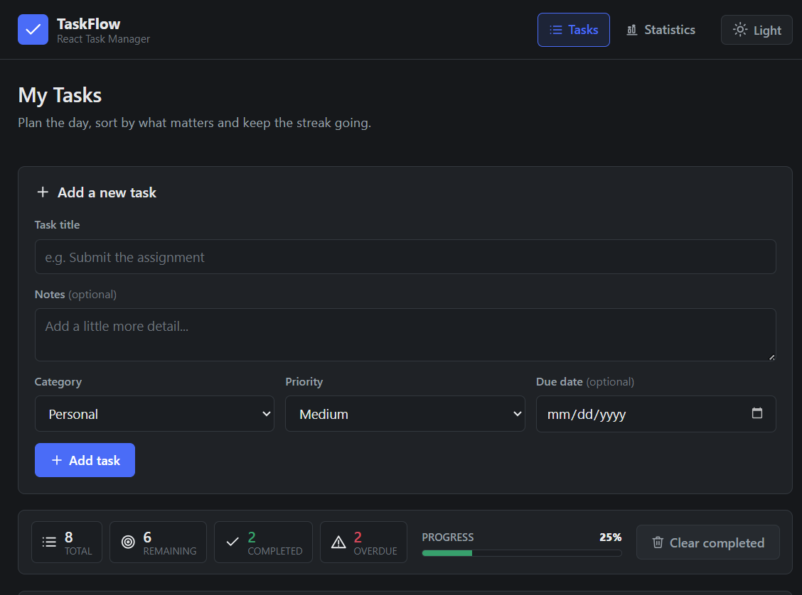
Note. The main screen: the form collects a title, note, category, priority and optional due date, and the panel below shows the totals updating live.

Figure 2
Tasks Page — Task List With Categories, Priorities and Due Dates
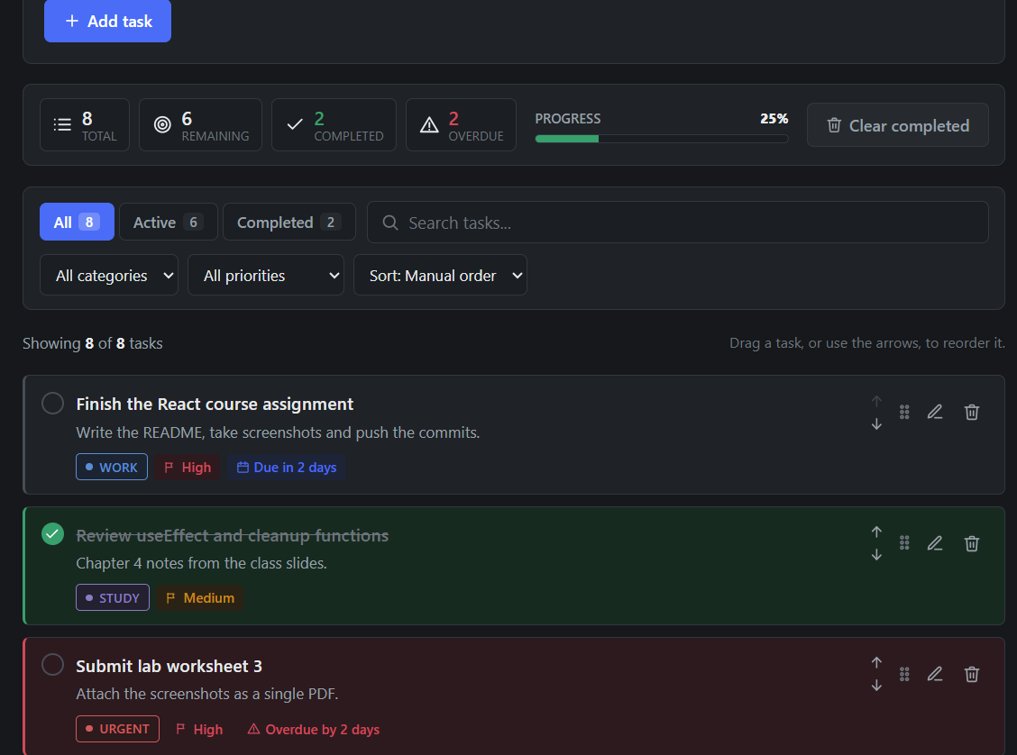
Note. The task "Submit lab worksheet 3" is past its deadline and is outlined in red; the grip handle and the two arrow buttons reorder a task.

Figure 3
Tasks Page — Editing an Existing Task
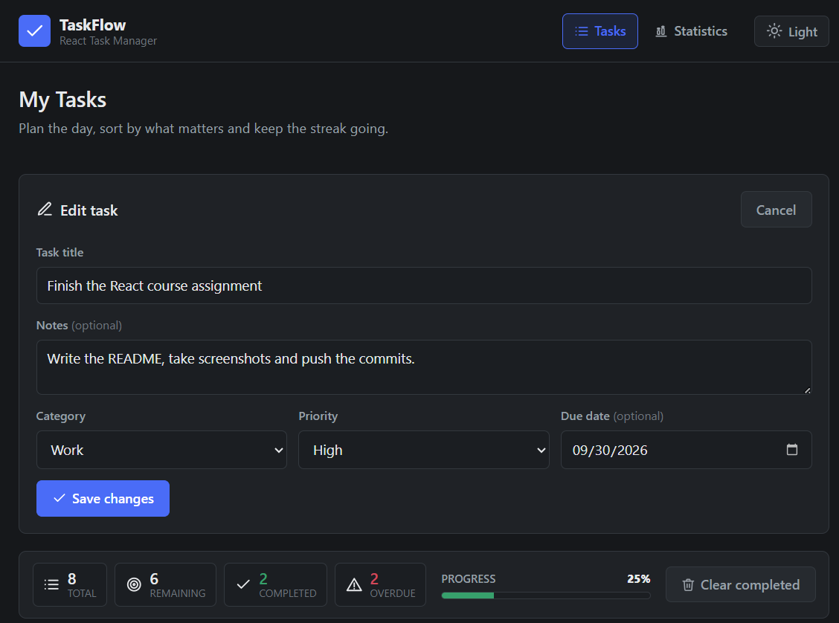
Note. Pressing the pencil icon loads the task values into the same form and turns the submit button into Save changes.

Figure 4
Tasks Page — Delete Confirmation Dialog
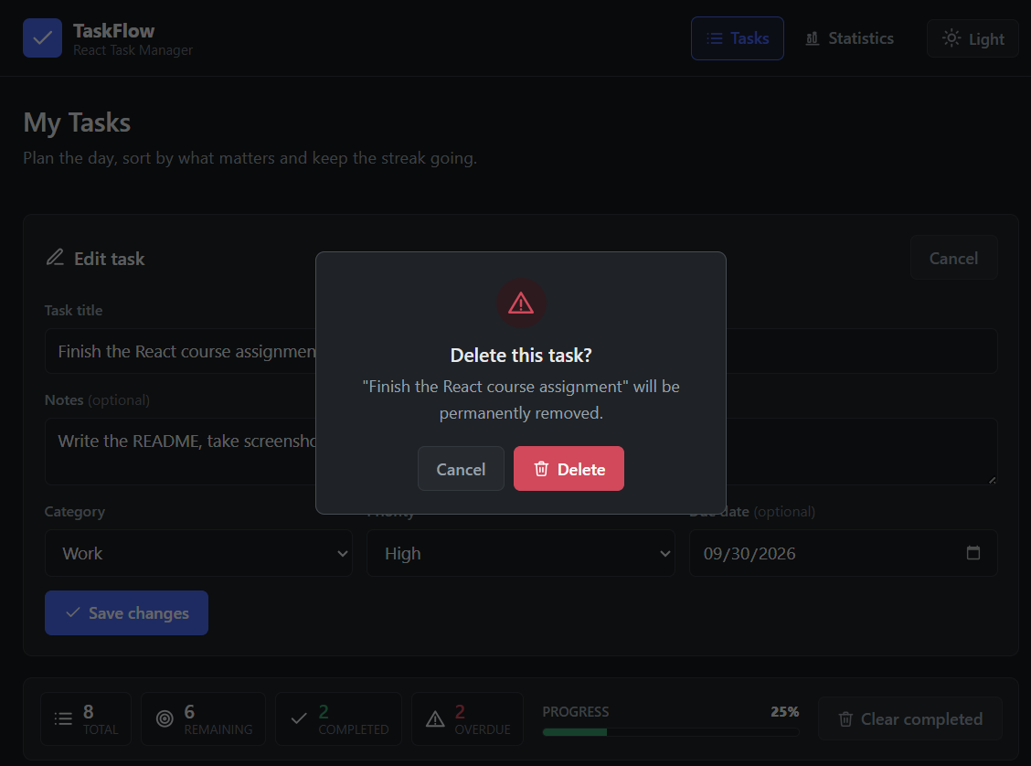
Note. Nothing is deleted immediately; the dialog names the task and asks for confirmation, which protects against accidental clicks.

Figure 5
Tasks Page — Filtered to Active Tasks Only
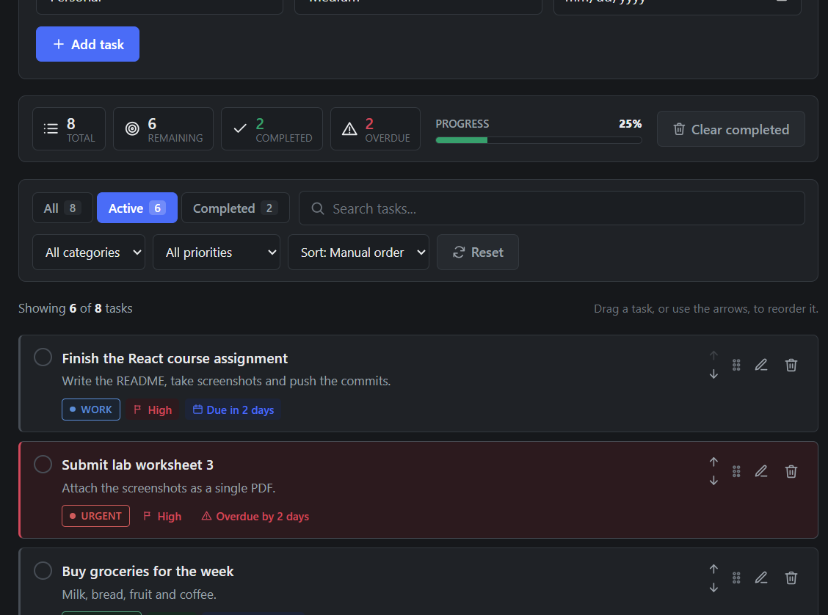
Note. The count on the Active tab changes to match, the simplest example of conditional rendering driven by state.

Figure 6
Tasks Page — Empty State When Nothing Matches the Filters
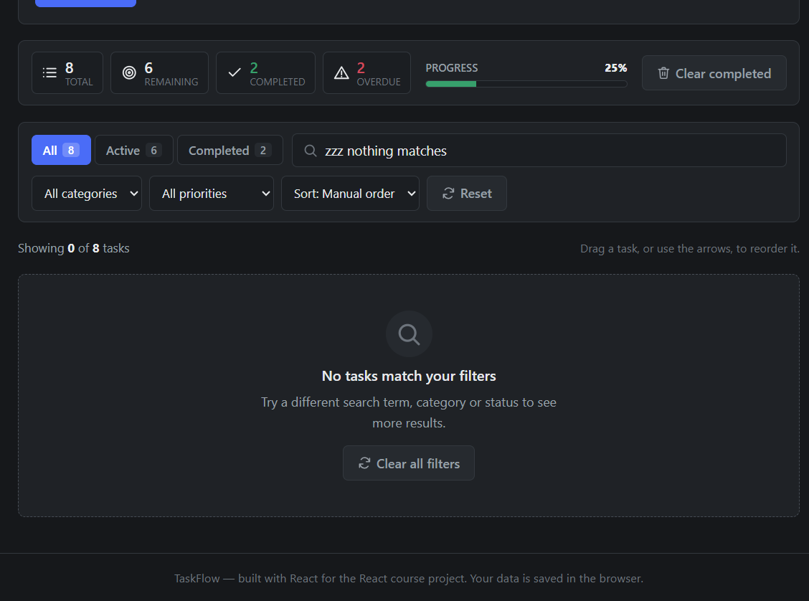
Note. A short explanation and a button that clears every filter, so the user is never left looking at a blank area.

Figure 7
Statistics Page — Summary Cards and Completion Rate
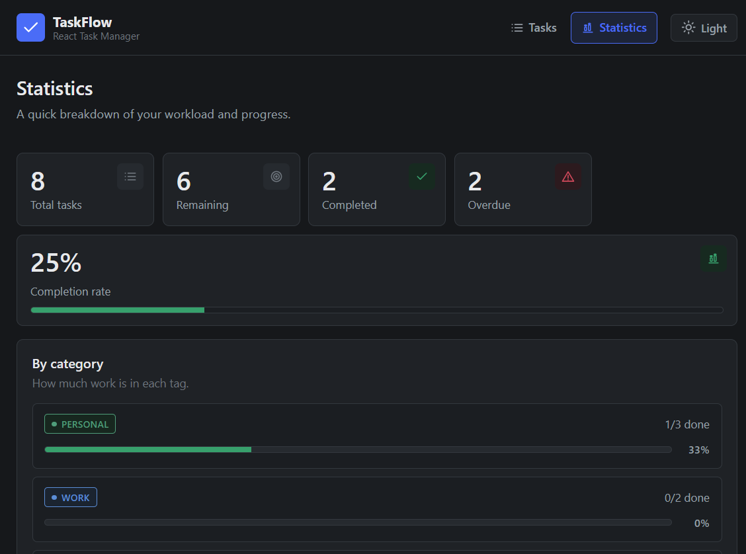
Note. The second view, reached through React Router. The 25 percent rate is 2 completed out of 8 tasks.

Figure 8
Statistics Page — Progress by Category
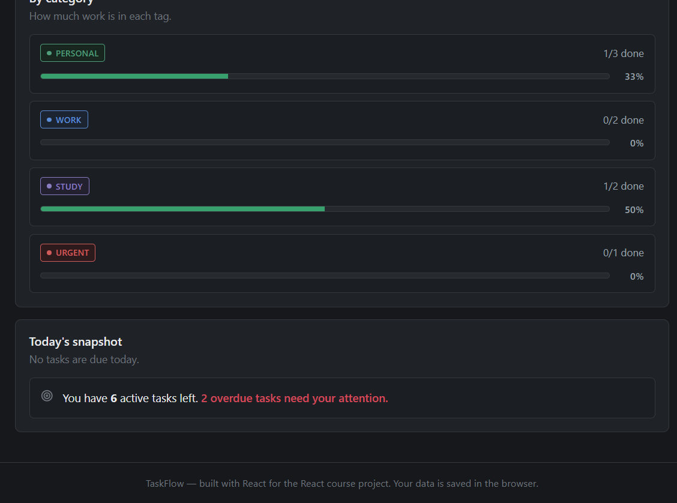
Note. Each category gets its own bar showing how much of it is finished: Personal 1 of 3, Work 0 of 2, Study 1 of 2, Urgent 0 of 1.

Figure 9
Tasks Page — Light Theme
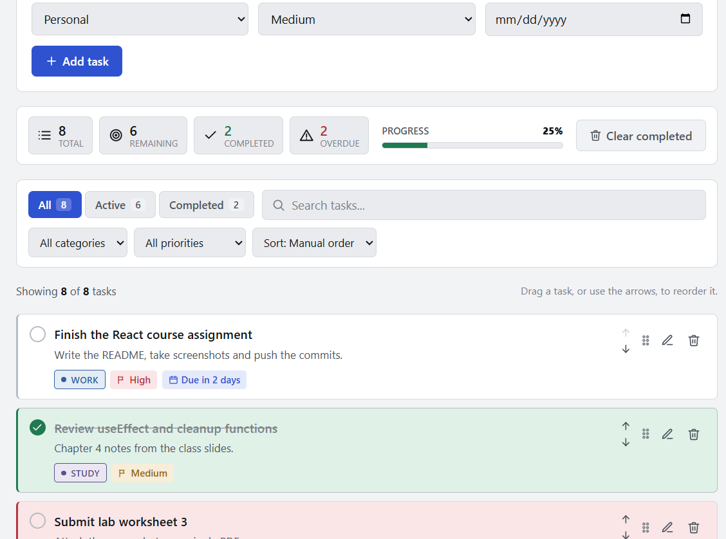
Note. Only one attribute on the html element changes, because every component reads its colours from CSS variables.

Figure 10
Not Found Page
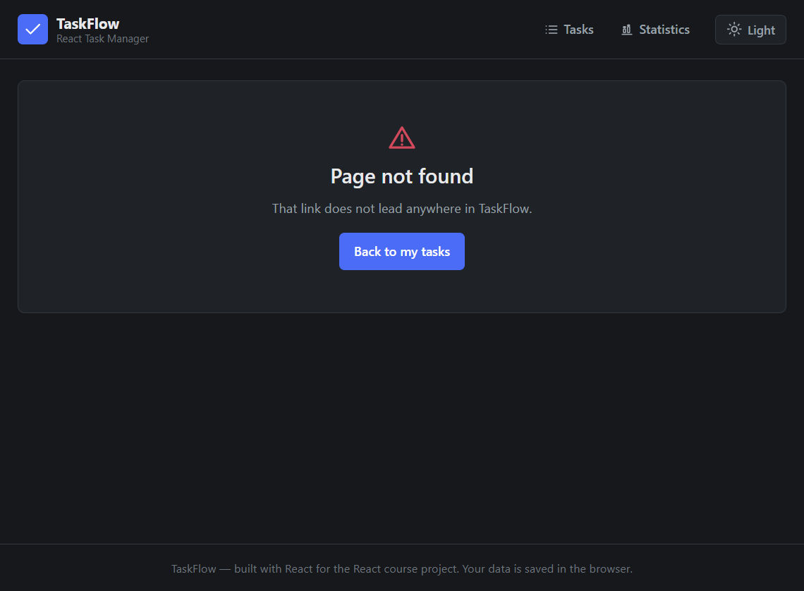
Note. Any address that does not match a route renders this page instead of a blank screen, with a link back to the task list.

8. React Concepts Used
This section explains the React concepts that the project actually uses and where each one is applied.

8.1 Components
Every component in the project is a function component. There are no class components anywhere in the source. A component is a plain JavaScript function that returns JSX, and each one is written in its own file under src/components or src/pages.
The project contains ten components, and they are reused rather than repeated:
Component | What it does | How often it is reused
Header | The top bar: brand name, the two navigation links and the theme button. | Once, in App
TaskForm | Collects the task data, for both adding and editing. | One definition, two modes
FilterBar | Status tabs, search box and three drop-downs. | Once per page
TaskList | Maps the array and renders one TaskItem per task. | Once
TaskItem | A single row of the list. | Once per task
CategoryBadge | The coloured category tag. | In every row and on the stats page
StatsPanel | The live counts and the progress bar. | Once, on the tasks page
EmptyState | Shown when the list has nothing to show. | Once, when empty
ConfirmDialog | The delete confirmation. | Once, only while open
Icon | A small set of inline SVG icons. | Throughout the interface

8.2 Props
Props are how a parent hands data and functions to a child. They are read-only: a child may use them but must never change them, which is what keeps the flow of data predictable. Three kinds are used in this project, as shown below:
// 1. Data props carry a value down the tree.
<TaskItem
key={task.id}
task={task} // the data to display
isFirst={index === 0} // extra information about its position
canReorder={canReorder}
/>

// 2. Callback props carry behaviour. A child calls the function
// instead of doing the work itself.
<button onClick={() => onToggle(task.id)}>...</button>

// the parent is the one that actually changes the data
<TaskList onToggle={toggleTask} onEdit={handleEdit} />

The third kind is a placeholder prop, which lets the same component behave differently depending on what it is given. TaskForm uses an editingTask prop to decide whether it is adding or editing, and the header uses the render-prop form of NavLink, in which a function receives the current state of the link and returns the class name, so the active tab is highlighted without any extra state.
Props were chosen over a context for the shared data because the depth is only three levels. Passing the task list down through three components is easy to follow, whereas a context would hide where the data originally came from. The only data that genuinely needed to be lifted further was the task array itself, which is held in App so that both pages see the same list.

8.3 State
State is data that changes over time and causes the component to re-render. In this project it is created with the useState hook:
// src/hooks/useTasks.js
const [tasks, setTasks] = useLocalStorage(STORAGE_KEYS.tasks, SAMPLE_TASKS)

// tasks = the current value, read while rendering
// setTasks = a function that replaces the value and re-renders

State is created in four places, and each one is at the level that makes sense for the data:
- App.jsx holds the task array, because both pages need to read it.
- useFilters holds the five filter values, because they only matter on the tasks page.
- Home.jsx holds three small pieces of interface state: editingId, pendingDeleteId and draggingId. Keeping them in the page rather than in each row leaves the row components free of this bookkeeping.
- useTheme holds the name of the current theme, either dark or light.

State is always updated using the functional form of the setter, setTasks(function), rather than setTasks(newValue). The functional form receives the latest array at the moment the update runs, which avoids a subtle bug: if two updates are queued in the same render, reading a stale value would make the second one overwrite the first.

8.4 useEffect
An effect is used to synchronise React with something outside React. Two effects are used in this project, and both of them deal with the browser rather than with the interface.
// in useLocalStorage: write the value to the browser on every change
useEffect(() => {
try {
window.localStorage.setItem(key, JSON.stringify(value))
} catch (error) {
console.warn(`Could not save "${key}" to localStorage.`, error)
}
}, [key, value]) // runs again only if key or value changes

// in useTheme: apply the chosen palette to the html element
useEffect(() => {
document.documentElement.setAttribute('data-theme', theme)
}, [theme])

The array in the second argument is the dependency list. React only re-runs the effect when one of the values in that list changes, so the write happens once per change rather than on every render. The read on startup is not done in an effect either: it is passed to useState as a function, so React calls it once during the very first render instead of after the first paint, which avoids a flash of empty content while the stored value loads.
A third effect appears in TaskForm. It copies the values of the task being edited into the form inputs whenever the task changes. A linter suggests moving this out of the effect, but the situation is genuinely a synchronisation between two separate parts of the interface, the row that was clicked and the form at the top of the page, which is exactly what an effect is for.

8.5 Other Hooks
- useMemo is used in useFilters to remember the filtered and sorted list, and in Home and Stats to remember the statistics. Without it the whole list is walked again on every unrelated render, for example on every keystroke in the search box.
- useCallback is used in useTasks to keep the six action functions stable, which is what allows the memoised filtering to work.
- Custom hooks: useLocalStorage, useTasks, useFilters and useTheme. A custom hook is any function that starts with use and calls at least one built-in hook. Writing them kept the components short and reused the same persistence code for three pieces of state.

8.6 Event Handling
Events are handled with the standard React props, and there are four kinds in this project:
- onClick on buttons and icon buttons — completing, editing, deleting, reordering, changing tab, toggling the theme, navigating.
- onChange on the text, textarea and select inputs — every keystroke updates the form state so the inputs are controlled.
- onSubmit on the form — used instead of a click handler on the button, so that pressing Enter in a text field also works. The handler calls event.preventDefault() to stop the browser from reloading the page.
- The drag and drop handlers onDragStart, onDragOver, onDrop and onDragEnd on each task row, which handle reordering.

8.7 Forms and Validation
A controlled input is one whose value comes from React state instead of from the browser. The pattern is always the same: the value attribute receives a state value, and the onChange handler puts the new value back into state. The TaskForm follows this pattern for all five fields.
Validation happens in the submit handler, before anything is saved:
function handleSubmit(event) {
event.preventDefault()

const title = form.title.trim()

if (!title) {
setError('Please enter a task title.')
return // stop here, nothing is saved
}
if (title.length > TITLE_MAX_LENGTH) {
setError(`Title must be ${TITLE_MAX_LENGTH} characters or fewer.`)
return
}
if (form.dueDate && !isValidDateString(form.dueDate)) {
setError('Please choose a valid due date.')
return
}

onSubmit({ ...form, title }) // only now is the data passed up
}

// TaskList.jsx: the list is built with map, and the key is the
// task id and never the array index
{tasks.map((task, index) => (
<TaskItem key={task.id} task={task} onToggle={onToggle} />
))}

The error is held in state and rendered below the form with the role="alert" attribute, so a screen reader announces it. Clearing the error as soon as the user types again means the message never becomes stale.

8.8 List Rendering and Keys
The list is built with the map method shown at the end of the previous code block. The key is the task id and never the index. The index is a position, and positions change when a task is deleted or dragged, so using it as a key would make React think that a different task simply changed its data at that position. With a stable id React can identify exactly which row was added, moved or removed, which is why drag-and-drop behaves correctly.

8.9 Conditional Rendering
Conditional rendering is used in five places:
- TaskList returns the EmptyState component instead of the list when the array is empty, and the EmptyState shows different wording depending on whether there are no tasks or the filters are hiding them all.
- ConfirmDialog returns null while it is closed, so the modal is not in the page at all until a delete is requested.
- TaskForm shows an error message only when the error state is set, and switches between Add task and Save changes depending on whether a task is being edited.
- TaskItem adds the classes is-completed, is-overdue and is-dragging, so the strike-through, the red overdue border and the drag feedback all appear and disappear automatically from the data alone.
- The up and down arrow buttons are disabled when a task is already first or last, and the Clear completed button is only rendered when something is actually completed.

8.10 React Router
React Router gives the application more than one view without reloading the page. Three routes are declared in App.jsx:
<BrowserRouter>
<Routes>
<Route path="/" element={<Home tasks={tasks} ... />} />
<Route path="/stats" element={<Stats tasks={tasks} />} />
<Route path="*" element={<NotFound />} />
</Routes>
</BrowserRouter>

The header builds its links with NavLink, which reads the current URL itself and applies the is-active class automatically, so the interface always shows which page is open. The catch-all route "*" matches anything that is not "/" or "/stats" and renders the NotFound page. Outlet is not used, because the two pages are passed to Route as elements rather than rendered as nested children.

8.11 Context API
The Context API is not used in this project. The shared data is the task array, and it is held in App and passed down as props for three levels, which is short enough to stay readable. A context would only be justified if the prop list became long or the data had to travel five or six levels down, and in that case it would also hide the origin of the data, making the code harder to follow rather than easier.

8.12 API Integration
No web API is used. TaskFlow is a fully local application: the data is created by the user, kept in React state and saved to localStorage, so there is no fetch call, no Axios request and no loading or network error state to handle. The loading and error states that the assignment mentions are covered in a different way — the form has a validation error state, and the delete action has a confirmation state.

9. Important Code Explanation
The whole project is not reproduced here. The snippets below are the pieces of logic that carry the application, and each one is explained in terms of what it does and why it is written that way.

9.1 Adding a Task
The addTask function is defined once in the useTasks hook:
const addTask = useCallback((input) => {
setTasks((current) => [createTask(input), ...current])
}, [setTasks])

The new task is placed at the front of the array so that it appears at the top of the list, where the user is looking. The important detail is the use of the functional form of the setter. Instead of writing setTasks([newTask, ...tasks]), the code passes a function that receives the current array. If two tasks were added in quick succession, the second call would receive the array that already contains the first task. With the value form, both calls would have captured the same stale array and one task would have been lost.

9.2 Updating and Deleting a Task
const updateTask = useCallback((id, changes) => {
setTasks((current) =>
current.map((task) => (task.id === id ? { ...task, ...changes } : task)),
)
}, [setTasks])

const deleteTask = useCallback((id) => {
setTasks((current) => current.filter((task) => task.id !== id))
}, [setTasks])

const toggleTask = useCallback((id) => {
setTasks((current) =>
current.map((task) =>
task.id === id ? { ...task, completed: !task.completed } : task,
),
)
}, [setTasks])

Updating uses map to walk the array and rebuild only the one task whose id matches, spreading the old task and the new changes together. Because a new object is created, React sees a different reference and re-renders. Deleting uses filter, which keeps everything that does not match and naturally produces a shorter array. Completing a task is the same shape as updating: the new object flips the completed field with the ! operator.

9.3 Persisting to localStorage
export function useLocalStorage(key, initialValue) {
// The function passed to useState runs once, on the first render.
const [value, setValue] = useState(() => readFromStorage(key, initialValue))

useEffect(() => {
try {
window.localStorage.setItem(key, JSON.stringify(value))
} catch (error) {
console.warn(`Could not save "${key}" to localStorage.`, error)
}
}, [key, value])

return [value, setValue]
}

The hook returns a pair just like useState does, so it can be used in exactly the same way. Three details make it work reliably. The initial read is passed as a function to useState, so the lazy initialiser runs only once instead of on every render. The dependency list is [key, value], so the write happens only when the value genuinely changes. And the write is wrapped in try and catch, because localStorage can be unavailable when a browser is in private mode or when the quota is full, and a storage failure should not be allowed to crash the interface.

9.4 Filtering, Sorting and Statistics
export function filterAndSortTasks(tasks, filters) {
const search = filters.search.trim().toLowerCase()

const filtered = tasks.filter((task) => {
if (filters.status === 'active' && task.completed) return false
if (filters.status === 'completed' && !task.completed) return false
if (filters.category !== 'all' && task.category !== filters.category) return false
if (filters.priority !== 'all' && task.priority !== filters.priority) return false

if (search) {
const haystack = `${task.title} ${task.notes} ${task.category}`.toLowerCase()
if (!haystack.includes(search)) return false
}
return true
})

return sortTasks(filtered, filters.sortBy)
}

Every filter is one early return inside a single filter callback, which keeps the conditions readable and means a task must satisfy all of them in order to survive. The search term is lower-cased once before the loop, and the haystack is lower-cased for each task, so the comparison ignores capital letters. The sorting step is a separate function, and because it starts with [...tasks] it never mutates the original array, which matters for the memoisation in useMemo.

The statistics are calculated in the same way, from the array itself. No counter is stored anywhere, so the summary can never disagree with the list:
export function getTaskStats(tasks) {
const total = tasks.length
const completed = tasks.filter((task) => task.completed).length
const active = total - completed
const overdue = tasks.filter(
(task) => !task.completed && getDueDateStatus(task.dueDate) === 'overdue',
).length

return {
total,
completed,
active,
overdue,
percent: total === 0 ? 0 : Math.round((completed / total) * 100),
}
}

A task only counts as overdue if it is also unfinished, and the division-by-zero case is handled with a conditional, because an empty list has no completion rate to report.

9.5 Working Out the Due Date Status
export function getDueDateStatus(dueDate) {
const target = parseDateString(dueDate)
if (!target) return 'none'

const today = new Date()
today.setHours(0, 0, 0, 0) // midnight, so the time of day
// cannot affect the result

if (target.getTime() < today.getTime()) return 'overdue'
if (target.getTime() === today.getTime()) return 'today'
return 'upcoming'
}

Due dates are stored as plain "YYYY-MM-DD" text rather than as Date objects, because a Date becomes a string the moment it is written to localStorage, and reading it back can shift it by a day because of timezones. Zeroing the time of day on the current date means only the calendar dates are compared, so a task due today stays "due today" even at 11 p.m. The status string is then used both to colour the label and to count the overdue tasks.

9.6 Drag and Drop Reordering
function handleDragStart(event, id) {
setDraggingId(id)
event.dataTransfer.effectAllowed = 'move'
event.dataTransfer.setData('text/plain', id) // Firefox needs this
}

function handleDragOver(event) {
event.preventDefault() // without this the drop is refused
event.dataTransfer.dropEffect = 'move'
}

function handleDrop(event, targetId) {
event.preventDefault()
const fromIndex = tasks.findIndex((task) => task.id === draggingId)
const toIndex = tasks.findIndex((task) => task.id === targetId)

if (fromIndex !== -1 && toIndex !== -1 && fromIndex !== toIndex) {
reorderTasks(fromIndex, toIndex)
}
setDraggingId(null)
}

// a small immutable helper in taskUtils.js
export function moveTask(tasks, fromIndex, toIndex) {
const result = [...tasks]
const [moved] = result.splice(fromIndex, 1)
result.splice(toIndex, 0, moved)
return result
}

Three browser rules have to be respected for dragging to work at all, and each one is visible in the code. A drag does not start in Firefox unless some data is placed in dataTransfer, hence the setData call. The drop is refused unless onDragOver calls preventDefault, which is why handleDragOver always does. And dropEffect has to be set for the cursor to show the move symbol. The reordering itself never mutates the original array; splice is applied to a copy, so React still sees a new reference and re-renders.

9.7 Lifting State Up for Two Pages
// App.jsx
const { tasks, addTask, updateTask, ... } = useTasks()

<Routes>
<Route path="/" element={<Home tasks={tasks} addTask={addTask} ... />} />
<Route path="/stats" element={<Stats tasks={tasks} />} />
</Routes>

The task list is needed on two different pages, so it is held in the closest common parent, App, and passed down to both as props. Completing a task on the tasks page therefore updates the statistics on the other page immediately, with no extra code and no duplicate copy of the data. This is the pattern the React documentation calls lifting state up.

10. API Documentation
TaskFlow does not use any web API or backend, so there are no endpoints, request bodies or HTTP methods to document. All data is created by the user, held in React state and saved in the browser. Instead, the interfaces the application does expose to the outside world are the browser storage keys it uses, which are listed below.
Name | Type | Purpose
taskflow.tasks | localStorage key | Holds the full task array as a JSON string. Read once on startup and rewritten every time a task is added, edited, deleted, completed or reordered.
taskflow.filters | localStorage key | Holds the five filter values, so the status tab, search term and sort order are the same on the next visit.
taskflow.theme | localStorage key | Holds the theme name, either "dark" or "light", which is read back and applied to the html element.

Because there is no server, there is no network failure to handle. The equivalent error handling in this project happens in two other places: the try and catch around every localStorage access, and the form validation that stops an invalid task from being created in the first place.

11. Application Flow
This is what happens from the user's point of view, from opening the application to finishing the work.
User opens the app
|
v
useLocalStorage reads taskflow.tasks from the browser
|
+-- nothing stored yet? --> three sample tasks are used
|
v
Home page renders: form + live summary + filter bar + task list
|
+--> type a task, press "Add task"
| |
| +--> validate: fail --> show the error, stop
| | pass --> TaskForm calls onSubmit
| | |
| | v
| | Home.handleFormSubmit
| | |
| | v
| | useTasks.addTask (state changes)
| | |
| | v
| | useEffect writes to localStorage
| | |
| v
| list re-renders, summary counters update
|
+--> press the circle --> toggleTask --> done / reopened
+--> press the pencil --> form loads the task --> edit --> updateTask
+--> press the bin --> dialog --> confirm --> deleteTask
+--> drag a task or use the arrows --> reorderTasks
+--> change tab, search, or a drop-down --> filters change
| |
| v
| filterAndSortTasks
| (runs inside useMemo)
|
+--> click "Statistics" --> React Router swaps the view
| same tasks prop, read-only view
|
`--> click the theme button --> useEffect sets data-theme on <html>
all colours change at once

Every arrow in this flow is either a state change or a callback travelling down the tree. There is no place in the flow where a component changes data on its own, which is what makes the application predictable when something goes wrong.

12. Challenges Faced
Five problems came up while building the project, and how each was solved.

12.1 Keeping one copy of the task list for two pages
Challenge: the Tasks page and the Statistics page both need the task list. The list was originally written inside the Tasks page, so the Statistics page had nothing to show, and duplicating the state in two places meant the two copies drifted apart as soon as a task was completed.
Solution: the state was moved up into App, the closest common parent of both routes, and passed down to each page as a prop. There is now only ever one copy of the list, and completing a task updates the statistics immediately because both pages read from the same source. The Context API was considered and rejected at this stage, because passing the data through two levels is still easy to follow and a context would hide where the data came from.

12.2 Losing the task list on refresh
Challenge: state created with useState exists only in memory, so closing the tab lost every task.
Solution: a useLocalStorage custom hook was written that reads the value on the first render and writes it back through an effect. Writing the storage logic once and returning a pair just like useState meant the same hook could then be reused for the filters and the theme, so the three pieces of persisted state cost almost no extra code.

12.3 Drag and drop behaving differently in different browsers
Challenge: the first version of the drag and drop code worked in Chrome but did nothing in Firefox, and the drop was refused in every browser.
Solution: two browser rules were found and applied. A drag will not begin in Firefox unless data is placed in the dataTransfer object, and the browser will refuse every drop unless the onDragOver handler calls event.preventDefault(). Both were added, together with a setData call so that the dragged task could be identified, and dropEffect so that the cursor shows the correct symbol.

12.4 Reordering a sorted list
Challenge: with the list sorted by due date or by name, dragging a task produced a result that jumped straight back, because the sort immediately put the task back in its sorted position.
Solution: reordering is only enabled while the sort option is set to Manual order, and a short line under the toolbar tells the user which mode is active. The arrow buttons call exactly the same reorderTasks function, so nothing is lost for users who cannot drag, and the reason for the restriction is written in a comment next to the check so it is not removed by accident later.

12.5 A form that has to do two jobs
Challenge: the add form and the edit form needed the same five fields, the same validation and almost the same layout, and duplicating them would have meant two sets of bugs to fix.
Solution: one TaskForm component is used for both. An editingTask prop decides which mode it is in: when the prop is null the component adds a task, and when it holds a task an effect copies that task's values into the inputs and the buttons change their labels. The component still has to decide whether to add or to update, but that decision stays in the page, where the list of tasks actually lives, so the form itself has no knowledge of the data.

12.6 Keeping the filter list responsive
Challenge: with a long list, every keystroke in the search box re-filtered and re-sorted the whole array, which made typing feel slow.
Solution: the filtering logic was moved out of the component into pure functions, the visible list was wrapped in useMemo, and the action functions were wrapped in useCallback so their references stay the same between renders. The list is now only recalculated when the tasks or the filters actually change.

13. Limitations
The following limitations are known and have not been fixed yet.
- Data is not stored on a server. Everything lives in the browser's localStorage, so there is no account, no synchronisation between devices, and clearing the site data deletes the list permanently.
- There are no recurring tasks. A task can be given a due date but cannot be made to repeat daily, weekly or monthly.
- Reordering and sorting cannot be used together. Drag and drop only works while the sort option is set to Manual order.
- There are no subtasks, attachments or comments. A task is a flat record with a title, one note, a category, a priority and an optional due date.
- There are no automated tests. Everything was checked manually in the browser. A Vitest and React Testing Library suite would make future changes much safer.
- The icon set is incomplete. The icons are hand-written inline SVG elements covering only what the application currently needs.
- The application is not installed as a PWA. There is no service worker, so it must be served over HTTP and cannot be added to the home screen or used offline after the tab is closed.
- The application is not deployed. A vercel.json rewrite rule is included, so deploying to Vercel needs no extra configuration, but there is no public live link yet.

14. Future Enhancements
If the project were continued, the following would be added, in roughly this order.
- Automatic tests. Unit tests for the pure functions in utils, and component tests for the form, the filters and the list, using Vitest and React Testing Library.
- A real backend. A small Express and MongoDB service with authentication, so that tasks belong to an account and follow the user between devices.
- Recurring tasks and reminders, with an option to repeat daily, weekly or monthly and a browser notification when something is due.
- Subtasks, so that a task such as "write the assignment" can be broken into smaller steps with their own checkboxes.
- Tags in addition to categories, so a task can belong to several groups at once instead of exactly one.
- A weekly and monthly view, showing how much was completed in each period rather than only the current totals.
- Keyboard shortcuts, for example a shortcut to add a task without reaching for the mouse.
- Deployment to Vercel with the live link added to the README, and a service worker so the application also works offline.

15. Conclusion
TaskFlow is a complete, working task manager built entirely with React function components and hooks. It creates, edits, deletes, completes and reorders tasks, groups them into categories with priorities and due dates, filters and searches the list, saves everything to localStorage, and presents the result on two separate pages through React Router. All three of the stretch goals suggested in the brief, drag-and-drop reordering, due dates with overdue highlighting, and a dark and light theme, were implemented as well. The most valuable things learned were practical rather than theoretical: the location of state decides how easy the code is to write, because the moment the Statistics page could not see the tasks, moving the list up into App fixed the problem and made both pages correct at the same time; a small custom hook pays for itself quickly, because the same eleven lines of useState and useEffect now handle the tasks, the filters and the theme; and the parts of React that look like overhead, the key prop, the functional form of a setter and useMemo, are exactly what stop bugs from appearing later, as the drag-and-drop feature showed when the array index was replaced with the task id.
The project also showed where the browser fights back. Drag and drop needed two non-obvious calls before it worked in Firefox, and date handling needed the due date stored as plain text to avoid a day being lost every time the page was reloaded. None of these were visible from reading the documentation; they were found by testing the application and then working out which browser rule was being broken. Overall this was a good exercise in turning a course assignment into something genuinely usable, and the resulting code is simple enough to extend.

16. GitHub Repository
The complete source code is available at:
https://github.com/your-username/taskflow-todo-app

The repository contains the following, as required by the assignment:
- A properly organised project structure, with components, hooks, utils and pages in separate folders.
- README.md, describing the features, the technologies, the folder structure, the setup instructions and the screenshots.
- The full source code.
- package.json, listing the dependencies and the npm scripts.
- .gitignore, excluding node_modules, dist and other generated files.
- This documentation, together with the screenshots in docs/screenshots.

No .env file, password, API key or token is included in the repository, because the application does not connect to any service and does not need one.

To run the project locally:
git clone https://github.com/your-username/taskflow-todo-app.git
cd taskflow-todo-app
npm install
npm run dev

References
The following documentation and tools were referred to while building this project.
1. American Psychological Association. (2020). Publication manual of the American Psychological Association (7th ed.). https://doi.org/10.1037/0000165-000
2. Meta Open Source. (2025). React [Computer software]. https://react.dev
3. Meta Open Source. (2025). React: Thinking in React [Documentation]. https://react.dev/learn/thinking-in-react
4. Meta Open Source. (2025). React: Sharing state between components [Documentation]. https://react.dev/learn/sharing-state-between-components
5. Meta Open Source. (2025). React: useState hook [Documentation]. https://react.dev/reference/react/useState
6. Meta Open Source. (2025). React: useEffect hook [Documentation]. https://react.dev/reference/react/useEffect
7. Meta Open Source. (2025). React: useMemo hook [Documentation]. https://react.dev/reference/react/useMemo
8. React Router. (2025). React Router [Computer software]. https://reactrouter.com
9. Vite. (2025). Vite: The frontend build tool [Computer software]. https://vite.dev
10. Mozilla Developer Network. (2025). Window: localStorage property. Mozilla Foundation. https://developer.mozilla.org/en-US/docs/Web/API/Window/localStorage
11. Mozilla Developer Network. (2025). HTML drag and drop API. Mozilla Foundation. https://developer.mozilla.org/en-US/docs/Web/API/HTML_Drag_and_Drop_API
12. Mozilla Developer Network. (2025). Array.prototype.map(). Mozilla Foundation. https://developer.mozilla.org/en-US/docs/Web/JavaScript/Reference/Global_Objects/Array/map
13. Mozilla Developer Network. (2025). Using custom properties (CSS variables). Mozilla Foundation. https://developer.mozilla.org/en-US/docs/Web/CSS/Using_CSS_custom_properties
14. Mozilla Developer Network. (2025). Using media queries for responsiveness. Mozilla Foundation. https://developer.mozilla.org/en-US/docs/Learn/CSS/CSS_media_queries/Using_media_queries_for_responsiveness
15. OpenJS Foundation. (2025). OXLint [Computer software]. https://oxc.rs
16. OpenAI. (2025). ChatGPT [Large language model]. https://chat.openai.com

Appendix A: Testing Performed
The application was verified manually in the browser, and the code was checked with the linter and a production build. The table below records what was tested and what happened.
# | Test | Action | Result
1 | Form validation | Submitted the form with an empty title | Showed "Please enter a task title." and created nothing. Pass
2 | Add a task | Entered a title, chose a category and priority, clicked Add task | The task appeared at the top of the list and the form cleared. Pass
3 | Edit a task | Clicked the pencil, changed the title, clicked Save changes | The row showed the new title, the total did not change, the form reset. Pass
4 | Cancel editing | Clicked edit, then clicked Cancel | The form returned to Add task and no data was lost. Pass
5 | Complete a task | Clicked the round checkbox | The title was struck through, the border turned green, the counters updated. Pass
6 | Delete a task | Clicked the bin icon, then Delete | The dialog named the task and it was removed. Pass
7 | Cancel a delete | Clicked the bin icon, then Cancel | The dialog closed and the task was still there. Pass
8 | Status filter | Selected the Active tab with 8 tasks, 2 of them completed | Exactly 6 tasks were shown and the tab count read 6. Pass
9 | Search | Typed a word into the search box | Only matching tasks remained. Pass
10 | Combined filters | Used category, priority and search together | Only tasks matching every condition remained. Pass
11 | Empty state | Searched for a word that matches nothing | The "No tasks match your filters" panel and a Clear all filters button appeared. Pass
12 | Sorting | Switched to Due date, Priority and Name | The list was ordered correctly and tasks without a due date were last. Pass
13 | Reordering | Used the arrow buttons and dragged a task | The task changed position and the new order survived a refresh. Pass
14 | Persistence | Added and reordered tasks, then reloaded the page | The same list in the same order was restored. Pass
15 | Theme toggle | Clicked the theme button twice | The palette changed between dark and light and the choice was remembered. Pass
16 | Routing | Clicked Statistics, then used the browser Back button | Both pages rendered without a page reload. Pass
17 | Unknown URL | Opened an address that matches no route | The NotFound page appeared with a link back to the list. Pass
18 | Overdue styling | Viewed a task whose due date has passed | A red border and a red "Overdue by N days" label were shown. Pass
19 | Clear completed | Pressed Clear completed with three finished tasks | The three finished tasks were removed and the counters updated. Pass
20 | Console output | Used every control and watched the browser console | No errors and no warnings were printed. Pass
21 | Production build | Ran npm run build | The build completed with no errors. Pass
22 | Linter | Ran npm run lint | No errors. One advisory about synchronising form state with an effect. Pass
23 | Responsive layout | Resized the window down to mobile widths | The form, toolbar and statistics stack without horizontal scrolling. Pass
24 | First visit | Opened the application with no saved data | Three sample tasks were created and the list was not empty. Pass

The one advisory message from the linter suggests that the form state should not be filled in from within an effect. The suggestion was not applied, because loading the values of the task that the user clicked into the form at the top of the page is a genuine synchronisation between two separate parts of the interface, which is the situation an effect exists to handle.

Appendix B: Git Commit History
The work was committed in small, meaningful steps rather than in one large commit, following the Conventional Commits convention so that the type of each change is readable from the log.
Commit | Type | Description
4fc82aa | chore | Scaffold the Vite and React project and install the dependencies
89698f9 | style | Add the dark theme design tokens and the global base styles
e84c310 | feat | Add the shared constants and the date formatting helpers
8fd8f48 | feat | Add the useLocalStorage hook to persist state in the browser
c8a3379 | feat | Add the task filtering, sorting and statistics utilities
27ab2fc | feat | Add the useTasks and useFilters hooks for state management
726bc99 | feat | Add the useTheme hook for dark and light mode
ed84b12 | feat | Add the app shell with React Router navigation and the icon set
551d107 | feat | Add the task form with controlled inputs and validation
86c3fce | feat | Add the filter bar with status tabs, search and sorting
72707b4 | feat | Add the task item and category badge components
c55277e | feat | Add the task list, the empty state and the delete confirmation dialog
b69f52c | feat | Add the live statistics summary panel with a progress bar
1e97bc5 | feat | Build the home page with full task create, edit and delete
c3b12e8 | feat | Add drag and drop reordering with keyboard move controls
c932a80 | feat | Add the statistics page with the category breakdown and the cards
1c7b8b9 | docs | Add the README with the features, setup, structure and screenshots
dcc6830 | docs | Add the APA 7 project report with screenshots and code structure
ea2e145 | chore | Replace the default favicon with the TaskFlow brand mark
bd6091c | chore | Add the Vercel rewrite config and sync the docs with the report
d333c31 | style | Simplify the design tokens to a flat, single accent palette
0196105 | style | Flatten the header, form and filter styles with square corners
198fcec | style | Use colour only where it carries meaning in the task components
811a255 | style | Simplify the statistics page cards and remove decorative effects
8cc032a | docs | Refresh the screenshots after the interface simplification

