### Studıo bıllıon

ADB Wifi Build – Editor

ADB Wifi Build is a tool for connecting an Android device to the Android Debug Bridge (ADB) over a wireless connection.

**Setup:**

Import the package via Unity Asset Store.

**Usage:**

1. Be sure your PC and Android device is connected to same wireless internet.
2. Connect your Android device to PC via USB cable.
3. Open Wifi Build Window from ***StudioBillion->ADB Wifi Build*** and Click ***“Refresh Device List”***.

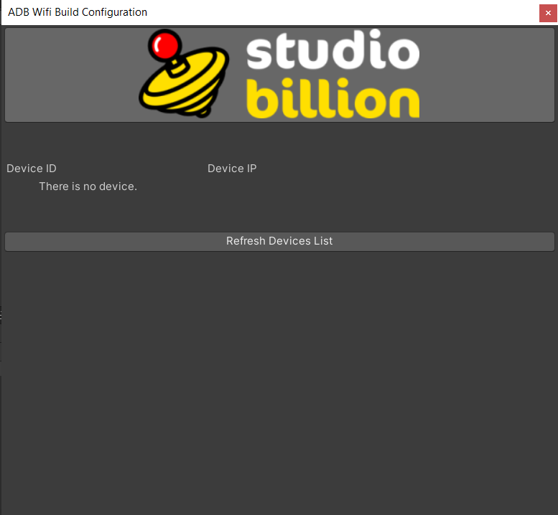

1. You will see your connected devices. Click “Try to Find IP Address” button.

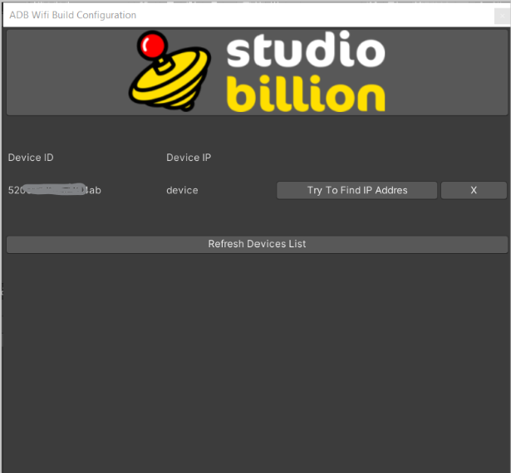

1. After IP configuration you can unplug device cable connection. Then Click “Connect to Device” button

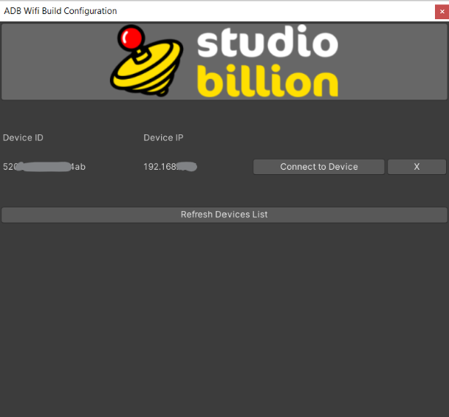

1. You will see a connection report after connection process.

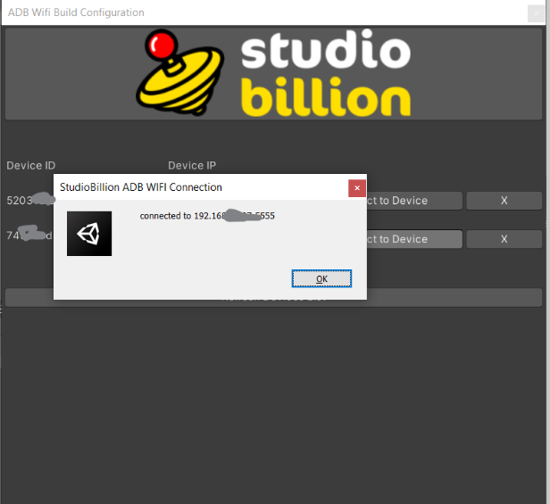

1. You can save and connect multiple devices.

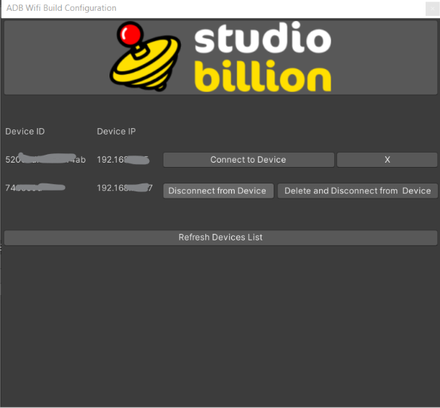

**Support:**

[info@studiobillion.com](mailto:info@studiobillion.com?subject=ADB%20Wifi%20Build)