

**AquaNet: Mobile Application for Transforming Biophysical Ocean Buoy (BoB) Data into Readable Ocean Current and Water Quality Insights Using a Random Forest Regressor Algorithm**

**roberto M. Prisoris Jr.**

**Cyril Lloyd Balanay**

**Joomer Jake C. Caballero**

**A BSIT Capstone Project Submitted to the Faculty of Computing, Engineering, and Technology of the Davao Oriental State University in Partial Fulfillment of the Requirements for the Degree**

**BCHELOR OF SCIENCE IN INFORMATION TECHNOLOGY**

**MAY 2025**

**Chapter I**

**Introduction**

* 1. **Rationale**

Marine pollution, particularly the accumulation of floating wastes, poses severe environmental issues, affecting marine and coastal ecosystems. In the Philippines, a highly reliant country on marine resources, studies have highlighted the indispensable contribution of community involvement in marine conservation initiatives. For instance, Narido et al. (2021) study involving coastal communities in Palawan listed 16 marine environmental issues, necessitating local involvement in resolving the same. Likewise, worldwide, the Copernicus Marine Environment Monitoring Service (CMEMS, 2023) has provided ocean current data to facilitate understanding of the flow of marine debris, yet the same is not made available to the masses.

While there is accessible ocean current data online on platforms such as the Global Ocean Currents Database (NOAA, 2023) and CMEMS (2023), the data are presented in formats and resolution that are not easily interpretable or usable by the local communities. To this end, it has been challenging to engage the local communities in the monitoring and prevention of marine waste. To this shortcoming, the study proposes development of a mobile application that extracts ocean current data and provides the data in formats and ways that are easily interpretable and usable by the local communities in order to allow them to make informed and actionable choices and enhance waste and environmental management.

AquaNet, an application, will serve to bridge this gap by processing raw Biophysical Ocean Buoy (BoB) sensor data into a form that is more readable and accessible. Using high-level data processing methods, the application will process complicated oceanographic data and render it into a user-friendly interface, enabling individuals to gain better insight into current ocean conditions. By making the ocean data readable to the masses, AquaNet will enable local communities to access the information that will help promote marine conservation activities and react actively to environmental transformations.

* 1. **Purpose and Project Description**

AquaNet is a mobile application designed to assist coastal communities in visualizing and understanding the behavior and quality of the sea.

The application has the capability to:

1. Provide insights of ocean quality and current direction.
2. Help users track the movement of marine debris based on ocean currents.
3. Present the information through graphs, charts, and dashboard summaries.

Additionally, this application encourages public awareness through more accessible ocean data, allowing society to make more informed ocean conservation decisions. Since this research is premised on the forecasting of where the ocean trash would be based on sea currents, AquaNet is a key part in translating hard scientific information to actionable knowledge for local beneficiaries.

**1.3 Objectives**

The project aims to develop a mobile application that collects and displays real-time ocean data in a simple, visual format to help local communities monitor marine conditions and make informed decisions. Specifically, it seeks to:

* Collect real-time Global Positioning System, pH, temperature and total dissolved solids data from Biophysical Ocean Buoys (BoBs),
* Receive and process real-time data using an Arduino board that formats sensor input
* Transmits the received data via a GSM module to the application server.
* analyze ocean current data using the Random Forest Regressor algorithm in order to predict future patterns and smooth out changes for more accurate trend observation.
* Design and deploy a mobile app user interface capable of real-time data updates, interactive graphs and summary dashboards.
* Track and predict ocean debris movement in support of local communities and environmental authorities
* Conduct usability testing and launch in-app user evaluation surveys with a target of 85% user satisfaction on ease of use and feature usefulness.
  1. **Significance of the Study**

This study primarily benefits coastal communities by providing a simplified understanding of ocean conditions and currents. AquaNet serves as a tool to make complex ocean data accessible and actionable, especially for those directly affected by marine pollution and environmental changes.

**Coastal communities**: Gain timely insights on water quality, pH levels, and potential pollution risks, enabling better-informed decisions regarding health, livelihood, and environmental conservation.

**Local Governments** Monitor and track the movement of marine debris to plan and execute targeted cleanup operations more effectively.

By integrating predictive analytics, AquaNet makes it possible to identify and project the pathways of marine debris, which helps beneficiaries expect possible environmental hazards and carry out request, based on data actions, thereby encouraging coastal resilience and sustainable management of marine resources.

* 1. **Scope and Limitation**

AquaNet is a mobile application designed to translate raw oceanographic data from Biophysical Ocean Buoys (BoBs) into readable and visual information for local communities. The primary deployment location for this study is Davao Gulf, where the system will focus on collecting and displaying data from that specific coastal area:

* Data collection will include location (via GPS), pH levels, temperature, and Total Dissolved Solids (TDS) as measured by the buoys.
* The application will process and display data in an intuitive format using graphs, charts, and dashboard summaries to aid community understanding.
* The mobile application will also provide features to support the monitoring and basic forecasting of ocean debris movement, based on the collected GPS.

Although AquaNet seeks to improve access to ocean data, it has some limitations:

* AquaNet is **geographically limited** to the Davao Gulf and does not extend to other coastal or marine regions.
* The accuracy of the data depends heavily on the reliability and calibration of BoB sensors.
* The system does not perform advanced hydrodynamic modeling or simulate complex oceanographic conditions beyond basic forecasting of debris movement.
* The application does not independently collect or alter oceanographic data, but rather processes and visualizes data transmitted from external sensors.
* Internet connectivity and SIM card load for SMS transmission are required to retrieve and update data in real-time from the buoy via GSM communication.
* AquaNet does not include the maintenance, calibration, or replacement of buoy hardware, which is assumed to be handled by third-party or institutional partners.

Despite these limitations, AquaNet serves as a vital tool for enhancing community awareness and understanding of ocean conditions, particularly for coastal populations in the Davao Gulf.

**1.6 Definition of Terms**

AquaNet A mobile application designed to transform Biophysical Ocean Buoy (BoB) data into readable ocean current and water quality insights for local communities.

Biophysical Ocean Buoy (BoB) A floating device equipped with sensors that collect oceanographic data such as water temperature, salinity, and currents.

Random Forest Regressor Algorithm A machine learning algorithm used for predicting numerical values based on multiple decision trees, applied in AquaNet to process and simplify oceanographic data.

Marine Pollution The presence of harmful substances such as plastics, chemicals, and debris in ocean waters, negatively affecting marine ecosystems and coastal communities.

Ocean Currents Large-scale movement of seawater driven by factors like wind, temperature, and salinity, influencing marine life and debris distribution.

Water Quality Insights Information derived from oceanographic data, indicating factors like pollution levels, temperature variations, and salinity changes.

Global Ocean Currents Database A publicly accessible platform providing data on ocean currents, managed by organizations such as NOAA.

Copernicus Marine Environment A European program providing real-time

Monitoring Service (CMEMS) and historical ocean data to support environmental monitoring and marine conservation.

Data Visualization The graphical representation of complex oceanographic data, making it easier for users to interpret and understand.

Community Engagement The involvement of local communities in using AquaNet to track marine debris, promote conservation, and make informed decisions about ocean health.

Modified Waterfall Model A structured software development methodology used for AquaNet, allowing iterative feedback and adjustments during the development process.

Predictive Analysis The use of historical and real-time ocean data to forecast trends such as marine debris movement and water quality changes.

User Interface (UI) The visual and interactive components of AquaNet, designed for ease of access and usability.

Marine Conservation Efforts to protect and preserve marine environments through actions such as monitoring pollution, reducing waste, and promoting sustainable practices.

Environmental Monitoring The continuous collection and analysis of ocean data to assess water quality and detect pollution trends.

* 1. **Conceptual Framework**

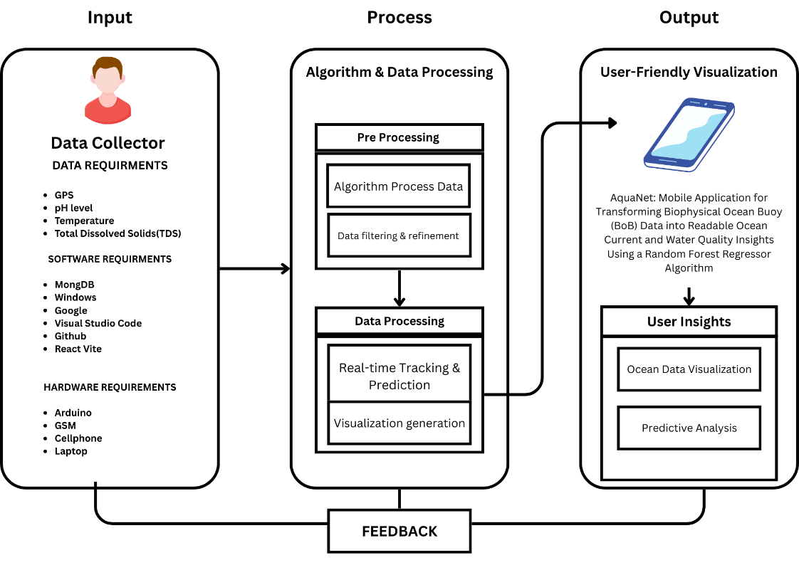The AquaNet system uses an Input-Process-Output (IPO) framework to collect and process real-time ocean data—such as GPS, temperature, pH, and TDS—and deliver it via a mobile app. Figures 1 and 2 illustrate the data flow and hardware setup, showing how AquaNet converts raw sensor data into useful information for coastal safety and conservation.

*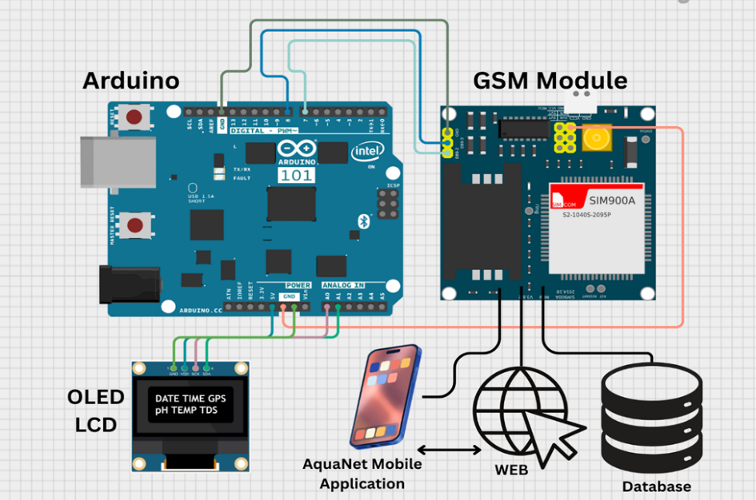****Figure 1****: Conceptual Framework of the Mobile Application AquaNet on this Study*

***Figure 2****: Conceptual Framework of the Receiver Module on this Study*

The two(2) conceptual framework demonstrates how real-time oceanographic data is collected, transmitted, processed, and visualized, with the processed data displayed on a mobile app to enable informed decision-making for ocean quality monitoring and tracking ocean debris directions.

**Chapter II**

**Review of related literature**

**2.1 Technical Background**

* **Details of the Technology Being Used**

The proponents utilized the following technological tools in developing the said system.

**React Native**

React Native is an open-source framework developed by Meta for building mobile applications using JavaScript and React. It enables the development of cross-platform apps with near-native performance from a single codebase (Meta, 2023). AquaNet’s user interface will be developed using React Native to ensure a responsive, mobile-friendly experience for users accessing ocean data.

**Node.js**

Node.js is a runtime environment built on Chrome’s V8 JavaScript engine, designed for building scalable and efficient server-side applications. It uses an event-driven, non-blocking I/O model that is ideal for real-time data handling (Node.js Foundation, 2023). AquaNet will utilize Node.js for backend services, API routing, and data processing.

**Python**

Python is a high-level programming language widely used in machine learning, data analysis, and artificial intelligence. It is known for its simplicity and powerful libraries (Python Software Foundation, 2023). AquaNet will use Python to develop and train its machine learning model—the Random Forest Regressor—for predicting ocean current behavior.

**Visual Studio Code**

Visual Studio Code (VS Code) is a source code editor developed by Microsoft. It supports multiple programming languages and integrates with version control, debugging, and extension tools (Microsoft, 2023). It will be used as the primary integrated development environment (IDE) for managing AquaNet’s codebase.

**MongoDB**

MongoDB is a document-based NoSQL database designed for storing and managing large volumes of unstructured data in a flexible JSON-like format (MongoDB, 2023). AquaNet will use MongoDB to store sensor data, model predictions, and user-submitted reports securely and efficiently.

**Figma**

Figma is a cloud-based interface design and prototyping tool used for creating user interface layouts and visual prototypes collaboratively (Figma, 2023). It will be used to design AquaNet’s user interface wireframes and ensure an intuitive and accessible mobile experience for end users.

**Balsamiq**

Balsamiq is a wireframing tool used to create low-fidelity mockups and early-stage UI design concepts quickly and easily (Balsamiq, 2023). The team will use Balsamiq during the planning stage to sketch initial user interfaces and gather feedback before proceeding with detailed design and development.

**Google Chrome Browser**

Google Chrome is a widely used browser that offers powerful developer tools for debugging and performance analysis (Google, 2023). During development and testing, Chrome will be used to monitor API responses, inspect user interface behavior, and validate real-time outputs.

**GitHub**

GitHub is a cloud-based platform for version control and collaborative software development using Git (GitHub, 2023). It will be used by the AquaNet development team to track changes, manage branches, and ensure collaborative coding and version safety throughout the project lifecycle.

**2.2 Related Literature**

In recent years the increasing concern over marine pollution and data inaccessibility has driven efforts to simplify and democratize ocean information. While global organizations like the Copernicus Marine Environment Monitoring Service (CMEMS) and the National Oceanic and Atmospheric Administration (NOAA) provide real-time and historical ocean data, these datasets are often presented in complex formats limiting their practical use among coastal communities (CMEMS, 2023; NOAA, 2023). This gap emphasizes the need for systems that not only collect data but also process, visualize and distribute it in ways that are easily understood and actionable by non-specialists.

Narido et al. (2021) investigated marine environmental concerns across coastal communities in Palawan, Philippines, and highlighted the critical role of public participation in marine conservation. Their research found that while awareness was high, communities lacked the tools to engage with real-time data effectively. AquaNet addresses this need by offering simplified oceanographic data and debris tracking capabilities that empower grassroots involvement in environmental efforts.

Smith and Zhao (2021) studied the use of machine learning models, including the Random Forest Regressor in forecasting ocean parameters. Their research demonstrated the model’s robustness in handling noisy environmental datasets and its potential in predictive analytics. AquaNet applies this same algorithm to model water current behavior and forecast the movement of marine debris with improved accuracy.

In a separate study, Gonzales et al. (2022) explored how data visualization enhances public awareness and action in marine conservation. They found that real-time visual data dashboards significantly improved decision-making among local beneficiaries. AquaNet similarly incorporates user-friendly dashboards, interactive maps, and visual cues to make complex ocean data accessible and engaging.

Furthermore Fernandez and Lee (2020) emphasized the importance of data reliability in community-based monitoring systems. Their work identified sensor calibration, anomaly detection, and cross-validation with other datasets as key practices for maintaining data integrity. AquaNet integrates these approaches to ensure accurate and consistent data presentation.

Lastly international initiatives such as SmartBay Ireland have successfully deployed buoy-based monitoring systems for marine conditions. However these platforms primarily serve researchers and policymakers rather than local communities. AquaNet distinguishes itself by prioritizing accessibility and usability for everyday users, aligning its design with the needs of coastal populations who depend on the sea for livelihood and safety.

Together these studies underscore the importance of making ocean data accessible, accurate and community-centered. AquaNet builds upon these principles leveraging machine learning signal processing, and user-friendly interfaces to support marine conservation and public awareness.

**2.3 Related Systems**

Several systems have been developed globally to provide oceanographic data and environmental monitoring serving as references for the development of AquaNet:

* **Copernicus Marine Service (CMEMS)**

CMEMS provides satellite based ocean data including sea surface temperature, salinity and current information. It is widely used in scientific and policy making sectors for large-scale ocean modeling and environmental assessments. However its interface and data complexity are primarily designed for expert users, making it less accessible to local communities who require simplified and actionable insights.

* **Global Ocean Currents Database (NOAA)**

NOAA’s Global Ocean Currents Database offers detailed models of global ocean circulation based on buoy, satellite and ship data. The platform is an authoritative source for ocean researchers but lacks a user-friendly format for general public consumption. It does not provide predictive tools or visualization features that are tailored for community use features that AquaNet specifically aims to deliver.

* **Marine Debris Tracker App**

Developed by the University of Georgia and NOAA the Marine Debris Tracker App allows users to report and log marine debris sightings in real time. While it supports data collection and awareness it does not offer predictive analytics or ocean current modeling. AquaNet enhances this concept by integrating machine learning to forecast marine debris movement, offering users proactive tools rather than reactive reporting.

* **Smart Buoy Systems (e.g., SmartBay Ireland)**

Smart buoy systems like SmartBay Ireland deploy ocean sensors to collect data such as wave height, current speed, and water quality. These systems are highly effective in real-time marine condition monitoring and support scientific studies and testing. However they are not specifically designed for public interaction or educational outreach. AquaNet builds upon this technology by making similar sensor data accessible through a mobile interface enabling community members to engage with ocean information directly.

**Table 1.** Comparison of Related Systems and AquaNet Mobile Application

|  |  |  |  |  |  |
| --- | --- | --- | --- | --- | --- |
| **Features / Systems** | **CMEMS** | **NOAA Global Currents DB** | **Marine Debris Tracker** | **Smart Buoy Systems (SmartBay)** | **AquaNet Mobile App** |
| Real-time environmental  monitoring | ✅ | ✅ | ✅ | ✅ | ✅ |
| Public-friendly interface | ❌ | ❌ | ✅ | ❌ | ✅ |
| Predictive analytics | ❌ | ❌ | ❌ | ❌ | ✅ |
| Marine debris tracking | ❌ | ❌ | ✅ | ❌ | ✅ |
| Mobile application support | ❌ | ❌ | ✅ | ❌ | ✅ |
| Sensor integration (e.g., buoy data) | ❌ | ✅ | ❌ | ✅ | ✅ |

**2.4 Synthesis**

There are several key considerations when designing a community focused ocean data application. These include real-time data collection from ocean sensors, machine learning for predictive modeling, signal filtering for data accuracy, user-friendly visualization tools and mobile accessibility. Equally important is ensuring that local users such as coastal residents, fishers, and environmental groups can easily interpret and act on the data presented.

The study by Narido et al. (2021) highlights the importance of involving coastal communities in marine conservation and underscores the need for accessible environmental data. Their findings emphasize that community engagement is more effective when supported by understandable and localized ocean information. Similarly, Smith and Zhao (2021) demonstrate how machine learning, particularly the Random Forest Regressor can enhance predictive accuracy in environmental monitoring system providing AquaNet with a solid foundation for modeling marine current behavior and forecasting debris movement.

Gonzales et al. (2022) emphasize the role of data visualization in public environmental awareness, suggesting that well-designed dashboards significantly improve comprehension and action. This supports AquaNet’s approach of delivering interactive maps, simplified graphs, and real-time data feeds for ease of understanding. Fernandez and Lee (2020) further note that maintaining data integrity is crucial, advocating for automated validation, cross-referencing, and calibration methods all of which are integrated into AquaNet’s processing pipeline.

In addition, existing systems such as CMEMS and SmartBay demonstrate the technological feasibility of remote ocean monitoring but lack community-oriented features. AquaNet synthesizes these approaches by combining sensor-based data collection, predictive analytics, and mobile-first design to create a tool that empowers local benificiaries.

By incorporating these insights, AquaNet not only simplifies complex oceanographic data but also fosters real-time, informed community action bridging the gap between scientific data and everyday environmental decisions.

**Chapter III**

**Methodology**

1. **Software Methodology**

Ensuring the proper development of AquaNet, the Modified Waterfall Model was employed as the software development process. This methodology offers a formal but adaptable framework with step-by-step advancement and iterative feedback loops. The mobile application is based on real-time ocean data and predictive analysis, a strict waterfall method would not be appropriate. Rather, the revised model facilitates adjustments during the development process so that ocean data visualization is precise and user experience enhanced through testing and feedback from real-world experience.

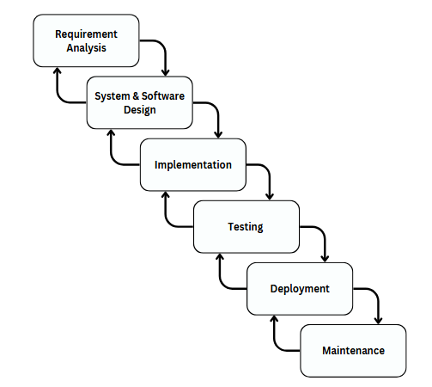

***Figure 2****: Iterative Waterfall Model (*[*https://www.journalijdr.com/sites/default/files/issue-pdf/6140.pdf*](https://www.journalijdr.com/sites/default/files/issue-pdf/6140.pdf)*)*

* **Iterative Waterfall Model**

As shown in Figure 2, our development process follows the Iterative Waterfall Model, which allows a structured yet flexible approach. Each phase—starting from requirement analysis to maintenance—is completed in sequence but can be revisited based on feedback and testing results. This model ensures that AquaNet is developed systematically while allowing improvements throughout, resulting in a more accurate and user-focused application.

**Requirement Analysis**

This study's initial phase will require researchers to carry out an exhaustive requirements analysis which should allow them understand the challenges that coastal communities face in obtaining and interpreting oceanographic data. The team will collect insights from reviewing related literature, consulting local beneficiaries, and analyzing existing technologies. It will focus on identifying functionalities that AquaNet must support such as real-time access to ocean data, user-friendly visualization, and predictive modeling of marine debris. They aim defining both functional and non-functional requirements addressing the various needs of local communities, local government units, environmental groups and marine researchers. A comprehensive examination of these requirements will help the researchers to create a possibly sound system, socially relevant and technically sound.

**System and Software Design**

After the requirement analysis, the researchers will be proceeded to the designing, in which the structural and technical blueprints of AquaNet will be created. In this phase, system-level and software-level design strategies will develop. Application architecture, data flow diagrams and interaction among system components will be defined by the researchers. The technology choices-from mobile development of React native to back-end operations of Node.js to MongoDB as data storage-foundation will be justified on scalability, compatibility and user accessibility-ground. User interface mockups and wireframes will be developed to ensure appropriate flows and effective presentation of data will be ensured. Besides, the team will develop machine learning aspects, particularly the Random Forest Regressor, into the backend for real-time predictive analytics. Thus, this design phase is the most important in transferring abstract system goals into a solid and executable plan.

**Implementation**

At this stage of implementation, the research team will start the coding and building of AquaNet according to the design done in the previous phase. The mobile application will be developed through React Native for cross-platform compatibility. For the backend server, Node.js will be adopted and connected to MongoDB to enable efficient handling of data. Biophysical Ocean Buoys (BoBs) produce real-time data, from which there will be ingestion and the development of preprocessing pipelines for cleaning, structuring, and storing. The predictive algorithm was based on Random Forest Regressor, programmed in Python, and integrated into the system to predict ocean current behavior and track possible marine debris trails. Modular development will take place and versioned via GitHub so that iterative improvements can occur based on testing feedback. Implementation will be incremental such that each module will be tested and refined before progressing to the next.

**Testing**

To guarantee reliability, functionality, and accuracy, mechanical AquaNet testing will be done extensively. AquaNet testing will take place on different levels: unit testing will test individual modules, integrations will test communication between components such as UI, database, and prediction model. The researchers will further check the accuracy of the Random Forest Regressor model through standard statistical metrics: Mean Absolute Error (MAE), Root Mean Squared Error (RMSE), and R² score. User acceptance testing (UAT) will include members from the community to assess usability, clarity of data presentation, and overall satisfaction. The feedback will be taken from surveys and structured interviews, providing avenues for the research team to improve. The whole iterative testing procedure guarantees that the application will meet its objectives prior to its deployment.

**Deployment**

This marks the completion of the necessary testing and revision of the system. From here, the research group can deploy AquaNet into real-world environments. Back-end services will be hosted on a cloud platform for both stability and scalability. The mobile application will be available for downloading from respective platforms for pilot use. This deployment phase will also include user on boarding from local communities and possibly training or orientation sessions to help the users understand and use the application system effectively. Deploying monitoring tools to track system performance, usage statistics, and accuracy of data in a live environment will be part of the plan. This deployment will basically be soft-launch with continued refinements as needed based on live user interaction and system feedback.

**Maintenance**

After deployment, the researchers will enter into the Maintenance Phase to continue ensuring system functionality and responsiveness to users. This involves routine monitoring of sensor data, updating machine learning models to keep pace with time drift on accuracy, and software patch applications for bug fixes or performance improvements. The post-deployment feedback will be evaluated as a guide for future updates and feature enhancements. The research team also intends to build a feedback mechanism which will allow local users be able to directly report issues within the app in order to keep the system community centered, and adaptive. By focusing attention towards both technical maintenance and user engagement, the researchers seek to continue making AquaNet relevant and effective for long-term community-based marine monitoring solution.

* 1. **Timeline Summary**

This model uses a sequential approach but with iterative revisions when required, ensuring that one phase is finished before moving on to the next. By adopting this approach, the project is seeking to obtain a well-defined system with clear requirements, solid design, effective implementation, comprehensive testing, and smooth deployment. The following chart illustrates the main phases of development, together with their respective tasks and estimated duration.

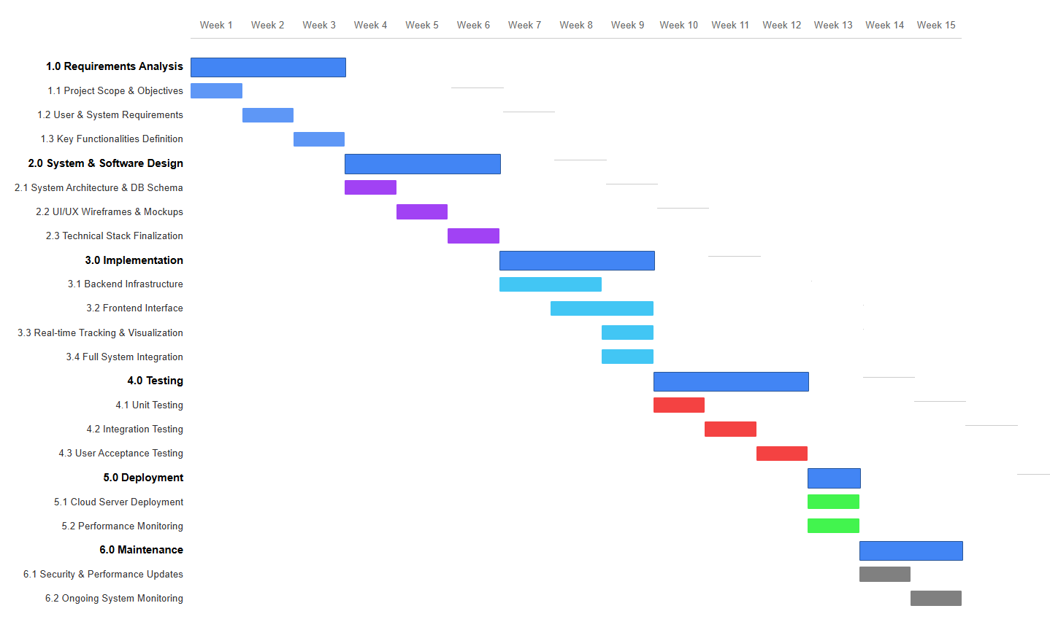

***Figure 3:*** *Timeline Summary*

* 1. **MockUp**

The **mock-up design** provides a visual blueprint of AquaNet’s interface, ensuring intuitive navigation and accessibility. It allows for early evaluation and refinements, optimizing user experience before development.

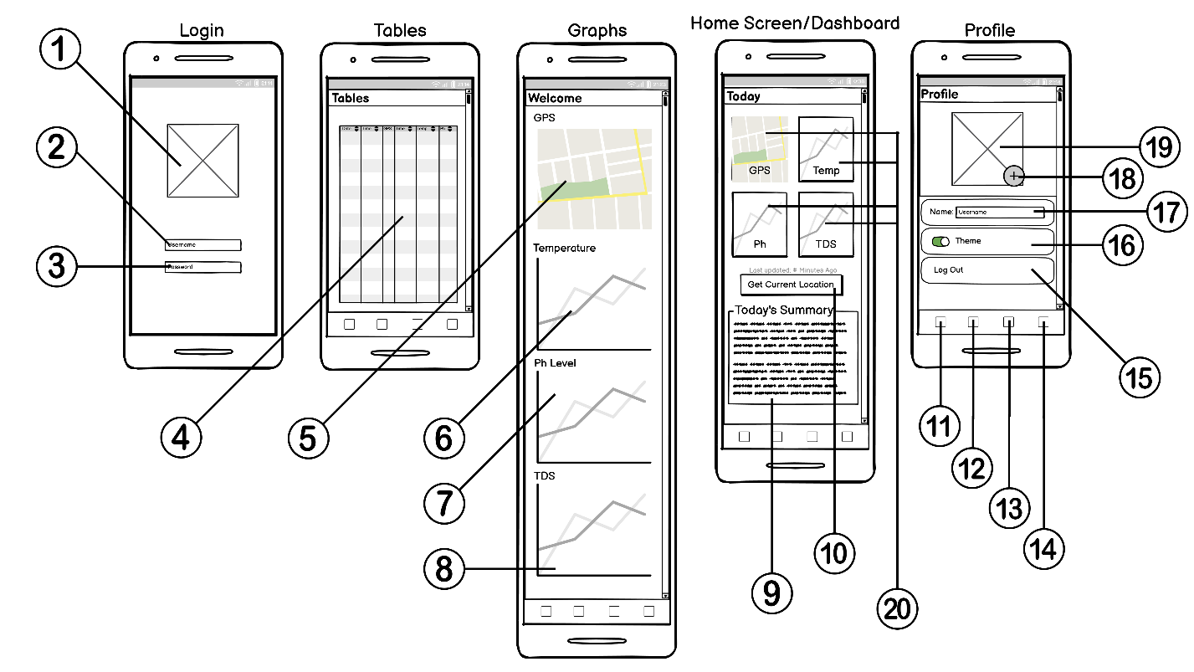

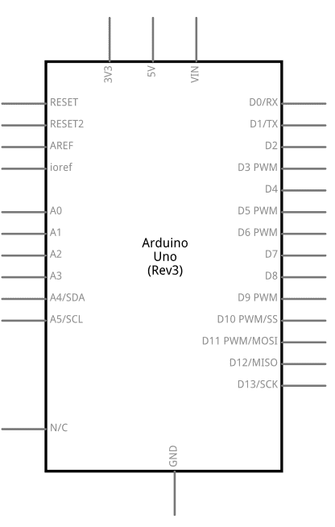***Figure 4:*** *Screens/Wireframe for AquaNet Mobile Application*

**2**

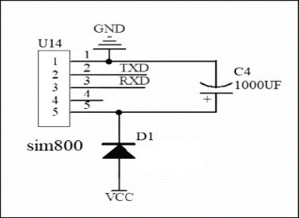

**1**

***Figure 5.*** *Receiver Module*

**Component Description Table for Figure 4.**

|  |  |  |  |
| --- | --- | --- | --- |
| **No.** | **UI Components** | **Name** | **Description** |
| **1** | Photo | Logo | Displays the Full logo of the App |
| **2** | Text Input | Username | Text input for Username |
| **3** | Text Input | Password | Text input for Password |
| **4** | Data Grid | Data Table | Displaying the Data in the Table such as Date, Time, GPS, Time, Temp, Ph, |
| **5** | Street Map | GPS | Displaying Map for Location |
| **6** | Chart | Temperature | Displaying the temperature |
| **7** | Chart | Ph Level | Displaying the Ph Level |
| **8** | Chart | TDS | Displaying the TDS |
| **9** | Text Paragraph | Summarization | Summarization of the current state or the current status of the Buoy |
| **10** | Button | Get Current Location | Gets Current Information of the Buoy |
| **11** | Button | Home | Navigates to Home Screen |
| **12** | Button | Tables | Navigates to Tables Screen |
| **13** | Button | Graphs | Navigates to Graphs Screen |
| **14** | Button | Profile | Navigates to Profile Screen |
| **15** | Button | Log Out | Logs out the current session of the User |
| **16** | Switch | Switch Themes | Switches to Light mode or Dark Mode |
| **17** | Text Input | Username | Displaying the Username, also editable |
| **18** | Button | Add | Clickable to add a new Photo/Profile Picture |
| **19** | Image | Profile Photo | Displaying the Profile Photo of the User |
| **20** | Info Blocks | Graphs | Displays the Last Saved Information of the buoy |

**Component Description Table for Figure 5.**

|  |  |  |
| --- | --- | --- |
| **No.** | **Part** | **Description** |
| **1** | Microcontroller Board | open-source electronics platform used for creating interactive objects and environments |
| **2** | A module | Will receive the data |

**References**

Copernicus Marine Environment Monitoring Service (CMEMS). (2023). Copernicus marine service ocean data. <https://marine.copernicus.eu>

Fernandez, L., & Lee, A. (2020). Ensuring data integrity in community-based monitoring systems. Journal of Environmental Data Management, 12(3), 45–58.

Gonzales, M., Ramirez, J., & Cruz, L. (2022). The role of data visualization in marine conservation advocacy. Marine Policy & Communication Journal, 18(2), 112–129.

Narido, C., Dizon, A., & Reyes, P. (2021). Marine environmental concerns and community participation in Palawan, Philippines. Journal of Coastal Studies, 35(1), 67–79.

National Oceanic and Atmospheric Administration (NOAA). (2023). Global ocean currents database. <https://www.noaa.gov>

SmartBay Ireland. (n.d.). SmartBay marine monitoring platform. https://smartbay.ie

Smith, J., & Zhao, H. (2021). Applying machine learning in ocean forecasting: A case study of the Random Forest Regressor. Ocean Science and Technology, 27(4), 88–101.

University of Georgia & NOAA. (n.d.). Marine Debris Tracker App. <https://marinedebris.engr.uga.edu>