Lab Assignment: Streaming Message with Apache Kafka

University of Virginia

DS 7200: Distributed Computing

Last updated: November 3, 2023

TOTAL POINTS: 4

**Objective**: In this assignment, you will get some hands-on experience with Apache Kafka. You will do these tasks:

1) Install Apache Kafka

2) Start a server locally

3) Create a topic

4) Send messages and receive them

**Important Notes**

1) On Windows platforms, Kafka files live in bin\windows\   
2) Windows uses backslashes in paths \  
 Mac and Linux use forward slashes /  
3) Windows script extensions are .bat

4) You will need to work with multiple terminal windows (CMD for Windows platforms), including a window for

**the ZooKeeper server, Kafka server, the producer, and the consumer.**

5) ZooKeeper is a configuration manager

**Important Prerequisites**

1. Install a binary file and not a source file.

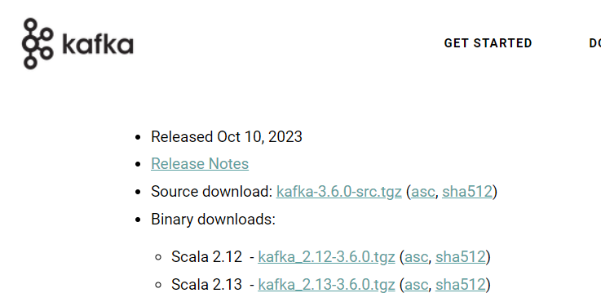

2. **Keep the path to Kafka short**. Save Kafka near the root of the hierarchy. Rename the folder to something short. You might have issues with path length otherwise. For example I use:

C:\Users\apt4c\kafka

3. **Kafka is coded in Java, and you’ll need Java.**

Install: Java SE Development Kit

Source: https://www.oracle.com/java/technologies/javase-downloads.html

Find the relevant installer for your OS  
Note where you install Java for the next step

4a. Modify Environment Variables to find Java.  
On Windows, in Environment add JAVA_HOME variable. The value is the path to Java.

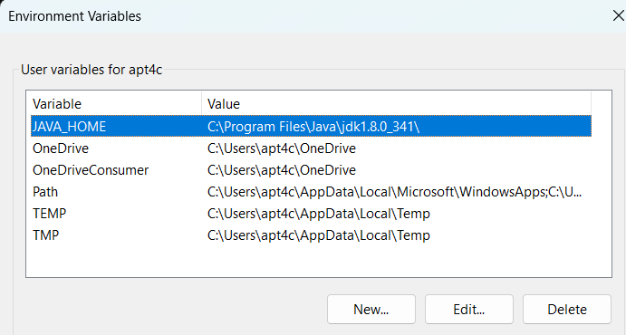

4b. Edit the PATH variable. Notice I've added to bottom: %JAVA_HOME%\bin

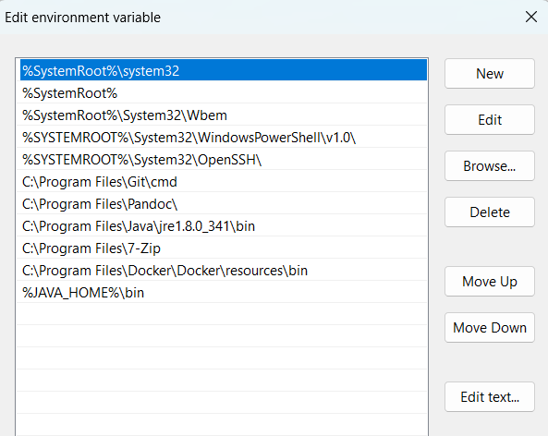

**Instructions**

Visit here to get started: https://kafka.apache.org/quickstart

Follow the directions closely and run steps 1-5.

The Tasks listed below provide details on what you need to collect in a document.

Please keep things concise and organized. Convert the doc to a PDF, and submit through Canvas.

**Tasks**

**Step 1**: Install Kafka and copy/paste snapshot showing install. Example below. (1PT)

Directory of C:\Users\apt4c\kafka

07/28/2020 11:23 AM <DIR> .

07/28/2020 11:23 AM <DIR> ..

07/28/2020 11:23 AM <DIR> bin

07/28/2020 11:23 AM <DIR> config

07/28/2020 11:23 AM <DIR> libs

07/28/2020 11:16 AM 29,975 LICENSE

07/28/2020 11:16 AM 337 NOTICE

07/28/2020 11:23 AM <DIR> site-docs

2 File(s) 30,312 bytes

6 Dir(s) 272,366,256,128 bytes free

**Step 2: Start the server (1 PT)**   
Copy/paste or snapshot (1) the commands you entered and (2) a portion of the logging that prints.

**Step 3: Create a topic (1 PT)**   
Copy/paste or snapshot (1) the commands you entered and (2) use the **list topic** command to list the topic you have created.

**Steps 4-5: Send and consume messages (1 PT)**   
Copy/paste or snapshot (1) the commands you entered and (2) show evidence that you can successfully type messages into the producer terminal and see them appear in the consumer terminal.

**Apache Kafka Tips**

Kafka can get finicky. You'll be opening several terminal windows that act as servers including:

-zookeeper server which manages configs

-kafka server

-consumer server

-producer

-brokers

Be sure to keep straight what each terminal is doing.

Another thing that will help is to propertly shut down the zookeeper and kafka servers when you are finished with

them. You can stop an instance with Ctrl-C or the following commands (windows OS syntax):

Shut Down Zookeeper Server:

**> bin\windows\zookeeper-server-stop.bat config\zookeeper.properties**

sample output:

Deleting instance \\DESKTOP-AN37MQS\ROOT\CIMV2:Win32_Process.Handle="15128"

Instance deletion successful.

Shut Down Kafka Server:

**> bin\windows\kafka-server-stop.bat config\server.properties**

sample output:

Deleting instance \\DESKTOP-AN37MQS\ROOT\CIMV2:Win32_Process.Handle="1112"

Instance deletion successful.

Note: If you cannot get a step to work, you can try reinstalling kafka. If you still have difficulty, please

provide a brief writeup of what went wrong so the grader can give you full credit.