Background

Smart Ltd. is an online retail platform that serves thousands of customers daily while handling sensitive customer information, including personal details, payment information, and order history. The organisation's sensitive data leaves it open to regulatory requirements and mandatory external audit reviews. The company has become a target for cybercriminals recently due to the rapid expansion of its operations without corresponding development in its information security management practices. As the newly appointed CISO of the organisation, I’ve been charged by the executive members to create a cyberattack contingency plan while ensuring the ability of the organisation to recover quickly from a cyberattack event and sustain the ability of the organisation to continue its operation with minimal disruption to the general operation

Cyber Attack Scenario

A cyberattack has recently occurred against the organisation in the form of a ransomware attack, which encrypted and halted critical business systems, such as databases containing customer information, payment systems, and order management systems.
The post cyberattack incident report detailed suspicious and unusual periods of packet flow out of the organisation periodically over the space of two months which has now been revealed to be part of the reconnaissance process of the cyberattackers, after which they exploited the use of the authority bias on one of the IT personnel in the organisation through the use of a vishing attack the employee, which granted the attackers initial access to the system, and due to the weak security management practices previously prevalent across the organisation they were able to use the harvested credentials to inject elevated buffer overflow codes into the system and elevate their privilege, which then led to the attackers conducting lateral movement towards a DNS server and spoofing the legitimate requests of employees in the organisation to precreated malicious sites that harvested user access and installed C2 code across the systems, after which the cyber attackers sent malicious requests to other users on the internal network that were trusted by default and led to the attackers compromising 87% of the enterprise systems, after which they activated the malicious ransomware code through previously installed malicious C2 code.
This attack resulted in three weeks of downtime and cost the organisation an estimated financial revenue loss of €60,000 and significant reputational and regulatory harm, with the customer retention rate metric dropping by 65% in the short term and stabilising to a 23% loss in customer retention over a longer span of time. The Data Protection Commission queried the standards of the organisation, with a mandatory audit carried out and corrective actions mandated towards the technical and operational standards of the organisation according to the current information security management practices and best industry practices.

Scope

The information security management practices outlined in this document shall apply to all relevant systems with a direct relationship to the organisation and all relevant personnel who interact with any systems and their components that are under the jurisdiction of the organisation.

Applied Framework

The information security management frameworks applied in this document were the ISO 27001 and NIST 800-30r1 for the standardisation, implementation, maintenance and continual improvement of the information security management practices of Smart Ltd according to evolving industry best practices relevant to the context of the organisation, with the use of GDPR for regulatory compliance best practices.

Business Impact Analysis

Critical Business Functions
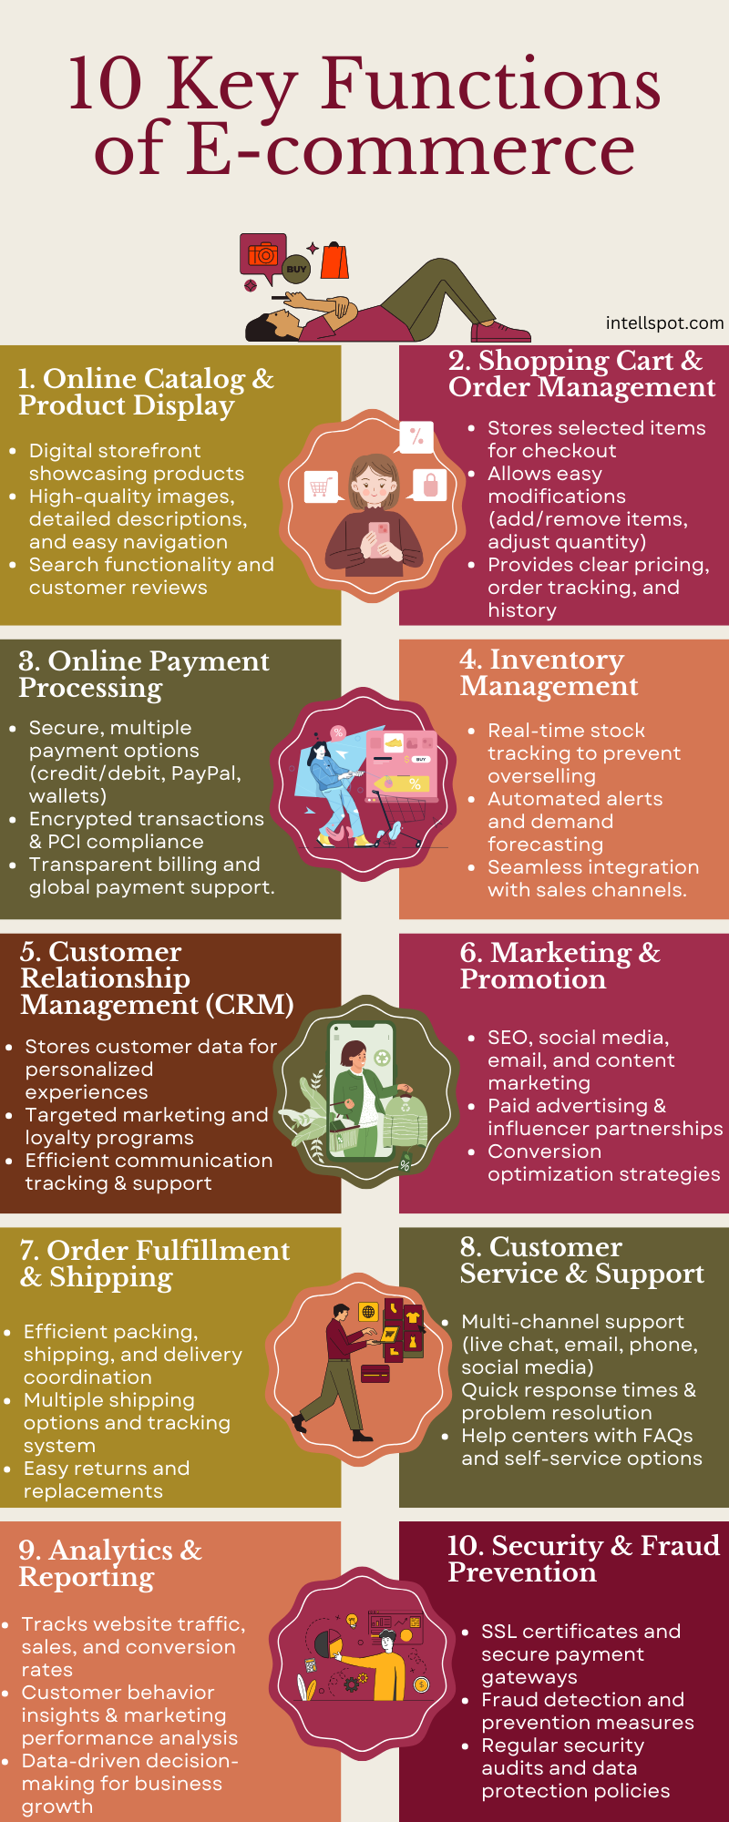
An image displaying the critical business functions of an e-commerce organisation (Valcheva, 2025)
Some critical business functions relevant to the operation of the organisation include components such as the following:
- Customer-facing systems: Web application software made use of by customers for interaction with the business. It includes components such as product pages, checkout sections and user accounts (Valcheva, 2025). This business function suffered critical damage due to the significant downtime of three weeks during which this business component was completely non-functional, costing the organisation significant loss in customer traffic and reputational damage.
- Order Management System: This system comprises a backend database management system which stores and matches customer data in the database to authorised user accounts. It consists of components such as order creation and validation systems, payment authorisations and returns, and a tracking system for order fulfilment (Valcheva, 2025). During the corruption of the organisation’s systems, orders were unable to be tracked, thereby causing frustration to customers who had already made payment but were unable to receive their order in the promised timeline.
- Inventory Management: A system that assesses the current level of stock and conducts demand forecasting to project adequate resupply into stock (Valcheva, 2025). This component was less affected than other business functions in the organisation due to the almost complete halt in existing stock and customer traffic.
- Customer Relationship Management: A system that provides a personalised customer experience in terms of user preference and is used to create a targeted marketing scheme for users based on their general user profile and habits (Valcheva, 2025). As there was a complete halt in customer access and behaviour, this component was rendered dysfunctional, with a substantial impact on the functionality of the business component.
- Finance & Payments: A critical function in the operation of the business, which is responsible for the management of the payment gateway, fraud detection and prevention, revenue reporting, and tax compliance (Valcheva, 2025). This was the most critically impacted business function, as the absence of access to the financial systems led the organisation to be unable to verify payments automatically and create revenue reports to assess the current financial state of the organisation due to the attack.
- Marketing and growth: This component of the business deals with expanding the customer base, extending the influence of the organisation, and converting attention into value (Valcheva, 2025). This business component was not affected due to the attack, due to its separation from the core business operation of the organisation, with minimal disruption to the existing operation of this business function
- Customer-service support: A customer-facing business function which deals with customer issue resolution, handles customer reviews and feedback, and provides support across multiple platforms (Valcheva, 2025). While this section of the business faced increased levels of activity due to the downtime caused by the attack, its ability to carry out its core business operation remained largely unchanged due to the multi-platform redundancy support present in the business function. Of several business functions affected by the attack, this particular business component was observed to have received the least substantial impact on its operation.
- Analytics & Reporting: Gathers relevant metrics such as user traffic and customer behaviour on the web application, used to make informed decisions by the organisation (Valcheva, 2025). Due to the downtime experienced as a result of the attack, metrics were unable to be gathered on most of the critical business functions to take data-driven decisions, leaving management to act based on limited information and previous experience, with the business component experiencing a significant impact on its operation due to the ransomware attack.

Potential Business Impacts

Financial Impact

The attack cost the organisation €60,000 in revenue during the three weeks of downtime. This value was obtained through the use of Lost Profits = Annual Revenue * Hours of downtime (Shopify, 2025). Chargeback liability on the organisation was also experienced by the organisation, with the failure of the order management system leading to increased chargeback liability on the organisation with a loss of €8,500 in customer refunds.
However, the company is expected to lose much more due to chargebacks, as the chargeback to total investment loss has been found to be at a ratio of 5/12 (Clearsale, n.d.), with the amounts lost at present expected to be just 41.67% of total cost incurred by the organisation due to chargebacks. The company has also been left liable to PCI DSS fine risk due to the ransomware attack as the risk exposure from the failure in payment systems to the customers is a violation of the PCI DSS regulation, the most significant liability however is the GDPR violation through the failure of the current systems to maintain the security of confidential and personally identifiable customer data and exposure of customer data in the customer database during the ransomware attack.

Operational Impact

Three weeks of downtime across 87% of the systems led to a huge loss of productivity in the organisation; the material loss experienced by the organisation in terms of productivity loss can be calculated as Lost Productivity = Number of Affected employees * Average hourly employee cost * hours of downtime (Shopify, 2025).
However, more than that, the dominoes effect across most of the critical business functions, such as the failure of the order management system leading to the failure in the function of the finance and payments component which led to an increased load on the customer service component from customers unable to properly get their orders fulfilled and finances properly evaluated, with the analytics unable to make data-driven decisions on the ways to ensure gradual stability back to the business, led to the exposure of multiple separate business functions to an increased level of strain, which sunk the efficiency of the organisation as a whole.

Reputational Impact

The damage to the brand image was directly expressed in the customer retention metrics of the organisation, with a 65% drop in customer retention following the attack, stabilising to 23% loss over the longer term. The mandatory audit initiated by the Data Protection Commission following the attack compounded this reputational harm, as customers, partners, and the general public took the regulatory scrutiny as a failure in the duty of the organisation to protect sensitive data. The visible loss in downtime, unfulfilled orders to customers and regulatory involvement all combine to create a reputational damage that the recovery of systems and finances cannot repair.

Prioritisation of Functions and Recovery Objectives
The prioritisation was determined based on the operational criticality of each function to revenue generation, customer obligation fulfilment, and regulatory compliance, in alignment with ISO 27001:2022 Annex A Control 5.30 and the impact tiering methodology outlined in NIST SP 800-30r1.

Priority | Business Function | Criticality | RTO | RPO | Justification
1 | Finance & Payments | Critical | 4 hours | 1 hour | This was the most critically impacted business function in the attack. Without access to the payment gateway and revenue reporting, the organisation cannot verify transactions or assess its financial position, and its exposure to both PCI DSS and GDPR violations begins immediately. Restoring this function first is necessary to limit ongoing revenue loss and bring the organisation back into regulatory compliance.
2 | Customer-Facing Systems | Critical | 8 hours | 4 hours | The complete three-week outage of this system was the direct cause of the full €60,000 revenue loss, as all customer interaction with the business ceased entirely during that period. Without the platform restored, no other customer-facing recovery effort is possible, making this the second most urgent function to bring back online.
3 | Order Management System | High | 12 hours | 4 hours | Customers who had already made payment at the time of the attack were left without order tracking or fulfilment, which created immediate chargeback liability on the organisation. The longer this system remains offline, the more that liability increases, making its recovery important to limiting the financial and reputational damage already caused by the attack.
4 | Analytics & Reporting | High | 24 hours | 8 hours | During the attack, the absence of this function left management without the data needed to make informed decisions about the recovery of all other business functions. Restoring it early means that the decisions that follow are based on actual information rather than assumptions, reducing the risk of recovery resources being directed to the wrong areas.
5 | Customer Service & Support | Medium | 24 hours | 12 hours | While multi-platform redundancy allowed this function to continue operating during the attack, the volume of customer complaints increased substantially due to the downtime. Restoring full capability is important to prevent further reputational damage from customers unable to get a resolution on unfulfilled orders and payment issues.
6 | Customer Relationship Management | Medium | 48 hours | 24 hours | The complete halt in customer activity rendered this system dysfunctional, as there was no customer behaviour to track or respond to. Restoring it is necessary to begin rebuilding customer engagement following the 23% long-term loss in customer retention caused by the attack.
7 | Inventory Management | Low | 72 hours | 48 hours | This component was the least impacted of all business functions during the attack, as the halt in customer traffic and stock movement meant there was little for the system to manage. Its absence does not directly prevent the organisation from restoring revenue or customer trust in the short term.
8 | Marketing & Growth | Low | 72 hours | 72 hours | This component was entirely unaffected by the attack due to its separation from the core systems of the organisation. There is no operational urgency to its recovery, and it therefore receives the longest acceptable recovery window of all the business functions.

Finance & Payments and Customer-Facing Systems receive the shortest RTOs because their failure has an immediate effect on all other functions, consistent with the domino effect described in the Operational Impact section above. The prioritisation order is structured to break that chain of failure as quickly as possible, with the €60,000 revenue loss over three weeks, which is approximately €2,857 per day, demonstrating the significance of the impact these delays can have on the organisation.

Resource Identification
The identification of resources required to recover and sustain each critical business function is a necessary component of the business impact analysis, as supported by ISO 27001:2022 Annex A Control 5.29 and the contingency planning methodology outlined in NIST SP 800-34 Rev.1. The resources relevant to the business context of the organisation include human resources such as the incident response and disaster recovery personnel; the technical resources, including the backup systems and recovery systems; the financial resources, which are a commitment by leadership in line with the ISO 27001 Clause 5.1, which includes approving an emergency budget to cover the cost of incident response and other processes relevant to the information security system of the organisation; and informational resources, which include updated asset inventory and supplier lists outside of the main system to maintain the supply chain in the event of an attack.

Risk Assessment
The risk assessment was conducted in accordance with ISO 27001:2022 Clause 6.1.2, which requires the organisation to identify risks associated with the loss of confidentiality, integrity, and availability of information and to assess the likelihood and impact of those risks. The threat identification and scoring methodology is drawn from NIST SP 800-30r1, using a High, Medium, and Low rating scale. Each threat below corresponds directly to a stage of the attack, ensuring that the assessment reflects the actual risk profile of the organisation.

Asset | Threat | Vulnerability | Likelihood | Impact | Risk Level | Control (ISO 27001:2022 Annex A)
IT Personnel Credentials | Vishing / Social Engineering | Lack of security awareness training left staff open to authority-based manipulation over the phone, allowing attackers to obtain valid credentials. | High | High | Critical | A.6.3 – Security Awareness, Education and Training: Staff must be trained to recognise and respond to social engineering attempts, including unsolicited requests made by phone.
Employee Access Accounts | Credential Harvesting via Malicious Sites | DNS spoofing was used to redirect staff to fake sites that collected their login details, which went undetected due to weak monitoring practices. | High | High | Critical | A.8.5 – Privileged Access Management: Access to systems should be restricted based on role, and login activity should be monitored so that stolen credentials can be detected quickly.
Internal Systems | Buffer Overflow / Privilege Escalation | Weak input validation and the absence of controls to limit user account actions allowed the attackers to move from standard access to full system control. | High | High | Critical | A.8.28 – Secure Coding: Systems should be built and maintained in a way that prevents attackers from using input errors to gain levels of access they were not granted.
DNS Server | DNS Spoofing | The DNS server was not adequately protected, allowing attackers to redirect legitimate employee web requests to sites under their control. | High | High | Critical | A.8.22 – Segregation of Networks: Separating critical infrastructure such as DNS from general internal systems limits the ability of an attacker to affect other parts of the network.
Internal Network | Lateral Movement | The internal network operated on a model of default trust, meaning that once the attackers had access to one system, they were able to move freely across 87% of the organisation's systems without triggering alerts. | High | High | Critical | A.8.22 – Segregation of Networks: Dividing the internal network into separate zones ensures that access to one system does not automatically grant access to others.
Customer Database / Payment Systems / Order Management System | Ransomware Deployment via C2 | Malicious code installed during the reconnaissance phase was activated remotely once the attackers had sufficient control, encrypting critical systems and halting operations for three weeks. | High | High | Critical | A.8.13 – Information Backup: Tested backups stored outside the main network allow the organisation to restore operations without meeting attacker demands. A.5.26 – Response to Incidents: A defined response process reduces the time taken to identify, contain, and recover from an active attack.

All six threats have been rated as Critical, reflecting the fact that the attack succeeded across each of these stages. The controls mapped to ISO 27001:2022 Annex A directly inform the recovery and prevention measures in the sections that follow, and the functions carrying the highest risk correspond to those given the shortest recovery objectives in the prioritisation table above.
Incident Response Plan
The incident response plan has been developed in accordance with ISO 27001:2022 Clauses 5.24 and 5.26, which require the organisation to plan for and respond to information security incidents. The plan addresses the full lifecycle of the ransomware attack, from detection through to containment, eradication, and regulatory compliance.
Incident Detection
The failure to detect the attack is itself a significant finding. Two months of suspicious outbound packet flow went unnoticed, which represents a complete absence of effective network monitoring during the attackers' reconnaissance phase. Under ISO 27001:2022 Annex A Control 8.16, the organisation is required to monitor networks and systems for anomalous behaviour, a control that was clearly absent at the time of the attack. Going forward, detection will be built around a SIEM, which will aggregate and correlate log data from across the organisation's systems in real time, configured to raise alerts on anomalous outbound traffic, unusual login activity, repeated failed authentication attempts, and command and control communication patterns. Endpoint detection and response tools will be deployed on all devices to monitor for the process injection and privilege escalation activity used in this attack, with any alert meeting a defined severity threshold automatically notifying the security team. Incidents will be classified in line with NIST SP 800-61 Rev.2, with ransomware deployment classified at the highest severity level.

Containment and Eradication
Once an incident is confirmed, the immediate priority is to stop the spread of the attack before additional systems are compromised. Affected network segments must be isolated immediately, the DNS server must be taken offline and treated as a compromised asset, all user credentials must be reset without exception, and remote access must be suspended for the duration of containment, consistent with ISO 27001:2022 Annex A Control 8.22. Eradication begins only once containment is confirmed. All C2 code installed during the reconnaissance phase must be fully identified and removed before any restoration takes place, as restoring onto a compromised environment would allow the attackers to reactivate the ransomware. A forensic investigation must run simultaneously to establish the full scope of the compromise, and the organisation must not proceed to recovery until the forensic team has confirmed that all malicious code has been removed.

Roles and Responsibilities
The roles and responsibilities below are defined in alignment with ISO 27001:2022 Clause 5.24. The CISO holds overall command and is responsible for all strategic decisions during the incident, including activating the recovery plan, notifying regulators, and engaging external support, and is ultimately accountable to the board for the outcome. The IT Security Team is responsible for the technical execution of containment and eradication, reporting directly to the CISO with regular status updates. Legal Counsel is responsible for assessing regulatory obligations, advising on the timing of DPC notifications, and managing legal exposure arising from the breach, and must be notified as soon as the incident is confirmed. The communications lead manages all external-facing communication, such as customer notifications, public statements, and media enquiries. The communications lead is also the only person, alongside the CISO, authorised to speak publicly about the incident. A DPC Liaison, which may be fulfilled by Legal Counsel, is responsible for preparing and submitting the formal breach notification within the 72-hour window required under GDPR Article 33.

Incident Escalation and Regulatory Compliance
The escalation path follows a direct chain from the IT security team to the CISO to the board, who must be notified as soon as the incident is confirmed. The most time-sensitive obligation is the GDPR Article 33 requirement to notify the Data Protection Commission within 72 hours of becoming aware of a personal data breach. Given that the attack compromised the customer database, this obligation is triggered immediately upon confirmation of the incident, and failure to meet the window is itself a separate regulatory violation. The breach of the payment systems also triggers PCI DSS notification obligations to the acquiring bank and relevant card brands, with non-compliance fines escalating the longer the organisation remains outside compliance (Joseph, 2026).

Communication Plan
Internal communication must be issued promptly, with all staff given clear guidance that only the CISO and communications lead are authorised to speak publicly about the incident. The IT Security Team, Legal Counsel, and DPC Liaison must receive regular updates from the CISO throughout the response, and the board must be briefed at agreed intervals until the incident is resolved. Externally, customers whose data was affected must be notified directly once the DPC has been informed, as required under GDPR Article 34, with the notification explaining in plain terms what happened, what data was affected, and what steps the organisation has taken. All media enquiries must be directed to the Communications Lead and responded to through a single prepared statement, with no operational details disclosed publicly until the forensic investigation is complete.

Disaster Recovery Plan
The disaster recovery plan outlines how the organisation will restore its critical business systems and data following the ransomware attack. It has been developed in accordance with ISO 27001:2022 Annex A Controls 8.13 and 5.30, and the recovery order follows directly from the prioritisation table established in the Business Impact Analysis.
Backup Strategy
The ransomware attack was able to encrypt critical systems because the organisation had no backup copies isolated from the main network. Going forward, the backup strategy will follow the 3-2-1 rule, which mandates three copies of all critical data, across two different types of media, with one copy kept offsite and offline in a cloud environment not directly connected to the internal network. Full backups will be taken weekly with daily incremental backups to capture changes between cycles. All backups will be encrypted at rest, and access will be restricted to authorised personnel in line with ISO 27001:2022 Annex A Control 8.13. The RPO values in the prioritisation table, ranging from one hour for Finance and Payments to 72 hours for Marketing and Growth, will determine backup frequency for each system.
Recovery Strategy
System recovery will follow the prioritisation order above, beginning with Finance and Payments and Customer-Facing Systems. Before any system is restored, the forensic team must confirm the environment is clean and free of C2 code, and each system will be restored from the most recent clean backup predating the point of compromise. Systems will be restored and verified one at a time before the next restoration begins, to avoid introducing further instability into a partially recovered environment.
Testing and Validation of Disaster Recovery Plan
The plan will be tested through two methods: a tabletop exercise, in which the incident response team walks through the recovery process step by step without executing it to identify gaps and clarify responsibilities; and a simulated recovery test, in which systems are actually restored from backup in an isolated environment to verify that backups are complete and that RTOs are achievable in practice. Both tests will be carried out at a minimum annually and after any significant change to the organisation's systems, in line with ISO 27001:2022 Clause 8.1, with findings documented and used to update the plan.
Post-Recovery Actions and Improvements
A formal lessons learned review will be carried out once systems have been fully restored, examining each stage of the attack chain to identify the specific control failures that allowed each stage to succeed. The controls identified in the risk assessment, including security awareness training, privileged access management, network segmentation, and DNS protection, will be implemented based on the findings, and the risk assessment and incident response plan will both be updated in line with ISO 27001:2022 Clause 10.1, which requires the organisation to continually improve its information security management system.

Integration with Business Continuity
During the three weeks of downtime, the only business function that continued to operate was Customer Service and Support, which did so because of the multi-platform redundancy already in place. This demonstrates that business continuity during a major incident depends on decisions made before the incident occurs. Going forward, manual fallback procedures will be defined for each critical business function so the organisation can continue to operate in a reduced capacity during recovery, in line with ISO 27001:2022 Annex A Control 5.29. The disaster recovery plan will be reviewed as part of the broader business continuity planning process on a regular basis to ensure the two remain aligned as the organisation's systems change over time.

Project Organisation on Contingency Plan

WBS Images on the project
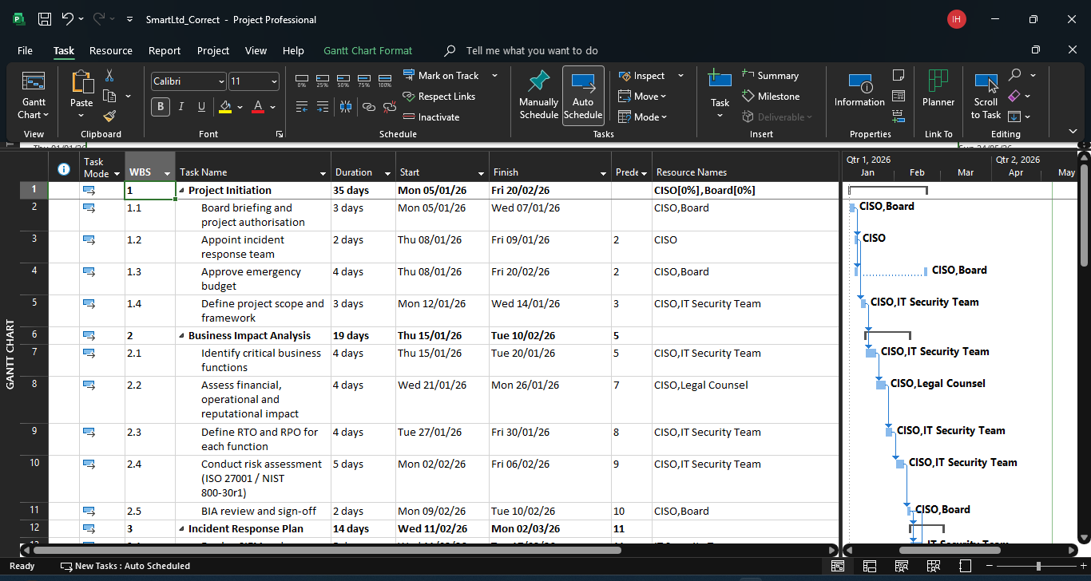
Image a.1 first image of WBS
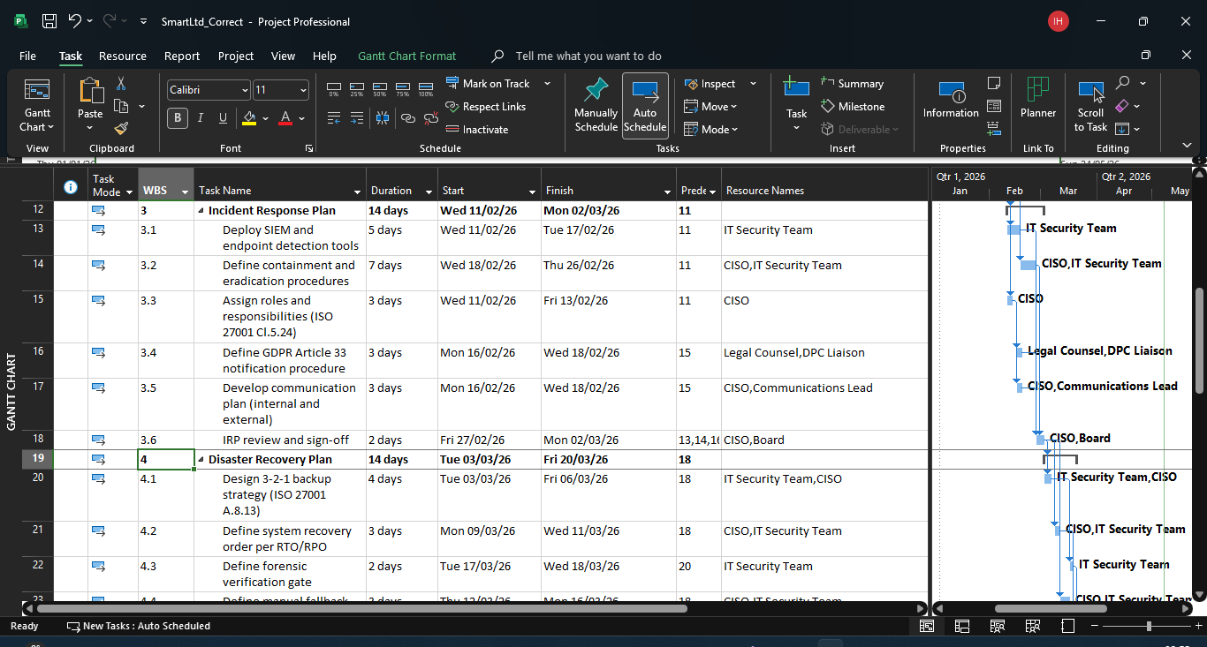
Image a.2 Second Image of WBS
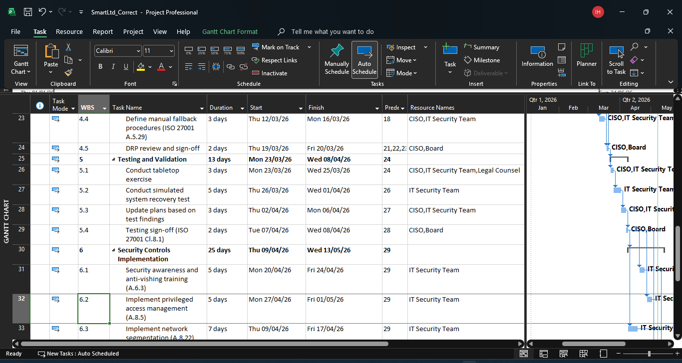
Image a.3 Third Image of WBS
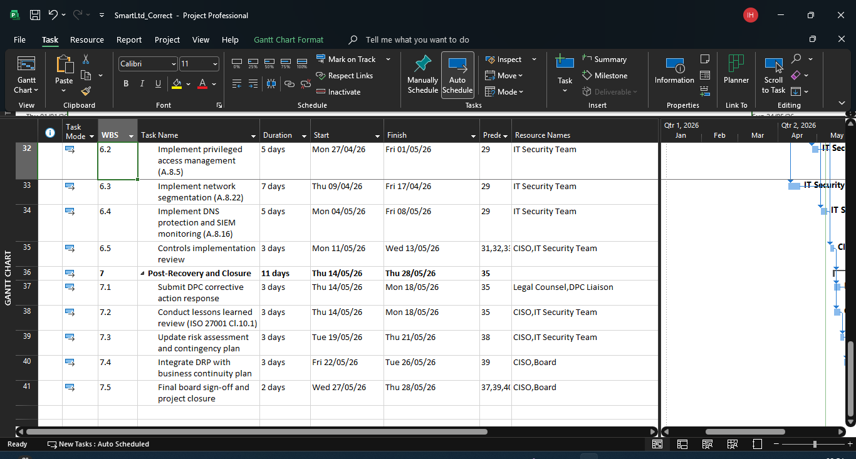
Image a.4 Fourth Image of WBS

Gantt Chart Images on the Project

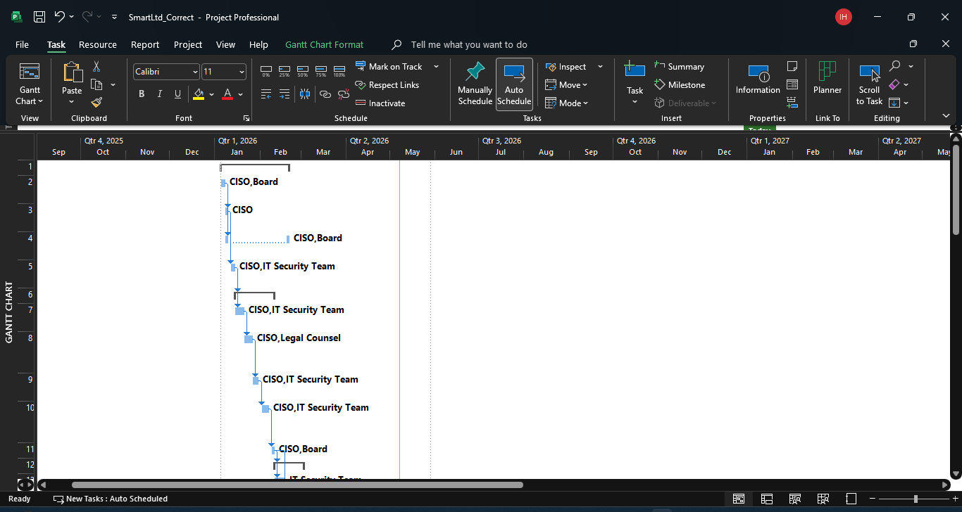
Image b.1 First Image of Gantt Chart
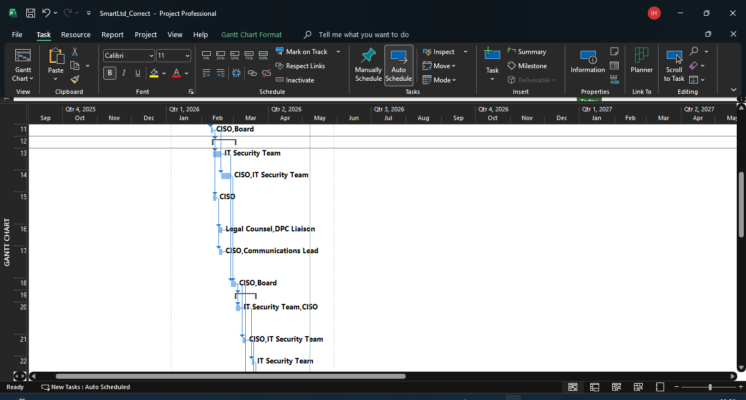
Image b.2 Second Image of Gantt Chart
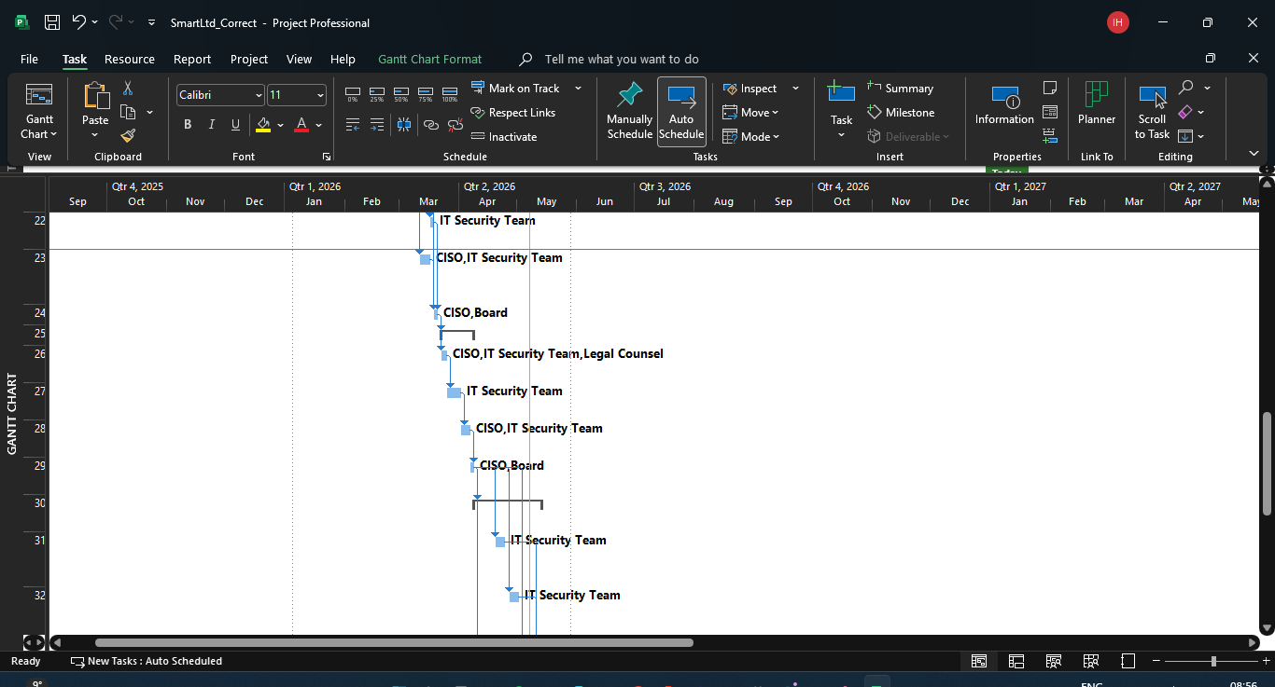
Image b.3 Third Image of Gantt Chart
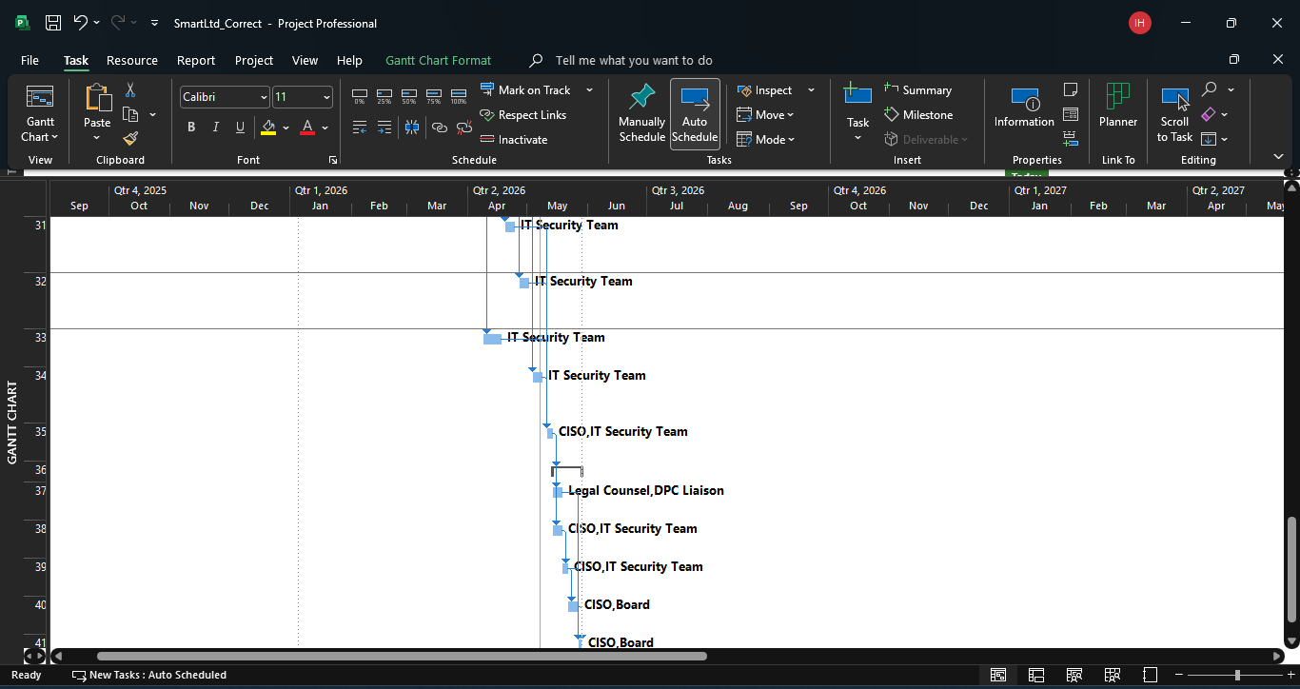
Image b.4 Fourth Image of Gantt Chart

References
Clearsale n.d. Understanding Ecommerce Chargebacks: A Complete Guide. [Accessed 29 April 2026]. Available from: https://www2.clear.sale/understanding-ecommerce-chargebacks-complete-guide.
Joseph, S. 2026. PCI DSS violations: What They Mean and How to Prevent Them in 2025. [Accessed 29 April 2026]. Available from: https://www.scrut.io/hub/pci-dss/pci-dss-violations.
Shopify 2025. How To Minimize Your Website’s Ecommerce Downtime (2025) - Shopify Ireland. Shopify. [Online]. [Accessed 29 April 2026]. Available from: https://www.shopify.com/ie/blog/ecommerce-downtime.
Valcheva, S. 2025. 10 Key Functions of E-commerce: A Full Guide with Examples. Blog For Data-Driven Business. [Online]. [Accessed 27 April 2026]. Available from: https://www.intellspot.com/e-commerce-functions/.

