Aims
1. To understand and configure a basic network switch to best practice.
2. To have the knowledge to fault find and do basic layer two diagnostics.
3. To understand port security.
4.To understand segmentation in a network switch.
5.To be able to create, configure and assign ports to VLANs.
6. To be able to configure VLAN tagged connections to best practice.
7. To implement the best security and practice on the Switches. This is the most important part of this assignment.

Scenario

You are building an SME network. At the end of this Lab you will have built a switched network with VLANs. The SME has an Engineering VLAN, Manufacturing VLAN, Guest Radio VLAN and an Accounts VLAN. You will have configured trunking and given each switch a management VLAN.
Create VLANs as shown in table below.
Name | VLAN | Address Space | Switch Model
Engineering | VLAN 21 | 192.168.21.0/24 | 2960-24TT
Marketing | VLAN 22 | 192.168.22.0/24 | 2960-24TT
Accounts | VLAN 23 | 192.168.23.0/24 | 2960-24TT
Guest Radio | VLAN 24 | 192.168.24.0/24 | 2960-24TT

The finished topology should be as shown.
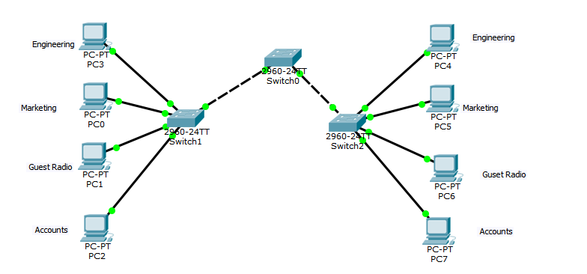

Step1 Before configuring VLANS
- Investigate MAC tables of switches
- Investigate ARP tables.
What do you notice about these tables before configuring the VLANs. Answer below.

Step2
- Configure VLANs
- Configure trunking/tagging on links.
- Test devices connectivity.

Research and mention MAC table, ARP aging, static entries and associated commands. Switchport and port security you have implemented must be discussed.
Password ‘pgdip’

REPORT
Before I undertook the segmentation of the network through vlans, I made investigations towards the default state of the MAC and ARP tables of the switches, in the MAC table of the primary switch, I observed a connection to 2 different dynamic ports with varying MAC addresses, however for the other two switches, there was almost no difference except a slight change in the number of the MAC address and they were both only connected to one port each. As for the ARP table, when I ran the command to investigate the state of the ARP table, A looping domain lookup that I had to terminate was all I got and when I finally ran the “no ip domain lookup” command, I got an error message which said “Unknown command or computer name, or unable to find computer address”.
A Mac Address table is where a switch stores all the mac addresses it has access to, it acts as a central storage and processing point for the switch, the table enables the switch to avoid broadcasting of information but rather sending it to its specific location through the destination address it possesses on its MAC Table, ARP Aging on the other hand is the length of time a switch keeps the MAC Address it learned through the ARP in the ARP cache, the timer on the switch is continuously reset each time the ARP entry is refreshed and the ARP entry is removed if the time of the switch reaches the current date of the ARP, which can be set through the “ip arp-age number” command on the configuration terminal of the switch, the ARP age can also be displayed by the “show ip” command on the configuration or administrative terminal of the switch
Static entries are inputs that have been manually added into the MAC table, this is usually done by an individual with executive or administrative privilege over the network, and can be useful to protect against MAC Spoofing attacks, an example would be “switch# configure terminal” “switch(config)# mac-address-table static 12ab.47dd.ff89 vlan 3 interface ethernet 2/1”. Associated commands are the different system controls the network professional has over the system based on their privilege or access levels, there are different commands for different levels of privilege that are essential to the management and control of the network, an example would be the enable command in the privileged exec mode or the hostname command in the Global Configuration mode.
For each of the three switches, All ports were initially shut down, after which active ports were restarted, the inactive ports were then assigned to an isolated VLAN for security through the switchport access command, the next step was to then create an authentication control to manage who has access to the network, and each switch was given a username based on their name, Switch0 was given the username of s1config, Switch1 was attributed s2config and Switch2 was assigned as s3config, with the passwords all using the pgdip password given, finally a MAC Adress Switchport port security with a maximum port security value of 2 was assigned to each of the switches.

References
- Youtube(2025) How to secure a cisco packet switch tracer. Available at: https://youtu.be/VkXitpHaCyg?si=vxw3fObm_LIcsh6K (Accessed: 21 October 2025)
- Aruba(n.d.) MAC Address Table. Available at: https://arubanetworking.hpe.com/techdocs/AOS-CX/10.07/HTML/5200-7865/Content/Chp_mac/mac-add-tab.htm (Accessed: 21 October 2025)
- Aruba(n.d.) ARP Age Timer. Available at: https://arubanetworking.hpe.com/techdocs/AOS-S/16.10/MRG/YC/content/common%20files/arp-age-tim.htm (Accessed: 21 October 2025)
- Krishnedu, AR (2015) Static and dynamic entries. Available at: https://community.cisco.com/t5/switching/mac-address-table-showing-static-and-dynamic-entries/td-p/2640846 (Accessed: 21 October 2025)
- Sahar Kazemi(2024) Essential cisco switch commands. Available at: https://itman.ae/2024/09/09/essential-cisco-switch-commands/ (Accessed: 21 October 2025)

