* Arrays
  + IndexOf: vooraan zoeken
  + lastIndexOf: achteraan zoeken
  + Push: element achteraan toevoegen, return length
  + Pop: achterste element verwijderen, return verwijderde element
  + Unshift: element vooraan toevoegen, return length
  + Shift: eerste element verwijderen, return verwijderde element
  + Slice(i1, i2): return nieuwe array van [i1, i2]
  + Join(): t-string, optioneel scheidingsteken
* Form method
  + POST: schrijf naar resource, data op server bewaren
  + GET: lees van resource, data wordt niet op server bewaard
* Tijd
  + let var = setInterval(f, m); met f = function, m = tijdsinterval
  + clearInterval(var);
  + let var = setTimeout(f, m); met f = function, m = tijdsinterval
  + clearTimeout(var);
* Getallen
  + Math.random() * m, met m = [0, m[
  + Math.floor()
  + Math.ceil()
  + Math.round(), afrondingsregels
  + parseInt()
  + getal.toFixed()
* Date
  + New date(value)
  + New date(dateString)
  + const event = new Date('2020-04-10T23:15:30'); console.log(event.toString());
    - // expected output: "Fri Apr 10 2020 23:15:30 GMT+0200 (Midden-Europese zomertijd)"
    - // (note: your timezone may vary) toISOString()
  + const event = new Date('2020-04-10T14:48'); console.log(event.toString());
    - // expected output: "Fri Apr 10 2020 14:48:00 GMT+0200 (Midden-Europese zomertijd)"
    - // (note: your timezone may vary) console.log(event.toISOString());
    - // expected output: "2020-04-10T12:48:00.000Z"
    - // The timezone is always zero UTC offset, as denoted by the suffix "Z". toDateString()
  + const event = new Date("2020-04-10T10:10:40"); console.log(event.toString());
    - // expected output: "Fri Apr 10 2020 10:10:40 GMT+0200 (Midden-Europese zomertijd)" // (note: your timezone may vary) console.log(event.toDateString());
    - // expected output: "Fri Apr 10 2020" toTimeString()
  + const event = new Date("2020-04-10T12:10:40"); console.log(event.toTimeString());
    - // expected output: "12:10:40 GMT+0200 (Midden-Europese zomertijd)"
    - // (note: your timezone may vary) Zelf de datum opbouwen
  + Let event = new Date(‘2020-04-10T12:10:30’); console.log(event.getDate() + “-“+ (event.getMonth()+1) + 1 “-“ + event.getFullYear() + “ “ + event.getHours() + “:” + event.getMinutes() + “:” + event.getSeconds());
    - // expected output: "10-4-2020 12:10:30"
    - // getMonth() geeft de maand als een getal tussen 0 en 11 (januari is maand 0 daarom + 1)
  + Let event = new Date();
    - // huidige datum console.log(event.getDate() + "-"+ (event.getMonth()+1) + "-" + event.getFullYear() + " " + event.getHours() +":"+event.getMinutes() +":"+event.getSeconds());;
    - // expected output: "15-4-2020 16:37:26"
* Storage
  + localStorage.setItem(“myKey”, “myValue”);
  + localStorage.getItem(“myKey”);
  + localStorage.removeItem(“myKey”);
  + localStorage.clear();
  + JSON.stringify(item);
  + JSON.parse(item);
* Handig
  + ClasstList.add()
  + ClassList.remove()
  + txtDemo.textContent = "dit is een <a href=’http://www.example.com’>hyperlink</a>"; geeft : dit is een <a href=’http://www.example.com’>hyperlink</a
  + txtDemo.innerHTML = "dit is een <a href=’http://www.example.com’>hyperlink</a>"; "; geeft : dit is een [hyperlink](http://www.example.com)
  + const compare = (a,b) => { return a-b; // enkel negatief, positie of nul is relevant voor return, dus zo kan het ook } let array=[34, 67, 12, 5, 23]; array.sort(compare);

**VOOR EXAM**

alert/prompt…

string converting to array with space



array converting to string met space



String comparisons

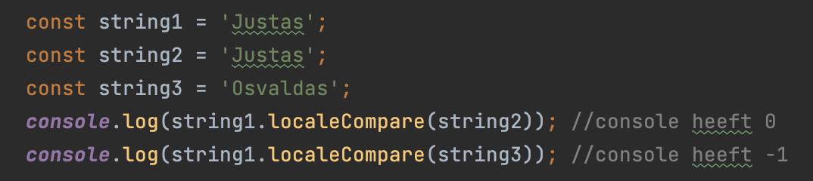

Array strings soorteren

Number arrays soorteren

creating element functie

creating elements and addting text

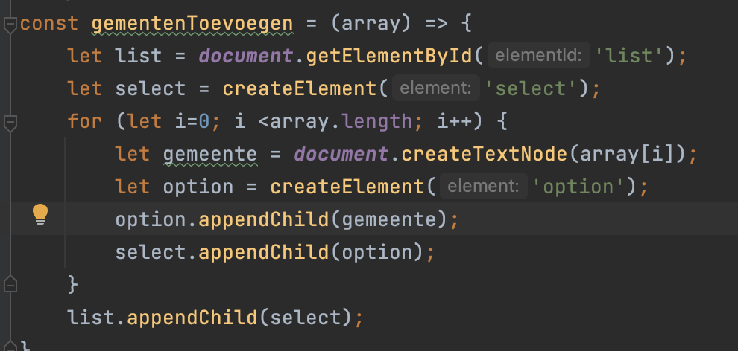

Getting values of cheked box (true or false) - (Labo 5, opdracht - formwaarden):

Getting values of multiple buttons (true or false) - (Labo 5, opdracht - formwaarden):

Element select gekozen optie opvragen (text van de optie)

Getting multiple selected option elements from select element:

string indexOF zoek

document.getElementByName(“string”) - retourneer een element die een name attribuut heeft met de gegeven naam.

document.getElementByTagName(“p”) - img, section, div…

document.querySelectorAll(“[name=‘xxx’]”);

e.getAttribute(“naamAtribut”)

e.setAttribute(“naamAtribut”, “waarde” );

p.appendChild(c)

p.removeChild(c)

target.parentElement

JSON stringify && Local storage



