Calibration of a Spatialized Urban Growth Model

Abstract
We propose a stochastic model of urban growth that generates spatial distributions of population densities, at an intermediate scale between economic models at the macro scale and land-use evolution models focusing on local relations. Integrating simply the two opposite key processes of aggregation (“preferential attachment”) and diffusion (urban sprawl), we show that we can capture the whole spectrum of existing urban forms in Europe. An extensive exploration and calibration of the proposed model allows determining the region of parameter space corresponding morphologically to observed european urban systems, providing an validated thematic interpretation to model parameters, and furthermore determining the effective dimension of the urban system at this scale regarding morphological objectives.

%%%%%%%%%%%%%
% 1 - Introduction
\section{Introduction}
%%%%%%%%%%%%%

% - > literature on stochastic urban growth, ABM for Urban Growth, CA Models and urban morphogenesis models. Reproducing urban growth at different scales, capturing different processes.
% ⇒ Plus réponse à cette question : pourquoi simuler la croissance urbaine (quels enjeux scientifiques et sociaux ?)

% Macro models (Gibrat and extensions) are partially spatialized (Favaro - Pumain includes distance between cities, Simpops/Marius also) whereas micro (most CA) are ‘’over-spatialized’’ (neighborhood-based).
% -> Research Question : What about a simple model at the meso scale, close to macro by the stylized facts (preferential attachment) but producing morphologically consistent spatial distribution of densities ?

%%%%%%%%%%%%%%%%%
% 2 - Materials and Methods
\section{Materials and Methods}
%%%%%%%%%%%%%%

% 2.2 - The urban growth model
\subsection{The urban growth model}

Preferential attchment and diffusion, extension of [Batty, 2006]. small litt. prefAtt and then Urban sprawl, opposed forces that must shape morphology of urban systems. choice of a scale at which spatial form has a sense but city system is ‘’wide enough” : 50-100km, meso-scale ?

Precise formulation, description and formalization of the model. ; parameters and their possible interpretation ; def of parameter space.

% 2.3 - Indicators
\subsection{Indicators}

% Literature on morphological analysis, method taken from [Le Nechet 2015] to qualify/quantify urban form. Why would form be relevant at this scale ? -> thematic references on variety of urban developments, rural settlements, etc. : form translates many spatial processes at this scale. [beware question of equifiniality : model is however themtically-based for processes].

% Definition of indicators

%%%%%%%%%%%%
% 3 - Results
\section{Results}
%%%%%%%%%%%%

- Precise description of the implementation (pub openmole exploration etc, importance of intensive computation)

% 3.1 - Generation of urban patterns
\subsection{Generation of urban patterns}

- variety of genered forms, examples of extreme shapes.

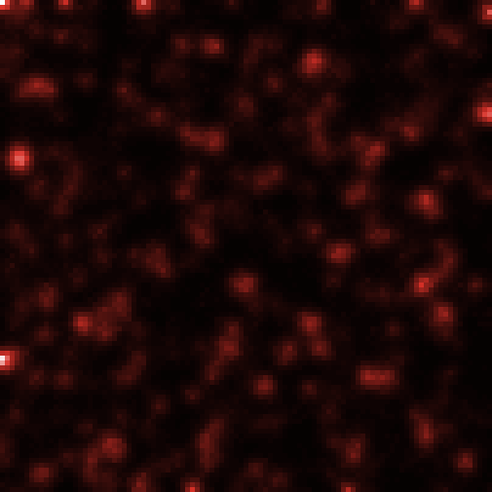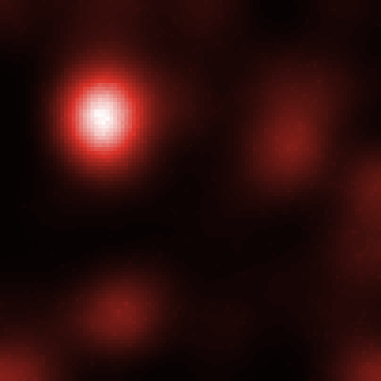
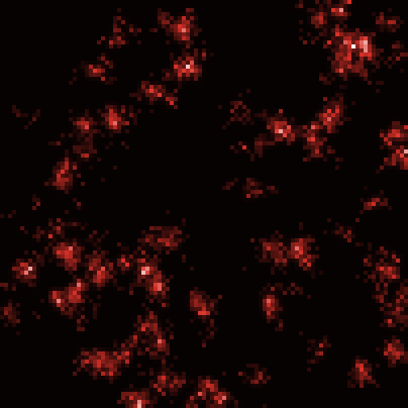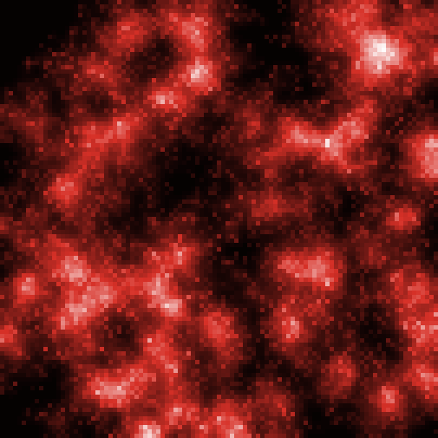

Figure : Example of the variety of generated urban shapes

3.2 - Model Behavior

3.2.1 - Convergence - internal model validation

convergence properties of indicators ; number of repetitions needed for consistence of results. [histograms and stats of \sigma TODO]

3.2.2 - Exploration of parameter space

Grid, then LHS explorations.

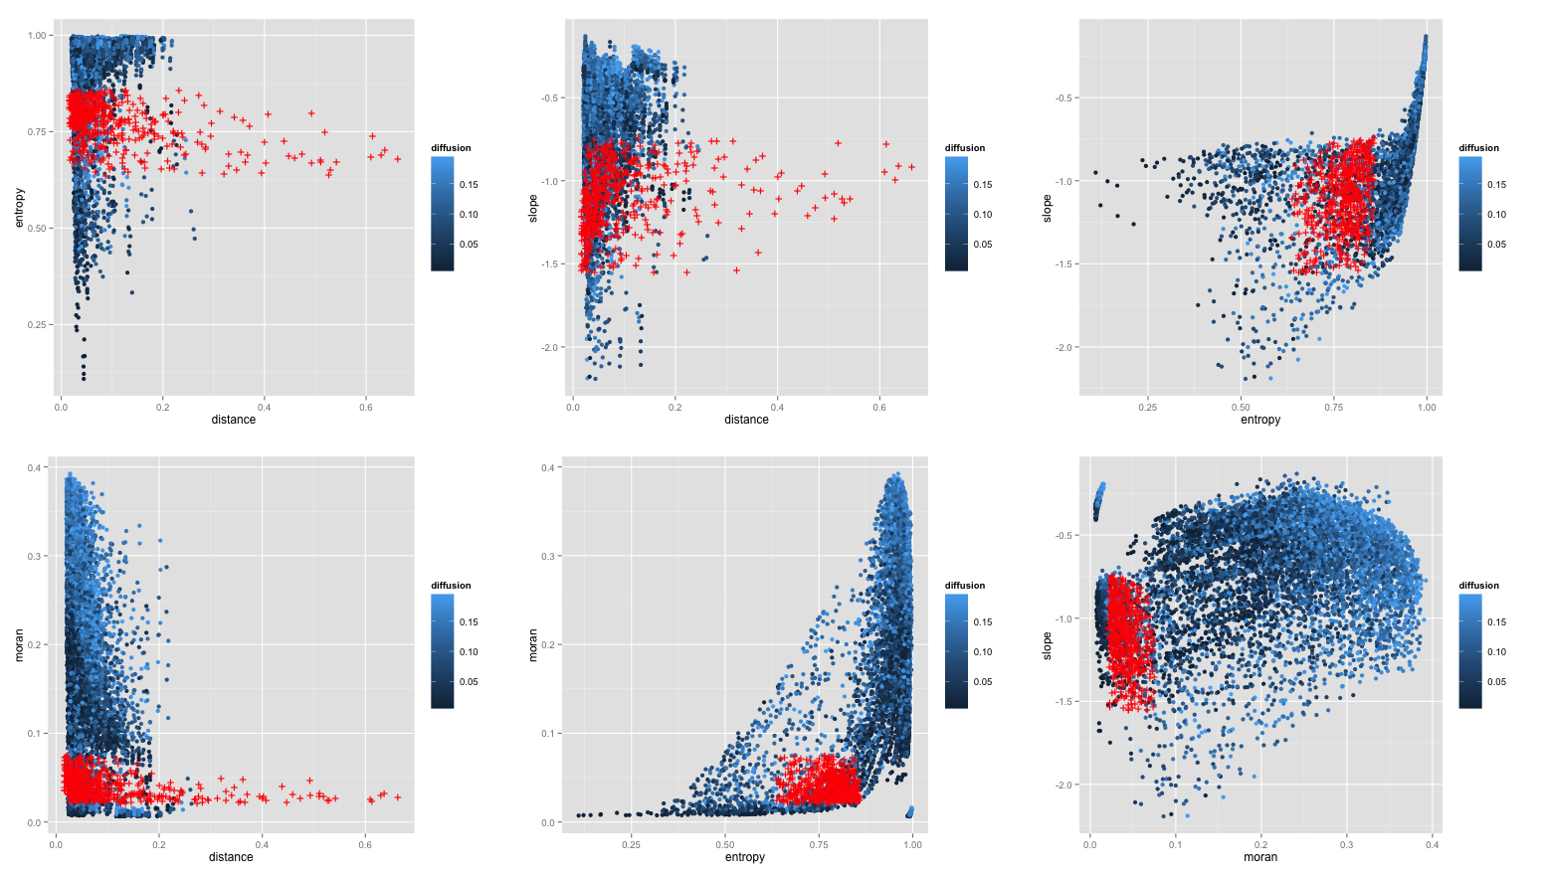

Figure : Scatterplots of indicators distribution in an hypercube of the parameter space. We show here the influence of one parameter (diffusion rate). Red points correspond to real data.
3D plots as supp material ?

Figure : on 2 first PC of morpho indicators, localization of typical shapes (monocentric city, polycentric city, diffuse rural settlements, aggregated rural settlements) / comparing generated shape with a typical real one

3.2.3 - Statistical analysis

Regression indics = f(params) . TO BE DONE.
interpretation ?

% 3.3 - Model Calibration
\subsection{Model Calibration}

% 3.3.1 - Real Data
\subsubsection{Real Data}

%% Data source (density grid), computation methodology [comparison of sampling/smoothing to avoid bord effects ?] -> reals values of morpho indics on 50kmx50km grids, on all Europe.
%% + summary stats

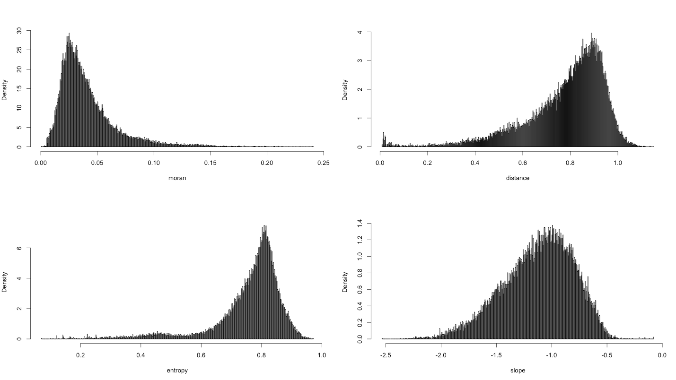
Figure : Distributions of indicators values for real dataset of european densities, computed on 50kmx50km grids, with 10km offset to avoid bord effects. [TODO : add log-normal/normal fits ? ]

3.3.2 - Calibration Process

Specific calib process : PCA that maximize the cumulated distance between generated points and reals points ; then select point cloud that overlaps real points in (PC1,PC2) plan, given a distance threshold.

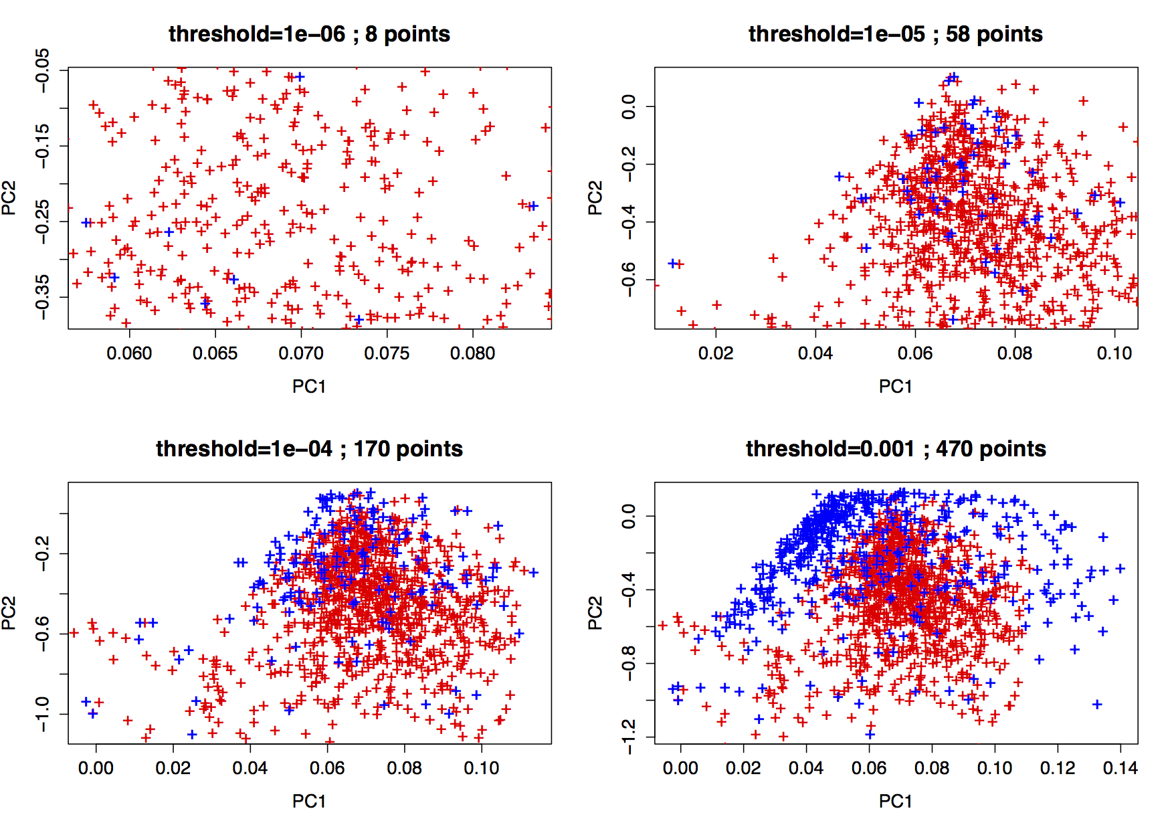

Figure : Precise calibration of the model. The principal component analysis is conducted to maximize the spread of the differences between real data and model output, i.e. on the set {|R_i - M_j|} where R_i is the set of real points, M_j the set of model outputs. We select then the overlapping cloud at threshold $\theta$, by taking models output closer to real point cloud than $\theta$ in the (PC1,PC2) plan.

% 3.3.3 - Calibration Results
\subsubsection{Calibration Results}

-> extraction of the exact parameter space covering all real situations.
interpretation of its shape (correlations between parameters ?) and its volume in different directions (relative importance of parameters).
[possible development : application of Calibration Profile algo to check relative influence of parameters + ad hoc linear algebra on regression of 3.2.3 to do the same]

Remarque générale : c’est bien d’inclure tes résultats de manière extensive dans le doc, qu’on puisse en discuter collectivement

4 - Discussion

4.1 - Thematic interpreation of growth behavior

- interpret positions of typical shapes within param space : confirms thematic interpretation of parameters.
- depending on results of 3.3.3, necessary and sufficient parameters to explain growth at this scale -> interpretation ?

4.2 - Integration into a multi-scale growth model

Possible coupling on a gibrat (or favaro-pumain) at europa scale (macro) (with addition of consistence on migration constraints), where meso growth rates which werer exogeneous before, are top-down determined, and bottom-up feedback is done through local aggregation level, that influence attractivity of an area.

%%%%%
%% 4.3 - Methodological application ?
%%%%% -> maybe out of scope here ?

Conclusion

-> Accurately calibrated spatialized urban growth model, can reproduce any (european) urban pattern.
-> interpretation of parameter influence ; effective independant dimensions of the urban system at this scale.

