Quantifying Co-evolution in Urban Systems with Transfer Entropy
Juste Raimbault¹
¹ LaSTIG, University Gustave Eiffel, IGN-Géodata Paris, Champs-sur-Marne, France
juste.raimbault@ign.fr
Understanding urban systems, either from a theoretical viewpoint or for practical sustainable planning applications, often implies intricate dynamics, that can be in some cases with circular causalities between populations of agents or objects, be coined as co-evolution [1]. In particular, the co-evolution between transportation networks and land-use remains quite unknown, despite direct usefulness regarding several Sustainable Development Goals (better accessibility, decarbonised transport, limited urban sprawl). A method to characterise co-evolution, and more generally the structure of the causal graph between the considered urban system variables, and to establish causality regimes either in empirical data or across the parameter space of a simulation model, has been proposed [2], based on Granger causalities. This contribution investigates how the method can be extended and refined with Transfer Entropy (TE), which provides a more robust and non-linear measure of causality. Given two or more time-series of urban dynamics, observed on a population of objects, Effective Transfer Entropy between all directional couples of variables are estimated on the ensemble (Kraskov estimator implemented in the jidt Java library). We test the method on a stylised yet rich model of urban morphogenesis [3], which simulates settlement and network growth simultaneously, with weight parameters balancing between the explaining factors of future urbanisation (among local density, distance to centre, distance to road network) and with a network growth following a simple connection rule. We compute causalities on the population of raster cells, and density, distance to centre and distance to roads variables. A first experiment, a grid exploration of the model parameter space, provide a broad set of causality regimes, with some illustrated in Fig. 1. The TE method appears more systematic and robust than the previous method, with some regimes not found significant by lagged correlations before. This confirms that TE is an appropriate tool to quantify co-evolution in urban systems, to be further tested on more cases.
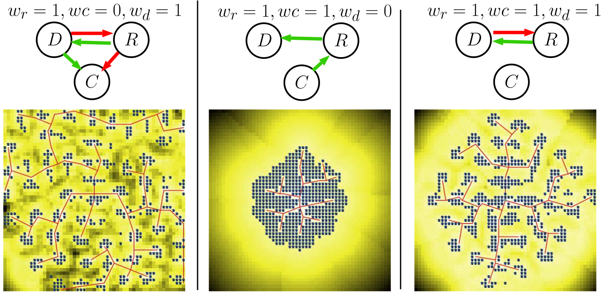
Figure 1. Examples of causality regimes (parameters, causal graph, simulated configuration).
[1] Raimbault, J. (2021). Modeling the co-evolution of cities and networks. In Handbook of cities and networks (pp. 166-193). Edward Elgar Publishing.
[2] Raimbault, J. (2020). Unveiling co-evolutionary patterns in systems of cities: a systematic exploration of the simpopnet model. In Theories and Models of Urbanization (pp. 261-278).
[3] Raimbault, J., Banos, A., & Doursat, R. (2014). A Hybrid Network/Grid Model of Urban Morphogenesis and Optimization. In 4th ICCSA (pp. 51-60).

