**A co-evolution agent-based model for systems of cities and transportation networks integrating top-down governance with game theory**

***J. Raimbault****1,2,3. (1) CASA, UCL, London, United Kingdom,* [*j.raimbault@ucl.ac.uk*](mailto:corresponding.email@address)*. (2) UPS CNRS 3611 ISC-PIF, Paris, France. (3) UMR CNRS 8504 Geographie-cites, Paris, France.*

The evolutionary theory for systems of cities at the macroscopic scale proposed by [1] suggests the existence of co-evolutionary dynamics in the trajectories of cities and their environment. In particular, transportation infrastructure connecting cities can in some cases co-evolve with them [2]. Understanding such processes is crucial for sustainable planning at large scales. We propose in this contribution a model of co-evolution for cities and transportation networks, with a focus on how network evolution is guided. More particularly, we extend the model of [3] by introducing top-down governance agents which decide on investments in transportation links. Using a game-theoretic approach, these agents arbitrate stochastically between national and international investments, following a payoff-matrix considering optimal accessibility gains and collaboration costs, with probabilities obtained under the assumption of mixed strategies in a Nash equilibrium. The evolution of city populations is determined by a spatial interaction model, and traffic flows assignment within the network follows a shortest paths heuristic. The model is applied to synthetic systems of cities, in a stylized configuration of two neighbor countries of comparable size. We systematically study model behavior with the OpenMOLE platform for model exploration and validation. First exploration results suggest a strong qualitative influence of propensity to collaborate on trajectories of the full system, and that intermediate levels of international investments may be more optimal in terms of accessibility gains at fixed costs. In comparison to null model behavior obtained running the base model from [3], the introduction of top-down governance decisions also changes considerably model behavior. This work shows how co-evolution models at this scale can be refined, opening research possibilities towards more complex or multi-scale models.

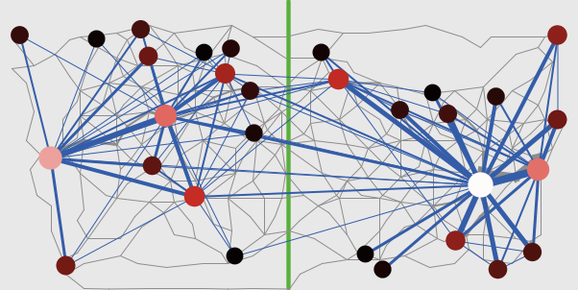

**Figure 1**: Synthetic model setup

**References**

[1] Pumain, D. (2018). An evolutionary theory of urban systems. In *International and transnational perspectives on urban systems* (pp. 3-18). Springer, Singapore.

[2] Raimbault, J. (2018). Modeling the co-evolution of cities and networks. In *Handbook of Cities and Networks*. Rozenblat C., Niel Z., eds.

[3] Raimbault, J. (2020). Hierarchy and co-evolution processes in urban systems. *arXiv preprint arXiv:2001.11989*.