Development of a computer-based game and a board game as interactive and dynamic tools to transmit freshwater ecology concepts (max 200 characters)
Hélène SERRA¹, Juste RAIMBAULT²
¹University of Bordeaux, France
²Affiliation, Address
E-mail contact: serra.helene@gmail.com

Introduction
There is an increasing expectation on people to be aware and to get involved in the environmental issues that our world is facing. However, expert knowledge is often required to understand most issues, which eventually can lead to make people losing interest and getting bored. One of the challenges in science today lies in explaining complex issues in a simple and understandable way to an unspecialized audience. As young and enthusiastic scientists, we thought that games could turn out to be a good medium for informal science learning. Play is the first form of learning we all experienced. It is very popular in our culture and often recalls socially important moments of shared entertainment with friends and family. From an educational point of view, games present many advantages. They are dynamic and interactive. Therefore, the player engagement increases, as well as its knowledge retention. Furthermore, through the immersion into a world with given boundaries, the player discovers a virtual environment. Following a quest and facing challenges, the player develops strategies thus, he indentifies the crucial moments. Those characteristics might be wisely used to spread scientific topics.
In this context, our objective is to develop tools based on games to transmit the basic concepts of fish ecology. We choose to focus on a classical board game and on a computer based game because they are complementary in the targeted audience (groups versus online gamers) and the possibilities offered, in particular regarding the interactions between players and the time incorporation.

Materials and methods
The methodology is divided in five big steps: (1) selection of fish species (ecological relevance); (2) definition of the instructions (object, game board, rules); (3) incorporation of environmental stressors (biotic and abiotic), (4) design and construction of the interfaces (board and computer model); (5) test with players. All steps are inevitably interdependent and evolve in parallel during the development of the games.
The material basically relies on our past and present experience of games in addition of knowledge acquired during our specialization in ecotoxicology and (?? Mets ce qui te concerne!!).

Results and discussion

General outcomes
Both games are based on the same general rules, even if slight modifications have to be expected according to the type of game. The game might be summarized as follows:
“You, little fish, just reached a new lake after an extremely intense rain event. This new area is to be conquered. But you are not the only one: three other fish species just arrived. Which player will find its territory first? Which of you will reproduce fast enough to reach a stable population and therefore remain forever and ever in the lake? Be careful! Nature is often hostile and might stay in your way. You will need to use strategy to avoid enemies; to compete for resources, to grow up and eventually you will reproduce … and become the next master of water!”
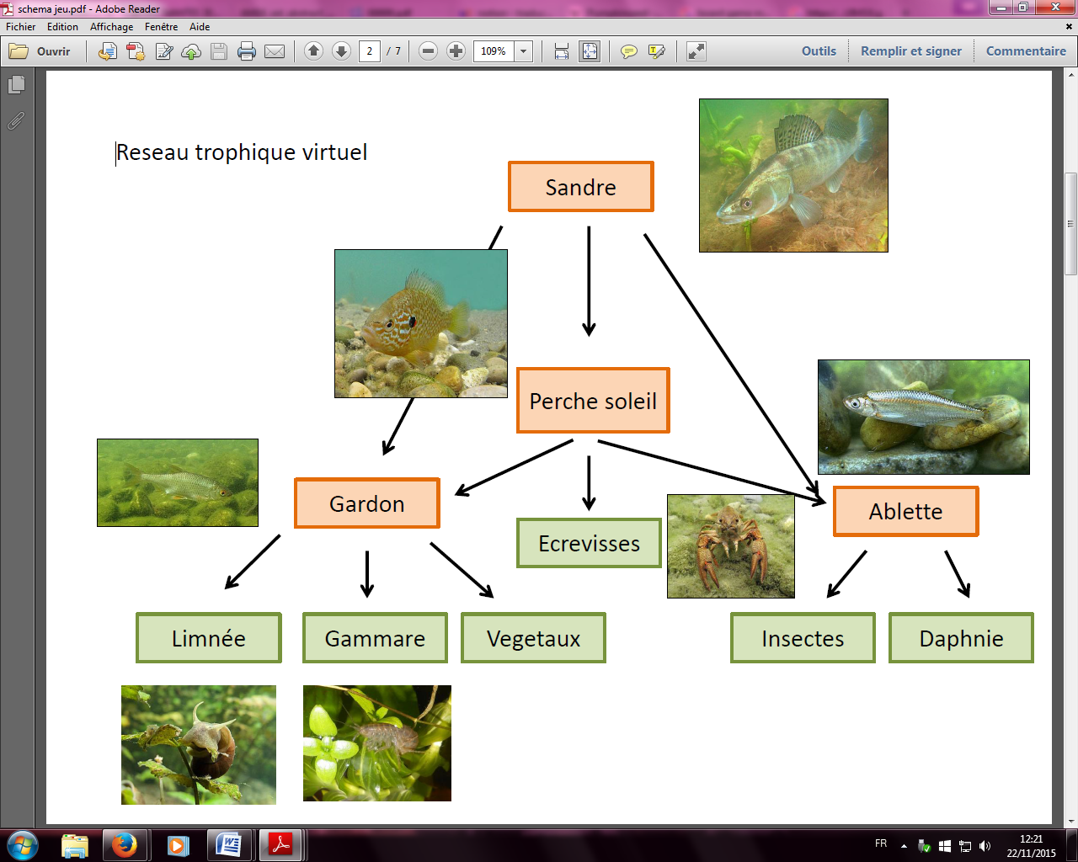
The virtual ecosystem is presented from a fish perspective. The object of the game is to reach a given number of adults and juveniles that will guarantee the stability of the population in the lake. For this purpose, each player has to find resources accordingly to his fish species. The resources are converted into “units” that can be used thereafter by the player for different purposes, such as reproduction, juvenile growth, to escape a predator or to attack a pray. Because nature is unpredictable, the “events” from the outside world could alter the virtual ecosystems either directly or indirectly, with positive and/or negative impacts depending on the fish species. They are supposed to represent abiotic (e.g. water temperature, light, water scarcity) and biotic (e.g. chemicals, parasites, nutrients, fisherman) stressors.
In the current version, there are four players, each of them being a different species, namely the roach (Rutilus rutilus), the pumpkinseed (Lepomis gibbosus), the zander (Sander lucioperca), and the bleak (Alburnus alburnus). The rationale behind is to maximize interactions between player including predation and competition for resources. Furthermore, we aim to share some ecological notions such as the type of resources used and reproduction strategies, from a perspective of a big fish (zander and pumpkinseed) or of a small shoal fish (roach and bleak). We include deliberately the pumpkinseed to introduce the notion of invasive species, one other type of stressors faced by native fish.

The board game
Basically the board is composed of boxes, each of them representing one type of resource (crustacean, plants, insects, zooplankton, mollusk…). The player has 2 token on the board (one male and one female) and is moving them by throwing dice. Some boxes are combined with an “event” that allows the introduction of random effects in the game. Each player holds a small record paper with the ecological characteristics of his species (resources, reproduction, number of juveniles per clutch, etc) and the ideal population to reach to win the game. Special rules for pray and predators are specified on the record paper (how to attack and how to escape).
Currently, we are testing the first prototype to determine and adjust the number of boxes on the board, their repartition, the ecological characteristics (number of units needed to reproduce, units needed to escape/to attack, for a juvenile to become an adult etc.) and the characterization of the events, in particular how each species is affected. The design of the board is under progress and will figure the edge of a lake.

Computer-based game
Text text text text text text text text text text text text text text text text text text text text text text text text text text text text text text text text text text text text Text text text text text text text text text text text text.
Text text text text text text text text text text text text text text text text text text. Text text text text text text text text text text text text text text text text text text.

Conclusion and perspectives
Table 1 could look like this
A prototype of each game is now available for testing and the basic rules are settled, even if improvements are expected while experiencing the games. In a short term, we aim to play and play again with selected committee in order to improve and define the final version. The aesthetic design of the games just started. We aim to get an attractive interface that is enjoyable for both young and “old” children, as we target a wide audience. There is no guarantee of success, but if we reach our goal, we would like to make available the computer game for free on the internet, and to use crowdfunding platforms to offer and diffuse the board game.
The very first objective of our games is to be entertaining, keeping in mind that a good game is the one that is played again because it is fun and not because it is educative. If the players forget that the game is about ecology, it is perfect! It would mean that the scientific concepts are clearly understood - exactly what we want.

References
[1] Author AB, Author CD, Author EF. 1998. Title of article. J Agric Food Chem 22:11-33.
[2] Author AB, Author CD. 1998. Title of book. City (ST), Country: Publisher. 00 p.
[3] Author AB. 2004. Title. http://www.address.com. Accessed Day Month Year.

Acknowledgement - The authors thank .....

