Development of a computer-based game and a board game as interactive and dynamic tools to transmit freshwater ecology concepts
OU ? (propositions)
// Games as media to transmit freshwater ecology concepts
OU ?
// A gamed-based approach to scientific vulgarization in freshwater ecology
Hélène SERRA¹, Juste RAIMBAULT²
¹University of Bordeaux, France
²Ecole Polytechnique, France (ou UMR CNRS 8504 Géographie-cités, France – vaut mieux dire que je suis géographe ou pas, qu'aiment les ecotoxicologues ? )
E-mail contact: serra.helene@gmail.com ← pas mettre un gmail ! : adresse de la fac ?

Introduction
There is an increasing expectation on people to be aware and to get involved in the environmental issues that our world is facing. However, expert knowledge is often required to understand most of these issues, thus a challenging problem in making people feeling concerned. One of the challenges in science today lies in explaining complex issues in a simple and understandable way to an unspecialized audience. Games turn out to be a good medium for scientific vulgarization. The first form of learning we all experience is to play. It is very popular in our culture and often recalls socially important moments of shared entertainment with friends and family. From an educational point of view, games present many advantages. They are dynamic and interactive. Therefore, the player engagement increases, as well as its knowledge retention. Furthermore, through the immersion into a world with given boundaries, the player discovers a virtual environment. Following a quest and facing challenges, the player develops strategies and thus indentifies crucial processes. Those characteristics can be wisely used to spread scientific topics, and gamification has already been proposed as a tool for an easier propagation of scientific thinking [1] and similar techniques such as serious games or mobile application developed in various disciplines such as e.g. pharmacology [2] or geosciences [3]. In this context, we propose to develop game-based tools to transmit the basic concepts of freshwater ecology. We choose to focus on a classical board game and on a computer based game because they are complementary in the targeted audience (groups versus online gamers) and the possibilities offered, in particular regarding the interactions between players and the incorporation of system dynamics.

Materials and methods
The methodology is divided in five steps: (1) selection of fish species (ecological relevance); (2) definition of the instructions (object, game board, rules); (3) incorporation of environmental stressors (biotic and abiotic), (4) design and construction of interfaces (board and computer model); (5) test with players. All steps are necessarily interdependent and are parallely tackled during the development of the games.
The material basically relies on our past and present experience of games in addition of knowledge acquired during our specialization in ecotoxicology and (?? Mets ce qui te concerne!!). Pas nécessaire à mon avis
ou si c'est obligé de mettre le material, décrire les bases des notions d'écotox/ecologie/modélisation que l'on aborde ? → je peux développer ici sur la méthode de modélisation basée agent – lien avec la gamification éventuellement ? – en fait j'ai dévelopé plus loin donc pas besoin ?

Results and discussion

General outcomes
Both games are based on the same general rules, even if slight modifications have to be expected according to the type of game. Table 1 gives an overview on how the game can be introduced to a specific audience.
Je pense que c'est mieux de le mettre comme illustration non ?
“You, little fish, just reached a new lake after an extremely intense rain event. This new area is to be conquered. But you are not the only one: three other fish species just arrived. Which player will find its territory first? Which of you will reproduce fast enough to reach a stable population and therefore remain forever and ever in the lake? Be careful! Nature is often hostile and might stay in your way. You will need to use strategy to avoid enemies; to compete for resources, to grow up and eventually you will reproduce … and become the next master of water!”

Table 1 : Example of board game card | Terminology and semantics may be adapted to the targeted audience.
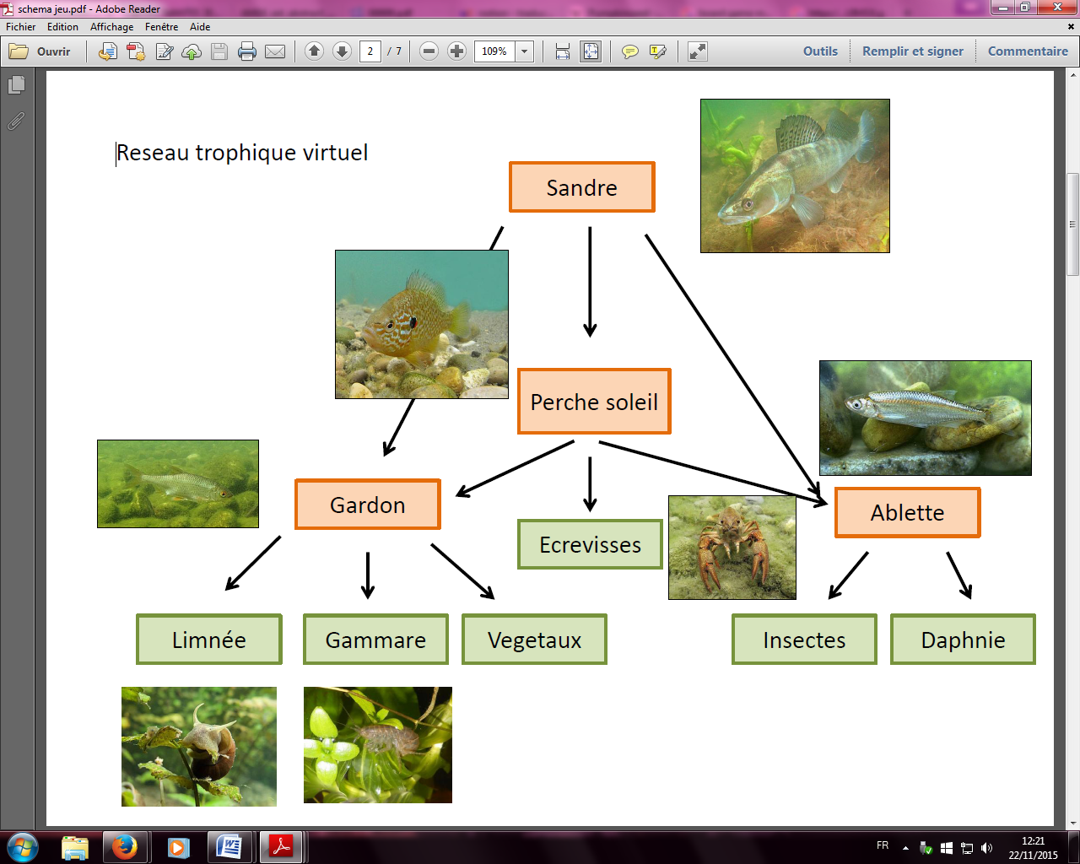Figure 1: Trophic chain

The virtual ecosystem is presented from a fish perspective. The object of the game is to reach a given number of adults and juveniles that will guarantee the stability of the population in the lake. For this purpose, each player has to find resources accordingly to his fish species. The resources are converted into “units” that can be used thereafter by the player for different purposes, such as reproduction, juvenile growth, to escape a predator or to attack a pray. Because the ecological system is unpredictable, the “events” from the outside world could alter the virtual ecosystems either directly or indirectly, with positive and/or negative impacts depending on the fish species. They are supposed to represent abiotic (e.g. water temperature, light, water scarcity) and biotic (e.g. chemicals, parasites, nutrients, fisherman) stressors.
The current version of the game includes four players, each of them being a different species, namely the roach (Rutilus rutilus), the pumpkinseed (Lepomis gibbosus), the zander (Sander lucioperca), and the bleak (Alburnus alburnus). The rationale behind is to maximize interactions between players including predation and competition for resources. Furthermore, we aim to share some ecological notions such as the type of ressources used and reproduction strategies, from a perspective of a large fish (zander and pumpkinseed) or of a small shoal fish (roach and bleak). The pumpkinseed is deliberately included to introduce the notion of invasive species, one other type of stressors faced by native fish.

The board game
The board is basically composed of boxes, each of them containing one type of resource (crustacean, plants, insects, zooplankton, mollusk, etc.). The player has 2 token on the board (one male and one female) and is moving them by throwing dice. Some boxes are combined with an “event” that allows the introduction of random effects $ ← attention au terme, ça a un rapport avec les' random effets models' dont ils sont friands en epidemio (donc surement chez vous aussi ?) – sinon plutôt mettre externalities perturbating the ecosystem ? $ in the game. Each player holds a small record paper with the ecological characteristics of his species (resources, reproduction, number of juveniles per clutch, etc) and the ideal population to reach to win the game. Special rules for pray and predators are specified on the record paper (how to attack and how to escape).
A first prototype is currently being tested to determine and adjust the number of boxes on the board, their repartition, the ecological characteristics (number of units needed to reproduce, units needed to escape/to attack, for a juvenile to become an adult etc.) and the characterization of the events, in particular how each species is affected. The design of the board is under progress and will figure the edge of a lake.

Computer-based game
The second and complementary approach is a computer game based on a model of simulation for the ecosystem. Indeed, dynamical ecological processes are inherently multiscalar and the board game allows to perceive the associated processes at a rather small time scale. In order to introduce notions of equilibrium and perturbations of equilibrium that occur at a larger time scale in an ecosystem into the scientific material transmitted by the game, we propose to implement an agent-based model (ABM) and couple its dynamics with gaming actions. ABM have already been widely used in ecology what has even contributed to progresses in the associated methodology such as Pattern-oriented Modeling [4]. We use a trophic chain dynamic model (extended prey-predator model). If simple prey-predator systems are well studied through dynamical systems (Lokta-Volterra equations e.g.), more complex aspects including behavioral rules for species or spatially heterogeneous environment can be captured by such a model, what is precisely wanted for game implementation : players must be able to influence fishes behavior and external events must be included as perturbations of the system.
More precisely, the aforementioned species and natural ressources are the basis of the system. Discrete dynamics consists in the following steps : (a) wandering of species in their prefered zone of the river; (b) trophic interactions (fish-fish and fish-ressources) ; (c) renewing of fishes (reproduction) and of ressources. Model parameters include reproduction rates, movement parameters, etc. (see code documentation for an exhaustive list). Large-scale model exploration and calibration is currently running in order to find parameter ranges for which ecosystem is in equilibrium, that will consist in the default state of the system without user control (note that this calibration is the analog of board game adjustement). User interaction is then integrated, as the choice of each player of a wandering area and strategy at given time intervals (one month, when one time step is 6h for example). It allows the system to evolve in-between and the player to observe the consequence of their actions and reactions to external events on the ecosystem : an simple example is the collapse of the ecosystem through an overly aggressive behavior of the invasive species. Further developments will consist in model refinment and user latitude adjustements thanks to player feedbacks, and also in technical prospective for an online version of the game.

Je peux mettre un illustration de l'interface mais déjà plus de place non ?

Conclusion and perspectives
A prototype of each game is currently available for testing and refinments are expected while experiencing the games. In a short term, next versions of the games will be developped after player feedback, to complete the aesthetic design of the games that just started and refine processes parameters. A wide audience is targeted thus the need of an attractive interface. The very first objective of our games stays to be entertaining, keeping in mind that the ludic rather than pedagogical aspect is central in the success of such game-based media. If players forget that the game is about ecology, our precise objective is reached since it would mean that the underlying scientific concepts are clearly understood.
There is no guarantee of success, but if we reach our goal, ne jamais dire ça dans une soumission, on succède toujours (parfois de mauvaise fois mais ça on l'avoue pas ;) )
Next steps are oriented towards an online version of the computer game as described before, and the use of crowdfunding platforms to offer and diffuse the board game.

References
[1] Morris, B. J., Croker, S., Zimmerman, C., Gill, D., & Romig, C. (2013). Gaming science: the “Gamification” of scientific thinking. Frontiers in psychology, 4.
[2] Cain, J., & Piascik, P. (2015). Are Serious Games a Good Strategy for Pharmacy Education?. American journal of pharmaceutical education, 79(4).
[3] Reynard, E., Kaiser, C., Martin, S., & Regolini, G. (2015). An Application for Geosciences Communication by Smartphones and Tablets. In Engineering Geology for Society and Territory-Volume 8 (pp. 265-268). Springer International Publishing.
[4]Grimm, V., & al. (2005). Pattern-oriented modeling of agent-based complex systems: lessons from ecology. Science, 310(5750), 987-991.
[5] Wilensky, U. (1999). NetLogo.
[6] Reuillon, R., Leclaire, M., & Rey-Coyrehourcq, S. (2013). OpenMOLE, a workflow engine specifically tailored for the distributed exploration of simulation models. Future Generation Computer Systems, 29(8), 1981-1990.

Model was implemented on NetLogo modeling platform [5] and source code is openly available on the repository of the project at https://github.com/JusteRaimbault/MediationEcotox . Netlogo allows easily further required developments such as web embedding and user interaction.
Using OpenMole model exploration platform [6]

