Gamed-based tools as media to transmit freshwater ecology concepts
Hélène SERRA¹, Juste RAIMBAULT²
¹University of Bordeaux, France
²Ecole Polytechnique, France
E-mail contact: helene.serra@u-bordeaux.fr

Introduction
There is an increasing expectation on people to be aware and to get involved in the environmental issues that our world is facing. However, expert knowledge is often required to understand most of these issues. One of the challenges in science today lies in explaining complex issues in a simple and understandable way to an unspecialized audience. Games can turn out to be a good medium for scientific vulgarization. Indeed, the first form of learning we all experienced was by playing. Games are very popular, and from an educational point of view, they present many advantages. They are dynamic and interactive. Therefore, the player engagement increases, as well as its knowledge retention. In addition, the player is immerged into a new world and discovers a virtual environment where he needs to develop strategies and to indentify crucial processes. Those characteristics can be wisely used to spread scientific topics, and gamification has already been proposed as a tool for an easier propagation of scientific thinking [1] such as in pharmacology [2] or geosciences [3]. In this context, our project aims at developing game-based tools to transmit the basic concepts of freshwater ecology. We choose to focus on a classical board game and on a computer based game because they are complementary in the targeted audience (groups versus online gamers) and the possibilities offered, in particular regarding the interactions between players and the system dynamics.

Materials and methods
The general methodology is divided in five steps: (1) selection of species; (2) definition of the instructions (object, game board, rules); (3) incorporation of environmental stressors (biotic and abiotic), (4) design and construction of interfaces (board and computer model); (5) test with players. All steps are necessarily interdependent and are tackled in parallel during the development of the games.
While the board game is inspired by past experiences of player, the computer game is based on a model of simulation of the ecosystem. In order to introduce notions of equilibrium and its perturbations that occur at a larger time scale than on the board game, we propose to implement an agent-based model (ABM) and to couple its dynamics with gaming actions. ABM have already been widely used in ecology [4]. Therefore, we selected a trophic chain dynamic model (extended prey-predator model) that can capture fish behavioral rules and spatially heterogeneous environment. It is particularly suitable for the game implementation: fish behaviors are influenced by players whereas the ecosystem is disturbed by external events.

Results and discussion

General outcomes
Both games are based on the same general rules, even if slight modifications have to be expected according to the type of game. Table 1 gives an overview on how the game can be introduced to a specific audience:
“You, little fish, just reached a new lake after an extremely intense rain event. This new area is to be conquered. But you are not the only one: three other fish species just arrived. Which player will find its territory first? Which of you will reproduce fast enough to reach a stable population and therefore remain forever and ever in the lake? Be careful! Nature is often hostile and might stay in your way. You will need to use strategy to avoid enemies; to compete for resources, to grow up and eventually you will reproduce … and become the next master of water!”

Table 1 : Example of board game introduction | Terminology and semantics have to be adapted to the targeted audience.
The virtual ecosystem is presented from a fish perspective. The object of the game is to reach a given number of adults and juveniles that will guarantee the stability of the population in the lake. For this purpose, each player has to find resources accordingly to his fish species. The resources are converted into “units” that can be used thereafter by the player for different purposes, such as reproduction, juvenile growth, to escape a predator or to attack a pray. The external perturbations are illustrated by “events” that are supposed to reflect abiotic (e.g. water temperature, light, water scarcity) and biotic (e.g. chemicals, parasites, fisherman) stressors.
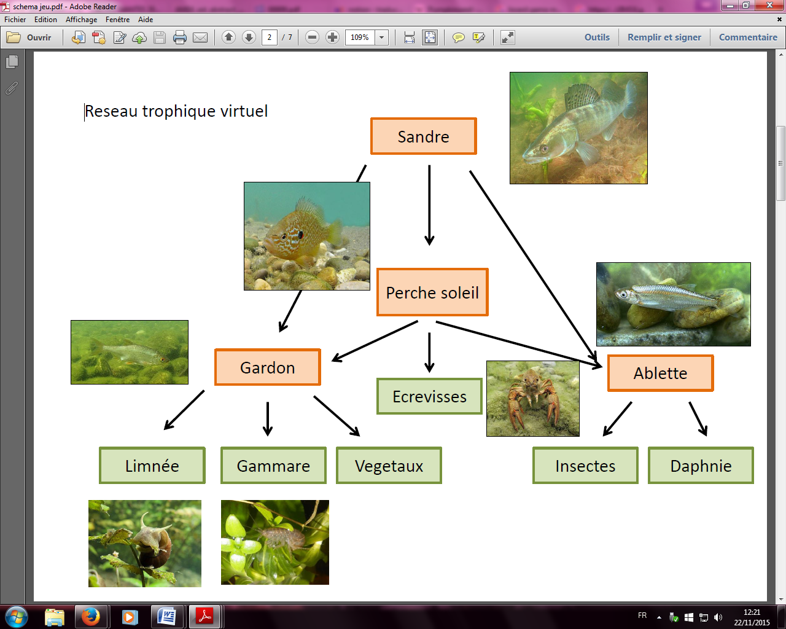
The current version of the game includes four players, each of them being a different species, namely the roach (Rutilus rutilus), the pumpkinseed (Lepomis gibbosus), the zander (Sander lucioperca), and the bleak (Alburnus alburnus). The rationale behind lies in maximizing interactions between players (predation and competition, see fig. 1) and to illustrate feeding and reproduction strategies from different perspectives (from a big solitary fish to a shoal fish, including a invasive fish species).

The board game
The board is basically composed of boxes. Each of them represents a type of resource (e.g. crustacean, plants, insects), and some boxes are combined with an “event” to include the external perturbations in the game. The player has 2 token on the board (one male and one female) and is moving them by throwing dice. The ecological characteristics of each species are kept on a record paper by each player. It describes the species-specific rules (feeding preferences, time and resources needed to reproduce, how to escape/attack etc). A first prototype is currently being tested to determine and adjust the board game design, the ecological characteristics of each species and the characterization of events, in particular their impacts on players. The design of the board is under progress and will figure the edge of a lake.

Computer-based game
The aforementioned species and natural ressources are the basis of the system. Discrete dynamics consist in the following steps : (a) wandering of species in their prefered zone of the lake; (b) trophic interactions (fish-fish and fish-ressources) ; (c) renewing of fish (reproduction) and of ressources. The model parameters include reproduction rates, movement parameters, etc. Large-scale model exploration and calibration are currently running in order to find parameter ranges at which ecosystem is in equilibrium. The equilibrium will constitute the default state of the system without user control. User interactions are then integrated after each turn, at given time intervals (one month, when one time step is 6h for example). It allows the system to evolve in-between. During this time frame, the players observe the consequences of its actions and the reaction of the ecosystem to external events. Further developments will consist in model refinment and user latitude adjustements thanks to player feedbacks.

Conclusion and perspectives
A prototype of each game is currently available for testing and refinements are expected while experiencing the games. In a short term, next versions of the games will be developed after player feedback and will include the aesthetic design of the games and refined processes parameters. Mid-term and long-term objectives are oriented towards an online version of the computer game as described before, and the use of crowdfunding platforms to offer and diffuse the board game.
The very first objective of our games remains to be entertaining, keeping in mind that the ludic rather than pedagogical aspects are central in the success of such game-based media. If players forget that the game is about ecology, our precise objective is reached. It would mean that the underlying scientific concepts are clearly understood.
References
[1] Morris, B. J., Croker, S., Zimmerman, C., Gill, D., & Romig, C. (2013). Gaming science: the “Gamification” of scientific thinking. Frontiers in psychology, 4.
[2] Cain, J., & Piascik, P. (2015). Are Serious Games a Good Strategy for Pharmacy Education?. American journal of pharmaceutical education, 79(4).
[3] Reynard, E., Kaiser, C., Martin, S., & Regolini, G. (2015). An Application for Geosciences Communication by Smartphones and Tablets. In Engineering Geology for Society and Territory-Volume 8 (pp. 265-268). Springer International Publishing.
[4]Grimm, V., & al. (2005). Pattern-oriented modeling of agent-based complex systems: lessons from ecology. Science, 310(5750), 987-991.
[5] Reuillon, R., Leclaire, M., & Rey-Coyrehourcq, S. (2013). OpenMOLE, a workflow engine specifically tailored for the distributed exploration of simulation models. Future Generation Computer Systems, 29(8), 1981-1990.

Using OpenMole model exploration platform [5] to explore the NetLogo implementation which source code is openly available on th e repository of the project at https://github.com/JusteRaimbault/MediationEcotox

