The Title of the Paper

J. Raimbault[1]* and Author B1

1DCenter for Advanced

February 15, 2021

**Summary**

Large scale urban transportation models such as four-step models require the integration of heterogenous data and the coupling of sub-models which can already be consequent in terms of complexity. Therefore, such integrated models are difficult to transfer, reproduce, and validate. We propose a modular and reproducible approach based on scientific workflow systems to build and validate such models. We illustrate it by coupling different open-source components within workflows to construct a four-step transportation model applied to all functional urban areas in the UK, and discuss its application to health indicators within public transport in the context of the COVID-19 crisis.

**KEYWORDS:** Urban transport models; Scientific workflow systems; Modularity; Reproducibility

# Introduction

Urban transportation models such as four-step models, and more generally land-use transport interaction models \citep{wegener2004land}, require the integration of heterogenous data and the coupling of various submodules with possibly high levels of complexity. This raises issues on the one hand for their implementation, transferability and reproducibility, and on the other hand for their validation which requires large scale numerical experiments to validate the submodules and the whole models \citep{lee1973requiem,batty2014can}. This work proposes to tackle both issues by leveraging modularity and transparency for the construction of large urban models in a modular way, using scientific workflow systems \citep{barker2007scientific} to couple the different components of models and to launch numerical experiments for their validation.

# Methods

More particularly, we demonstrate this approach by building a modular four-step multimodal transportation model using only open-source projects. We couple together the MATSim model (MATSim Community \citep{horni2016multi}) to simulate the transportation system, the SPENSER model (University of Leeds, \url{https://github.com/nismod/microsimulation}) for the generation of synthetic population, the QUANT model (University College London \citep{milton2019accelerating}) to estimate spatial interactions, and the spatialdata library (OpenMOLE Community \citep{raimbault2020scala}) for data preparation. The model parts are embedded as docker containers into the DAFNI facility (\url{https://dafni.ac.uk/}), which workflow system is used to couple them and build the integrated model. DAFNI provides a scientific workflow system for model integration and coupling, direct access to relevant open datasets, visualisation functionalities, and access to a High Performance Computing infrastructure. We show in Figure 1 the workflow constructed with the interactive workflow builder within the platform, and an example of visualisation of model outputs.

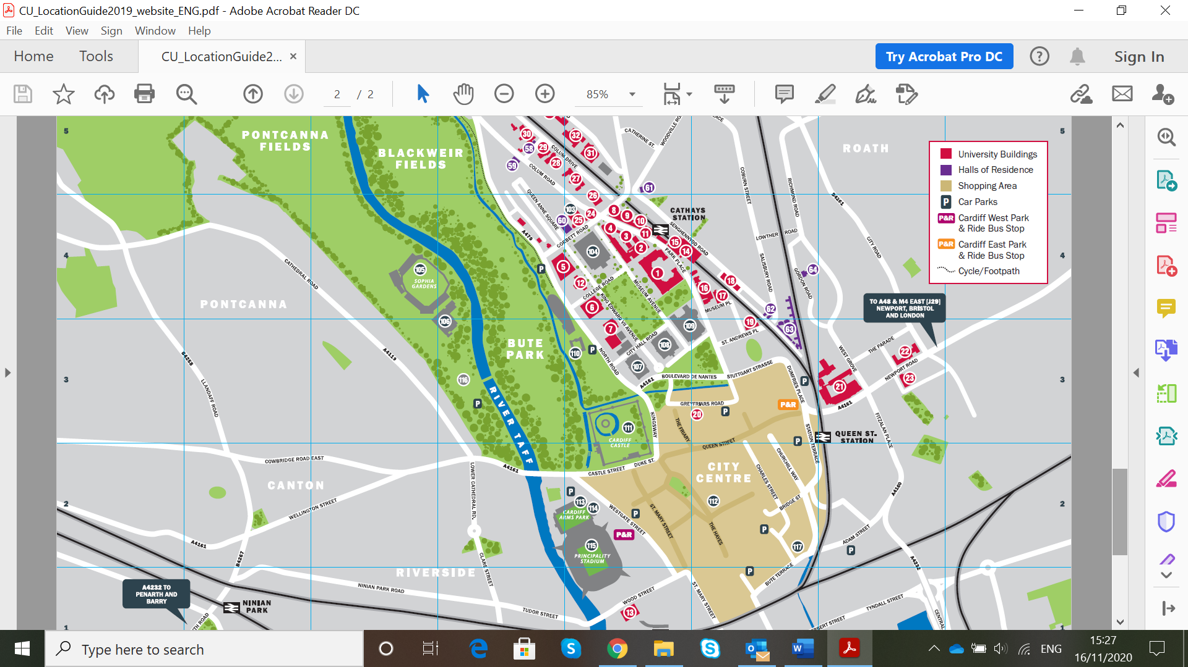

**Figure** 1 Construction of the transport model using the DAFNI workflow system. \textit{(Top)} DAFNI workflow including model steps and a computational experiment (Monte Carlo simulations); \textit{(Bottom)} Example of visualisation of model output (MATSim generated trips) within the DAFNI platform..

# Results

A list of references cited should be provided at the end of the paper using the Harvard format as shown below. Citations of these within the text should be given as follows: papers such as an interesting one by Harvey and Tulloch (2006) and also interesting books (Day, 1995).

# Discussion

Abstracts

# Acknowledgements

Acknowledgement should be made of any funding bodies who have supported the work reported in the paper, of those who have given permission for their work to be reproduced or of individuals whose particular assistance is due recognition. Acknowledge data providers here where appropriate.

# References

Day R A (1995). *How to write and publish a scientific paper*. Cambridge University Press, Cambridge.

Harvey F and Tulloch D (2006). Local-government data sharing: Evaluating the foundations of spatial data infrastructures. *International Journal of Geographical Information Science,* 20(7), 743-768.

# Biographies

All contributing authors should include a biography of no more than 50 words each outlining their career stage and research interests.

1. author.a@university.edu