Title for an abstract submitted to ECTQG2021

First C. AUTHOR1; Second AUTHOR2; Last AUTHOR1,2

1Full affiliation

Postal address, ZIP Code, Country

International Phone number, Email address (correspondent author)

2Full affiliation

Postal address, ZIP Code, Country

International Phone number, Email address

1,2Full affiliation

Postal address, ZIP Code, Country

International Phone number, Email address

Keywords: keyword 1, keyword 2, keyword 3, keyword 4, keyword 5

Extended abstracts submitted to ECTQG2021 will be peer-reviewed by the Scientific Committee of the Meeting. Authors may submit an abstract with up to 1500 words extended abstract. The abstract may have up to four figures (with proper caption, all referenced in the body of the text) and may have a group of references formatted in Harvard style.

Abstracts must be submitted via the submission link is <https://easychair.org/conferences/?conf=ectqg2021> by 10 September 2021.

Submissions should follow this template, which can be reproduced in ant Latex processor and submitted as a pdf file.

Each abstract must not exceed 1,500 words, including title, authors and their affiliations, acknowledgements, and references. Page size must be A4 with the following margins: 2.54 cm on top and bottom margins, 1.91 cm on the left and right ones. Title must be in Times New Roman bold, 20pt, centred. Authors must be listed with their names in Times New Roman bold, 12pt, and remaining information in Times New Roman, 10pt. The correspondent author must be clearly identified. The maximum number of keywords is 5, written in Times New Roman, 12pt, left aligned. The body of the text is written in Times New Roman 12pt, double space. Headings (Times New Roman 12pt bold) and subheadings (Times New Roman 12pt Italic) must be numbered.

You can use the word styles list to find all relevant styles for this document.

1. Headings

You can use numbered headings and subheadings.

1.1 Subheading

This is a subheading.

Please us the Harvard citation style to insert and list citations, [support on this style can be found here](https://subjects.library.manchester.ac.uk/referencing/referencing-harvard).

The organizers may reject abstracts if they do not comply with this template.



Figure 1: Captions and references should be in Times New Roman font size 9 centred

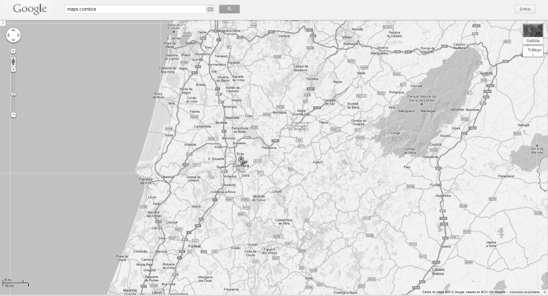

Map 1: Captions and references should be in Times New Roman font size 9 centred

Acknowledgments

Please write any acknowledgements or funding information here.

References

List your references using the Harvard style of referencing, the Manchester flavour of it can be found here.