**Title in Times New Roman (12pt Bold) Using First Capital Letters (Recommended Size: Up to Two Lines)**

***F. Author****1, S. Author2, T. Author1,2. (1) Institution, Address, Town, Country,* [*first_author_email@address*](mailto:corresponding.email@address)*. (2) Institution, Address, Town, Country*

The presenting author must be registered to attend the **CCS2021** Meeting. Abstracts may be rejected unless the following guidelines are respected. The full abstract as presented in this template cannot be longer than 1 page for both oral and poster presentations. Do not use non-standard abbreviations in the title. Abstracts MUST be submitted electronically through the Easychair platform. Abstracts submitted by fax or by email will not be accepted. It is important to follow strictly the format of this document. We strongly recommend to type the abstract over this template in order to ensure that all abstract contributions have the same style, i.e. one column of text written in Times New Roman 11pt (justified) with page margins of 1'' (top – bottom) and 1.25'' (left – right). You may include Figures and Tables in your abstract. Leave one line (11pt) before and after each Figure. The corresponding captions (Times New Roman 11pt) should follow straight after the Figures, without any line between the Figure and its caption.

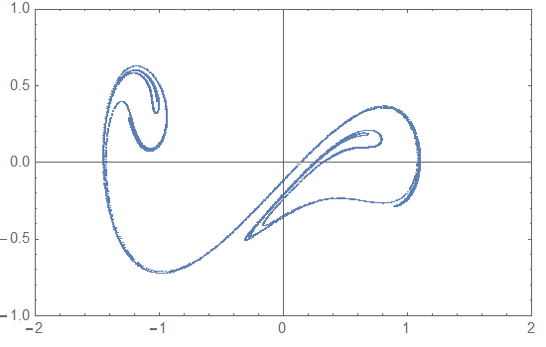

**Figure 1**: Poincare set of the Duffing equation, for a=0.1, b=0.3

The sections for acknowledgements and references should appear at the end of the abstract (Times New Roman 11pt).

**Acknowledgements (optional)**

The acknowledgements should be written here. Thank you for spending your time in reading the instructions. Feel free to contact us for any further information.

**References (optional)**

[1] X. Author, Y. Author, Z. Author, *Scientific Reports*, 20 (2011) 537.

[2] X. Author, Y. Author, Z. Author, *Proc. of Solar Chemistry and Photocatalysis: Environmental Applications, Las Palmas de Gran Canaria*, Spain, 2006, 10.