19th EURO Working Group on Transportation Meeting, EWGT2016, 5-7 September 2016, Istanbul, Turkey
Investigating the Empirical Existence of Static User Equilibrium
Juste Raimbault ^{a,b}
ª UMR CNRS 8504 Géographie-cités, 13 rue du Four, 75006 Paris, France
^{b} UMR-T IFSTTAR 9403 LVMT, Cité Descartes, 77455 Champs-sur-Marne, France
Abstract
The Static User Equilibrium is a powerful framework for the theoretical study of traffic. Despite the restricting assumption of stationary flows that intuitively limit its application to real traffic systems, many operational models that implement it are still used without an empirical validation of the existence of the equilibrium. We investigate its existence on a traffic dataset of two months for the region of Paris, FR. The implementation of an application for interactive spatio-temporal data exploration allows to hypothesize a high spatial and temporal heterogeneity, and to guide further quantitative work. The behaviour of spatial autocorrelation index for relative travel speed at different spatial ranges suggest a chaotic evolution at the local scale, especially during peak hours, invalidating in a first approximation the SUE assumption of locally stationary flows. We finally describe on-going further developments based on the estimation of Lyapounov dynamical stability of traffic flows and aimed to estimate typical stability time scales during peak-hours.

© 2016 The Authors. Published by Elsevier B.V.
Peer-review under responsibility of the Scientific Committee of EWGT2016.
Keywords: Static User Equilibrium ; Spatio-temporal Data Visualization ; Dynamical Stability
- Introduction
Traffic Modeling has been extensively studied since seminal work by Wardrop (1952): economical and technical elements at stake justify the need for a fine understanding of mechanisms ruling traffic flows at different scales. Many approaches with different purposes coexist today, of which we can cite dynamical micro-simulation models, generally opposed to equilibrium-based techniques. Whereas the validity of micro-based models has been largely discussed and their application often questioned, the literature is relatively poor on empirical studies assessing the equilibrium assumption in the Static User Equilibrium (SUE) framework. Various more realistic developments have been documented in the literature, such as Dynamic Stochastic User Equilibrium (DSUE) reviewed by Han (2003). Extensions including user behavior with choice models have more recently been proposed, such as Zhang et al. (2013) taking into account both the influence of road pricing and congestion on user choice with a probit model.
However some studies and real-world applications still rely on SUE. Parisian region e.g. uses a static model (MODUS) for traffic management and planning purposes. Leurent and Boujnah (2014) introduce a static model of traffic flow including parking cruising and parking lot choice: it is legitimate to ask, specifically at such small scales, if the stationary distribution of flows is a reality. An example of empirical investigation of classical assumptions is (Zhu and Levinson, 2010), in which revealed route choices are studied. Their conclusions question “Wardrop’s first principle” implying that users choose among a well-known set of alternatives. In the same spirit, we investigate the possible existence of the equilibrium in practice. More precisely, SUE assumes a stationary distribution of flows over the whole network. This assumption stays valid in the case of local stationarity, as soon as time scale for parameter evolution is considerably greater than typical time scales for travel. The second case which is more plausible and furthermore compatible with dynamical theoretical frameworks, is here tested empirically.
- Data Collection
  - Dataset Construction
We propose to work on the case study of Parisian Metropolitan Region. An open dataset was constructed for highway links within the region, collecting public real-time open data for travel times (available at www.sytadin.fr). As stated by Bouteiller & Berjoan (2013), the availability of open datasets for transportation is far to be the rule, and we contribute thus to their opening by the construction of our dataset. The automatized data collection script continues to enrich the database as time passes, allowing future extensions of this work on a larger dataset and a potential reuse by scientists or planners. The dataset is available online under a Creative Commons License at.
A time granularity of 5 minutes was obtained for a three months period (February 2016 to April 2016 included). Spatial granularity is in average 10km, as travel times are provided for major links. The dataset contains 101 links. Raw data we use is effective travel time, from which we can construct travel speed and relative travel speed, defined as the ratio between optimal travel time (travel time without congestion, taken as minimal travel times on all time steps) and effective travel time. Data was partially cross-validated using Google directions API, which provides limited access to real-time travel times: each 5min, 50 links randomly chosen (API limit) were checked. Variation across datasets has an overall relative variance less than 10%, what we estimate reasonable for the use of our dataset.

  - Data Summary
- Methods and Results
  - Visualization of spatio-temporal congestion patterns
As our approach is fully empirical, a good knowledge of existing patterns for traffic variables, and in particular of their spatio-temporal variations, is essential to guide any quantitative analysis. As in Pattern-oriented Modelling (Grimm, 2006), we are interested in macroscopic patterns at given temporal and spatial scales: the same way stylized facts are in that approach extracted from a system before trying to model it, we need to explore interactively data in space and time to find relevant patterns and associated scales. We implemented therefore an interactive web-application for data exploration using R packages shiny and leaflet. It allows dynamically visualizing of travel time and congestion variables among the whole network or in a particular area when zoomed in. A screenshot of the application is presented in Figure 1. Main conclusion from interactive data exploration is that strong spatial and temporal heterogeneity is the rule. The temporal pattern recurring most often, peak and off-peak hours is on a non- negligible proportion of days perturbed. In a first approximation, non-peak hours may be approximated by a local stationary distribution of flows, whereas peaks are too narrow to allow the validation of the equilibrium assumption. Spatially we can observe that no spatial pattern is clearly emerging. It means that in case of a validity of static user equilibrium, meta-parameters ruling its establishment must vary at time scales smaller than one day. We argue that traffic system must in contrary be far-from-equilibrium, especially during peak hours when critical phase transitions occur at the origin of traffic jams.

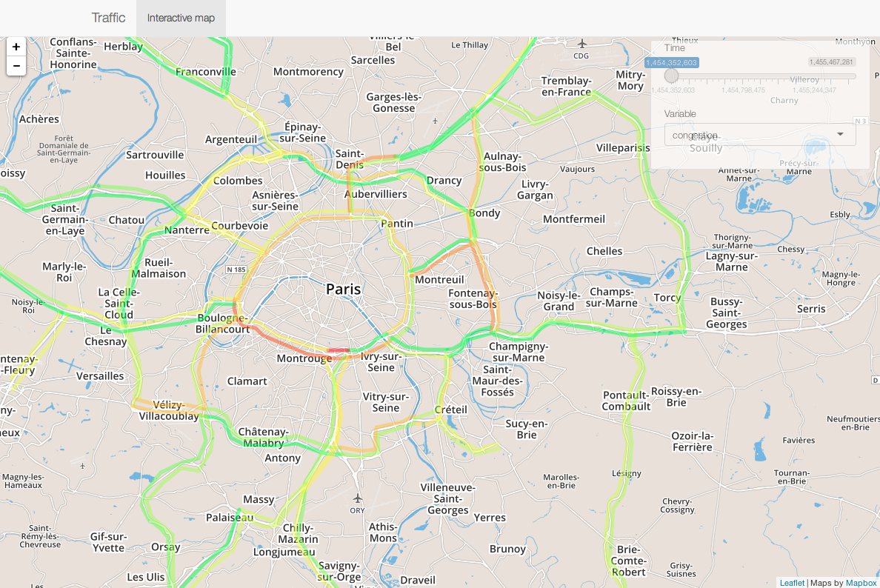
Fig. 1. Capture of the web-application to explore spatio-temporal traffic data for Parisian region. It is possible to select date and time (precision of 5min) and the variable visualized (travel time or relative travel speed).

  - Spatio-temporal variability of travel paths
Following interactive exploration of data, we propose to quantify the spatial variability of congestion patterns to validate or invalidate the intuition that if equilibrium does exist in time, it is strongly dependent on space and localized.
  - Stability of Network measures
The variability of potential trajectories observed in the previous section can be confirmed by studying the variability of network properties.

  - Spatial heterogeneity of equilibrium
To obtain a different insight into spatial variability of congestion patterns, we propose to use an index of spatial autocorrelation, the Moran index. It allows to establish neighborhood relations and unveils spatial local consistence of an equilibrium if applied on localized traffic variable. At a given point in space, local autocorrelation for variable c is computed by, with
(1)
where K is a normalization constant equal to the sum of spatial weights times variable variance and $\overline{c}$ is variable mean. In our case, we take spatial weights of the form $w_{ij}=e^{-{d_{ij}}/{d_{0}}}$ with $d_{0}$ typical decay distance. We capture therefore spatial correlations within a radius of same order than decay distance around the point i. The mean on all points yields spatial autocorrelation index I. A stationarity in flows should yield some temporal stability of the index.
Figure 2 presents temporal evolution of spatial autocorrelation for relative travel speed. As expected, we have a strong decrease of autocorrelation with distance decay parameter, for both amplitude and temporal average. The high temporal variability implies short time scales for potential stationarity windows. When comparing with relative speed (fitted to plot scale for readability) for 1km decay, we observe that high correlations coincide with off-peak hours, whereas peaks involve vanishing correlations. Our interpretation, combined with the observed variability of spatial patterns, is that peak hours correspond to chaotic behaviour of the system, as jams can emerge in any link: correlation thus vanishes as feasible phase space for a chaotic dynamical system is filled by trajectories in an uniform way what is equivalent to apparently independent random relative speeds.

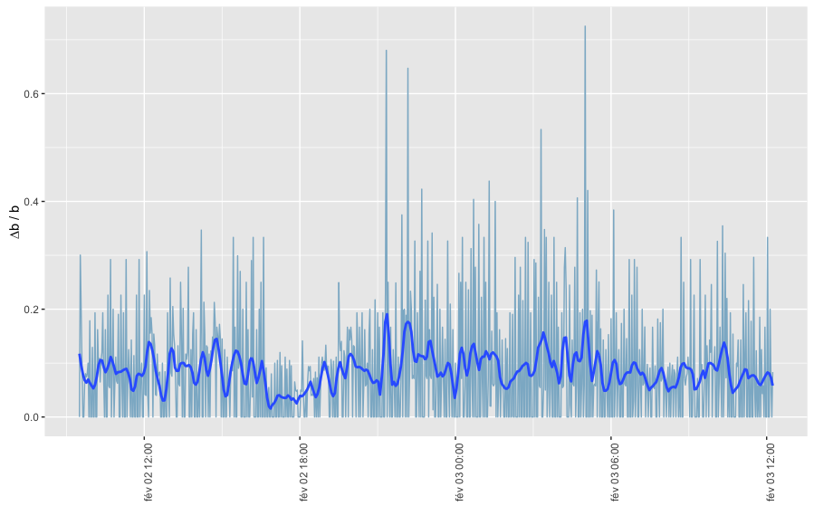
Fig. 2 : Temporal stability of maximal betweenness centrality. We plot in time the normalized derivative of maximal betweenness centrality, that expresses its relative variations at each time step. The moving window smoothing eases reading by giving local variability in time. The maximal value up to 70% correspond to very strong network disruption on the concerned link, as it means that this proportion of travellers assumed to take this link in previous conditions should take a totally different path.

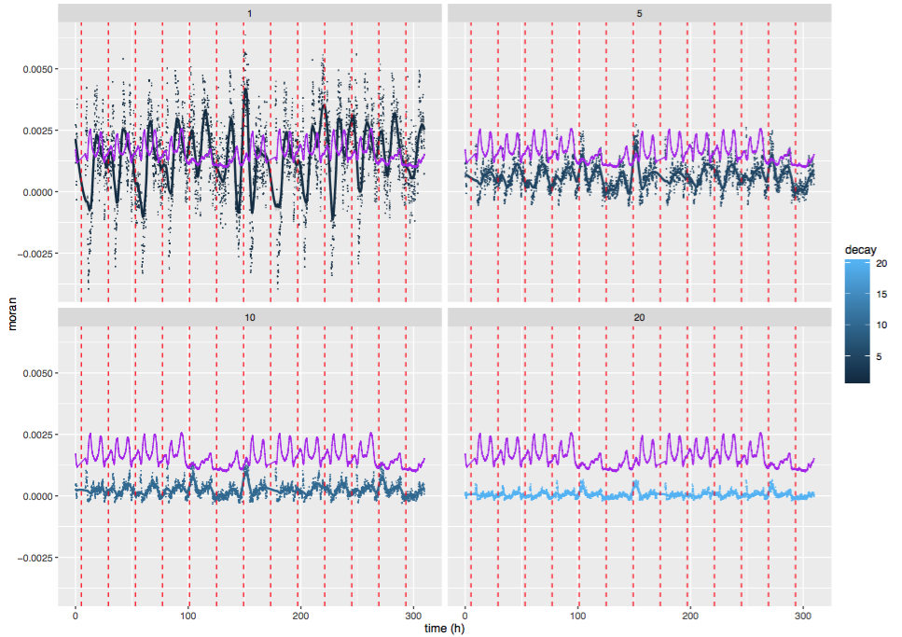
Fig. 2. Spatial auto-correlations for relative travel speed on two weeks. We plot for varying value of decay parameter (1,5,10,20km) values of auto-correlation index in time. Points are smoothed with a 2h span to ease reading. Vertical dotted lines correspond to midnight each day. Purple curve is relative speed fitted at scale to have a correspondence between auto-correlation variations and peak hours.

- Discussion
  - Possible developments
Further work is planned towards a more refined assessment of temporal stability on a region of the network, i.e. the quantitative investigation of consideration of peak stationarity given above. We expect to compute numerically Liapounov stability of the dynamical system ruling traffic flows (Goldhirsch et al., 1987). The value of Liapounov exponents provides the time scale by which the instable system runs out of equilibrium. Its comparison with peak duration and average travel time, across different spatial regions and scales should provide more information on the possible validity of the local stationarity assumption. This technique has already been introduced at an other scale in transportation studies, as e.g. Tordeux & Lassarre (2016) that study the stability of speed regulation models at the microscopic scale to avoid traffic jams.

- Conclusion
Conclusion
Acknowledgements
Acknowledgements
References
Bouteiller, C., & Berjoan, S. (2013). Open Data en transport urbain : quelles sont les données mises à disposition ? Quelles sont les stratégies des autorités organisatrices ?
Goldhirsch, I., Sulem, P. L., & Orszag, S. A. (1987). Stability and Lyapunov stability of dynamical systems: A differential approach and a numerical method. Physica D: Nonlinear Phenomena, 27(3), 311-337.
Grimm, V., Revilla, E., et al. (2005). Pattern-oriented modeling of agent-based complex systems: lessons from ecology. Science, 310(5750), 987-991.
Han, S. (2003). Dynamic traffic modelling and dynamic stochastic user equilibrium assignment for general road networks. Transportation Research Part B: Methodological, 37(3), 225-249.
Leurent, F., & Boujnah, H. (2014). A user equilibrium, traffic assignment model of network route and parking lot choice, with search circuits and cruising flows.Transportation Research Part C: Emerging Technologies, 47, 28- 46.
Tordeux, A., & Lassarre, S. (2016). Jam avoidance with autonomous systems.arXiv preprint arXiv:1601.07713.

Wardrop, J. G. (1952). Some theoretical aspects of road traffic research.
Zhang, K., Mahmassani, H. S., & Lu, C. C. (2013). Dynamic pricing, heterogeneous users and perception error: Probit-based bi-criterion dynamic stochastic user equilibrium assignment. Transportation Research Part C: Emerging Technologies, 27, 189-204.

Zhu, S., & Levinson, D. (2015). Do people use the shortest path? An empirical test of Wardrop’s first principle. PloS one, 10(8), e0134322.

* Corresponding author. Tel.: ; fax: . E-mail address: juste.raimbault@polytechnique.edu
source code for the application and analyses is available on project open repository at https://github.com/JusteRaimbault/TransportationEquilibrium

