Handbook on "Entropy, Complexity, and Spatial Dynamics: The Rebirth of Theory?”

Chapter by Juste Raimbault[1] and Denise Pumain[2]

**Spatial dynamics of complex urban systems within an evolutionary theory frame**

**Abstract:**

This chapter is about Complexity and Spatial Dynamics in Urban Systems. Strong inequalities in the size of cities and the apparent difficulty of limiting their growth raise practical issues for spatial planning. At a time when new constraints in terms of limited energy and raw material resources or possible catastrophic events such as pandemics are challenging further urban expansion, it is important to consolidate the theories from various scientific disciplines to estimate to what extent the urban dynamics can be modified. While briefly reviewing the contributions to urban theories provided by the new developments in complexity sciences, we first advocate for the soundness of urban theories. Second, we develop our original approach considering spatial interaction and evolutionary path dependence as major features in the general behavior of urban entities. Third, we test these principles grounded in an evolutionary theory of urban systems by experimenting four dynamic models of urban growth calibrated on harmonized empirical data sets with comparisons across the whole world.

**Keywords: spatial dynamics; complex systems; system of cities; evolutionary theory; urban growth; simulation**

# 1 - Introduction

The title chosen by Aura Reggiani, Laurie Schintler and Danny Czamanski for this book: “Entropy, Complexity, and Spatial Dynamics: The Rebirth of Theory” is challenging. The problem is twofold: first, it means demonstrating how the insights provided by concepts and models associated with the notion of complexity have contributed to theories on spatial dynamics; second, it questions whether this is a rebirth of the theoretical approach in this field, which would therefore presume its relative abandon before.

This chapter provides answers to these two questions about a particular dimension of spatial dynamics, that of cities and systems of cities. In response to the second question, and considering the progress of research on urban complexity over the last forty years or so, we identify an enrichment and consolidation of existing theories by the principles of complex systems rather than a true renaissance of urban theory. Indeed, contrary to what some scholars claim, the theories developed around the spatial dynamics of urbanization processes and the evolution of settlement systems are far from being obsolete (Brenner and Schmid 2014). Neither are they limited in their fundamentals and application to only one part of the world (Robinson 2016). Scott and Storper (2015) and Wu (2020) rightly criticized both “theories”. We may add that many scholars did not abandon the former urban theories but on contrary tested, revised and completed them during the last four decades (Pumain 1997, 1998, 2003 and 2020; Batty, 2013). The major theoretical challenge of that period was three folds: first, to shift from idiographic postures to nomothetic ones; second, from static views toward dynamic and evolutionary; and third, to really transfer concepts and models from natural sciences to build a socially relevant knowledge. Elements of knowledge from ancient theories can consolidate when situated in their geo-historical contexts, when tests of these theoretical propositions are carried out on subsets of empirical data that are well identified in time and space, and when the means are provided to articulate the observations made at multiple levels of geographic scales.

Starting from such a spiral theoretical conception of the cumulativeness of knowledge (Pumain 2009), we try here to demonstrate how it is possible to construct an evolutionary theory of cities and systems of cities. This theory is abductive in the sense that it is constructed by frequent to-and-fro movements between empirical observations, logical propositions and mathematical and computer models. This theory is not entirely new as it integrates elements of knowledge already well identified by specialists in urban issues, such as geographers, economists, historians and archaeologists, sociologists, town planners and architects. Its originality stems from progress in international comparisons made through using new harmonized databases, methods for validating the results of computer simulation models, and putting these results into the perspective of complex systems theories.

This chapter brings a step forward in the long process of building and testing an evolutionary theory of systems of cities. This theory is based on empirical observations and tested with dynamic models that are designed for simulating urban development at various spatial and temporal scales. We follow the methodology and results already obtained in the GeoDiverCity project (Pumain et al. 2015, Cura et al. 2015, Pumain, Reuillon 2017), including USA, Europe and BRICS countries, and complete them with new datasets at world scale and other types of models. These models are designed for explaining urban growth and city size distributions with an increasing deepening in the complexity of the implemented processes (Cottineau et al. 2015). They are all conceived for exploring the correspondences between urban trajectories observed at the meso-level of individual cities and the structuring of systems of cities at macro geographical scale. We shall test the validity and representativeness of these four models of complex urban systems and their variations across regions of the world within different spatial frames (Raimbault 2018a, 2018b). Here we use both the GeoDivercity databases and a new data source that for the first time compares the evolution of cities globally over a period between 1970 and 2015. Eric Denis (2020) already explored the source statistically for comparing urban sprawl trends in the countries of the world. We calibrate four different models of urban growth on both sets of data, across different regions of the world. We analyze their results and assess for each their possible contribution to the theory of urban complex systems.

# 2 - For a theoretical rearming in urban science

To clarify our position vis-à-vis urban theories, we propose a first discussion of the diversity of possible meanings attributed to this word among the disciplines that have been interested in explaining the evolution of cities. This discussion is based on a few recent publications, without claiming to be exhaustive within the limits of this chapter. The main question we address is to understand how the disciplines most formerly interested in the scientific object "city" have been able to revise or complete their theoretical statements using the contributions proposed by the natural sciences, which have been advancing interesting concepts and models for thinking about and studying complex systems for some forty years. To begin with, we can start with the definition of complexity as proposed by Aura Reggiani (2014) for whom “the term “complexity” embeds both the assemblage of different units in a system and their intertwined dynamics. In other words, the term “complexity” is strictly related to the concept of networks”. In this definition we would emphasize the physical and societal interactions that are creating and using these networks with a consequence of making the evolution of “different units” strongly interdependent on each other. That leads to a specific deepening in the concept of co-evolution for cities belonging to systems of cities (Paulus 2004; Raimbault 2020a).

Two repeated observations prompted the development of a theory of the evolution of systems of cities. The first, empirical, is the long persistence of urban networks in large integrated territories, which retain, over time, the same spatial configurations of the relative size of cities. This is visible for example on maps representing the population of cities in proportional circles more than a century apart, in Europe, in India, or even in the United States since 1950. The second results of applying to the evolution of these urban population distribution a simple stochastic statistical model formalized by the French statistician Gibrat since 1931. This model states that the growth of urban populations is proportional to the initial size of cities during each short time interval, with fluctuations such as growth rates (amount reported to the population) are statistically independent from the size of the cities and from one time interval to the next. The interest of this model of spatially distributed urban growth in integrated systems of cities is to predict that the result of such a growth process is always a lognormal distribution. Thus, the model provides a first statistical explanation to the "mystery" of the Zipf's law still recently mentioned by the economist Paul Krugman (1996). A huge literature is dedicated to Zipf’s law and Pareto distributions that are observed in many natural and social systems, to the extent that these “universal” laws, together with fractal spatial patterns, have been sometimes considered as the “signature” of complexity in different systems. The underlying regularities in the urban spatial dynamics that these models capture have attracted many scientists from various disciplines to propose different theories of urban complexity.

## 2.1 - Which acceptation of “theory” for complex urban systems?

A preprint posted on the Internet in January 2020 (Lobo et al. 2020) deserves particular attention at first sight for three reasons. First, it announces an “integrated theory”. Second, it covers the full historical period “from the first cities to sustainable metropolises”. Third, 35 names of prominent scholars signed it, which is rather rare among papers dealing with objects of social sciences.

On which propositions do they come all in agreement? A first one is about the necessary multidisciplinary character of “urban science”, which we fully agree with as well. A second proposal is about acknowledging the fact that cities are the product of a long but relatively recent and socially driven historical evolution, which should lead to the conclusion that urban theories are part of social sciences dealing with historical objects. However, the paper acknowledges, “a basic tension in current urban science between approaches from the social sciences and those from the natural sciences” (p.3). The authors conclude nevertheless: “the time is ripe for a targeted integration of the social and physical sciences of cities and urbanism” (p.4).

The author’s argumentation about this point becomes ambiguous and even contradictory. When they enunciate what the urban theory should be, they suggest Darwinian biology as a model of science to imitate in focusing on processes rather than forms, which we can agree. But they add :” A theoretically grounded science of cities should capture fundamental processes that lie at the core of all human spatial agglomerations, whether these are past or present, agrarian or industrial, in developed economies or developing countries” (p. 11). They clearly tend to think of universal “fundamental principles” that would appear as the core of urban science, while the categories that were elaborated and coined by history or other disciplines of social sciences would be considered as part of a “context”. Should we not require that a “historically grounded” urban science would have processes from societal theories as “fundamental principles”? In other words, the processes leading to the elaboration of concepts such as “agrarian” or “industrial” society or “developing country” may receive at least the same level of attention that the one of “agglomeration” if we want to understand urban evolution and properly integrate the disciplinary points of view.

That is why we are not sure that the “scaling analytic framework” is indeed the first thing to mention of what we have learned from “urban science injected into the study of cities and urbanization” – even if that may appear paradoxical speaking from a geographer’s point of view, always caring about scale! We can nevertheless subscribe to most of the authors’s 13 propositions enabling them to converge toward “unified perspectives” –although a few would deserve more discussion. As the authors, we are convinced that there is a need for urban theory and that is it necessarily grounded in history, properly tested with abundant and diverse data compared in space and time. Of course, we agree to consider cities as places of high density, frequent social interaction and mixed activities, knowing that their size is both a cause and consequence of their creativity, acknowledging the universal character of urban hierarchies and the specific role of innovations in their development. However, we could question the list of nine propositions that the authors consider as new insights provided by the new “urban science”. The list of 23 questions to solve in future research is not so new either. We acknowledge that the sciences of complex systems that developed during the second half of 20th century can be granted for having challenged social sciences toward more interest in mathematical and computational formalisms and having provided a series of formalized tools and models and a common vocabulary that established a bridge between researchers in mathematics and physics and social sciences. Nevertheless, the urban theory cannot be reduced to its quantifiable dimensions only.

We may wonder if any “integrated theory” is yet imaginable because at a given moment in science, and in social sciences especially, there are a plurality of theories. Social sciences may deserve a specific definition of complexity that would depend on the number of different disciplines that are required for providing a satisfying explanation or interpretation of a particular object, by borrowing concepts and models from these disciplines, each having investigated a category of complex processes, to make the object intelligible at a particular granularity level of description. Thus it is likely that while we pretend currently to build an evolutionary theory of urban systems, through integrating as much as possible from accumulated empirical knowledge in geographical, archeological and historical tradition, using statistical and simulation models from the new “urban science”, other fields are not yet satisfied with a theory of urban hierarchy, such as Paul Krugman (1996) for whom it remains a “mystery” that cannot be properly derived from the principles of economic theory only.

## 2.2 - Minimum requirements for a theory of urban complex systems

When adopting a nomothetic attitude in urban research, we adopt a series of epistemological concepts and practices that are common with other sciences. The starting point is to work with *empirical data that are properly defined before being properly measured*. Taking care for meaningful definitions of cities is not a trivial exercise, because it supposes to enter and to understand the criteria that societies chose for establishing a distinction between rural and urban settlements (Rozenblat 2020). It is obvious for any social scientist that such a distinction has a political origin, even if many state governments in the last two centuries decided to objectivize as much as possible their definition through elaborating statistics. For centuries being “urban” was part of a social status, an attribute conveyed to people rather than to places. Most social scientists are uneasy with attempts at qualifying the urban areas delineated from satellite images of built-up areas or street networks as “natural cities” (Jiang et al. 2015). Of course, cities belong to “nature” in using material resources and energy and hosting humans. They may even become greener if they succeed in managing the next ecological transition… However, social organizations are driving cities' generative processes, rather than natural features. There are traces of the history of cities as political constructions in the social representations opposing peasants and urban citizens, with sometimes practical and economic consequences on their way of life, if you think for instance of the former Chinese *hukou* system (Wu 2020). There are traces as well in the decisions of naming “urban” different places such as India distinguishing “Statutory towns” and “Census towns” (Swerts et al. 2018). Some countries periodically delineate the perimeters of urban areas to follow the spatial expansion of their cities, such as Germany or Russia, whereas others do not.

This did not prevent too many experimented and incidentally prominent scholars to capture “urban data” without any care about their quality, selection, claiming and striking results after crunching them with sophisticated statistical or mathematical models. Such an attitude is detrimental, for instance regarding the endless controversies about the models of city sizes distribution, for building a sound science that accumulates knowledge with reproducible means (Pumain 2012). The resulting cacophony is sometimes disentangled in courageous articles, such as for instance (Cottineau 2017 and 2020) in a meta-review of hundreds of references, but certainly represents a waste of time and efforts that could be avoided. A recent paper seemed promising in announcing the observation of worldwide trends in urbanization from 1950 to 2030 using some 1857 cities larger than 300 000 inhabitants from 155 countries (Egidi et al. 2020). The paper offers surprising results such as a systematic “inverse relationship” between urban growth and city size in all regions “up to the late 1990s”. At first sight, this could result from mixing countries with opposite urban growth trends, but the authors observe it as well in homogenous sub regions. However, after questioning the authors who kindly accepted to precise the origin of their data, it seems that the selected cities were delineated over time in a way not measuring the spatial expansion of the urban area. This could explain why the results seem in contradiction with those obtained from large parts of the world during the same period with harmonized urban databases (Cura et al 2015). It also reminds about the necessity of starting with a sound conceptual definition of cities for measuring their attributes and controlling the possible effects of the data selection on the results. The urban definition may vary but should be in accordance with concepts and theory, i.e. with the research question and the selection of attributes that are measured for answering them (Rozenblat, 2020).

To specify the fundamentals of our theory we retain a conceptual framework that relies on the long history of social sciences investigating cities and interpreting them (Pumain, Robic, 1996). Thus even if we can integrate insights from complex systems science such as fractals and scaling laws, we do not agree that all fundamentals should stem from “physics for society” (Caldarelli et al. 2018). While maintaining a strong attention to the spatial dimension, our concern with space is neither static nor geometric. It is geographical, and geo-historical. Space is crucial in the definition of cities and systems of cities, it is a social space whose properties are revised and updated with the changing technologies, and it is as well made of transformed natural space in the process of using earth resources and developing political territories. The dimensionality of cities is constrained by the accessible space for face-to-face daily activities, whereas transportation networks enabling less frequent encounters may generate and sustain interdependencies at much longer distances leading to identify systems of cities. At each observation level, those of individuals (persons or institutions), cities and systems of cities, new attributes and new concepts do correspond to emergent phenomena in complex systems that are produced from multiple interactions.

Although the recent development of networks and the accelerating circulation of information seem to blur the three-level conceptual definition of these geographical objects, we believe that this representation remains useful and relevant for guiding urban research and applications. An interesting contribution by C. Roth (2006) discusses the emergentist view compared to the reductionist and suggests that different modes of access and not only bottom-up interactions could be part of the generative processes of the features constituting one level – which is the view point from statistical mechanics in envisaging self-organizing systems. This rejoins our theory for which urban interactions shaping cities and systems of cities are mostly but not exclusively conceived as emanating from one low level toward the higher level, in societal processes that take a long time, often longer than a human life. Over decades and sometimes centuries, most frequent interactions among urban stakeholders at micro level shape the emerging properties of a city at meso-geographical level, and inter-urban interactions generate the hierarchical organization and the functional differentiation of cities within the system of cities at macro-level. However, for instance, a location decision taken by an individual firm (at micro-level) can operate a definite change in the relative specialization of a particular city within the system of cities (at macro level), as well as many policy regulations decided at macro-level may directly change the situation of an individual firm or citizen at micro-level inside a city.

Sociologists such as Michel Grossetti (2020) discuss the ontology of entities that scholars identify in social sciences. A science of cities is possible because cities are remarkably persistent entities, among all societal institutions entities of the meso level, in an intermediary position between individual agents and the territories that embed them. Through their interactions however, they build at a much higher level, comparable to the one of civilizations, spatial organizations that we name systems of cities and maintain their “emerging” properties over much longer durations. The rhythm of relative societal change within cities is much slower than the changes in human life and change in systems of cities is much slower than change in individual cities. Our theory of cities as complex social systems embedded within systems of cities and territories is *evolutionary*. However, the historical evolution is different from biological, of course because its processes are social, meaning they are guided with human intentions (even if that causality is not always directly effective) and they proceed much more rapidly than changes in biology.

While trying to identify major processes guiding the evolution of cities within system of cities, we stressed the role of information and innovation (Lane et al, 1999). Innovation when defined as a socially accepted invention may represent a form of social organization or a belief or a practice as well as a technological device or a new service. We shall develop further in the models presented below how innovation and its more or less always hierarchical diffusion among cities within systems of cities appears as a major dynamic process for explaining the expansion of urbanization and the persistency of cities’ relative situation in urban systems.

## 2.3 - How to make models and theory dialogue?

If the theory is constructed from empirical observations, prioritized and simplified into stylized facts, the design of the model should enable to reproduce these stylized facts. Dynamic models start from an initial observed situation that is described in a simplified way by state variables (such as the population of cities, their income level or their employment structure). These models reconstruct the evolution of these quantities on the basis of mechanisms (rules and parameters), which represent the interactions (i.e. social processes) that are supposed to explain the transformations of the state variables over time (Pumain, Sanders 2013).

For a model to be an interesting tool for testing a theory, a correspondence must be established between the way it is implemented in the model and the expected result of the simulation. Selecting the stylized facts to be reconstructed and the granularity of their description is a crucial choice for the success of the exercise. For example, it is rather pointless to give the model the sole objective of correctly simulating a distribution of city sizes, in the form of a lognormal or Pareto law. This form of distribution (described as an 'over-identified model' by B. Robson, 1973) can indeed emerge from a whole series of mathematical or computer mechanisms, some of which have little to do with the functioning of a system of cities. Without aiming for absolute realism but in order to get closer to it and make better use of modelling, it is necessary, for example, to go one-step further and ensure that the growth process produced by the model corresponds in detail to what is summarized in Gibrat's (1931) statistical model (Modica et al, 2013).

All models described below include the well-established fact that the urban hierarchy receives a relevant statistical explanation from Gibrat’s model of urban growth. However, this random mathematical model has at its core a hypothesis that makes it little credible to found a theory of cities, since it assumes that all cities (elements of the statistical distribution) are independent of each other, as well as the random events that lead to their growth. Such a hypothesis enters in conflict with the definition, the functioning of cities and the processes of their emergence and their evolution, which organizes them into systems of co-evolution, counteract these simplifying assumptions a priori. In fact, the slight deviations noted in relation to the hypotheses of the model have led to the completion of other hypotheses that adapt this simple model, powerful but too general, to different historical and geographical contexts.

In the Simpop family of models, the reconstruction of cities’ trajectories is based on their interactions using the multi-agents systems as computing technique for simulation. This technique was chosen because, when compared to mathematical systems of differential equations, they enable more flexible representation of the variety of spatial interactions that characterize inter-urban trade according to the functional specialization of cities. In brief, the so-called “central functions” providing services to the population interact with their market according to gravitational principles, while manufacturing and touristic cities select sometimes distant but specific places to interact with, and administrative functions deal in a systematic way with all other cities in their circumscription. More detailed precisions can be injected in the simulation, as for instance the political selection of some urban places for developing industries of national interest during the socialist regime in former Soviet Union (Cottineau, 2014).

So, logically the theory is as much as possible embedded in the model, but how can the model contribute to the building of the theory? Of course, the usual recursive processes during model building may ensure that the major theoretical principles are correctly framed in the implemented model. Nevertheless, until recently there was too little confidence in the results obtained from simulation models when using multi-agents modelling techniques (Rey-Coyrehourcq, 2015). The validation procedures were considered as not sufficiently reliable for guarantying that the estimated parameters were the only values capable of generating the required features of the system’s evolution and that all the included rules were necessary to produce the simulated result. A real scientific breakthrough for SSH occurred when the combined use of genetic algorithms and distributed computing enabled to shift from the usual few hundred simulations of the same model toward several hundred millions (Schmitt et al. 2015). This experiment not only provides an almost full exploration of the parameter space but also ensures that all parameters leading to the expected result are both sufficient *and* necessary (Reuillon et al. 2015; Raimbault & Pumain, 2020).

Tested with models including progress in technologies for simulating and validating with evolutionary algorithms and distributed computing = a scientific breakthrough for SHS (à developer en début ou fin de cette section) (Raimbault & Pumain, 2019)

Restes à intégrer?

*(going beyond Gibrat)*

* successive epistemologies in Geography: (Varenne, 2018)
* integrated knowledge and domains of knowledge (Raimbault, 2017)
* (simulation) models as a knowledge domain in itself; exchanges with theory
* simulation models as medium to couple theories

# 3 - Simulation models for systems of cities

Following what we just developed, simulation models and their systematic exploration seem to be a powerful way to (re-)build urban theories. We propose now to detail the structure of a few simulation models for systems of cities, which were all introduced within the frame of the evolutionary urban theory. We describe in particular the processes taken into account by each model, and what the corresponding exploration results may imply for the theory.

All these models can be formulated within a common framework which has been described by (Raimbault, 2018b). First of all, we consider a deterministic version of the Gibrat’s model, for which the extensions with interactions will capture the covariance structure between population trajectories. In the Gibrat’s model, formulated as P(t+1) = R(t) P(t) where P and R and independent random variables, we have E[P](t+1) = E[R](t) E[P](t). Furthermore, city trajectories are assumed independent, i.e. Cov[Pi,Pj] = 0 for any cities i≠j. Writing E[Pi](t) = μi(t), we generalize the deterministic formulation above to a non-linear one by taking μ(t+1) = f(μ(t)). The specification of the transition function or algorithm between these average populations will fully determine the model. The corresponding Gibrat’s model (named “gibrat” on figures 5 to 9) has one single parameter which is the average endogenous growth rate. Note that in this deterministic version, there is no additional parameter for the variance (or other moments depending on the distribution chosen) of growth rates.

## 3.1 - A model developing urban hierarchy with transportation network

This model is a spatial interaction model taking into account physical networks, studied by (Raimbault, 2018b).

The network interaction model proposed by (Raimbault, 2018b) includes linearly a Gibrat’s component of fixed endogenous growth rates, a spatial interaction component given by the average interaction potential with all other cities for each city (with Euclidian or network distance, see (Raimbault, 2018b) for details) and a second order term of network flow feedback that we do not include here for simplicity. We consider two versions of the model, one (named “intgib” for “Interaction Gibrat” on figures 5 to 9) with Euclidian distance between cities to determine interaction potential, the other (named “intgibphysical” for “Interaction Gibrat Physical” on figures 5 to 9) with a physical network distance computed as shortest paths with a terrain slope impedance derived from a global Digital Elevation Model. Both models have the same four parameters, namely endogenous growth rate, weight of interactions, hierarchy of interactions, and geographical range of interactions.

One dimension of urban systems that can be the focus of simulation models is the role of transportation networks and more generally physical infrastructure. Indeed,

## 3.2 - A model explaining urban growth with economic and environmental processes

Finally, the Marius model family based on economic exchanges (Cottineau, 2014) implements the following processes. Cities are attributed an initial wealth following a scaling law of populations. At each time step, (i) supply and demand are updated for each city as superlinear functions of populations; (ii) cities exchange goods according to a spatial interaction potential and their supply and demand, and wealth are updated accordingly; (iii) population are updated such that population difference follows a scaling law of wealth difference with a given economic multiplier and exponent. A restricted Marius model (named “mariusrestr” for “Marius restricted” on figures 5 to 9) has four parameters, namely economic multiplier, supply and demand exponents, and the interaction distance. The full model (named “marius”) has six parameters, adding the exponent for the initial wealth and the exponent for the population update.

## 3.3 - A model linking urban growth with innovation as spatial diffusion process

### 3.3.1 - The Favaro-Pumain model

Thus, Favaro and Pumain (2011) proposed to link this model to that of the hierarchical diffusion of innovations realized by Torsten Hägerstrand.

The Favaro-Pumain model for the diffusion of innovation (Favaro and Pumain, 2011) considers population of cities and additional variables representing an adoption rate of a given innovation. To evolve populations, (i) innovations are diffused in the network of cities following a spatial interaction model and with an intensity depending on the utility of the innovation; (ii) population are updated following another spatial interaction model, interaction potential being driven by the innovative characters of cities; (iii) we introduce exogenously a new innovation with an increased utility if a certain global adoption threshold is reached for the previous innovation, at a fixed initial penetration rate and in a city chosen with a probability calculated according to a scaling law of population. A first simplified version of this model (named “innovation” on figures 5 to 9) has default parameter values from (Favaro and Pumain, 2011) and four free parameters which are the endogenous growth rate, the weight of interactions, interaction range for innovation diffusion and interaction range for population growth. The full version (named “innovationext” for “Innovation extended” on figures 5 to 9) has nine parameters, with additional parameters being the initial utility of the first innovation, the fixed growth rate of innovation utilities, the initial penetration rate, the adoption threshold for a new innovation, and the hierarchy exponent to determine innovative cities.

### 3.3.2 - An explicit model of urban evolution

This first model implements in a most simple way the major conceptual process that we think is at the core of the spatial dynamics: urban evolution based on innovation diffusion (Raimbault 2020b). The evolution of the sizes of cities in a system of cities is represented in a multi-agent system where cities are interacting agents. The model is experimented on synthetic data for a first exploration of its capabilities. Two processes induce change in urban population over time; the first one is a transformation of urban activities and capabilities that represents in an abstract and aggregated way a multidimensional innovation process (equivalent to DNA mutations in biological evolution, or changes in the *meme* concept in cultural evolution). The second is a transmission process of innovation between cities that couples two models of spatial interaction for representing innovation diffusion.

Cities are characterized by their size in terms of population, and city sizes evolve following a spatial interaction model in which city attractivity is included. This attractivity is determined by how innovative cities are. Transformation processes are included as mutations, when random innovations appear in cities. Transmission processes (spatial crossover) are included by diffusing innovations between cities.

Each city has an innovation profile that represents the proportion of its population engaged in the innovation it has adopted. The city profile is also described by a diversity parameter reflecting the number of innovations that it successfully adopted and ranked according to their utility. Innovations are randomly characterized with a utility parameter that controls the speed of their diffusion in the system. Aggregated indicators of averaged utility and diversity are computed over all cities and are related to the corresponding urban hierarchies.

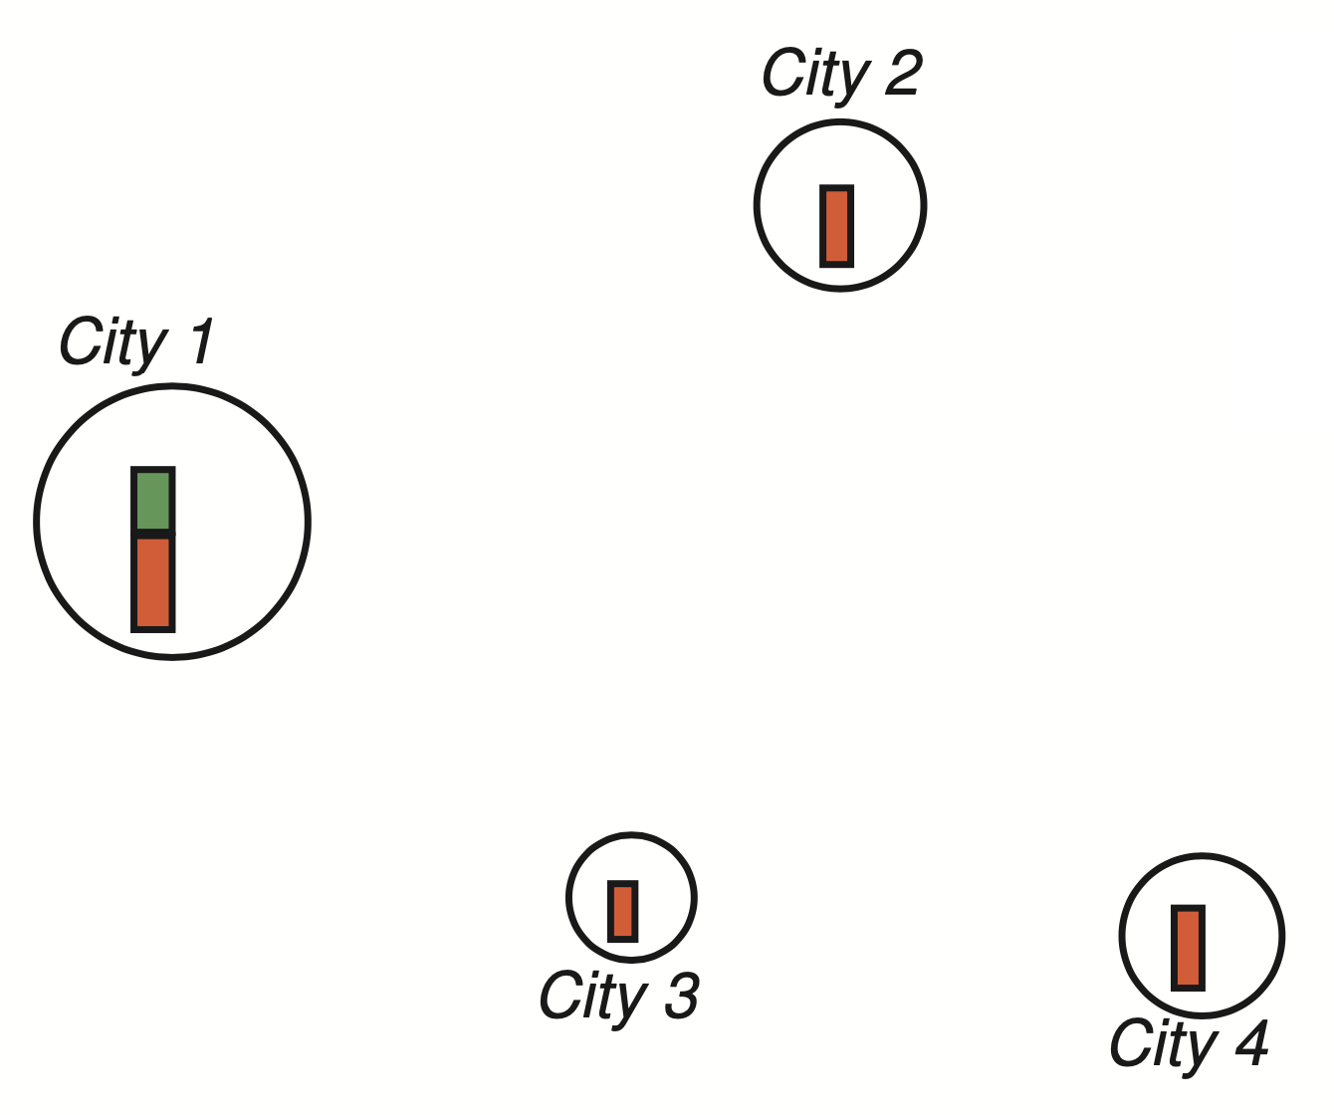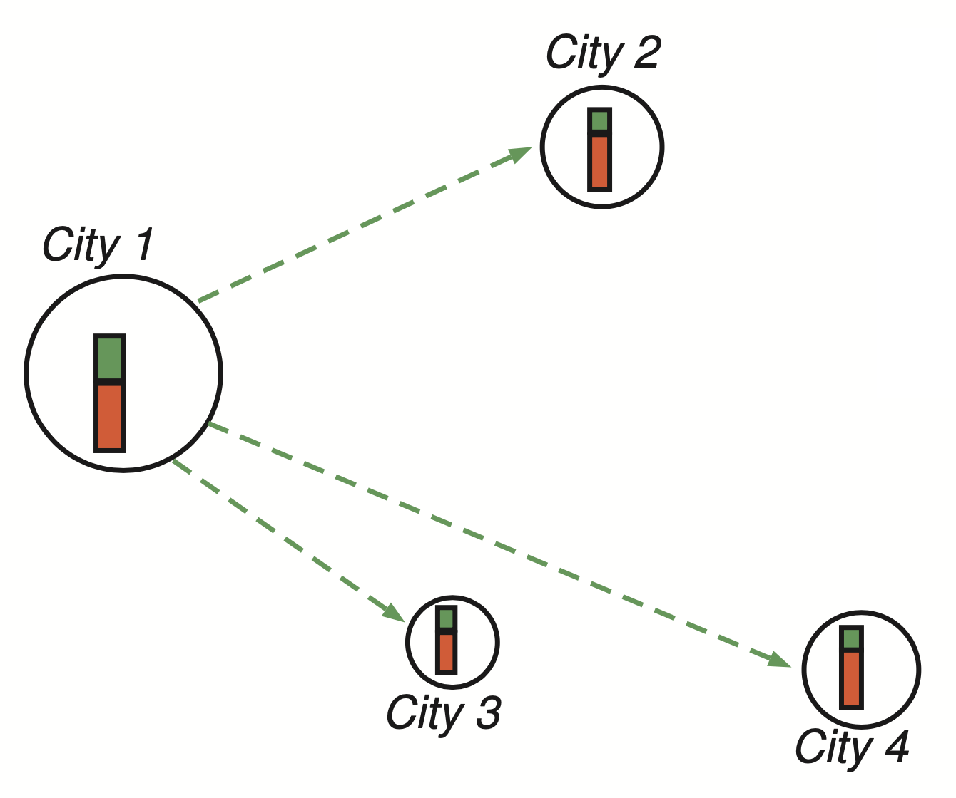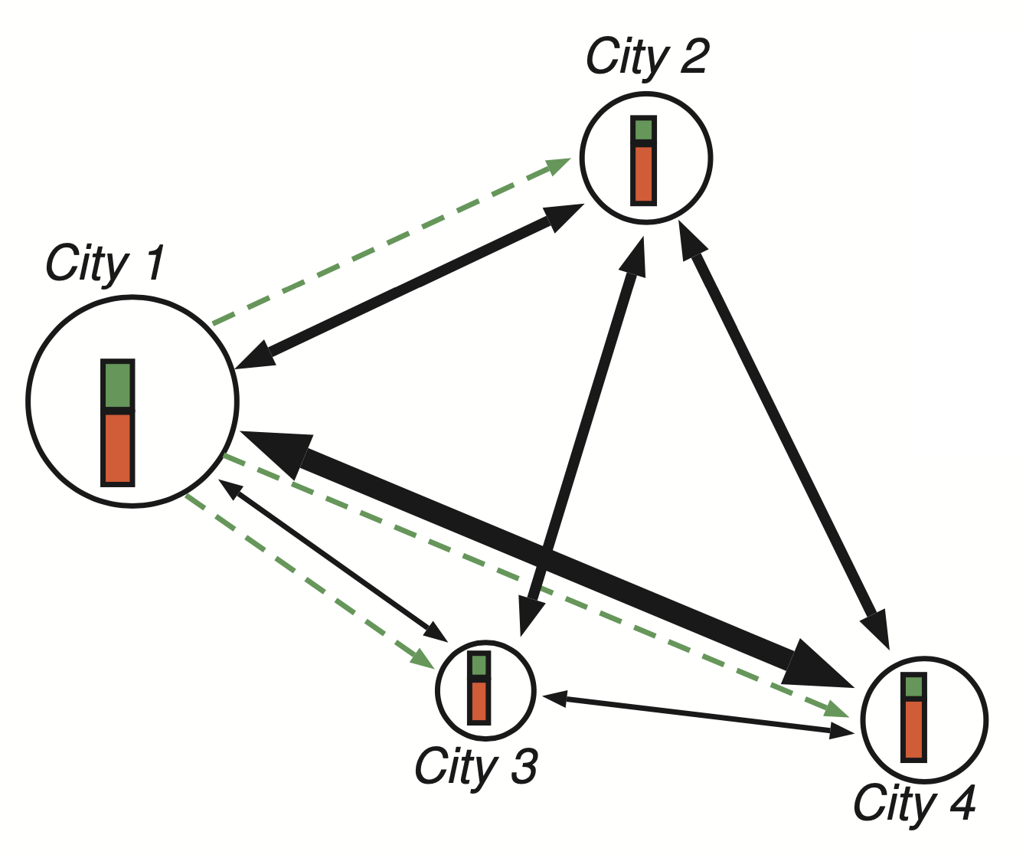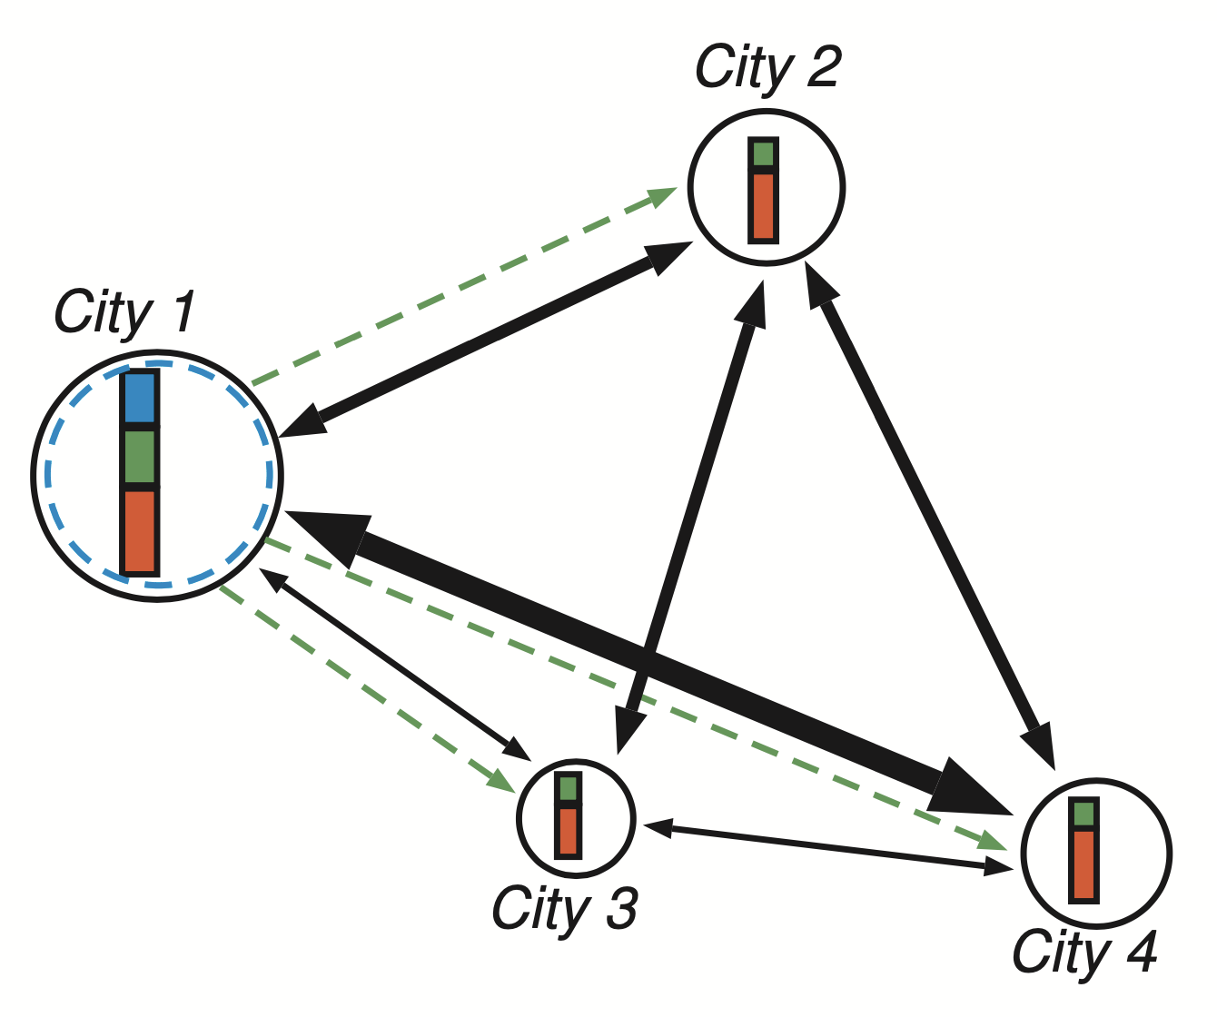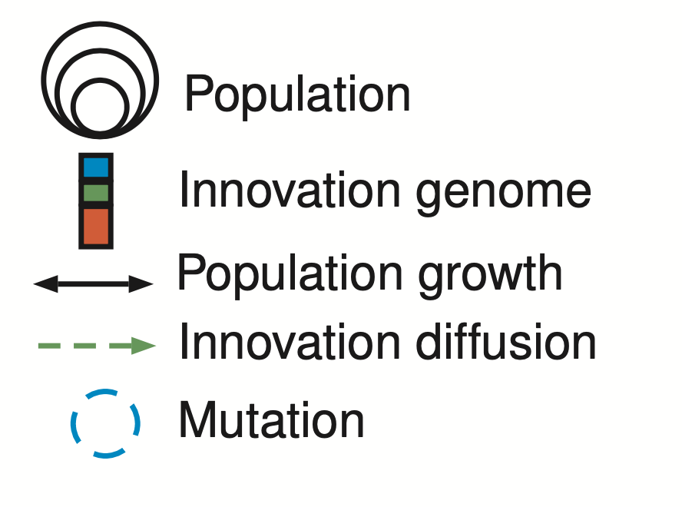

Model explorations yield complex behavior while multi-objective optimization shows the potentiality for the model to produce compromises between utility and diversity in the system of cities. It also introduced the possibility of technical co-evolution niches (expliciter)

# 4 - Discussion

*Multi-modeling and concurrent hypotheses*

Nous avons réalisé le test des six modèles à l’aide de la plateforme OpenMOLE. En entrée du modèle nous utilisons les populations des villes en 1970 de GHS et nous calculons la population qu’elles auraient en 2015 en fonction des hypothèses de chaque modèle. Un choix important est alors celui de la mesure de l’adéquation de des résultats avec les observations. Utiliser un seul critère comme par exemple la pente de la loi rang-taille serait trop réducteur. Nous avons décidé de mesurer l’ensemble des écarts de population constatés pour chaque ville. Compte tenu de la forme très dissymétrique des distributions les écarts sont mesurés sur les logarithmes des populations. Deux calculs sont alors considérés pour mesurer la qualité des ajustements : le premier est une mesure classique de la fitness qui est la somme des carrés des écarts entre populations observées et populations simulées, le second est la somme des logarithmes de ces écarts. En effet, la première mesure attribue un poids très important aux plus grandes villes dans le calcul, tandis que la seconde permet de mieux caler le modèle sur l’évolution des plus petites villes, en queue de distribution.

*From synthetic to real systems of cities*

# 5 - Conclusion

À revoir

We investigate models of urban growth at different scales and on different urban systems: a model of urban morphogenesis at the metropolitan scale which we calibrate dynamically using the diachronic population grid on largest urban clusters, and interaction models for systems of cities at the macroscopic scale on main systems of cities across the world. We also suggest research directions towards the coupling of these models into a multi-scale model of urban growth.

We use among others a new unique source correlating population and build-up footprint at world scale: the Global Human Settlement built-up areas (GHS-BU). The dataset is available at different dates between 1975 and 2015. In 2015 the source delineates precisely some 13 000 urban agglomerations between 50000 and tens of million inhabitants in the world. These data help in further empirical testing to the hypotheses of the evolutionary theory of urban systems and partially revising them.

: complex systems’ dynamics is in principle unpredictable, but Contextualizing regarding demographic, income and resource components may help in minimizing the forecasting errors

# References

Brenner N. & Schmid C. (2014). The ‘Urban Age’ in Question. *International Journal of Urban and Regional Research*, 38, 33, 731-755.

Caldarelli, G., Wolf, S., & Moreno, Y. (2018). Physics of humans, physics for society. *Nature Physics*, *14*(9), 870.

Cottineau, C., Chapron, P., & Reuillon, R. (2015). Growing models from the bottom up. An evaluation-based incremental modelling method (EBIMM) applied to the simulation of systems of cities. *Journal of Artificial Societies and Social Simulation*, *18*(4), 9.

Cottineau, C. (2017). MetaZipf. A dynamic meta-analysis of city size distributions. *PloS one*, *12*(8), e0183919.

Cura R. Cottineau C. Swerts E. Ignazzi C.A. Bretagnolle A. Vacchiani-Marcuzzo C. Pumain D. (2017). The old and the new: qualifying city systems in the world with old models and new data. *Geographical Analysis*, *49, 4, 363–386*. DOI: 10.1111

Egidi, G., Salvati, L., & Vinci, S. (2020). The Long Way to Tipperary: City Size and Worldwide Urban Population Trends, 1950-2030. *Sustainable Cities and Society*, 102148.

Grossetti M. (2020). Matière sociale - Introduction : à la recherche d’une ontologie robuste. ‌Hal- 02523130v3

Jiang, B., Yin, J., & Liu, Q. (2015). Zipf’s law for all the natural cities around the world. *International Journal of Geographical Information Science*, *29*(3), 498-522.

Krugmam P., 1996, Confronting the Mystery of Urban Hierarchy, *Journal of the Japanese and international Economies*, 10, 399-418.

Lane D., Pumain D., van der Leeuw S., West G. (eds.), 2009, *Complexity perspectives on innovation and social change*, ISCOM, Springer, Methodos Series 7, 492 p.

Lobo, Jose and Alberti, Marina and Allen-Dumas, Melissa and Arcaute, Elsa *et al.*, Urban Science: Integrated Theory from the First Cities to Sustainable Metropolises (January 28, 2020). Report submitted to the NSF on the Present State and Future of Urban Science, 2020, Available at SSRN: <https://ssrn.com/abstract=3526940> or [http://dx.doi.org/10.2139/ssrn.3526940](https://dx.doi.org/10.2139/ssrn.3526940)

Modica, M., Reggiani, A. & Nijkamp, P. (2017). Methodological advances in Gibrat’s and Zipf’s laws: a comparative empirical study on the evolution of urban systems, in H. Shibusawa et al. (eds.), *Socioeconomic Environmental Policies and Evaluations in Regional Science*, New Frontiers in Regional Science: Asian Perspectives 24, Springer. DOI 10.1007/978-981-10-0099-7_3

Paulus, F. (2004). *Coévolution dans les systèmes de villes : croissance et spécialisation des aires urbaines françaises de 1950 à 2000*. PhD thesis, Université Panthéon-Sorbonne-Paris I.

Pumain D. & Robic M.-C. (1996). Théoriser la ville, in Derycke P.H. Huriot J.M. Pumain D. (eds), *Penser la ville, théories et modèles*. Paris, Anthropos, 107-161.

Pumain, D. (1997). Pour une théorie évolutive des villes. *L’Espace géographique*, 26, 2, 119–134.

Pumain D. (1998). Urban Research and Complexity, in Bertuglia C.S., Bianchi G., Mela A. (eds) *The City and its Sciences*, Heidelberg, Physica Verlag, 323-362.

Pumain D. (2003). Une approche de la complexité en géographie. *Geocarrefour*, 78, 1, 25-31.

Pumain D. (2009) L’espace, médium d’une construction spiralaire de la géographie, entre société et environnement, in Walliser B. (ed), *La cumulativité des connaissances en sciences sociales.* Paris, EHESS, collection Enquêtes, 163-197.

Pumain D. (2012), Une théorie géographique pour la loi de Zipf. *Régions et Développement*, 36, 33-57.

Pumain D. Sanders L. (2013), Theoretical principles in inter-urban simulation models: a comparison. *Environment and Planning A*, 45, 2243-2260.

Pumain D., Swerts E., Cottineau C. Vacchiani-Marcuzzo C., Ignazzi A., Bretagnolle A., Delisle F., Cura R., Lizzi L & Baffi S. (2015) : Multi-level comparison of large urban systems. *Cybergeo*, 706, http://cybergeo.revues.org/26730 ; DOI : 10.4000/cybergeo.26730

Pumain D. & Reuillon R. (2017). *Urban Dynamics and Simulation Models*. Springer, International. Lecture Notes in Morphogenesis, 123 p. DOI 10.1007/978-3-319-46497-8_3.

Pumain D. (ed.) (2020) *Theories and Models of Urbanization*. Springer, Lecture Notes in Morphogenesis.

Raimbault, J., & Pumain, D. (2019). Methods for Exploring Simulation Models. *Geographical Modeling: Cities and Territories*, *2*, 125-150.

Raimbault, J. (2017). An Applied Knowledge Framework to Study Complex Systems. In *Complex Systems Design & Management* (pp. 31-45).

Raimbault, J. (2018a). Calibration of a density-based model of urban morphogenesis. *PloS one*, *13*(9), e0203516.

Raimbault J. (2018b) Indirect evidence of network effects in a system of cities. *Environment and Planning B: Urban Analytics and City Science*, 2399808318774335.

Raimbault, J. (2020a). Unveiling co-evolutionary patterns in systems of cities: a systematic exploration of the SimpopNet model, in Pumain D. (ed) *Theories and models of urbanization*. Springer, 261-278.

Raimbault J. (2020b) A model of urban evolution based on innovation diffusion. *Artificial Life Conference Proceedings 2020 NO. 32, 500-508*.

Reggiani A. (2014). Complexity and spatial networks, in M.M. Fischer, P. Nijkamp (eds.), *Handbook of Regional Science*, 811-832.

Reuillon, R., Leclaire, M., & Rey-Coyrehourcq, S. (2013). OpenMOLE, a workflow engine specifically tailored for the distributed exploration of simulation models. *Future Generation Computer Systems*, *29*(8), 1981-1990.

Reuillon, R., Schmitt, C., De Aldama, R., and Mouret, J.-B. 2015. A new method to evaluate simulation models: The calibration profile (cp) algorithm. *Journal of Artificial Societies and Social Simulation*, 18(1), 12.

Rey-Coyrehourcq S, 2015, *Simprocess, a integrated method to validate Agent-based models in geography.* Université Paris 1, thèse de doctorat

Robinson, J. (2016). Comparative urbanism: New geographies and cultures of theorizing the urban. *International Journal of Urban and Regional Research, 40*(1), 187–199.

Roth, C. (2006). *Reconstruction failures*. *Questioning Level Design*. Brescia, EPOS International Workshop; Pages 89–98.<https://doi.org/10.1007/978-3-642-01109-2_7>

Rozenblat C. (2020) Extending the concept of city for the delineation of large urban regions for the cities of the world. *Cybergeo, European Journal of Geography*.

Sanders, L. (2012). Regards scientifiques croisés sur la hiérarchie des systèmes de peuplement : de l'empirie aux systèmes complexes. *Régions et Développement*, 36, 127-146.

Schmitt C., Rey-Coyrehourcq S., Reuillon R., Pumain D. (2015), Half a billion simulations, Evolutionary algorithms and distributed computing for calibrating the SimpopLocal geographical model, *Environment and Planning B*, 42, 2,300-315.

Scott, A. J. & Storper, M. (2015). The nature of cities: the scope and limits of urban theory. *International Journal of Urban and Regional Research, 39*(1), 1-15.

Swerts, E., Denis, E., & Mukhopadhyay, P. (2018). Diffuse Urbanization and Mega-Urban Regions in India: Between Reluctant and Restrictive Urbanism?. in Rozenblat C. Pumain D. Velasquez E. (eds) *International and Transnational Perspectives on Urban Systems*, 237-262. Springer, Singapore.

Varenne, F. (2018). *Théories et modèles en sciences humaines: le cas de la géographie*. Éditions Matériologiques.

Wu F. (2020) Emerging cities and urban theories: a Chinese perspective, in Pumain D. (ed.) *Theories and Models of Urbanization*. Springer, Lecture Notes in Morphogenesis, 171-182.

1. Research Fellow, Center for Advanced Spatial Analysis, University College London. ORCID: 0000-0003-0768-9480
2. Emeritus Professor, Université Paris I Panthéon-Sorbonne, UMR Géographie-cités. ORCID : 0000-0002-0730-4563