Jason Gao, 2nd Year Undergraduate Student

The Department of Systems and Computer Engineering  
4456 Mackenzie Building, Carleton University

1125 Colonel By Drive   
Ottawa, ON, K1S 5B6

November 26, 2019

Cheryl Cundell, PhD, Instructor  
School of Linguistics and Language Studies   
236 Paterson Hall, Carleton University  
1125 Colonel By Drive  
Ottawa, ON, K1S 5B6

Dear Dr. Cundell,

This is my *Final Technical Report for Rechargeable Lithium-Ion Batteries.*

The topic of this report is rechargeable lithium-ion batteries in the Tesla Model S. The research question asks how rechargeable lithium-ion batteries work on a chemical level? This topic is important because lithium-ion batteries are what power the Tesla Model S.

I can be contacted at [jasongao@cmail.carleton.ca](mailto:jasongao@cmail.carleton.ca). Thank you for taking the time to read over my final technical report.

Best regards,

Jason Gao

Final Technical Report for Rechargeable Lithium-Ion Batteries

November 29, 2019

By: Jason Gao

For: Dr. Cundell

# Abstract

The Tesla Model S is an electric car that can drive semi-autonomously. It drives semi-autonomously by using components such as radars, cameras, and an on-board computer that are powered by a lithium-ion battery. The Model S-lithium ion battery is made of a lithium cobalt dioxide cathode, a carbon graphite anode, a lithium hexafluorophosphate electrolyte, and a polyethylene separator that undergo redox reactions to charge and discharge. During the charging phase, the cathode releases lithium cations and electrons towards the anode. The lithium cations flow through the electrolyte while the electrons flow in an outer wire. This flow of electrons from the cathode to the anode charges the battery. During the discharging phase, the anode releases the stored lithium cations and electrons back to the cathode through the electrolyte and outer wire respectively. The flow of electrons from the anode to the cathode discharges the battery.

Table of Contents

Abstract ii

List of Figures iv

Nomenclature iv

1.0 INTRODUCTION 1

2.0 TESLA MODEL S CAR BATTERY 1

3.0 RECHARGEABILITY OF LITHIUM-ION BATTERIES 2

3.1 Parts of a Lithium-Ion Battery 2

3.1.1 Anode 2

3.1.2 Cathode 3

3.1.3 Separator 3

3.1.4 Electrolyte 3

3.2 Redox Reactions 3

3.3 Charge and Discharge Phase of Lithium-Ion Battery 4

3.3.1 Charging phase of lithium-ion battery 4

3.3.2 Discharging phase of lithium-ion battery 6

4.0 CONCLUSION 7

Glossary 9

Appendix 10

# List of Figures

Figure 1.0 The four sections inside of a lithium-ion battery [2] 2

Figure 2.0 Charging phase of a lithium-ion battery [7, modified] 5

Figure 3.0 Discharging phase of a lithium-ion battery [7, modified] 7

# Nomenclature

Carbon graphite: C6

Lithium cobalt dioxide: LiCoO2

Lithium hexafluorophosphate: LiPF6

Polyethylene: C2H4

Final Technical Report for Rechargeable Lithium-Ion Batteries

# 1.0 INTRODUCTION

The reason for creating this report is to fulfill a requirement for this course. The purpose of this report is to answer the question about how rechargeable batteries recharge on a chemical level? There is a background section that gives a brief overview of Telsa batteries and establishes the context for and significance of the discussion. The discussion will use figures and equations to explain the technical concept and how it applies to answering the research question. Definition of key terms can be found in the glossary. Copies of sources used can be found in the appendix.

# 2.0 TESLA MODEL S CAR BATTERY

The Tesla Model S is an electric car that can drive semi-autonomously. It drives semi-autonomously by using components such as radars, cameras, and an on-board computer. The radar emits and receives radio signals that bounce off nearby objects. The signal received by the radar allows on-board computer to see its environment [1]. The camera also helps the on-board computer see its environment by sending the computer photographs of its environment. The radar, camera, and computer are powered by a lithium-ion battery. The Tesla Model S uses a lithium-ion battery because it has a long battery life, low-maintenance, and is rechargeable.

# RECHARGEABILITY OF LITHIUM-ION BATTERIES

The parts of a lithium-ion battery allow for rechargeability.

## 3.1 Parts of a Lithium-Ion Battery

A lithium-ion battery can be broken down into four parts: anode, cathode, separator, and electrolyte. Figure 1.0 shows the four parts in a lithium-ion battery: anode, cathode, separator, and electrolyte.

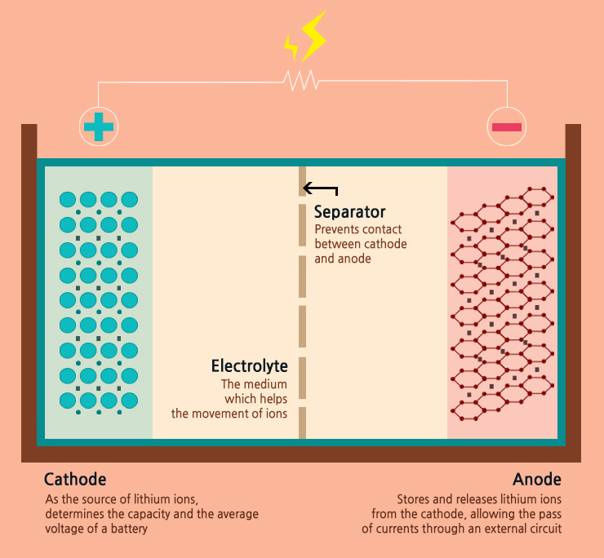

Figure 1.0 The four sections inside of a lithium-ion battery [2]

### Anode

The anode is a solid electric conductor that accepts electrons [3]. In Figure 1.0, the anode is made of a crystalline lattice of carbon called carbon graphite (C6).

### Cathode

The cathode is a solid electric conductor that releases electrons [3]. In Figure 1.0, the cathode is made of lithium cobalt dioxide (LiCoO2) molecules.

### Separator

The separator is a barrier between the cathode and the anode that prevents electrons from entering the electrolyte [2]. Electrons are subatomic particles that are negatively charged. In Figure 1.0, the separator is made of polyethylene (C2H4).

### Electrolyte

The electrolyte serves as a medium for lithium cation flow from the cathode to anode and anode to cathode [4]. A cation is defined as a subatomic particle with a positive net electric charge due to a loss of one or more of its electrons [5]. In Figure 1.0, the electrolyte is made of a lithium hexafluorophosphate (LiPF6) salt.

The four different battery parts are used in a redox reaction so that the battery can discharge and charge.

## 3.2 Redox Reactions

A redox reaction is a chemical reaction between an oxidizing agent and reducing agent that involves the transfer of electrons [6]. In a redox reaction, an oxidizing agent is defined as a molecule that gives up electrons and a reducing agent is defined as a molecule that takes in electrons from the oxidizing agent.

## 3.3 Charge and Discharge Phase of Lithium-Ion Battery

Redox reactions happen during the charging phase and discharging phase of a lithium-ion battery.

### 3.3.1 Charging phase of lithium-ion battery

In the charging phase, the LiCoO2 molecule is the oxidizing agent. The chemical reaction in the cathode is shown in the following equation

${\text{Li}}_{\text{x1}}\text{Co}{\text{O}}_{\text{2}} \text{⇔} {\text{Li}}_{\text{x2}}\text{Co}{\text{O}}_{\text{2}}\text{ + }{\text{ΔxLi}}^{\text{+}}\text{ +}{\text{ Δxe}}^{\text{-}}$ (1) [7]

Where ${\text{Li}}_{\text{x1}}\text{Co}{\text{O}}_{\text{2}}$ is the original molecule, ${\text{Li}}_{\text{x2}}\text{Co}{\text{O}}_{\text{2}}$ is the molecule after losing lithium cations, ${\text{ΔxLi}}^{\text{+}}$ is the number of lithium cations given up, and ${\text{ Δxe}}^{\text{-}}$ is the number of electrons given up by lithium cations. This equation shows that the LiCoO2 molecule releases a finite number of lithium cations where each ion has its electron removed.

In the anode, the C6 is the reducing agent and its reaction is shown in the following equation

${\text{C}}_{\text{6} }\text{+ Δx}{\text{Li}}^{\text{+}} \text{+} \text{Δx}{\text{e}}^{\text{-}} \text{⇔} {\text{Li}}_{\text{Δx}}{\text{C}}_{\text{6}}$ (2) [7]

Where C6 is the carbon graphite, ${\text{ΔxLi}}^{\text{+}}$ is the number of lithium cations taken in, $\text{Δx}{\text{e}}^{\text{-}}$ is the number of electrons given up by the lithium cations, and ${\text{Li}}_{\text{Δx}}{\text{C}}_{\text{6}}$ is the carbon graphite with lithium cations intercalated in it. Intercalation is a process where an ion is inserted into a crystalline lattice [8]. This equation shows that C6 is intercalating the released lithium cation into its crystalline lattice.

Figure 2.0 shows that LiCoO2 is the cathode, C6 is the anode, and LiPF6 is the electrolyte. The dotted line down the middle is the C2H4 polyethylene separator, and there is an external wire between the cathode and anode that connects the battery to the Tesla Model S.

Figure 2.0 Charging phase of a lithium-ion battery [7, modified]

Figure 2.0 is a visual representation of eq.1 and eq.2. It shows the lithium cations flowing through the LiPF6 towards the C6 crystal lattice anode. At the same time, the electrons lost by the lithium cations flow along the external wire in the direction of conventional current towards the C6 anode. Conventional current is defined as a flow of electrons from the cathode to the anode. The flow of electrons through this external wire creates current and charges the battery in the Tesla Model S.

### 3.3.2 Discharging phase of lithium-ion battery

In the discharging phase, the reactions at the cathode and anode happen in reverse so the cathode reaction becomes

${\text{Li}}_{\text{x2}}\text{Co}{\text{O}}_{\text{2}}\text{ + }{\text{ΔxLi}}^{\text{+}}\text{ +}{\text{ Δxe}}^{\text{-}}\text{ ⇔ }{\text{Li}}_{\text{x1}}\text{Co}{\text{O}}_{\text{2}}$ (3) [7, modified]

Where the released lithium cation and electrons return to the cathode.

The anode reaction is also reversed and is shown by

${\text{Li}}_{\text{Δx}}{\text{C}}_{\text{6}} \text{⇔} {\text{C}}_{\text{6 }}\text{+ Δx}{\text{Li}}^{\text{+}}\text{ + Δx}{\text{e}}^{\text{-}}$ (4) [7, modified]

Where the lithium cations and electrons return to the cathode.

Figure 3.0 shows that LiCoO2 is the cathode, C6 is the anode, and LiPF6 is the electrolyte. The dotted line down the middle is the C2H4 polyethylene separator, and there is an external wire between the cathode and anode that connects the battery to the Tesla Model S.

Figure 3.0 Discharging phase of a lithium-ion battery [7, modified]

Figure 3.0 gives a visual representation of the reversed equations, eq.3 and eq.4. It shows the intercalated lithium cations breaking apart from C6 crystalline lattice anode and flowing towards the LiCoO2 cathode. At the same time, the electrons lost by the lithium cations flow along an external wire against conventional current towards the LiCoO2 cathode. The flow of electrons through this external wire reduces current and discharges the battery in the Tesla Model S.

# CONCLUSION

The purpose of this report was to answer the question, how do lithium-ion batteries recharge on a chemical level? The Model S lithium ion battery is made of a cathode, anode, electrolyte, and separator that undergo redox reactions to charge and discharge. During the charging phase, the cathode releases lithium cations and electrons towards the anode. The lithium cations flow through the electrolyte while the electrons flow in an outer wire. This flow of electrons from the cathode to the anode charges the battery. During the discharging phase, the anode releases the stored lithium cations and electrons back to the cathode through the electrolyte and outer wire respectively. The flow of electrons from the anode to the cathode discharges the battery.

References

|  |  |
| --- | --- |
| [1] | "How Radar Detectors Work," Thomas Publishing Company, 17 November 2019. [Online]. Available: https://www.thomasnet.com/articles/instruments-controls/how-radar-detectors-work/. [Accessed 18 November 2019]. |
| [2] | "Samsung SDI," Samsung, [Online]. Available: https://www.samsungsdi.com/column/technology/detail/55272.html?listType=gallery. [Accessed 31 10 2019]. |
| [3] | A. M. Helmenstine, "How to Define Anode and Cathode," ThoughtCo, 09 October 2019. [Online]. Available: https://www.thoughtco.com/how-to-define-anode-and-cathode-606452. [Accessed 17 November 2019]. |
| [4] | "Battery Electrolyte (LiPF6) for Li-ion Cell Manufacturers," Targray, [Online]. Available: https://www.targray.com/li-ion-battery/electrolyte. [Accessed 15 November 2019]. |
| [5] | "What is an ion?," Propulsion, [Online]. Available: http://www.qrg.northwestern.edu/projects/vss/docs/propulsion/1-what-is-an-ion.html. [Accessed 17 November 2019]. |
| [6] | S. Khan, "Oxidation-reduction (redox) reactions," Khan Academy, [Online]. Available: https://www.khanacademy.org/science/chemistry/oxidation-reduction/redox-oxidation-reduction/a/oxidation-reduction-redox-reactions. [Accessed 2018 17 November]. |
| [7] | K. Krischer and K. Schonleber, "Exergy Storage," in *Physics of Energy Conversion*, Munchen, De Gruyter, 2015, p. 216. |
| [8] | A. J. Jacobson and L. F. Nazar, *Encyclopedia of Inorganic and Bioinorganic* Chemistry, Wiley, 2011. |

# Glossary

**Anode:** Solid electric conductor that accepts electrons.

**Cathode:** Solid electric conductor that releases electrons.

**Cation:** A subatomic particle with a positive net electric charge due to a loss of one or more of its electrons.

**Conventional Current:** Flow of electrons from the cathode to the anode.

**Electrolyte:** Medium for lithium cation flow from the cathode to anode and anode to cathode.

**Electrons:** Negatively charged subatomic particles.

**Intercalation:** Process where an ion is inserted into a crystalline lattice.

**Oxidizing Agent:** Molecule that gives up electrons in a redox reaction.

**Redox Reaction:** Chemical reaction between two molecules that involve the transfer of electrons.

**Reducing Agent:** Molecule that takes in electrons from the oxidizing agent in a redox reaction.

**Separator:** A barrier between the cathode and anode that prevents electrons from entering the electrolyte.

# Appendix

|  |  |
| --- | --- |
| [1] | "How Radar Detectors Work," Thomas Publishing Company, 17 November 2019. [Online]. Available: https://www.thomasnet.com/articles/instruments-controls/how-radar-detectors-work/. [Accessed 18 November 2019]. |



|  |  |
| --- | --- |
| [2] | "Samsung SDI," Samsung, [Online]. Available: https://www.samsungsdi.com/column/technology/detail/55272.html?listType=gallery. [Accessed 31 10 2019]. |



|  |  |
| --- | --- |
| [3] | A. M. Helmenstine, "How to Define Anode and Cathode," ThoughtCo, 09 October 2019. [Online]. Available: https://www.thoughtco.com/how-to-define-anode-and-cathode-606452. [Accessed 17 November 2019]. |

|  |  |
| --- | --- |
| [4] | "Battery Electrolyte (LiPF6) for Li-ion Cell Manufacturers," Targray, [Online]. Available: https://www.targray.com/li-ion-battery/electrolyte. [Accessed 15 November 2019]. |

|  |  |
| --- | --- |
| [5] | "What is an ion?," Propulsion, [Online]. Available: http://www.qrg.northwestern.edu/projects/vss/docs/propulsion/1-what-is-an-ion.html. [Accessed 17 November 2019]. |



|  |  |
| --- | --- |
| [6] | S. Khan, "Oxidation-reduction (redox) reactions," Khan Academy, [Online]. Available: https://www.khanacademy.org/science/chemistry/oxidation-reduction/redox-oxidation-reduction/a/oxidation-reduction-redox-reactions. [Accessed 2018 17 November]. |

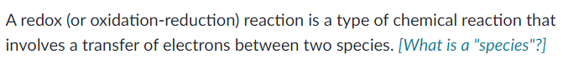

|  |  |
| --- | --- |
| [7] | K. Krischer and K. Schonleber, "Exergy Storage," in *Physics of Energy Conversion*, Munchen, De Gruyter, 2015, p. 216. |

|  |  |
| --- | --- |
| [8] | A. J. Jacobson and L. F. Nazar, Encyclopedia of Inorganic and Bioinorganic Chemistry, Wiley, 2011. |

