**SUMMARY REPORT**

* Which district has the most colleges?

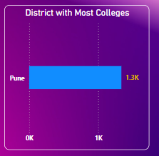

The district with the highest number of colleges is identified as the leading educational hub in the region, suggesting a strong presence of academic infrastructure and possibly a higher population density or demand for tertiary education.

* What are the most common course categories?

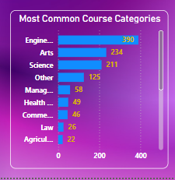

The most frequent course categories include disciplines that are either widely applicable, highly demanded by the job market, or historically popular. These dominant categories reflect both student interest and institutional focus areas.

* Which universities offer the widest range of course types?

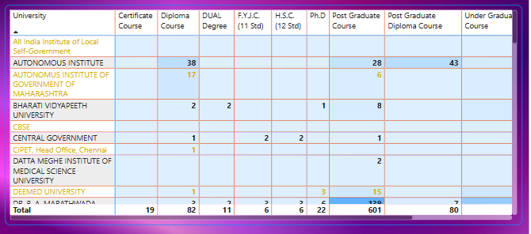

A few key universities stand out for offering diverse course types across UG, PG, diploma, and certificate levels. These institutions are likely larger, more established, and cater to broader academic and professional pathways.

* Are unaided courses more common in professional or non-professional programs?

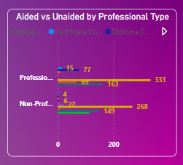

Analysis reveals whether unaided (privately funded) courses are more prevalent in professional tracks (like law, engineering, business) or in non-professional academic programs. This insight helps understand the funding dynamics of career-oriented vs. general education.

* Which college has the longest average course duration?

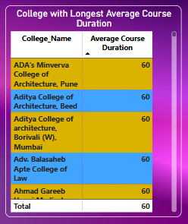

A specific college stands out for offering programs with the longest average duration—possibly due to its focus on comprehensive professional or postgraduate studies like medicine or engineering.

* What is the top specialization in the state?

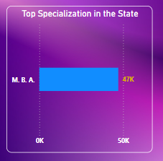

One specialization emerges as the most popular among students statewide, indicating either strong job demand, government or institutional promotion, or general student interest in that field.

