VoltMind is a persistent knowledge brain and knowledge runtime for AI agents. It turns scattered Markdown files, meetings, people, projects, and ideas into a system that agents can search, trace, reason over, and continuously improve. Instead of returning a list of documents, VoltMind can produce a cited answer, explain the relationships behind it, and identify what the brain still does not know.
The shortest version of the product differentiation is:
Traditional RAG returns documents. VoltMind returns a cited answer, explains the relationships, and tells the agent what is still unknown.

Slide 1 — The problem and the product
AI agents are intelligent, but they do not have durable knowledge of our world
VoltMind addresses these problems by adding a long-running brain layer between the agent and the user's personal or organizational knowledge.
I would describe it using three words.
It is persistent, because the context survives across conversations, agents, and devices.
It is structured, because it stores more than text chunks. It understands entities, page types, typed relationships, timelines, facts, takes, projects, risks, and actions.
And it is actionable, because the final output is not simply a file list. It can be an answer, a briefing, a risk, an action, or an explicit knowledge gap.
The goal is not to build another note-taking application. The goal is to give agents a durable and continuously improving model of the user's world.

Slide 2 — The compounding intelligence loop
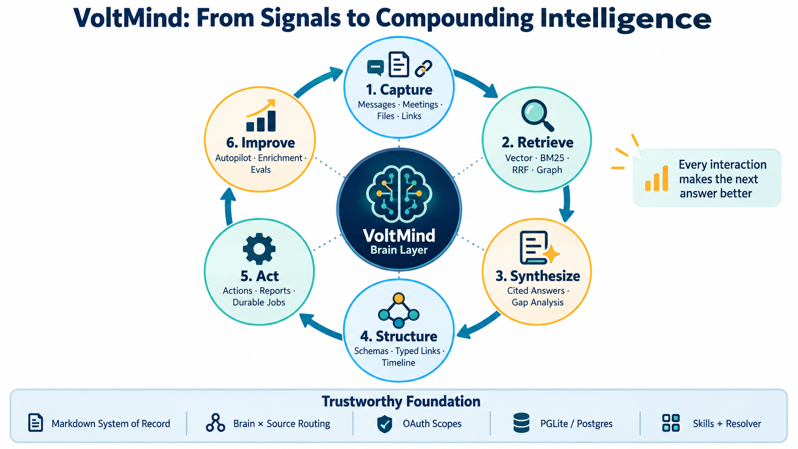
VoltMind Capability Loop
This diagram shows how VoltMind turns individual interactions into a compounding knowledge loop.
The first stage is Capture.
VoltMind can receive signals from messages, meetings, files, links, webhooks, voice workflows, email and calendar integrations, or direct CLI capture.
The second stage is Retrieve.
Retrieval combines vector similarity, BM25 keyword matching, reciprocal-rank fusion, source-aware ranking, graph signals, and optional reranking. This is important because no single retrieval strategy works for every question.
The third stage is Synthesize.
VoltMind can combine evidence from several pages into a cited answer. It can also identify stale information, contradictions, missing citations, and gaps in the available evidence.
The fourth stage is Structure.
Schema packs define which page types exist, which types can be used for expert routing or fact extraction, and which typed links are meaningful. Timelines preserve how facts, decisions, and relationships change over time.
The fifth stage is Act.
Knowledge can produce concrete actions, reports, or durable background jobs. The Minions queue gives long-running work persistent state, progress reporting, retries, checkpoints, and recovery instead of treating sub-agent work as a fire-and-forget promise.
The sixth stage is Improve.
Autopilot continuously synchronizes, extracts, embeds, enriches, consolidates, checks contradictions, and evaluates brain quality. This allows the brain to improve even when the user is not actively querying it.
Under the loop are five trust foundations:
- Markdown as the system of record;
- Brain and Source as explicit routing dimensions;
- OAuth scopes and a fail-closed trust boundary;
- interchangeable PGLite and Postgres engines;
- and Skills plus Resolver-based workflow routing.
The outcome is simple: every useful interaction should make the next answer better.

Slide 4 — Three real application examples

Example A: Meeting preparation
#### User trigger
I am meeting Alice tomorrow. Tell me what I need to know.
#### Full speaking script
The workflow Resolver routes this request into brain-first query and meeting-preparation behavior.
VoltMind first searches the relevant person, meeting, project, commitment, and action pages. It can then traverse graph relationships to find connected companies, projects, previous meetings, and outstanding commitments.
The synthesis layer returns a concise briefing with citations and explicitly warns about stale or missing information.
The business value is that a twenty-minute manual review becomes a short, actionable briefing while preserving traceability.

Example B: Ingesting a meeting and producing follow-up actions
#### User trigger
Put these meeting notes into the brain and organize the follow-up actions.
#### Full speaking script
The workflow Resolver selects the meeting-ingestion skill.
The raw evidence is preserved under sources/. A structured analysis belongs under meetings/. New information about participants and companies updates the relevant entity pages. A bounded body of work may produce a projects/ page, while a report or proposal belongs under artifacts/.
Concrete executable follow-ups are represented separately under state/actions/.
Every durable fact requires a citation, and entity references create links or backlinks so the meeting does not become an isolated document.
The result is not simply one saved transcript. The same evidence becomes a traceable source, a meeting summary, entity updates, relationships, and executable actions.

Example C: Capturing an idea and promoting it into a project
#### User trigger
Remember this idea: we could use customer-support conversations to generate a product-requirements map.
#### Full speaking script
At first, this is a possibility without an owner, milestone, execution scope, or completion condition. According to the brain filing Resolver, its primary home is ideas/.
If the user later assigns an owner, defines the goal, creates milestones, and establishes an end condition, it becomes a bounded work unit and should have a page under projects/.
Its concrete report or design document belongs under artifacts/. Its smallest executable steps belong under state/actions/. If it becomes an ongoing responsibility with no defined end state, it belongs under workstreams/ instead.
This illustrates an important property of the system: the knowledge structure can evolve as the work matures, without collapsing ideas, projects, deliverables, and actions into one generic note type.

Resolver trigger examples
User request | Workflow route | Filing route | Expected result
“What do we know about X?” | query | Read-only | Keyword search first, followed by hybrid query or direct page retrieval as needed; return a cited answer.
“What is the relationship between A and B?” | query plus graph query | Read-only | Traverse typed edges and return the relationship path.
“Save this idea.” | capture or idea-ingest | ideas/ or originals/ | Preserve the user's wording, citations, entity links, and backlinks.
“Process these meeting notes.” | meeting-ingestion | sources/, meetings/, and entity pages | Separate raw evidence from analysis and durable entity updates.
“Turn this into a tracked project.” | project | projects/, or workstreams/ when there is no end condition | Establish goals, ownership, milestones, source bindings, and status.
“What matters today?” | briefing | Normally read-only; a saved deliverable goes to artifacts/ | Aggregate meetings, actions, commitments, and risks.
“This action is complete.” | daily-task-manager or schedule-actions | state/actions/ | Update the authoritative local Markdown action lifecycle.
“That is not what I said. Correct it.” | correction-pipeline | Repair the canonical page and evidence chain | Prevent the incorrect claim from continuing to propagate.
“Audit these citations and facts.” | citation-fixer or fact-check | Repair the corresponding canonical pages | Keep durable claims traceable to evidence.
“Which team does this person belong to, and which projects are connected?” | query or find_experts | Read-only | Combine person, organization, project, and typed-link evidence.

